# Vulnerability to severe trauma: A spatial perspective

N Schuurman1 NJ Bell2 and SM Hameed3

1 Associate Professor, Department of Geography, Simon Fraser University

2 PhD Candidate, Department of Geography, Simon Fraser University

3 Assistant Professor of Surgery and Critical Care Medicine, Department of Surgery, University of British Columbia

**Word count: 2987**

**Key words:**

Trauma, injuries, epidemiology, socioeconomic status, geography

# Address Correspondence to:

# SM Hameed MD MPH

# Trauma Services, Vancouver General Hospital

# 855 West 12 Avenue

# Vancouver, BC V5Z 1M9 Canada

# morad.hameed@vch.ca

# Abstract

**Background:** Trauma is a leading cause of death, potential years of life lost, and health care expenditure in Canada. Injury control is increasingly recognized as a public health priority requiring investment in research and evidence-based action. In this study, geographic information science (GIS) is applied to characterize the spatial distributions of the major mechanisms of severe trauma and to identify socioeconomic and geographic vulnerabilities to severe injury in a large metropolitan region.

**Methods:** Data from the British Columbia Trauma Registry and national census data were used to measure population based incidence rates for 4 major mechanisms of severe trauma in Metro Vancouver over a 5 year period (2001-2006). The Vancouver Deprivation Index (VANDIX) was used to assess the impact of socioeconomic deprivation on injury risk. The spatial distribution of injuries was assessed using GIS techniques. Measures of SES and spatial statistics were used to characterize injury vulnerability.

**Results:** Variations in acute injury rates and patient’s SES quintile were widest for injuries sustained in assaults amongst young and middle aged adults (ages 18 – 54) and pedestrian related injuries amongst the elderly (over 65). Variations in acute injury rates and socio-economic quintile rankings were much smaller between all age groups for motor vehicle crashes and falls. Although there was no spatial dependency between adjacent large area administrative boundaries, at the neighbourhood level trauma cases were highly clustered suggesting a strong association between neigbourhood and vulnerability to severe injury.

**Discussion:** SES and geography are strong predictors of risk of severe injuries from assault and pedestrian trauma. GIS is a potentially valuable tool for identification of vulnerability, communication, and development of targeted injury control policy.

**Introduction**

Trauma is the leading cause death and potential years of life lost in the first four decades of life in North America and around the world [1]. In Canada in 1998, the economic burden of injury was estimated at $12.7 billion, or just under $400 per capita. Between April 1, 1998 and March 31, 1999, there were 195,116 acute care hospital admissions due to injury, accounting for 7% of all hospitalizations. During the same period, individuals under the age of 45 represented almost half (47%) of all injury admissions.[1]

Although advances in trauma prevention, pre-hospital care, shock resuscitation, operative technique, critical care medicine, and rehabilitation have been shown to reduce morbidity and mortality resulting from severe trauma, injury rates have remained high, and some populations remain particularly vulnerable to the risks and consequences of injury. More refined understanding of the impact of geographic and societal factors on trauma risk and outcome may result in the development of health policy that effectively reduces the tremendous burden of injury [2].

In the past two decades, geographic information science (GIS) has made important contributions in public health analysis, emerging as a valuable tool for the prediction of pathogen dissemination [3-6], location-allocation of health and emergency services [7-9], and the assessment of environmental effects on health [10, 11]. Over the same period, researchers have produced substantial evidence of a social gradient for a variety of health outcomes, rising from systematic differences in income, education, employment conditions, unemployment, and family structure [12-26]. GIS mapping technology has been employed for illustrating spatial patterns of social gradients in health outcomes [27] but perhaps not utilized the full analytical capabilities of this technology. This study measures the impact of societal and geographic factors on injury risk and illustrates the analytical potential of GIS for refining our understanding of community-specific determinants of injury.

**Methods**

Study population

Metro Vancouver is a partnership of 21 municipalities and one electoral area with a combined population of over 2 million ([www.gvrd.bc.ca](http://www.gvrd.bc.ca/)) in the Canadian province of British Columbia (BC). The region is a large and diverse urban area with high population density and an integrated system of trauma triage and treatment. Although there are numerous hospitals in the area, severely injured patients are, for the most part, transported to one of 4 trauma receiving hospitals. Data from patients admitted with severe injuries (Injury Severity Score > 12 or 2 or more days in hospital) to any of these hospitals are included in the British Columbia Trauma Registry (BCTR).

The study cohort was considered to be all adults (age > 18) with home addresses within the boundaries of Metro Vancouver. Data on the outcome of interest, severe trauma among residents of Metro Vancouver, were derived from the BCTR. The analysis focused on four injury mechanisms, including assault, pedestrian trauma, motor vehicle crashes (MVCs) and falls over the past 5 years (2001-2006). ICD-10 classification coding was used to determine injury mechanism.

Measurement of socioeconomic status

Neighbourhood SES was modeled using socio-economic data obtained from the 2001 Canadian Census. The proxy measure of socio-economic inequality was modeled using the *Vancouver Area Neighbourhood Deprivation Index* (VANDIX). The VANDIX was previously constructed by the authors for the purpose of measuring the influence of the socio-economic factors that shape health outcomes throughout British Columbia [28]. Briefly, the VANDIX was constructed from a survey of British Columbia’s Medical Health Officers (MHOs) between the months of June and August, 2005. Because socio-economic deprivation can be linked to multiple aspects of social and material inequality the survey included a number of SES variables taken from previously constructed deprivation indices in the UK in addition to more specific variables specific to the health and well-being of Canadians [13, 27, 29]. A total of 21 variables obtained from the 2001 Canadian Census were included in the original questionnaire. MHOs were asked to rank each variable according to its importance in characterizing relative health outcomes. The final index was constructed using the frequency of their response scores (see table 1). A core portion of the survey included variables related secondary and post secondary education, unemployment rates and employment ratios, in addition to average income. Family demographics, such as lone parent families and household overcrowding, were also included. Other variables included immigration and spoken language, mobility, and marital status.

Spatial analysis

Using GIS, each census spatial unit was linked to attribute types using a *census unique identifier*, which is a uniquely defined administrative identification number assigned for both spatial and tabular data. Raw rates for each SES variable were assigned to each census unit. The variables were then standardized using z-scores and multiplied by the corresponding weight originally assigned in the VANDIX using the *field calculator*, which is part of ArcGIS© software package produced by the *Environmental Systems Research Institute* (ESRI). Standardized z-scores are one of many ways to construct deprivation indices, which can also include log transformations, Principal Component or Factor Analysis [13, 27, 29]. Census units with population counts less than 250 residents were filtered from the database in order to suppress data in areas with low population counts. Trauma cases within these units were also filtered. Due to the data restrictions associated with the census and to avoid ecological fallacy, SES data from the census were age-standardized by population group – but not by individual variables.

Only assault cases were examined using a spatial clustering test. This test for spatial dependency was conducted at three scales using *Moran’s I* [30]: patient residential postal code, Census Tract and the Local Health Area (LHA) – a sub-division of the regional health authority.

The study was approved by the Clinical Research Ethics Board at the University of British Columbia. It was funded through a team grant from the Michael Smith Foundation for Health Research.

**Results**

During the study period, the Metro Vancouver census metropolitan area (CMA) accounted for 404 injuries from assault, 1,084 from MVCs, 1,216 from falls, and 403 pedestrian injuries. All incident cases were then aggregated into their corresponding Census Dissemination Area (DA) administrative boundary to match with socio-economic data. DAs are the smallest unit of dissemination of the Canadian Census. A single DA unit, on average, represents between 400-700 individuals. In 2001 there were nearly 4,000 DAs in the Vancouver CMA, representing just fewer than 2 million people, which in 2001 was slightly more than half of the total population of province.

The spatial epidemiology of assault-related injury

Age-standardized incidence rates (per 100,000) by age group for specific trauma incidents in the Vancouver CMA by socio-economic quintile are reported in table 2. Variation in prevalence rates of patient’s socio-economic quintile and assault injuries were sharpest for young adults aged 15 – 44, with step-wise increase from least to most deprived SES quintiles, the widest occurring for adults aged 35-44. In this age group rates increased from 4.7 per 100,000 in the least deprived socio-economic quintile to over 70 per 100,000 in the most deprived quintile. Prevalence rates of assault injuries decreased with age across all SES classes, with the largest drop in rates occurring in adults 55 and older. These results are consistent with previous research conducted by Williams et al [31] and Durkin [32] in which assault patterns were more common among adolescents of lower SES, although these trends in Vancouver extend far past adolescence and into middle-age populations. Across all SES classes these trends decreased across age groups as age increased. The gradient between SES and rates of injury, however, remained. Figure 1 illustrates that the concentration of injury based on assault, amongst elsewhere, is highest in Vancouver’s Downtown Eastside – Canada’s poorest postal code and lowest in West Vancouver – one of Canada’s richest postal codes.

## Table 1: shows the seven variables selected by British Columbia’s MHOs for the VANDIX. The original MHO variable rankings are proportional to the number of strongly agree and agree responses from the survey.

| **SES Variable Constructs** | | | **Strongly Agree Responses** | **Agree Responses** | **Rank** | **Weight (%)** |
| --- | --- | --- | --- | --- | --- | --- |
| **Material Wealth** | | |  |  |  |  |
| Average Income | | | 2 | 6 | 5.5 | 0.089 |
|  | | |  |  |  |  |
| **Housing** | | |  |  |  |  |
| Home Ownership | | | 2 | 6 | 5.5 | 0.089 |
|  | | |  |  |  |  |
| **Demographics** | | |  |  |  |  |
| Single Parent Family | | | 4 | 4 | 4 | 0.143 |
|  | | |  |  |  |  |
| **Education** | | |  |  |  |  |
| No High school Completion | | | 6 | 4 | 1 | 0.250 |
| With a University Degree | | | 5 | 3 | 3 | 0.179 |
|  |  |  |  |  |  |  |
| **Employment** | | |  |  |  |  |
| Employment Ratio | | | 4 | 3 | 7 | 0.036 |
| Unemployment Rate | | | 6 | 3 | 2 | 0.214 |
|  |  |  |  |  |  |  |

**Table 2**: Age-standardized incidence rates per 100,000 for persons aged 15 - over 65 years in Vancouver CMA, 2001 - 2006 by socio-economic quintile

|  |  |  |  |  |  |  |  |  |  |  |  |
| --- | --- | --- | --- | --- | --- | --- | --- | --- | --- | --- | --- |
|  | Rate per 100,000 persons | | | | | | | | | | |
|  |  |  |  |  |  |  |  |  |  |  |  |
|  | **15 - 24**† |  | **25 - 34** |  | **35 - 44** |  | **45 - 54** |  | **55 - 64** |  | **65 +** |
|  |  |  |  |  |  |  |  |  |  |  |  |
|  |  |  |  |  |  |  |  |  |  |  |  |
| **Assaults** | **44.3c** |  | **30.7c** |  | **24.7c** |  | **19.4c** |  | **15.6b** |  | **5.8** |
| SES 1 (least deprived) | 30.0 |  | 13.4 |  | 4.7 |  | 2.9 |  | 5.0 |  | 4.6 |
| SES 2 | 34.6 |  | 28.6 |  | 10.7 |  | 14.8 |  | 7.9 |  | 4.5 |
| SES 3 | 33.2 |  | 22.0 |  | 16.9 |  | 3.3 |  | 5.7 |  | 6.4 |
| SES 4 | 42.7 |  | 26.6 |  | 28.4 |  | 15.9 |  | 26.8 |  | 5.9 |
| SES 5 (most deprived) | 86.5 |  | 60.4 |  | 64.7 |  | 72.1 |  | 37.1 |  | 7.3 |
|  |  |  |  |  |  |  |  |  |  |  |  |
| **Motor Vehicle Crashes** | **101.8** |  | **68.4** |  | **49.5** |  | **57.5** |  | **55.1** |  | **62.2** |
| SES 1 (least deprived) | 80.5 |  | 67.1 |  | 34.4 |  | 54.6 |  | 30.3 |  | 64.3 |
| SES 2 | 129.2 |  | 53.9 |  | 38.9 |  | 56.1 |  | 50.0 |  | 38.3 |
| SES 3 | 90.3 |  | 69.5 |  | 60.7 |  | 44.4 |  | 79.1 |  | 83.4 |
| SES 4 | 104.1 |  | 76.6 |  | 55.4 |  | 65.5 |  | 74.5 |  | 61.3 |
| SES 5 (most deprived) | 107.0 |  | 75.1 |  | 58.7 |  | 72.1 |  | 46.4 |  | 63.5 |
|  |  |  |  |  |  |  |  |  |  |  |  |
| **Falls** | **21.4** |  | **28.0** |  | **40.8a** |  | **63.8** |  | **89.0** |  | **233.4b** |
| SES 1 (least deprived) | 26.2 |  | 21.1 |  | 32.9 |  | 53.1 |  | 80.7 |  | 337.6 |
| SES 2 | 20.0 |  | 32.0 |  | 33.5 |  | 48.7 |  | 65.8 |  | 250.3 |
| SES 3 | 18.4 |  | 20.3 |  | 29.6 |  | 44.4 |  | 93.2 |  | 188.2 |
| SES 4 | 24.2 |  | 34.4 |  | 45.4 |  | 86.7 |  | 101.3 |  | 184.0 |
| SES 5 (most deprived) | 18.5 |  | 31.0 |  | 64.7 |  | 98.1 |  | 111.4 |  | 224.9 |
|  |  |  |  |  |  |  |  |  |  |  |  |
| **Pedestrian Injuries** | **13.5** |  | **16.8a** |  | **15.8b** |  | **16.8b** |  | **28.4** |  | **64.3c** |
| SES 1 (least deprived) | 5.6 |  | 7.7 |  | 7.8 |  | 10.3 |  | 10.1 |  | 39.0 |
| SES 2 | 10.9 |  | 20.2 |  | 9.4 |  | 8.9 |  | 36.8 |  | 40.6 |
| SES 3 | 18.4 |  | 10.2 |  | 18.3 |  | 9.9 |  | 22.6 |  | 53.5 |
| SES 4 | 13.0 |  | 18.8 |  | 11.4 |  | 17.7 |  | 32.8 |  | 73.2 |
| SES 5 (most deprived) | 20.6 |  | 26.1 |  | 33.1 |  | 44.1 |  | 43.3 |  | 105.2 |
|  |  |  |  |  |  |  |  |  |  |  |  |
| *P values for single factor ANOVA by age-group and SES: a<0.05 ; b<0.01 ; c<0.001 | | | | | | | |  |  |  |  |
| † rates are based on smaller than expected injury cases as BCTR records begin at age 18 | | | | | | | | | | | |

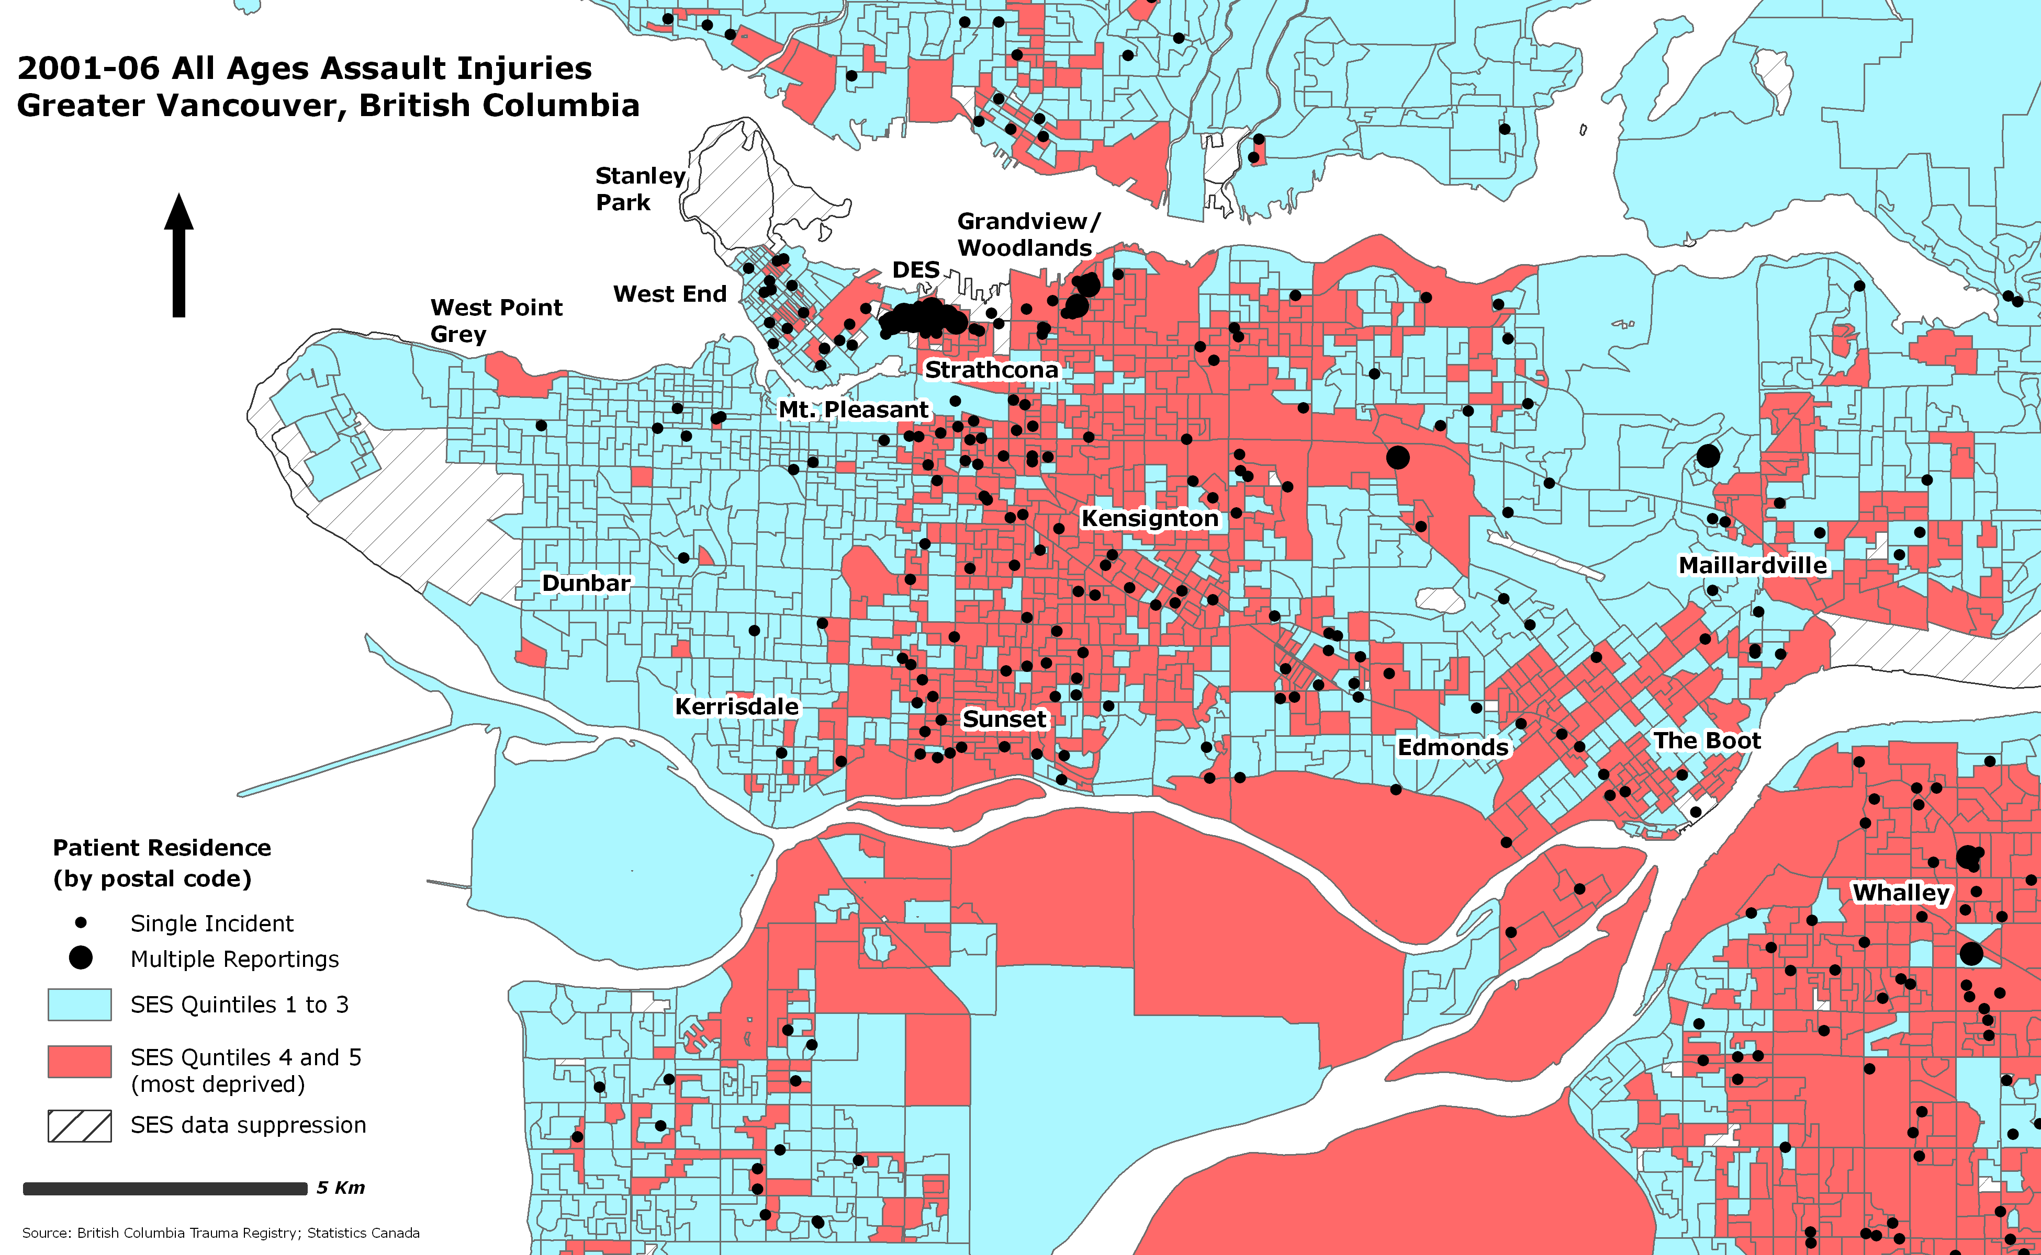

**Figure 1 –** Incidence of assault within the Core Vancouver CMA. The Downtown Eastside – Canada’s poorest postal code – has a spatially significant concentration of assault.

Depending on the administrative unit used to assess contextual community effects on injury the clustering or dispersion of feature locations may increase the likelihood of committing type I errors due to the confounding effects owing to spatial autocorrelation***.*** When measured using large scale (i.e. small area) administrative boundaries (postal codes, Census Tracts) there was less than a 1% likelihood that assault patterns within the Vancouver CMA were the result of random chance (p < 0.01). This likely stems from the high concentration of assaults within specific geographic areas.

## 

## Figure 2: Spatial distribution of violent assault injuries (by patient residence) throughout the Vancouver CMA. Spatial dependency may increase at a large-scale (i.e. postal code); however the predictive strength of SES may be removed at small-scale (i.e. Local Health Area).

Pedestrian trauma

Figure 3 is a map of both incident cases by pedestrian injury for adults aged 65 and older and adults aged 18 – 64. A social gradient between patient’s SES classification and prevalence of pedestrian injury was found for adults aged 65 and older, with age-adjusted incident cases rising step-wise from 39 per 100,000 in the least deprived quintile to over 100 per 100,000 in the most disadvantaged quintile. With the exception of persons aged 65 and older, however, SES had less significance for the number of pedestrian injuries compared to rates of assaults. Results show wide differences between the most and least deprived SES quintiles, with rates four to five times higher between both quintiles. Rates between the remaining quintiles, however, were less consistent and varied with the patient’s SES classification. Inverse to assaults, rates of pedestrian injury increased in nearly all SES categories by age. Although a social gradient in SES and pedestrian injury is frequently found amongst children [34, 35], relatively few studies have investigated the relationship between SES and pedestrian injuries amongst the elderly [36].

The spatial epidemiology of MVC and fall-related trauma

In contrast to pedestrian related and assault injuries, no obvious trends were found between patients’ SES and injuries resulting from motor vehicle crashes and falls. Although this research investigated only severe injury with ISS > 12,the findings are in contrast to early research conducted by Turrell [37] where motor vehicle crashes increased amongst persons from more disadvantaged backgrounds. Adults aged 45-54 in SES quintile five (most deprived), however, experienced the highest rate of injury stemming from MVCs. Further, among adults aged 25-34, rates of injury were again the highest for adults in SES quintiles four and five. In the remaining age groups and SES quintiles, however, our analysis revealed that SES frequently showed an inverse impact on the number of motor vehicle related injuries, particularly in middle SES quintiles 2 and 3.

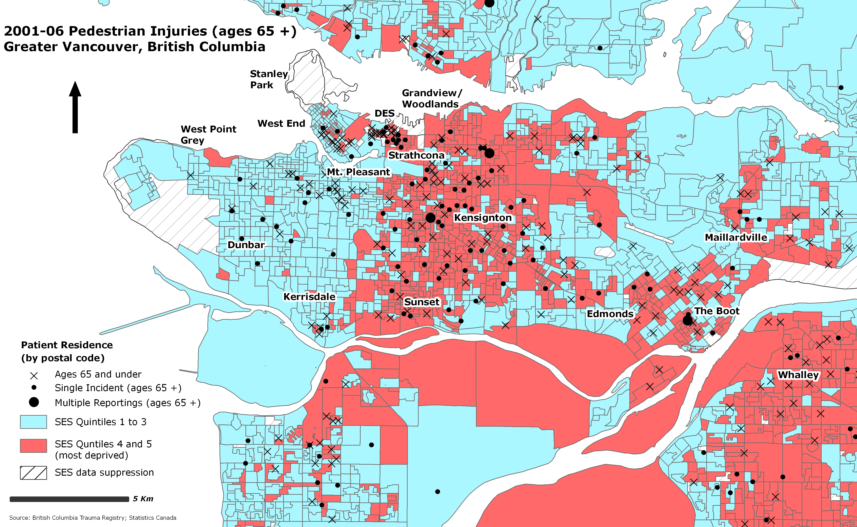

**Figure 3 –** Pedestrian injury cases (aged 65 and older) within the Core Vancouver CMA. Note that in the most deprived quintiles pedestrian injuries increased among persons 65 years or older.

Using data from the BCTR we also examined injury rates from falls in association with patient’s SES quintile and found similar patterns to motor vehicle crashes. With the exception of adults aged 35 – 54, the results revealed little significant variation when contrasted against the patient’s SES quintile. Although there was a downward trend between SES 1 (most privileged) and SES 5 for adults aged 25 – 34 and aged 45 – 54 the variation in SES quintile and rates of injuries was not statistically significant between all SES classes and injury rates. For the young, ages 15-24, and the elderly, age 65 and over, the relationship between patient’s SES and acute injury displayed inverse trends.

### Discussion

Societal factors are known to exert an impact on mortality through a wide range of mechanisms [38]. In the United States, a recent analysis of National Health Interview Survey (NHIS) data demonstrated significant disparities in potential years of life lost between strata of income, education, and race. These disparities were primarily attributable to ischemic heart disease, hypertension, cancers, type 2 diabetes, HIV and/or trauma depending on the societal factor under consideration [39]. Other societal factors, including income inequality, family structure, population density, and human rights violations are also associated with mortality [40, 41]. Canadian investigators have made similar observations – mortality rates for many common illnesses are higher among the socioeconomically disadvantaged [42]. Interestingly, Canadian studies have also demonstrated that even within systems of universal health care coverage, risk of acute illness and access to life-saving diagnostic and therapeutic interventions is influenced by socioeconomic factors [43-46].

Socioeconomic status (SES) has been shown to be a powerful predictor of trauma risk in the US, even accounting for disparities attributed to other societal factors. Centerwall [47] found that the risk of intraracial homicide was six times higher among black populations compared to white populations in New Orleans, with the observed association accounted for by one measure of SES: household crowding. Other studies have implicated SES as an important confounder of the race-trauma risk association; SES factors such as social disorganization, acculturation [48], neighbourhood SES [49],education of head of household [50], and birth weight [51] have all been found, at least in part, to explain high trauma rates observed in African Americans. An important Canadian study reflects similar experiences here: although injury mortality has declined overall in the last 3 decades, disparities in mortality rates between children from high and low income areas have persisted. The authors of this study concluded that, to reduce socioeconomic inequities, “targeted prevention should be implemented for injuries with the largest SES rate differences” [52].

The impact of SES on trauma risk in Canada has not been extensively studied, and to our knowledge, GIS tools have not been applied. Our analysis revealed striking and robust associations of socioeconomic deprivation and risk of assault and pedestrian trauma, including a 14 fold difference in the risk of severe injury resulting from assault between the most and least deprived segments of society. Quantification of these disparities may be important in efforts to reduce the burden of illness in Canada’s most disadvantaged populations. Equally importantly, GIS provided insights into spatial aspects of vulnerability, identifying neighborhoods with high rates of specific injury mechanisms. Applied in this way, spatial analyses can direct injury control mechanisms to high-risk environments.

This research makes a number of important methodological contributions to literature on SES and acute injury. We have shown that GIS can be used to produce analytical models of neighbourhood SES for injury surveillance and prevention strategies. Integration of GIS, Census geographies and a locally representative deprivation index can be used to measure SES against subsets of a provincial trauma registry. The resulting model also illustrates the potential of GIS to reveal spatial patterns in acute injury and their link to population health. . Results from this analysis were presented using large scale (i.e. small-area) analysis, as this is a more informative lens in which to measure local health outcomes than much larger, regional Health Authority or Health Service Delivery Area boundaries, which can contain on average tens to hundreds of thousands of people.

This work has some methodological limitations. Relying on aggregate Census data for mapping SES, is a limited, albeit still informative, approach for measuring the relationship between neighbourhood/individual SES and rates of injury. Census data are also susceptible to under-representation of current population and living dynamics given the 20% questionnaire sampling frame and two-year survey-to-publication periods[1]. Likewise, different variables and/or weighting schematics of the deprivation index may produce different results. Finally, due to limitations in available data, our analysis did not account for prehospital mortality and may have therefore slightly underestimated trauma volumes.

Our analysis illustrates that GIS is a useful tool in identifying and communicating socioeconomic vulnerability to severe injury and that it may have the potential to inform the development and evaluation of specific community and neighbourhood level injury prevention strategies. Furthermore, the relationship between SES and acute injury seems best analyzed when researchers work within a dynamic mapping environment. Continuing research will map the spatial distribution of trauma within British Columbia using GIS and integrate small-area statistical methods to more accurately target injury surveillance and prevention strategies.

References

1. **National Trauma Registry Report - Hospital Injury Admissions 1998/1999**. 2001.

2. National Scientific Advisory Committee: **Listening for Direction on Injury: Final Report**. In*.*: CIHR; 2004.

3. Beck LR, Rodrigues MH, Dister SW, Rodrigues AD, Rejmankova E, Ulloa A ea: **Remote sensing as a landscape epidemiologic tool to identify villages at high risk for malaria transmission**. *American Journal of Tropical Medicine and Hygiene* 1994, **51**:271-280.

4. Chadee DD, Williams FLR, Kitron UD: **Impact of vector control on dengue fever outbreak in Trinidad, West Indies, in 1998.** *Tropical Medicine & International Health* 2005, **10**(8):748-754.

5. Dragicevic S, Schuurman N, Fitzgerald M: **The Utility of Exploratory Spatial Data Analysis in the Study of Tuberculosis Incidences in an Urban Canadian Population**. *Cartographica* 2004, **39**(2):29-40.

6. Glass GE, Schwartz BS, Morgan JMI, Jonson DT, Noy PM, Israel E: **Environmental risk factors for Lyme disease identified with geographic information systems**. *American Journal of Public Health* 1995, **85**:944-948.

7. Conner RA, Kralewski JE, Hillson SD: **Measuring Geographic Access to Health Care in Rural Areas**. *Medical Care Research and Review* 1994, **51**(3):337-377.

8. Luo W, Wang F: **Measures of spatial accessibility to health care in a GIS environment: Synthesis and a case study in the Chicago region**. *Environment and Planning B: Planning and Design* 2003, **30**(6):865-884.

9. Walsh SJ, Gesler WM, Page PH, Crawford TW: **Health Care Accessibility: Comparison of Network Analysis and Indices of Hospital Service Areas**. In: *GIS/LIS '95: 1995; Nashville, Tennessee*; 1995.

10. Brody JG, Vorhees DJ, Melly SJ, Swedis SR, Drivas PJ, Rude RA: **Using GIS and historical records to reconstruct residential exposure to large-scale pesticide application**. *Journal of Exposure Analysis & Environmental Epidemiology* 2002, **12**(1):64-80.

11. Hellström L, Järup L, Persson B, Axelson O: **Using environmental concentrations of cadmium and lead to assess human exposure and dose**. *Journal of Exposure Analysis & Environmental Epidemiology* 2006, **14**(5):416-423.

12. Dunn JR: **Housing and inequalities in health: a study of socioeconomic dimensions of housing and self reported health from a survey of Vancouver residents**. *Journal of Epidemiology & Community Health* 2002, **56**(9):671-681.

13. Frohlich KL, Mustard C: **A regional comparison of socioeconomic and health indices in a Canadian province**. *Social Science & Medicine* 1996, **42**(9):1273-1281.

14. Heaney DC, MacDonald BK, Everitt A, Stevenson S, Leonardi GS, Wilkinson P, Sander JW: **Socioeconomic variation in incidence of epilepsy: prospective community based study in south east England**. *BMJ* 2002, **325**(7371):1013-1016.

15. Davey Smith G: **The Black Report on Socioeconomic Inequalities in Health 10 Years On**. *BMJ* 1990, **301**:373-377.

16. Roos LL, Magoon J, Gupta S, Chateau D, Veugelers PJ: **Socioeconomic determinants of mortality in two Canadian provinces: multilevel modelling and neighborhood context**. *Social Science & Medicine* 2004, **59**(7):1435-1447.

17. Singh SM, Paszat LF, Li C, He J, Vinden C, Rabeneck L: **Association of socioeconomic status and receipt of colorectal cancer investigations: a population-based retrospective cohort study**. *CMAJ* 2004, **171**(5):461-465.

18. Singh GK, Siahpush M: **Increasing inequalities in all-cause and cardiovascular mortality among US adults aged 25-64 years by area socioeconomic status, 1969-1998**. *International Journal of Epidemiology* 2002, **31**(3):600-613.

19. Evans RG, Barer ML, Marmor TR (eds.): **Why are Some People Healthy and Others Not? The Determinants of Health of Populations**. New York: Aldine de Gruyter; 1994.

20. Kawachi I, Berkman LF: **Neighborhoods and health**. Oxford: Oxford University Press; 2003.

21. Keating DR, Hertzman C (eds.): **Developmental health and the wealth of nations**. New York: Guilford; 1999.

22. Marmot M, Smith G, Stansfeld S, Patel C, North F, Head J, White L, Brunner E, Feeney A: **Health inequalities among British Civil Servants: The Whitehall II Study**. *The Lancet* 1991, **337**:1387-1393.

23. Marmot MG: **Social Inequalities in Mortality: The Social Environment**. In: *Class and Health: Research and Longitudinal Data.* Edited by Wilkinson RG. London: Tavistock; 1986: 21-33.

24. Marmot MG: **Social differentials in health within and between populations**. In: *Proceedings of the 11th Honda Foundation Discoveries Symposium, Prosperity, Health and Well-being: 1993; Toronto*: Canadian Institute for Advanced Research; 1993.

25. Townsend P, Davidson N, Whitehead M (eds.): **Inequalities in Health: The Black Report and the Health Divide**. Harmondsworth: Penguin Books; 1986.

26. Odoi A, Wray R, Emo M, Birch S, Hutchison B, Eyles J, Abernathy T: **Inequalities in neighbourhood socioeconomic characteristics: potential evidence-base for neighbourhood health planning**. *International Journal of Health Geographics* 2005, **4**(20):1-15.

27. Pampalon R, Raymond G: **A Deprivation Index for Health and Welfare Planning in Quebec**. *Chronic Diseases in Canada* 2000, **21**(3):104-113.

28. Bell N, Schuurman N, Oliver L, Hayes MV: **Towards the Construction of Place-Specific Measures of Deprivation: A Case Study from the Vancouver Metropolitan Area**. *The Canadian Geographer* accepted 2007.

29. Langlois A, Kitchen P: **Identifying and Measuring Dimensions of Urban Deprivation in Montreal: An Analysis of the 1996 Census Data**. *Urban Studies* 2001, **38**(1):119-139.

30. Moran PAP: **The Interpretation of Statistical Maps**. *Journal of the Royal Statistical Society Series B* 1948, **10**(2):243-251.

31. Williams JM, Currie CE, Wright P, Elton RA, Beattie TF: **Socioeconomic status and adlescent injuries**. *Social Science & Medicine* 1997, **44**:1881-1891.

32. Durkin MS, Davidson LL, Kuhn L, O'Conner P, Barlow B: **Low-Income Neighborhoods and the Risk of Severe Pediatric Injury: A Small-Area Analysis in Northern Manhattan**. *American Journal of Public Health* 1994, **84**(4):587-592.

33. Rezaeian M, Dunn G, St. Leger S, Appleby L: **Ecological association between suicide rates and indices of deprivation in the north west region of England: the importance of the size of the administrative unit**. *Journal of Epidemiology & Community Health* 2006, **60**:956-961.

34. Dougherty G, Pless IB, Wilkins R: **Social class and the occurrence of traffic injuries and deaths in urban children**. *Canadian Journal of Public Health* 1990, **81**:204-209.

35. Pless IB, Verreault R, Tenina S: **A case-control study of pedestrian and bicyclist injuries in childhood**. *American Journal of Public Health* 1989, **79**:995-998.

36. Lyons RA, Jones SJ, Deacon T, Heaven M: **Socioeconomic variation in injury in children and older people: a population based study**. *Injury Prevention* 2003, **9**(1):33-37.

37. Turrell G, Mathers C: **Socioeconomic inequalities in all-cause and specific-cause mortality in Austraila: 1985-1987 and 1995-1997**. *International Journal of Epidemiology* 2001, **30**:231-239.

38. Pappas G, Queen S, Hadden W, Fisher G: **The increasing disparity in mortality between socioeconomic groups in the United States, 1960 and 1986**. *N Engl J Med* 1993, **329**(2):103-109.

39. Wong MD, Shapiro MF, Boscardin WJ, Ettner SL: **Contribution of Major Diseases to Disparities in Mortality**. *N Engl J Med* 2002, **347**(20):1585-1592.

40. Witzig R: **The medicalization of race: scientific legitimization of a flawed social construct**. *Ann Intern Med* 1996, **125**(8):675-679.

41. Diez Roux AV, Merkin SS, Arnett D, Chambless L, Massing M, Nieto FJ, Sorlie P, Szklo M, Tyroler HA, Watson RL: **Neighborhood of residence and incident of coronary heart disease**. *N Engl J Med* 2001, **345**(2):99-106.

42. Raphael D: **Poverty, income inequality and health in Canada**. In: *Social Justice Series.* Edited by Anderson J. Toronto: CJS Foundation for Research and Education; 2002.

43. Brownell M, Friesen D, Mayer T: **Childhood injury rates in Manitoba: socioeconomic influences**. *Canadian Journal of Public Health* 2002, **93**(Suppl 2):S50 - S56.

44. Leslie WD, Derksen SA, Metge C, al e: **Demographic risk factors for fracture in First Nations people**. *Canadian Journal of Public Health* 2005, **96**(Suppl 1):S45- S50.

45. Soubhi H, Raina P, Kohen D: **Neighborhood, family, and child predictors of childhood injury in Canada**. *Am J Health Behav* 2004, **28**(5):397-409.

46. Katz SJ, Hofer TP: **Socioeconomic disparities in preventive care persist despite universal coverage. Breast and cervical cancer screening in Ontario and the United States**. *J Am Med Assoc* 1994, **272**(7):530-534.

47. Centerwall BS: **Race, socioeconomic status, and domestic homicide**. *J Am Med Assoc* 1995, **273**(22):1755-1758.

48. Krueger PM, Bond Huie SA, Rogers RG, Hummer RA: **Neighbourhoods and homicide mortality: an analysis of race/ethnic differences**. *Journal of Epidemiology & Community Health* 2004, **58**(3):223-230.

49. Winkleby MA, Cubbin C: **Influence of individual and neighbourhood socioeconomic status on mortality among black, Mexican-American, and white women and men in the United Status**. *Journal of Epidemiology & Community Health* 2003, **57**(6):444-452.

50. Hussey JM: **The effects of race, socioeconomic status, and household structure on injury mortality in children and young adults**. *Matern Child Health J* 1997, **1**(4):217-227.

51. Khoshnood B, Wall S, Lee KS: **Risk of low birth weight associated with advanced maternal age among four ethnic groups in the United States**. *Matern Child Health J* 2005, **9**(1):3-9.

52. Birken CS, Parkin PC, To T, Macarthur C: **Trends in rates of death from unintentional injury among Canadian children in urban areas: influence of socioeconomic status**. *CMAJ* 2006, **175**(8):867.

53. Rejineveld SA: **The impact of individual and area characteristics on urban socioeconomic differences in health and smoking**. *International Journal of Epidemiology* 1998, **27**:33-40.

54. Anderson RT, Sorlie P, Backlund E, Johnson N, Kaplan GA: **Mortality Effects of Community Socioeconomic Status**. *Epidemiology* 1997, **8**(1):42-47.

55. Pickett KE, Pearl M: **Multilevel analyses of neighbourhood socio-economic context and health outcomes: a critical review**. *Journal of Epidemiology & Community Health* 2001, **55**:111-122.

1. Results of the quinquennial Canadian Census are made public two years after the initial survey.