**The financial burden of prescription drug spending by Canadian households**

Paul V. Grootendorst, Ph.D (First Author, Corresponding/Reprint Author)

Associate Professor

Leslie Dan Faculty of Pharmacy, University of Toronto,

144 College Street

Toronto, ON M5S 3M2 Canada

Email: [paul.grootendorst@utoronto.ca](mailto:paul.grootendorst@utoronto.ca)

Fax: +1.416.978.1833

Tel: +1.416.946.3994

Logan McLeod, Ph.D (candidate) (Second author)

Assistant Professor

School of Public Health, University of Alberta

8303 112 Street

Edmonton, AB T6G 1K4 Canada

Email: logan.mcleod@ualberta.ca

Tel: +1.780.492.9911

Basil G. Bereza (Third author)

Graduate Student

Leslie Dan Faculty of Pharmacy, University of Toronto

144 College Street

Toronto, ON M5S 3M2 Canada

Email: basil.bereza@utoronto.ca

Tel: +1.416.693.0647

Minsup Shim, Ph.D (Fourth author)

Leslie Dan Faculty of Pharmacy, University of Toronto

144 College Street

Toronto, ON M5S 3M2 Canada

Email: minsupshim@gmail.com

Tel: +1.416.946.0126

**Word count:**

Abstract: 317

Main Text: 2,710

Number of references: 17

Number of tables: 1

Number of figures: 6

**Key words:** out of pocket, drug cost variation

**Running title:** Household financial burden from drug spending

**Conflicts of interest: none.**

# Abstract

**Background**: Commentaries on the state of drug insurance coverage available to Canadians have emphasized the differences in provincial government drug subsidies available to individuals depending on where they live, their age, income and types of drugs that are needed. Differences in drug plan design do not necessarily imply similar differences in financial burdens from prescription drugs. We therefore use nationally representative data from the 2006 Statistics Canada Survey of Household Spending to assess the financial burden of prescription drugs actually faced by Canadian households.

**Methods:** We focus on the prescription drug share of the household budget and consider how this share varies by province of residence, household affluence, and likely primary source of drug coverage (provincial government plans for seniors and welfare recipients; private plans for other households). We focus on the drug budget share of the typical household (i.e. households at the median of the distribution of drug budget shares) and households with relatively large shares (i.e. households in the top 5% of the distribution of drug budget shares). We also consider the fraction of households spending at least 10% of their budgets on drugs.

**Results:** We find that for the median household, prescription drugs do not pose a large financial burden. Nor are there marked regional variations in their financial burden. Similarly, non-senior, non-welfare households with relatively large budget shares spent less than 5% of their budgets on drugs. Some of these high spending households, however, spent very large sums on prescription drugs. There were also marked regional variations in the household drug budget share for seniors and welfare recipients with relatively high drug budget shares.

**Interpretation**: These estimates provide a more comprehensive picture of the burden from large drug costs among Canadian households than do simulation studies. Nevertheless, studies that highlight differences in drug plan coverage provide useful complementary information. In particular, they highlight the fact that some drugs are simply unaffordable to some households, and hence not purchased. The estimates of financial burden of purchased drugs presented here therefore represent a lower bound estimate.

# Introduction

In a recent issue of the *CMAJ*, Virginie Demers and colleagues1 assessed how the generosity of the public drug plan of the province in which an individual resides affects her out-of-pocket (OOP) spending on prescription drugs. They did so by simulating the proportion of the cost of prescription drugs that would be covered by the provincial government plan; the remainder was assumed to be paid OOP. They repeated this exercise for different types of individuals (i.e. different age, income and household composition) and different combinations of drug use. They reported marked inter-provincial variation in drug plan cost sharing requirements and OOP prescription drug spending and recommended that a national drug plan be introduced to eliminate these variations.

Demers’ study is the latest contribution to a burgeoning literature that highlights differences in the generosity of provincial government drug coverage and the resulting simulated differences in the financial burden of drug spending.  Studies have simulated OOP spending by seniors, welfare recipients and other groups of individuals,2-5 and by those with catastrophic drug costs.6,7 Other studies have highlighted the lack of coverage of specific drugs, such as those used in cancer treatment.8-13

Simulation studies, such as the one conducted by Demers et al, provide useful information on differences in drug plan design. However, differences in drug plan design do not necessarily imply similar differences in financial burdens from prescription drugs, for several reasons.

1. Individuals may have drug coverage from more than one source. Hence beneficiaries of the provincial plans may be able to rely on coverage from Veterans Affairs and other federal drug plans, the variety of disease-specific and catastrophic drug plans available from the provincial government, federal and provincial medical expense tax credits, and coverage provided by ones spouse. Moreover, welfare economics emphasizes that the household is the relevant decision making unit, given that household members typically pool resources and make important spending decisions collectively.14 This implies that OOP drug costs be expressed as a percentage of the financial resources available to the household. Simulation studies reported in the literature, by way of contrast, focus on drug coverage available from one source only – in Demers’ case, the provincial government drug plan – and typically ignore the range financial resources available to the household.
2. Studies that focus on provincial government drug plan cost sharing requirements tend to focus on coverage of so-called “general benefit” drugs. These are drugs that are reimbursed without restriction. Typically there is no account for the formulary restrictions imposed on the reimbursement of “limited use” drugs, which tend to be newer and more costly. Non-coverage of a prescription drug amounts to 100% coinsurance rate on that drug. Another limitation of simulation studies is that, given the complexities of the plan designs, it is easy to make errors that materially affect study results.[1]
3. Economic theory also emphasizes that individuals tend to adapt to their economic environment. For example, an individual facing a fixed fee per prescription may economize by filling fewer prescriptions, each with a larger pill count; lower income households may patronize pharmacies with lower dispensing fees. These behavioural responses are usually not considered.
4. Finally, simulations usually focus on several different types of individuals distinguished by their prescription drug needs, but do not consider the entire distribution of types of individuals and their associated population prevalence.

All of these limitations raise questions about the exclusive use of simulated interprovincial differences in OOP drug costs as a basis for policy making. One way to avoid these limitations – and provide additional policy relevant information – is to examine nationally representative, household level data on the actual financial burden posed by prescription drug spending. In this brief paper, we do exactly that. We focus on regional and income-based variations in the prescription drug share of household income for several different types of households: seniors, welfare recipients and all others. We do so using data from the 2006 Statistics Canada Survey of Household Spending (SHS) public use data. Briefly, we find that for the majority of households, prescription drug costs constitute a small fraction of household income. A small minority of households, however, allocate upwards of 10% of their income on prescription drugs.

**Methods**

The SHS is an annual household expenditure survey, conducted on a stratified, multi-stage sample of the residential households of the 10 provinces.  Lower population regions such as Atlantic Canada are over-sampled.  Statistics Canada provides sample weights in the public use micro data and we use the sample weights when calculating all statistics.  The 2006 SHS had a response rate of 71.6%, resulting in a sample size of 14,430 households (Statistics Canada 2008).15

Face-to-face interviews are conducted in January, February and March to collect expenditure (including OOP prescription drug expenditure) and income information for the previous year (for example, the 2006 data were collected in the first quarter of 2007).  Extensive efforts are made to ensure the quality of the responses.  Respondents are asked to consult bills and receipts, and income is carefully reconciled with expenditure and saving. SHS respondents are explicitly requested to identify drug expenditures not reimbursed by drug insurance plans.15

This study focuses on the ratio of OOP prescription drug spending to household income.  Following Alan *et al*16, we measure income using household spending on all goods and services except certain costly durables such as cars and recreational vehicles. Because a household’s budget reflects the effects of saving and borrowing, it is less variable than current income and better reflects households’ anticipated future incomes.

We assess how the household’s budget share for prescription drugs varies with household characteristics, including 1) the household’s province of residence; 2) the household’s affluence, measured using its budget; and 3) the household’s likely primary source of drug coverage. All provincial governments provide drug subsidies to seniors and welfare recipients. Non-senior, non-indigent households (hereafter referred to as “general population” households) are typically reliant on private drug plans. Some provincial governments do provide coverage to general population households who lack comprehensive coverage from other sources. This coverage, however, tends to be the least comprehensive; typically the plan covers drug costs in excess of a deductible that depends on household size and income. In our study, senior households are defined as those whose “reference person” is 65 years of age or older. (The reference person is the member of the household most responsible for its financial affairs, including paying the rent, utility bills, etc.) The remaining two household types, 2) welfare and 3) general population, are non-senior households distinguished by whether or not the household obtains the majority of its income from government transfers such as unemployment insurance and social assistance.

We also focus on the drug budget share of households situated at different points along the distribution of drug budget shares. In particular, we focus on the drug budget share of the median (i.e. 50th percentile) household. This share is the value such that half of households face a lower burden, the other half a higher burden. We also focus on the drug budget share of the household located at the 95th percentile of the drug budget share distribution. This share reflects the financial burden of households with relatively large shares; these tend to correspond to households that face large drug costs without comprehensive drug insurance.

We tabulate the median and 95th percentile drug budget shares of households by household province of residence and insurance type. We also estimate regression models to gain insights into how the median and 95th percentile drug budget share varies with household affluence. We estimate these models using methods that relax the strong functional form restrictions typical of linear regression. Specifically, the household’s prescription drug budget share is modeled using the nonparametric kernel conditional quantile estimator developed by Li and Racine (2008).17 Finally, we examine the fraction of households that incur catastrophic drug costs, defined as drug spending that represents in excess of 10% of the household budget.

# Results

Our study was based on a sample of 3,048 senior households, 1,291 welfare households and 10,091 households from the general population. This sample is deemed to be representative of 12.6 million Canadian households,[2] about 20% of which are senior, 8% welfare and 72% general population. Table 1 presents, for each province and household type, data on sample size as well as the median and 95th percentile values of household budget levels, expenditure on prescription drugs and prescription drug budget share.

The median budget of general population households in Canada for 2006 was $44,652, ranging from $51,906 in Ontario to $37,378 in New Brunswick. Nationally, the median budget for this group was much higher than the budgets for either the senior ($23,337) or welfare households ($19,658). The median budgets for senior households ranged from $24,591 in British Columbia to $18,776 in Newfoundland; while the median value for welfare households ranged from $23,893 in Alberta to $15,731 in Manitoba. Nationally, the 95th percentile household budget was: $99,083 (general population), $59,651 (seniors) and $58,001 (welfare).

The median OOP expenditure for prescription drugs reported by senior households in Canada was $275, ranging from $684 in Saskatchewan to $120 in Ontario. Median OOP outlays on prescription drugs by welfare households were much lower, $8, and ranged from $100 in Prince Edward Island (PEI) to no expenditures reported in British Colombia, Manitoba, Newfoundland, and Ontario. The median OOP expenditure on prescription drugs by general population households ($50) ranged from $40 in Ontario to $160 in PEI. Nationally, the 95th percentile value of OOP drug expenditure was highest among senior households ($2,000) followed by welfare ($1,200) and general population ($1,160) household types.

We next turn to the prescription drug share of the household budget. The median senior household in Canada spent 1.1% of its budget on prescription drugs; this share ranged from 3.6% in Saskatchewan to 0.4% in Ontario. The national median drug budget shares for welfare and general population households were 0.5% and 0.2%, respectively; these shares did not vary appreciably by province.

What about households who face relatively large financial burdens from prescription drug spending? The SHS data indicate that households situated at the 95th percentile of the drug budget share distribution spend a substantially larger share of their budgets on drugs than do other households. Senior households at the 95th percentile spent 7.4% of their budget on drugs; welfare households and general population households spent less (5.4% and 2.6%, respectively). There was also substantial interprovincial variation in the 95th percentile drug budget share; the inter-provincial range of this share was 10.7 percentage points for welfare households, 8.3 for senior households and 3.3 for general population households. This was markedly higher than the inter-provincial range in the median drug budget share for each of the three household types.

We next turn to our estimates of the drug budget shares, by the value of household budget and provide of residence. The relationship between drug budget share and budget is an example of what is known in economics as an “Engle curve”. We estimate the Engle curve for the median and 95th percentile prescription drug budget share, by household type and province, using the nonparametric kernel conditional quantile estimator described above. We present our estimates in graphical form in Figures 1-6. For the sake of clarity, only the most populous provinces (British Columbia, Ontario and Quebec) and the provinces that yielded the maximum or minimum values of drug budget share were included in the figures.

The first two figures present the Engle curves for the median (Figure 1) and 95th percentile (Figure 2) prescription drug budget share for senior households residing in the provinces of Quebec, Ontario, British Columbia and Saskatchewan. These figures indicate marked interprovincial variation in the budget shares for senior households facing the largest financial burdens. The differences in drug budget shares are especially pronounced for the most affluent senior households. This likely reflects differences in the provincial drug plan coverage available for higher income seniors; provinces like Saskatchewan provide relatively small subsidies, whereas coverage in Ontario is generous.[3] Drug budget shares for both the median and 95th percentile household tend to be slightly lower among more affluent households.

We next examine the Engle curves for welfare households, both the median prescription drug budget share (Figure 3) and the 95th percentile share (Figure 4). In both figures, drug budget shares tend to increase with affluence. This likely reflects the targeting of provincial government drug subsidies to the indigent. Interprovincial variation in the median drug budget shares is very low. Among welfare households located at the 95th percentile, PEI is a noticeable outlier.

The last set of figures display the Engle curves for general population households. Recall that these are households whose reference person is under 65 and who derive under 50% of household income from government transfers; this group constitutes the majority of Canadian households. Among households with median drug budget shares (Figure 5), one notices very little inter-provincial variation in shares across the entire income distribution. Moreover, the financial burden of drugs is slightly lower for more affluent households. Among households with relatively high drug budget shares (Figure 6), there is slightly more interprovincial variation in shares, especially among less affluent households. The difference in drug budget shares between affluent and less affluent households is also more pronounced. In Newfoundland and Labrador, for instance, less affluent households spend upwards of 4% of their budgets on drugs, whereas the most affluent households spend about 2% of their budgets on drugs.

Finally, we examine estimates of the fraction of households that spend 10% or more of their budgets on prescription drugs, by household type and province (Table 2). Also displayed is the average prescription drug spending of these high spending households. These estimates should be interpreted with caution given the small cell sizes. But it is likely safe to say that there is significant interprovincial variation in the fraction of senior and welfare households that incur what might be considered “catastrophic” drug costs. The interprovincial variation is less pronounced for general population households. But general population households that do incur catastrophic costs do appear to spend considerably larger amounts on prescription drugs than do other households that incur catastrophic costs.

**Discussion**

Commentaries on the state of drug insurance coverage available to Canadians have emphasized the differences in provincial government drug subsidies available to individuals depending on where they live, their age, income and types of drugs that are needed. Less is known about the financial burden of prescription drugs actually faced by Canadian households. We examine this issue using recent, nationally representative household spending data. We focus on the prescription drug share of the household budget and consider how this share varies by province of residence, household affluence, and likely primary source of drug coverage (provincial government plans for seniors and welfare recipients; private plans for other households). We focus on the drug budget share of the typical household (i.e. households at the median of the distribution of drug budget shares) and households that face large drug costs without comprehensive drug insurance (i.e. households in the top 5% of the distribution of drug budget shares). We also consider the fraction of households spending at least 10% of their budgets on drugs.

We find that for the median household, prescription drugs do not pose a large financial burden. Nor are there marked regional variations in their financial burden. The maximum drug budget share was about 4% (paid by senior households in Saskatchewan). Similarly, general population households situated at the 95th percentile of drug budget shares spent less than 5% of their budgets on drugs. Drug budget shares for seniors and welfare recipients at the 95th percentile – groups that rely heavily on provincial government drug plans – were larger and more variable across provinces and levels of affluence. For instance, Saskatchewan seniors of all levels of affluence allocated about 12% of their budgets on prescription drugs. Less affluent Ontario seniors, conversely, allocated 6% of their budgets on prescription drugs; affluent Ontario seniors allocated even less (about 4%). Similar inter-provincial variation was found for the fraction of senior and welfare households with catastrophic drug costs (operationalized as a drug budget share of at least 10%).

Our view is that these estimates provide a more comprehensive picture of the burden of prescription drug spending among Canadian households than do simulation studies. Nevertheless, studies that highlight differences in drug plan coverage provide useful complementary information. In particular, they highlight the fact that some drugs are simply unaffordable to some households, and hence not purchased. The estimates of financial burden of purchased drugs presented here therefore represent a lower bound estimate.

**REFERENCES**

1. Demers V, Melo M, Jackevicius C, Cox J, Kalavrouziotis D, Rinfret S, et al. Comparison of provincial prescription drug plans and the impact on patients’ annual drug expenditures. *Canadian Medical Association Journal* 2008;178:405-9.
2. Grootendorst P. Beneficiary cost sharing under Canadian provincial prescription drug benefit programs: history and assessment. *Canadian Journal of Clinical Pharmacology* 2002;9:79-99.
3. Grootendorst P, Palfrey D, Willison D, Hurley J. A review of the comprehensiveness of provincial drug coverage for Canadian seniors. *Canadian Journal on Aging* 2003;22:33-44.
4. Ungar WJ, Witkos M. Public Drug Plan Coverage for Children across Canada: A Portrait of Too Many Colours. *Healthcare Policy* 2005;1(1):100-22.
5. Kapur V, Basu K. Drug coverage in Canada: Who is at risk? *Health Policy* 2005;71:181-93.
6. Fraser Group/Tristat Resources. *Drug Expenses Coverage in the Canadian Population: Protection From Severe Drug Expenses*. Toronto: Fraser Group/Tristat Resources, 2002.
7. Coombes ME, Morgan SG, Barer ML, Pagliccia N. Who's the fairest of them all? Which provincial pharmacare model would best protect Canadians against catastrophic drug costs? *Healthcare Quarterly* 2004;7(4 Suppl):13-9.
8. Menon D, Stafinski T, Stuart G. Access to Drugs for Cancer - Does Where You Live Matter? *Canadian Journal of Public Health* 2005;96(6):454-58.
9. Anis AH, Guh D, Wang XH. A dog's breakfast: prescription drug coverage varies widely across Canada. *Medical Care* 2001;39:315-26.
10. Gregoire JP, MacNeil P, Skilton K, Moisan J, Menon D, Jacobs P, et al. Inter-provincial Variation in Government Drug Formularies. *Canadian Journal of Public Health* 2001;92(4):307-12.
11. MacDonald K, Potvin K. Interprovincial Variation in Access to Publicly Funded Pharmaceuticals: A Review Based on the WHO Anatomical Therapeutic Chemical Classification System. *Canadian Pharmaceutical Journal* 2004;137(7):29-34.
12. Morgan S, Hanley G, Raymond C, Blais R. Breadth, Depth and Agreement among Provincial Formularies in Canada. *Healthcare Policy* 2009;4(4):e162-e84.
13. Canadian Institute of Health Information. *How Common Are the Provincial/Territorial Public Drug Formularies?* National Prescription Drug Utilization Information System (NPDUIS) Formulary Bulletin 2005 (pp. 1-13). Ottawa: CIHI.
14. Boadway RF, Neil B. *Welfare Economics*. Wiley-Blackwell; 1991.
15. Statistics Canada. *User Guide for the Public-use Microdata File - Survey of Household Spending, 2006*. Statistics Canada Catalogue Number: 62M0004XCB, 2008.
16. Alan S, Crossley TF, Grootendorst P, Veall MR. Distributional effects of ‘general population’ prescription drug programs in Canada. *Canadian Journal of Economics* 2005;38:128-48.
17. Li Q, Racine JS. Nonparametric Estimation of Conditional CDF and Quantile Functions with Mixed Categorical and Continuous Data. *Journal of Business and Economic Statistics* 2008;26:423-34

**Table 1 Median & 95th percentile: household budget, prescription drug budget expenditure and share, by household type and province**

|  |  |  |  |  |  |  |  |  |  |
| --- | --- | --- | --- | --- | --- | --- | --- | --- | --- |
|  |  | **Seniors (65+)** | | | | | | | |
|  |  | **n** | **Median Household Budget ($)** | **Median Drug Expenditure ($)** | **Median Drug Share (%)** |  | **95th Percentile Household Budget ($)** | **95th Percentile Drug Expenditure ($)** | **95th Percentile Drug Share (%)** |
| Newfoundland |  | 280 | 18,776 | 252 | 1.3% |  | 39,234 | 2,400 | 10.8% |
| P.E.I. |  | 141 | 22,383 | 500 | 2.0% |  | 50,114 | 2,200 | 11.8% |
| Nova Scotia |  | 315 | 22,528 | 300 | 1.3% |  | 48,935 | 1,400 | 6.5% |
| New Brunswick |  | 291 | 20,340 | 300 | 1.4% |  | 45,520 | 2,000 | 8.4% |
| Quebec |  | 371 | 23,147 | 560 | 2.4% |  | 55,793 | 1,920 | 7.4% |
| Ontario |  | 425 | 23,592 | 120 | 0.4% |  | 69,131 | 1,000 | 3.5% |
| Manitoba |  | 318 | 20,281 | 500 | 2.6% |  | 48,582 | 2,500 | 11.0% |
| Saskatchewan |  | 340 | 19,993 | 684 | 3.6% |  | 43,836 | 2,900 | 12.7% |
| Alberta |  | 205 | 24,458 | 300 | 1.2% |  | 59,373 | 2,000 | 8.2% |
| British Columbia |  | 362 | 24,591 | 300 | 1.2% |  | 65,325 | 2,500 | 9.1% |
| Total |  | 3,048 | 23,337 | 275 | 1.1% |  | 59,651 | 2,000 | 7.4% |

**Table 1 Median & 95th percentile: household budget, prescription drug budget expenditure and share, by household type and province, continued**

|  |  |  |  |  |  |  |  |  |  |
| --- | --- | --- | --- | --- | --- | --- | --- | --- | --- |
|  |  | **Welfare Recipients (< 65)** | | | | | | | |
|  |  | **n** | **Median Household Budget ($)** | **Median Drug Expenditure ($)** | **Median Drug Share (%)** |  | **95th Percentile Household Budget ($)** | **95th Percentile Drug Expenditure ($)** | **95th Percentile Drug Share (%)** |
| Newfoundland |  | 226 | 18,591 | 0 | 0.0% |  | 45,096 | 2,400 | 11.0% |
| P.E.I. |  | 65 | 23,370 | 100 | 0.5% |  | 38,494 | 4,284 | 13.0% |
| Nova Scotia |  | 168 | 16,826 | 30 | 0.2% |  | 47,685 | 1,800 | 7.8% |
| New Brunswick |  | 151 | 20,278 | 80 | 0.3% |  | 52,155 | 2,400 | 10.2% |
| Quebec |  | 182 | 18,608 | 27 | 0.2% |  | 54,221 | 1,044 | 4.5% |
| Ontario |  | 161 | 19,855 | 0 | 0.0% |  | 60,022 | 1,200 | 5.8% |
| Manitoba |  | 116 | 15,731 | 0 | 0.0% |  | 41,332 | 900 | 5.0% |
| Saskatchewan |  | 81 | 20,564 | 10 | 0.1% |  | 56,232 | 2,000 | 7.8% |
| Alberta |  | 53 | 23,893 | 45 | 0.2% |  | 70,939 | 1,440 | 3.0% |
| British Columbia |  | 88 | 22,439 | 0 | 0.0% |  | 77,774 | 1,000 | 2.3% |
| Total |  | 1,291 | 19,658 | 8 | 0.1% |  | 58,001 | 1,200 | 5.4% |

**Table 1 Median & 95th percentile: household budget, prescription drug budget expenditure and share, by household type and province, continued**

|  |  |  |  |  |  |  |  |  |  |
| --- | --- | --- | --- | --- | --- | --- | --- | --- | --- |
|  |  | **General Population (<65)** | | | | | | | |
|  |  | **n** | **Median Household Budget ($)** | **Median Drug Expenditure ($)** | **Median Drug Share (%)** |  | **95th Percentile Household Budget ($)** | **95th Percentile Drug Expenditure ($)** | **95th Percentile Drug Share (%)** |
| Newfoundland |  | 804 | 40,360 | 100 | 0.2% |  | 81,029 | 1,600 | 4.3% |
| P.E.I. |  | 397 | 40,167 | 160 | 0.3% |  | 78,079 | 1,500 | 5.4% |
| Nova Scotia |  | 910 | 39,763 | 74 | 0.2% |  | 83,049 | 1,200 | 3.0% |
| New Brunswick |  | 858 | 37,378 | 81 | 0.2% |  | 71,647 | 1,300 | 4.3% |
| Quebec |  | 1,315 | 38,496 | 80 | 0.2% |  | 80,217 | 1,000 | 2.8% |
| Ontario |  | 1,533 | 48,630 | 40 | 0.1% |  | 108,223 | 1,200 | 2.1% |
| Manitoba |  | 1,020 | 39,688 | 50 | 0.1% |  | 78,483 | 1,300 | 3.8% |
| Saskatchewan |  | 997 | 39,487 | 50 | 0.1% |  | 79,905 | 1,440 | 3.6% |
| Alberta |  | 1,098 | 51,906 | 50 | 0.1% |  | 110,665 | 1,000 | 2.2% |
| British Columbia |  | 1,159 | 47,852 | 60 | 0.2% |  | 110,329 | 1,200 | 2.4% |
| Total |  | 10,091 | 44,652 | 50 | 0.1% |  | 99,083 | 1,160 | 2.6% |

Table 2: Proportion of households spending at least 10% of their budgets on prescription drugs, and average drug spending of these households, by household type and province

|  |  |  |  |
| --- | --- | --- | --- |
|  |  | **Seniors (65+)** | |
|  |  | **Proportion** | **Average drug spending** |
| Newfoundland |  | 6.2% | $2,734 |
| P.E.I. |  | 8.6% | $3,022 |
| Nova Scotia |  | 2.0% | $3,298 |
| New Brunswick |  | 4.0% | $2,521 |
| Quebec |  | 2.5% | $3,774 |
| Ontario |  | 0.5% | $3,883 |
| Manitoba |  | 6.1% | $3,697 |
| Saskatchewan |  | 10.4% | $3,055 |
| Alberta |  | 2.3% | $2,310 |
| British Columbia |  | 4.0% | $4,553 |
| Total |  | 2.5% | $3,609 |
|  |  |  | |
|  |  | **Welfare Recipients (< 65)** | |
| Newfoundland |  | 5.7% | $2,749 |
| P.E.I. |  | 15.9% | $3,818 |
| Nova Scotia |  | 2.8% | $2,720 |
| New Brunswick |  | 5.4% | $3,091 |
| Quebec |  | 0.7% | $2,976 |
| Ontario |  | 0.5% | $6,559 |
| Manitoba |  | 1.1% | $2,200 |
| Saskatchewan |  | 1.2% | $2,200 |
| Alberta |  | 2.1% | $3,300 |
| British Columbia |  | 0.0% |  |
| Total |  | 1.1% | $3,634 |
|  |  |  | |
|  |  | **General Population (< 65)** | |
| Newfoundland |  | 1.3% | $5,319 |
| P.E.I. |  | 1.6% | $3,602 |
| Nova Scotia |  | 1.0% | $5,080 |
| New Brunswick |  | 0.5% | $4,727 |
| Quebec |  | 0.4% | $5,258 |
| Ontario |  | 0.2% | $5,520 |
| Manitoba |  | 0.9% | $4,471 |
| Saskatchewan |  | 0.8% | $4,037 |
| Alberta |  | 0.2% | $7,800 |
| British Columbia |  | 0.1% | $4,018 |
| Total |  | 0.3% | $5,145 |

**Figure** 1**: Median prescription drug budget share, by budget and province: Senior Households**

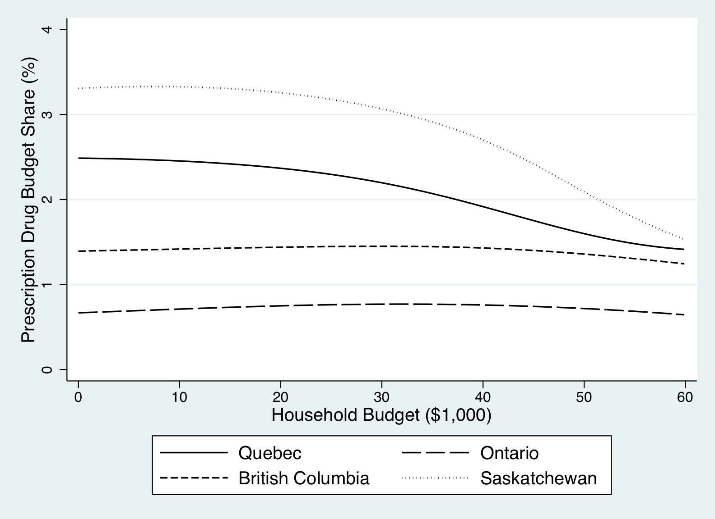

**Figure** 2**: 95th percentile prescription drug budget share, by budget and province: Senior Households**

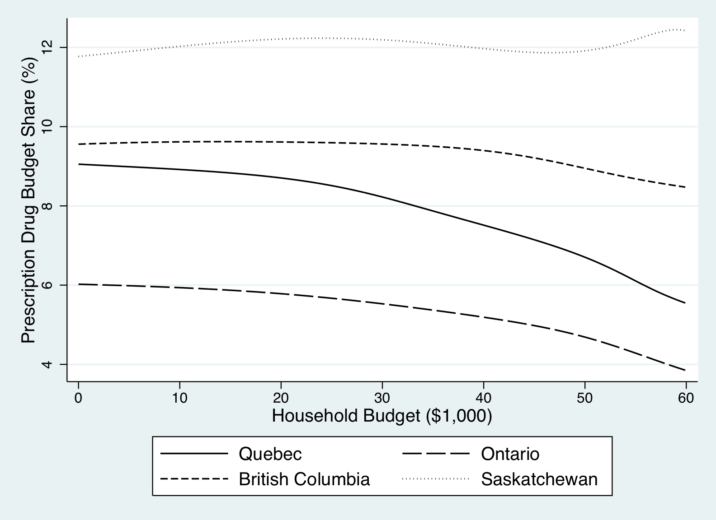

**Figure 3: Median prescription drug budget share, by budget and province: Welfare Households**

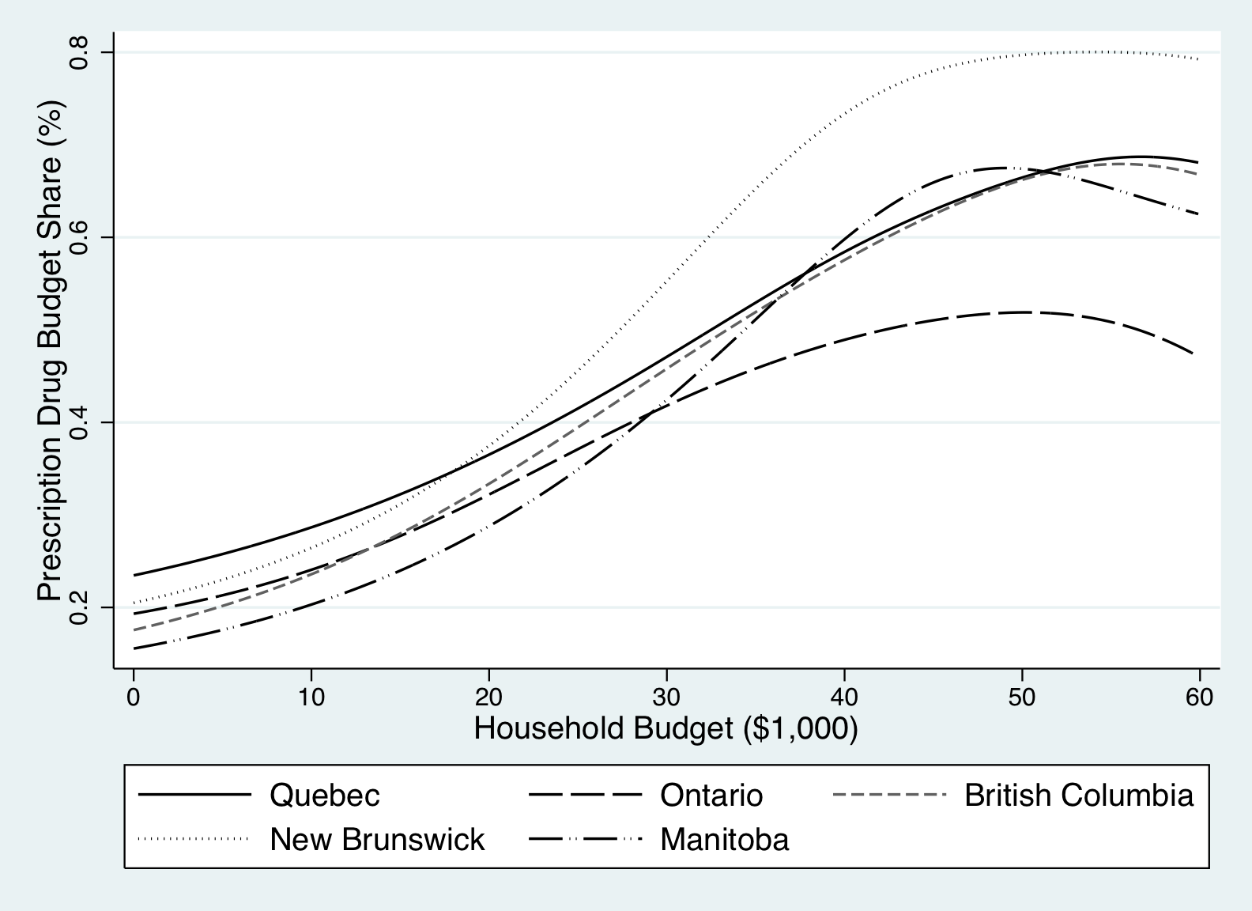

**Figure 4: 95th percentile prescription drug budget share, by budget and province: Welfare households**

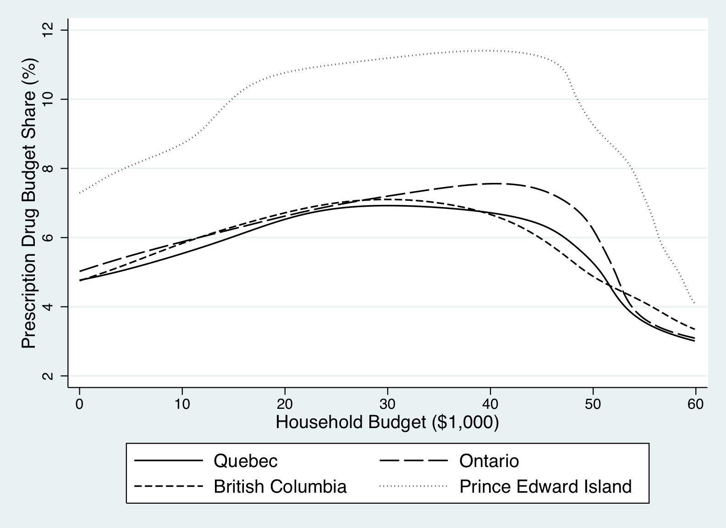

**Figure 5: Median prescription drug budget share, by budget and province: General population households**

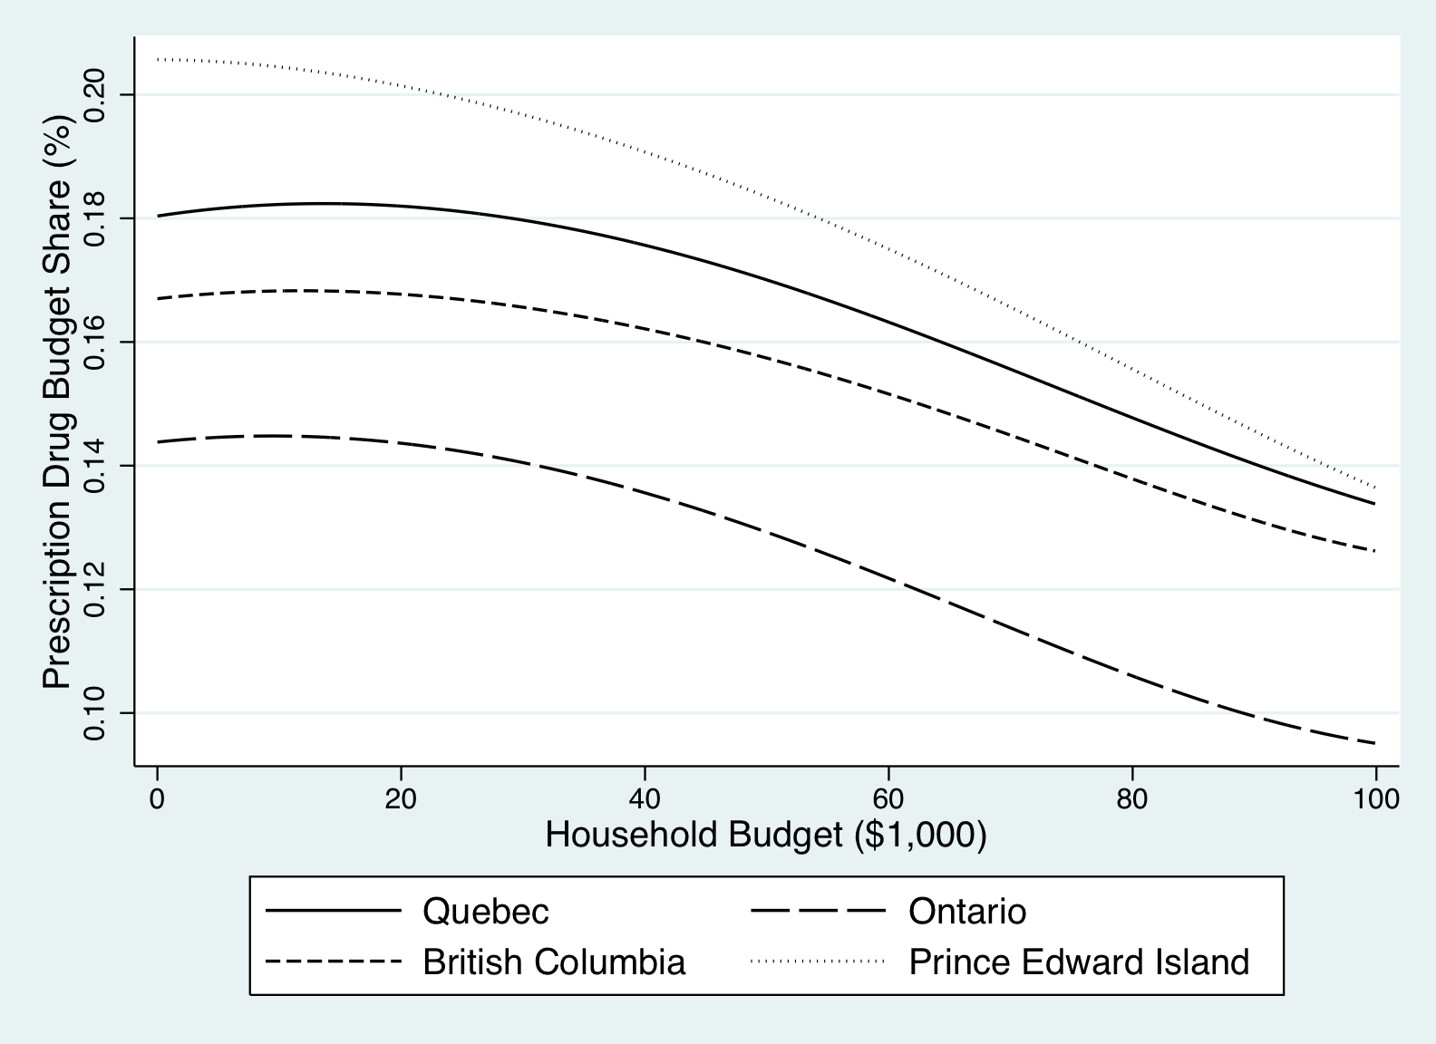

**Figure 6: 95th percentile prescription drug budget share, by budget and province: General population households**

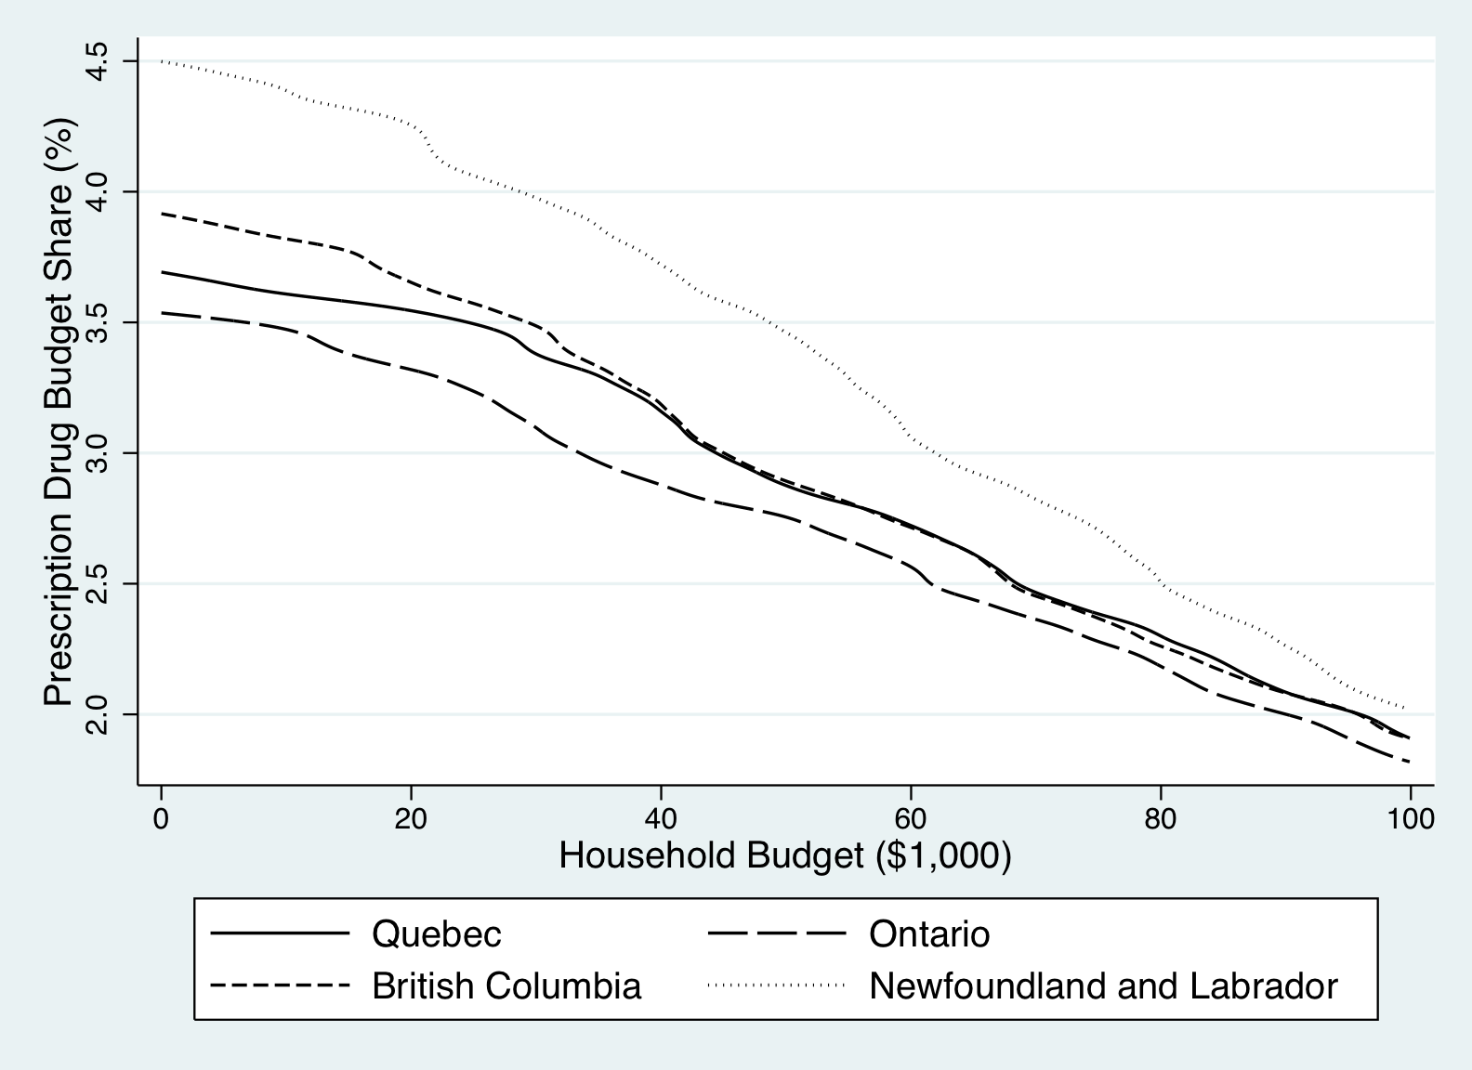

1. An electronic letter by James O'Sullivan questions Demers et al.’s assertion that higher income New Brunswick seniors are not required to pay a premium for drug coverage; in fact they are required to pay a $58 monthly premium. Correcting for this error would increase the OOP costs in the scenario of the 73-year-old senior (depicted in Demers et al Figure 2) from $60 to $696 (12×$58). We also note that the maximum annual beneficiary contribution in Quebec for those receiving ≤ 93% of their Guaranteed Income Supplement was $47.51 per month in 2006 and not $73.42 as stated by Demers et al. Correcting these errors would substantively alter the distribution of the inter-provincial variations reported by Demers et al. and conceivably change their conclusion identifying the province that offers the most comprehensive public prescription drug plan for seniors.
2. The sampling weights appear to be reliable. The 2006 Census indicates that there are an estimated 12.4 million private dwellings "Occupied by usual residents" in the 10 provinces.
3. See, for instance, see the provincial drug plan cost sharing requirements described by the National Prescription Drug Utilization Information System http://secure.cihi.ca/cihiweb/dispPage.jsp?cw_page=GR_1302_E