**Trends in Opioid Use and Dosing in the Socioeconomically Disadvantaged**

Tara Gomes MHSc

David N. Juurlink MD, PhD

Irfan A. Dhalla MD, MSc

Angela Mailis-Gagnon MD, MSc, FRCPC

J. Michael Paterson, MSc

Muhammad M. Mamdani PharmD, MA, MPH

**Word Count**:

Main Text: 2,901

Abstract: 295

**Number of Figures**: 4

**Number of Tables**: 3

**Correspondence:**

Tara Gomes

G Wing 106, Sunnybrook Health Sciences Centre

2075 Bayview Avenue, Toronto, Ontario CANADA M4N 3M5

Tel: (416) 480-6100 ext: 2746

Fax: (416) 480-6048

[Tara.Gomes@ices.on.ca](mailto:dnj@ices.on.ca)

**Keywords:** Chronic pain; addiction medicine; opioid analgesics; pharmacoepidemiology

**Tara Gomes** is the Project Lead of the Ontario Drug Policy Research Network, an epidemiologist at the Institute for Clinical Evaluative Sciences, and an Assistant Professor in the Leslie Dan Faculty of Pharmacy at the University of Toronto, Ontario, Canada. [Tara.Gomes@ices.on.ca](mailto:Tara.Gomes@ices.on.ca)

**David Juurlink** is the head of the Division of Clinical Pharmacology and Toxicology at Sunnybrook Health Sciences Centre in Toronto. He is also a Scientist at the Institute for Clinical Evaluative Sciences and Associate Professor of Medicine, Pediatrics, and Health Policy, Management, and Evaluation (HPME) at the University of Toronto. [Dnj@ices.on.ca](mailto:Dnj@ices.on.ca)

**Irfan Dhalla** is a Lecturer in the Departments of Medicine and Health Policy, Management and Evaluation at the University of Toronto. He is also a Staff Physician in the Department of Medicine and a Scientist in the Keenan Research Centre of the Li Ka Shing Knowledge Institute of St. Michael's Hospital in Toronto. [DhallaI@smh.ca](mailto:DhallaI@smh.ca)

**Angela Mailis Gagnon** is the Director of the Comprehensive Pain Program and Senior Investigator at the Krembil Neuroscience Centre at Toronto Western Hospital, University Health Network, Toronto, Canada. She is also a Professor in the Department of Medicine at the University of Toronto, Canada. [Angela.Mailis@uhn.on.ca](mailto:Angela.Mailis@uhn.on.ca)

**Michael Paterson** is a Scientist at the Institute for Clinical Evaluative Sciences, Toronto; an Assistant Professor in the Department of Health Policy, Management, and Evaluation, University of Toronto; an Assistant Professor in the Department of Family Medicine, McMaster University, Hamilton; and a member of the Centre for Evaluation of Medicines, St. Joseph’s Healthcare, Hamilton, Ontario, Canada. [Paterson@ices.on.ca](mailto:Paterson@ices.on.ca)

**Muhammad Mamdani** is the Director of the Applied Health Research Centre (AHRC), the Keenan Research Centre, Li Ka Shing Knowledge Institute of St. Michael's Hospital in Toronto. He is also Associate Professor in the Department of Health Policy, Management and Evaluation of the Faculty of Medicine and the Leslie Dan Faculty of Pharmacy of the University of Toronto, and an adjunct Scientist at the Institute for Clinical Evaluative Sciences, Toronto, Ontario, Canada. [MamdaniM@smh.ca](mailto:MamdaniM@smh.ca)

**ABSTRACT**

**Background**

Opioid therapy for patients with chronic nonmalignant pain remains controversial, primarily because of safety concerns and the potential for abuse. The objective of this study was to examine trends in opioid utilization for nonmalignant pain among social assistance recipients, and to explore the relationship between analgesic dose and mortality.

**Methods**

We characterized annual trends in opioid analgesic prescriptions and daily dose between 2003 and 2008 among Ontario public drug plan beneficiaries aged 15 to 64. Moderate, high and very high dose thresholds were defined as daily doses of ≤200, 200 to 400, and >400 mg oral morphine (or equivalent), respectively. In an exploratory cohort study, patients prescribed an opioid in 2004 were linked with mortality data to investigate two-year opioid-related mortality rates as a function of dose.

**Results**

Over the study period, opioid prescribing rates rose 16.2%, with 181,120 individuals receiving nearly 1.5 million opioid prescriptions by 2008. In 2008, 32.6% of long-acting oxycodone recipients were dispensed daily doses exceeding 200 mg morphine equivalent, compared with 20.3% of those treated with other long-acting opioids. Among patients prescribed high or very-high doses of opioids in 2004, 19% of deaths during the subsequent two years were opioid-related, at a median age of 46 years. Two-year opioid-related mortality rates were 1.6 per 1000 population (95% confidence interval (CI) 1.4 to 1.9), 7.9 per 1000 population (95% CI 5.2 to 11.4), and 9.9 per 1000 population (95% CI 2.8 to 25.1) among people prescribed moderate, high and very high doses, respectively.

**Interpretation**

The use and dose of opioids prescribed among socioeconomically disadvantaged patients with nonmalignant pain has increased substantially in Ontario, driven primarily by use of long-acting oxycodone, and to a lesser extent fentanyl. Our findings suggest that opioid-related mortality is strongly associated with the opioid dose prescribed.

**INTRODUCTION**

The use of opioid analgesics for the treatment of pain associated with cancer or end-of-life conditions is widely accepted. However, their appropriateness for the treatment of chronic nonmalignant pain is the subject of considerable debate.(1-5) Systematic reviews suggest that the safety and effectiveness of long term opioid therapy remains unproven (6-8), and recent studies have shown conflicting results with respect to pain reduction, improvement in quality of life and functional capacity in patients with chronic nonmalignant pain.(9-11) Furthermore, several studies suggest a strong association between prescription opioid abuse and younger age, poverty, and unemployment.(12-16)

Recognizing the potential for opioid abuse, addiction, diversion and opioid-related mortality, many jurisdictions have developed guidelines or implemented programs to promote more judicious use of these drugs.(1;2;17-21) For example, in 2007, Washington state issued guidelines recommending that the daily opioid dose in patients with chronic nonmalignant pain should generally not exceed 120 mg of oral morphine, or the equivalent amount of another opioid.(20) In 2009, the American Pain Society and the American Academy of Pain Medicine defined a high dose of opioid as >200 mg of oral morphine (or equivalent) per day, based on a systematic review of randomized trials and observational studies.(1) Recent Canadian guidelines identify 200 mg of morphine equivalent as a “watchful dose” and suggest that higher doses warrant frequent monitoring along with careful reassessment of the pain problem as well as the risk of misuse.(21) However, there are limited data regarding both the extent to which these thresholds are exceeded in clinical practice and the relative safety of such doses, particularly in vulnerable populations.

The objective of this study was to examine temporal trends in opioid use and dosing and their association to opioid-related mortality in economically disadvantaged patients with chronic nonmalignant pain. We focused particular attention on OxyContin® (Purdue Pharma), a long-acting formulation of oxycodone, because evidence suggests that opioid prescribing and opioid-related mortality increased substantially in Ontario following the introduction of OxyContin® onto the provincial formulary.(22)

**METHODS**

**Study Designs**

We performed two studies. First, we conducted a cross-sectional time series analysis examining annual prescription claims for opioid analgesics reimbursed by the Ontario Public Drug Program between January 1, 2003 and December 31, 2008. Second, we conducted an exploratory analysis of individuals in this group who received at least one prescription for opioids in 2004, with the intent of characterizing the relationship between opioid dose and two-year mortality. Ontario residents are eligible for drug coverage if they are unemployed, are disabled, have high prescription drug costs in relation to their net household income, receive home care, reside in a long-term care facility, or if they are aged 65 years or older. We restricted our analyses to individuals under 65 years of age who are eligible for drug coverage, because they represent a population of economically disadvantaged individuals who are thought to be at especially high-risk for opioid misuse and harm.(12;13)

**Identification of Patients**

We studied adults aged 15 to 64 on December 31st of each year who received at least 1 prescription for an opioid analgesic during the same calendar year. Individuals with any prior diagnosis of cancer and those receiving palliative care services in the six months preceding their first opioid prescription each year were excluded. We examined prescriptions for codeine, morphine, oxycodone, hydromorphone, meperidine and transdermal fentanyl. Prescriptions for parenteral and intranasal preparations of opioids and prescriptions for methadone were excluded, the latter because it is principally used for opioid addiction rather than chronic pain in Ontario.

Individuals were assigned to one of 5 mutually exclusive groups based on the characteristics of their opioid therapy over the course of each calendar year, as recipients of 1) long-acting oxycodone (regardless of other opioid therapy), 2) transdermal fentanyl with no long-acting oxycodone, 3) other long-acting opioids (with no long-acting oxycodone or fentanyl), 4) immediate-release single agent opioids or 5) immediate release opioids in combination with acetaminophen or aspirin (Figure 1). This hierarchy was based on the clinical impression that recipients of long-acting oxycodone and fentanyl receive higher doses than recipients of other long-acting opioids, the nature of the formulations (single vs. multiple analgesics; immediate vs. long-acting), and recent data suggesting an association between the introduction of long-acting oxycodone onto the public drug plan formulary and opioid-related deaths.(22) Although patients were assigned to one of the five opioid groups annually based upon the hierarchy described above, all opioids prescribed to each patient contributed to the analyses. A sensitivity analysis considered only the opioid(s) specific to the treatment group (e.g. long-acting oxycodone only), disregarding co-prescription with other opioids.

**Data Sources**

Treatment with an opioid was identified using the Ontario Public Drug Benefit Program database. Exclusionary cancer diagnoses were identified using the Ontario Cancer Registry, a computerized database of information on all Ontario residents newly diagnosed with or dying of cancer. Palliative care services, comorbidity, and health resource utilization were identified using hospitalization data from the Canadian Institute for Health Information Discharge Abstract Database and physician billings of the Ontario Health Insurance Plan database. Demographic information, including date of death, was obtained from the Ontario Registered Persons Database, which contains a unique entry for each resident who has ever received insured health services. These databases are anonymously linked using 10-digit health card numbers, have been described extensively elsewhere(23-25), and are routinely used to investigate drug safety in Ontario.(26-28) This project was approved by the ethics review board of Sunnybrook Health Sciences Centre, Toronto.

**Quantification of Opioid Use**

*Opioid Analgesic Prescription Rate*

For each of the 5 opioid groups, we expressed prescriptions as a rate per thousand eligible persons, with eligibility defined by the number of Ontarians younger than age 65 on December 31st of each calendar year who received any prescription paid by the Ontario Public Drug Program over the course of that same year.

*Dose of Opioid Analgesics Prescribed*

The mean prescribed daily dose (in milligrams) of oral morphine (or equivalent) was calculated for each individual who received at least one opioid prescription in a given calendar year based on their first 90 days of opioid therapy. If the supply of drug dispensed for a prescription in that interval extended beyond 90 days, we excluded the excess quantity. The adjusted amount of morphine equivalents dispensed over the 90 days was divided by 90 to obtain a mean daily dose over this period. Conservative morphine equivalence ratios were based on guidelines developed by the Canadian National Opioid Use Guideline Group (Table 1)(21) and are similar to those published elsewhere.(29;30)

Based on these guidelines (1;21), patients were categorized as receiving a *moderate* dose of opioids if they received an average daily dosage of ≤200 mg of oral morphine (or equivalent), a *high* dose if they received an average daily dose between 201 and 400 mg of oral morphine (or equivalent), and a *very high* dose if they received an average daily dosage of >400 mg of oral morphine (or equivalent) based upon the first 90 days of therapy in each year. The percentage of patients in each dose group was then calculated for each opioid therapy group every year.

Within each opioid therapy group and dose category in 2008, we ascertained demographic information and health care utilization (number of hospitalizations and number of physician visits) in the past year. We also calculated the median daily amount (in milligrams of oral morphine, or equivalent) for all opioids prescribed and for group-specific opioids.

**Opioid Dose and the Risk of Opioid-Related Mortality**

In an exploratory analysis, we conducted a cohort study that examined the risk of opioid-related death among all economically disadvantaged patients aged 15 to 64 who were prescribed an opioid in 2004. These patients were followed for a maximum of two years from the date of their initial opioid prescription to the date of their death or the end of follow-up, as applicable. Opioid-related deaths were identified from the records of the Office of the Chief Coroner of Ontario using methodology described elsewhere(22), and all-cause mortality was identified using the Registered Persons Database. We did not analyze files from 2007 onward to avoid incomplete coronial data since many later cases remained open at the time of data acquisition. For each opioid dose category (moderate, high and very high) we calculated age- and sex-standardized mortality rates over the subsequent two years, using the 2006 Ontario population as the standard population. Each patient was assigned to an opioid dosage group based on the medication they received during their first 90 days of therapy. For reference, 2-year age and sex-standardized mortality rates were calculated for the entire Ontario population aged 15 to 64 years on January 1, 2004.

**Statistical Analysis**

Basic descriptive statistics were calculated using mean and standard deviation for normally distributed data, and median and interquartile range for skewed data. Mortality rates were standardized using direct standardization, and 95% confidence intervals were estimated using methods based on the gamma distribution.(31) All analyses were performed using SAS version 9.2 (SAS Institute, Cary, North Carolina).

**Sponsor Role**

This study was supported by the Ontario Drug Policy Research Network which is funded by a grant from the Ontario Ministry of Health and Long-Term Care (MOHLTC) Drug Innovation Fund, and the Institute for Clinical Evaluative Sciences (ICES), a non-profit research institute sponsored by the Ontario MOHLTC. The collection, analysis and interpretation of data, results and conclusions reported in this paper as well as the decision to submit the report for publication are those of the authors and are independent from the funding sources.

**RESULTS**

Over the 6-year study period, the annual prescribing rate for opioids rose from 1,851 prescriptions per 1000 eligible individuals in 2003 to 2,151 prescriptions per 1000 eligible individuals in 2008, an increase of 16.2%. Among these individuals, annual prevalence of long-acting opioid use increased by 52%, from 12.5% to 18.9% of opioid recipients, and the use of long-acting oxycodone rose 142% (from 7,481 to 18,112 people). By 2008, of 686,307 eligible social assistance beneficiaries, 181,120 (26.4%) received 1,476,102 prescriptions for opioids, with 1 of every 8 such prescriptions (n=327,914 (22.2%)) being either long-acting oxycodone or fentanyl.

**Patterns of Opioid Analgesic Use**

Over the study period, prescription rates for long-acting oxycodone more than doubled (from 332 per 1000 population in 2003 to 675 per 1000 population in 2008), while prescribing of combination analgesic products decreased by 14% and prescription rates for all other opioids remained stable (Figure 2). By 2008, prescribing of long-acting oxycodone had risen to 675 prescriptions per 1000 eligible population. This accounted for nearly a third (31.4%) of all opioid prescriptions and more than half (56.3%) of all long-acting opioid prescriptions.

Between 2003 and 2008, the average daily dosage of opioid prescribed to each person remained relatively constant among all opioid therapy groups, except among those prescribed long-acting oxycodone or fentanyl. Mean daily doses in these groups rose by 27.0% (from 176 to 223 mg oral morphine equivalent) and 13.1% (from 135 to 152 mg oral morphine equivalent), respectively (Figure 3).

**High- and very-high dose opioid therapy**

The trends in prescribing of daily opioid doses exceeding current clinical guidelines (high and very high dose opioids) are shown in Figures 4a and 4b. While high doses of immediate-release opioids were uncommon, 20.5% of patients prescribed a long-acting opioid received high or very high dose therapy in 2003, increasing to 26.8% of patients by 2008. Among patients treated with very high dose opioids, two thirds (66.1%) received long-acting oxycodone.

*Long-acting oxycodone*

By 2008, a third of all patients (n=5,909; 32.6%) who received long-acting oxycodone received a high opioid dose, and almost half of these (N=2,597; 43.9%) received a very high dose, with a median daily opioid dose equivalent to 613 mg of oral morphine in the latter group (Table 2). The median dose was unchanged when we discounted all other opioids prescribed to these patients, indicating that the high dose is driven primarily by prescriptions for long-acting oxycodone.

*Fentanyl and other Long-Acting Opioids*

The percentage of fentanyl recipients prescribed high or very high daily doses of opioids rose 17.0% (from 17.7% to 20.7%) from 2003 to 2008. In contrast, there was no appreciable change (from 19.7% to 20.1%) in patients receiving other long-acting opioids such as morphine and hydromorphone. In 2008, opioid dose patterns were similar between these two groups, with 20.3% (n=3,277) receiving a high opioid dose, and over a third of these (N=1,257; 38.4%) receiving a very high opioid dose.

**Opioid-Related Mortality**

Of the 154,497 individuals who received a prescription for an opioid analgesic in 2004, 3,780 (2.4%) died from any cause within 2 years of the index prescription. The Provincial Coroner’s Office classified 303 of these (8.0%) as opioid-related (Table 3), including nearly 1 out of every 5 deaths (19.0%) among patients receiving high or very-high dose opioids. The median age of these patients was 46 years, and a small percentage (14.9%) of deaths were confirmed suicides. Oxycodone, fentanyl, and morphine were involved in 39.2%, 21.6%, and 39.2% of deaths, respectively.

Among Ontarians aged 15 to 64, the two-year age and sex-standardized rate of death from any cause was 4.3 (95% confidence interval (CI) 4.3 to 4.3) deaths per 1000 population compared to 20.3 deaths per 1000 population (95% CI 19.6 to 21.0) among drug plan beneficiaries who were prescribed an opioid. When stratified by dose grouping, age and sex-standardized all-cause mortality was considerably higher among patients prescribed high doses (42.3 per 1000; 95% CI 35.4 to 50.2) and very high doses (46.1 per 1000; 95% CI 33.6 to 61.7) compared to those prescribed moderate doses of opioids (19.5 per 1000; 95% CI 18.8 to 20.2). Opioid-related mortality was higher among patients prescribed very high doses of opioids (9.9 per 1000 population; 95% CI 2.8 to 25.1) as compared to those prescribed high doses (7.9 per 1000 population; 95% CI 5.2 to 11.4), and both death rates were far higher than that of patients prescribed moderate doses (1.6 per 1000 population; 95% CI 1.4 to 1.9) doses (Table 3).

**INTERPRETATION**

We found that among Ontarians eligible for publicly-funded prescription drugs, use of high and very high dose opioids increased substantially between 2003 and 2008, largely due to increased prescribing of long-acting oxycodone, and to a lesser extent, fentanyl. By 2008, 1 out of every 3 patients prescribed long-acting oxycodone received average daily doses exceeding current clinical guidelines.(1;21) This suggests that clinicians may not fully appreciate the analgesic potency of oxycodone, which is roughly 1.5 to 2 times more potent than morphine and 10 to 20 times more potent than codeine. Moreover, our data indicate that all-cause mortality rates are strongly correlated with opioid dose, with a 10-fold increase among patients receiving very high daily doses relative the general population.

A recent study investigating the relationship between opioid prescription and overdose found a mean daily dose of opioids of 13.3 mg (morphine equivalents),(32) substantially lower than seen in our study. The study by Dunn took place in Washington State, where opioid guidelines were first published,[20] and involved members of a health maintenance organization (HMO).(32), and therefore differences observed between this studies may reflect differences in the study population or patient monitoring associated with consumer-governed health plans. Although both studies describe a dose-response relationship between opioid prescribing and risk of opioid-related death, our findings are more readily generalized to socioeconomically disadvantaged individuals, a group at especially high risk of opioid abuse.(12;13) (14)

**Limitations**

Some limitations of our work merit emphasis. First, we were unable to determine the indications for, or appropriateness of, opioid therapy. However, appropriateness of opioid therapy for chronic nonmalignant pain is itself controversial, and whether a prescription is appropriate or not would have little or no bearing on our observations regarding mortality. Second, while opioid-related deaths identified in coronial data are highly specific, some opioid-related deaths may escape detection. This would tend to underestimate opioid-related deaths in our analysis. Furthermore, our approach to defining opioid dosage (based on the first 90 days of opioid therapy in each year) and our conservative morphine equivalence ratios may have resulted in an underestimate of the number of people receiving high or very high dose therapy for at least some portion of the year. Third, our claims data do not identify prescriptions paid for with cash or drugs obtained illicitly. Finally, our preliminary mortality analysis did not control for potential confounders other than age and gender and do not reflect dose changes during follow-up.

**Conclusions**

In a large cohort of social assistance recipients aged 15 to 64, we found that more than a quarter received at least one opioid prescription in 2008, while almost a third of patients prescribed long-acting oxycodone received average daily doses of opioids higher than recommended by current clinical guidelines. More than 1% of patients prescribed very high doses of opioids died from opioid-related causes over a two-year period.

Safety concerns regarding opioid analgesic use and misuse, particularly in younger and lower-income populations, are becoming widely appreciated by the public and medical communities alike.(22;33;34) Our findings highlight the widespread prescription of very high-doses of opioid analgesics, particularly among users of long-acting oxycodone, and indicate a relationship between opioid dose and opioid-related mortality. These results suggest a need for greater awareness of opioid prescribing guidelines, along with a better appreciation of the potency and potential hazards of long-acting opioids and long-acting oxycodone in particular. Programs that educate physicians and pharmacists about opioid safety and appropriate dosing, as well as initiatives that allow real-time monitoring of medication use may help address these risks.(2;19;35-37)

**ACKNOWLEDGEMENTS AND CONFLICTS OF INTEREST**

This study was supported by a grant from the Ontario Ministry of Health and Long-Term Care (MOHLTC) Drug Innovation Fund and the Institute for Clinical Evaluative Sciences (ICES), a non-profit research institute sponsored by the Ontario MOHLTC. Irfan Dhalla receives salary support in the form of a postdoctoral fellowship from the Canadian Institutes of Health Research. Angela Mailis-Gagnon is an advisory board member for Lyrica (Pfizer) and Cymbalta (Eli-Lilly) and has received an unrestricted research grant from Pfizer (2009) and Purdue (2010).   The funders had no role in the design and conduct of the study; collection, management, analysis, and interpretation of the data; decision to publish; or preparation, review, or approval of the manuscript. We thank Brogan Inc., Ottawa for use of their Drug Product and Therapeutic Class Database.

The opinions, results and conclusions reported in this paper are those of the authors and are independent from the funding sources.  No endorsement by ICES or the Ontario MOHLTC is intended or should be inferred.

**CONTRIBUTORS**

Tara Gomes was involved in study conception and design, data collection, data analysis, interpretation and manuscript preparation. Tara Gomes also wrote the first draft, and acts as guarantor for the manuscript. David N. Juurlink, Irfan Dhalla, J. Michael Paterson, and Muhammad M. Mamdani were involved in study conception and design, analysis and interpretation of the data, and critical revision of the manuscript, Angela Mailis-Gagnon was involved in the analysis and interpretation of the data and critical revision of the manuscript. All authors approved the final version for publication

**Table 1: Oral Opioid Analgesic Equivalence Table (adapted from the Canadian Guideline for safe and effective use of opioids in CNCP** **(21)**

|  |  |
| --- | --- |
| **Opioid** | **Ratio (opioid : morphine)** |
| Morphine | 1:1 |
| Codeine | 1 : 0.15 |
| Oxycodone | 1 : 1.5 |
| Hydromorphone | 1 : 5 |
| Meperidine | 1 : 0.1 |
| Transdermal fentanyl | 25mcg/h→ 1:97  50mcg/h→ 1:202  75mcg/h→ 1:292  100mcg/h→ 1:382 |

**Table 2: Characteristics of opioid recipients in 2008, by opioid group and dose**

|  |  |  |  |  |  |  |  |
| --- | --- | --- | --- | --- | --- | --- | --- |
| **Opioid** | **N** | **Age**  **(Mean, SD)** | **Male**  **(N, %)** | **Number Mg/Day - All Opioids**  **(Median, IQR)** | **Number Mg/Day -Specific Opioids**  **(Median, IQR)** | **Hospitalizations Past 1 year**  **(Mean, SD)** | **Physician Visits Past 1 year**  **(Mean, SD)** |
| **Long-acting oxycodone** |  |  |  |  |  |  |  |
| Moderate Dose | 12,203 | 46.7 (10.4) | 6,030 (49%) | 75 (40-122) | 61 (30-117) | 0.3 (0.9) | 29.1 (29.8) |
| High Dose | 3,312 | 46.1 (9.3) | 1,787 (54%) | 270 (235-327) | 272 (240-340) | 0.3 (0.8) | 28.7 (27.2) |
| Very High Dose | 2,597 | 45.5 (8.8) | 1,551 (60%) | 613 (489-910) | 613 (488-894) | 0.2 (0.7) | 31.7 (28.3) |
| **All Doses** | **18,112** | **46.4 (10.0)** | **9,368 (52%)** | **140 (64-305)** | **120 (45-264)** | **0.3 (0.8)** | **29.4 (29.2)** |
| **Fentanyl (no long-acting oxycodone)** | | |  |  |  |  |  |
| Moderate Dose | 3,501 | 49.2 (20.0) | 1,359 (39%) | 81 (42-125) | 67 (32-114) | 0.5 (1.2) | 37.3 (41.3) |
| High Dose | 634 | 49.0 (9.1) | 273 (43%) | 263 (226-313) | 260 (225-310) | 0.5 (1.1) | 34.5 (37.8) |
| Very High Dose | 281 | 47.2 (8.4) | 130 (46%) | 569 (462-771) | 534 (440-628) | 0.6 (1.4) | 43.0 (49.0) |
| **All Doses** | **4,416** | **49.0 (9.8)** | **1,762 (40%)** | **119 (60-209.7)** | **97 (43-170)** | **0.5 (1.2)** | **37.3 (41.4)** |
| **Other Long-acting Opioids (no long-acting oxycodone or fentanyl)** | | | | |  |  |  |
| Moderate Dose | 9,383 | 49.2 (9.8) | 4,291 (46%) | 52 (27-93) | 42 (20-88) | 0.4 (1.0) | 29.5 (34.2) |
| High Dose | 1,386 | 49.1 (8.7) | 714 (52%) | 271 (232.322) | 277 (237-325) | 0.3 (0.9) | 28.6 (32.1) |
| Very High Dose | 976 | 49.0 (8.3) | 524 (54%) | 619 (480-901) | 607 (479-870) | 0.4 (1.2) | 27.7 (31.7) |
| **All Doses** | **11,745** | **49.2 (9.5)** | **5,529 (47%)** | **80 (35-188)** | **61 (28-160)** | **0.4 (1.0)** | **29.2 (33.8)** |
| **Immediate-release opioid, single agent** | | | | |  |  |  |
| Moderate Dose | 13,767 | 44.9 (12.8) | 5,211 (38%) | 3 (1-10) | 2 (1-6) | 0.4 (0.9) | 28.1 (36.2) |
| High Dose | 95 | 47.9 (8.1) | 47 (49%) | 290 (230-331) | 284 (230-345) | 0.5 (1.2) | 33.7 (33.7) |
| Very High Dose | 73 | 47.2 (8.8) | 32 (44%) | 656 (466-882) | 662 (464-907) | 0.5 (0.9) | 33.5 (26.3) |
| **All Doses** | **13,935** | **45.0 (12.8)** | **5,290 (38%)** | **3 (2-11)** | **2 (1-6)** | **0.4 (0.9)** | **28.1 (36.1)** |
| **Immediate-release opioid combination product** | | | | |  |  |  |
| Moderate Dose | 132,907 | 44.0 (13.0) | 58,164 (44%) | 3 (2-8) | 3 (2-8) | 0.2 (0.6) | 18.9 (21.4) |
| High Dose | ≤5 | -- | -- | -- | -- | -- | -- |
| Very High Dose | 0 | -- | -- | -- | -- | -- | -- |
| **All Doses** | **132,912** | **44.0 (13.0)** | **58,164 (44%)** | **3 (2-8)** | **3 (2-8)** | **0.2 (0.6)** | **18.9 (21.4)** |

**Table 3**: Mortality Rates by Opioid Dose Grouping

|  |  |  |  |  |  |
| --- | --- | --- | --- | --- | --- |
| **Dose Grouping** | **No. Eligible People** | **No. Deaths from all causes** | **All-Cause**  **Mortality Rate**  **(95% CI)\*** | **No. Opioid-Related Deaths** | **Opioid-Related Mortality Rate**  **(95% CI)\*** |
| **Reference Population**† | 8,658,037 | 35,274 | 4.30 (4.25 to 4.34) | N/A | N/A |
| **All Opioid Users** |  |  |  |  |  |
| Moderate Dose | 148,320 | 3,511 | 19.49 (18.82 to 20.18) | 252 | 1.63 (1.43 to 1.86) |
| High Dose | 3,554 | 161 | 42.32 (35.44 to 50.15) | 33 | 7.88 (5.22 to 11.41) |
| Very High Dose | 2,623 | 108 | 46.07 (33.58 to 61.68) | 18 | 9.93 (2.77 to 25.11) |

*Age- and Sex-adjusted mortality rate, per 1000 population using 2006 Canadian Population (Statistics Canada) as standard population.

†Reference population: all Ontarians aged 15 to 64 and eligible for publically funded health care services on January 1, 2004

**Figure 1: Hierarchical placement of opioid recipients into five opioid groups**

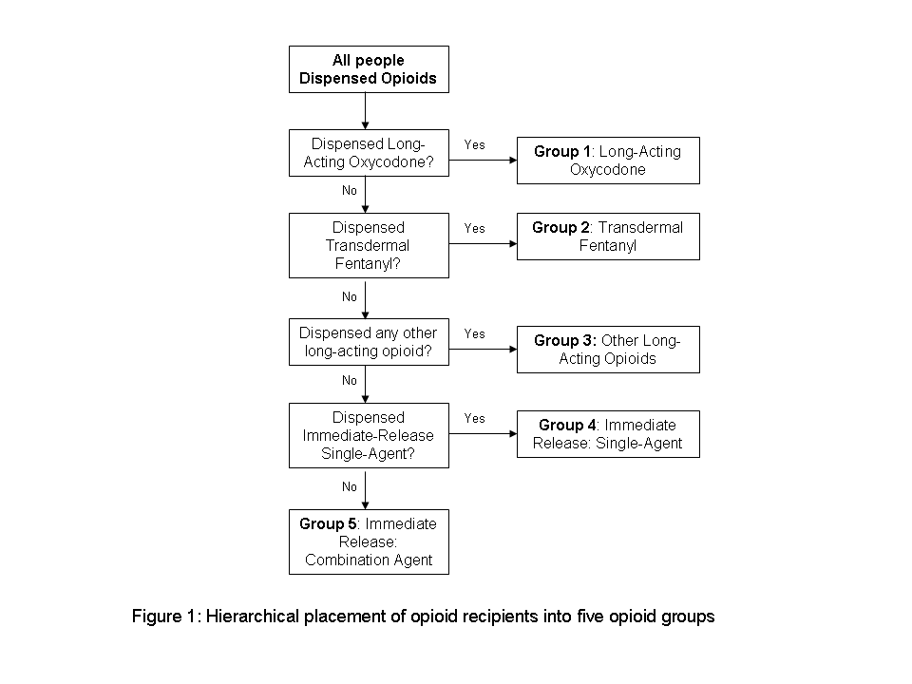

**Figure 2: Opioid dispensing rates by opioid therapy group, 2003 to 2008**



**Figure 3: Estimated average daily dosage of opioid medication prescribed (in mg oral morphine or equivalent) by opioid therapy group, 2003-2008**



**Figure 4: Proportion of subjects prescribed high doses of oral morphine (or equivalent) by Year and Opioid Group.\***

(a) Proportion prescribed ≥200 mg of oral morphine (or equivalent)

(b) Proportion prescribed ≥400 mg of oral morphine (or equivalent)

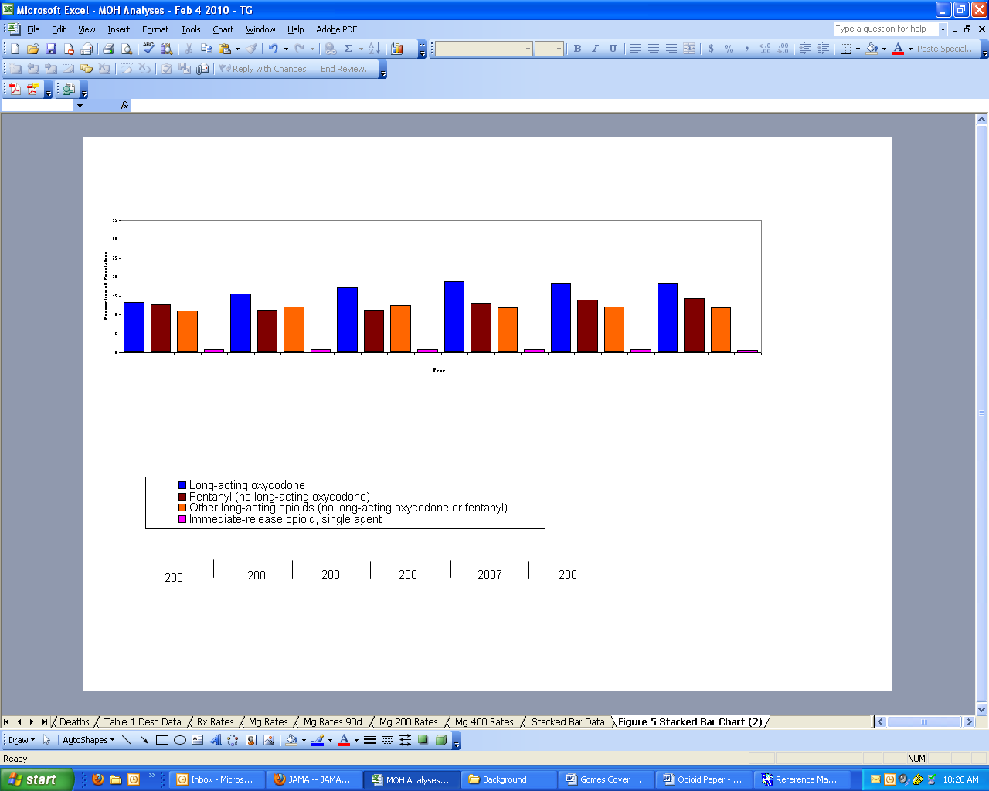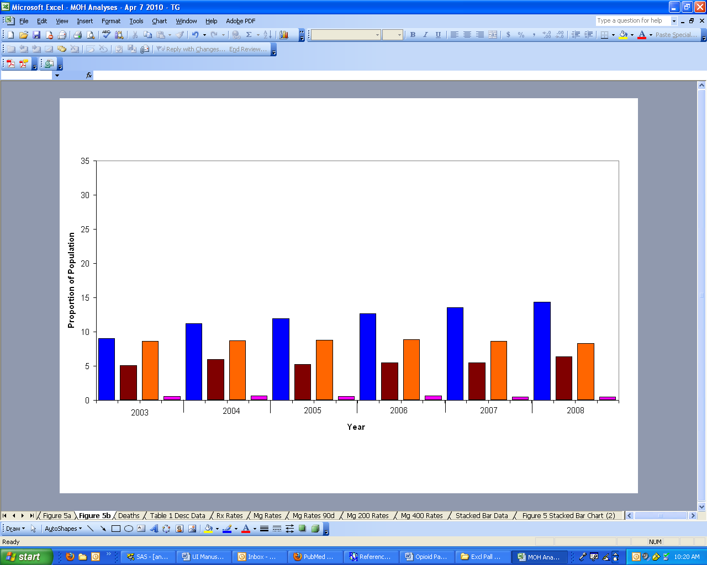

(a)

(b)

*Results for immediate-release opioids in combination with other products not shown due to small numbers