**Evidence-based policies for illegal drugs to improve community health and safety in Canada**

Evan Wood, MD, PhD

Moira McKinnon, MD, MBBS, FAFPHM

Robert Strang, MD, FRCPC

Perry R. Kendall, OBC, MBBS, MSc, FRCPC

**Evan Wood**, MD, PhD, ABIM, FRCPC, is Co-Director of the Urban Health Research Initiative at the BC Centre for Excellence in HIV/AIDS. He is also an Associate Professor in the Department of Medicine, Division of AIDS at the University of British Columbia, Vancouver, BC. **Moira McKinnon**, MD, MBBS, FAFPHM, is the Chief Medical Health Officer for Saskatchewan. **Robert Strang**, MD, FRCPC is the Chief Medical Health Officer for Nova Scotia. **Perry R. Kendall**, OBC, MBBS, MSc, FRCPC is the Chief Medical Health Officer for British Columbia and a Clinical Professor, Faculty of Medicine, University of British Columbia, Vancouver

**Competing interests:** none declared

**Send correspondence to: Evan Wood**

Urban Health Research Initiative

BC Centre for Excellence in HIV/AIDS

608 - 1081 Burrard Street  
Vancouver BC V6Z 1Y6

**Tel:** 604-806-9692 **Fax:** 604-806-9044  
**Email:** uhri-ew@cfenet.ubc.ca

**Abstract Word Count:** 158

**Word Count:** 2,264

**References:** 43

**Figures:** 2

**Tables:** 1

**ABSTRACT**

Although illegal drug use remains a serious threat to community health in Canada, there has been a remarkable discordance between scientific evidence and policy in this area, with most resources going to drug prevention and drug law enforcement activities that have proven ineffective. Alternatively, evidence-based drug treatment programs have been chronically underfunded despite the fact they are cost-effective. Similarly, various harm reduction strategies, such as needle exchange, supervised injecting programs and opioid substitution therapy, have also proven effective at reducing drug-related harm but receive limited government support. Accordingly, Canadian society would greatly benefit from a reorienting of its drug policies on addiction—that is, as a health, rather than primarily a criminal justice, issue. In this context, and in light of the simple reality that drug prohibition has not effectively reduced the availability of most illegal drugs and has instead contributed to a vast criminal enterprise and related violence, among other harms, regulatory alternatives should be urgently evaluated.

**Introduction**

Use of illegal drugs remains a serious threat to community health in Canada.1 However, despite the substantial social costs attributable to illegal drug use, including the use of heroin, cannabis and cocaine, there has been a well described discordance between scientific evidence and policy in this area,2 with most resources going to drug law enforcement activities that have not been well evaluated.3, 4 When the Office of the Auditor General last reviewed Canada’s drug strategy in 2001, its report estimated that, of the $454 million spent annually on illicit drug control efforts in Canada, $426 million (93.8%) was devoted to law enforcement.5 The report further concluded: “Of particular concern is the almost complete absence of basic management information on spending of resources, on expectations, and on results of an activity that accounts for almost $500 million each year.”5

Despite the longstanding emphasis on drug law enforcement, the federal government has recently further prioritized this approach by proposing legislation calling for mandatory minimum sentences for drug law offences.6 During the federal election of 2011, the government promised to enact comprehensive criminal legislation, including mandatory sentencing measures, during the first 100 days in office.6

Illicit drugs remain a critical public and community health issue internationally. For instance, according to the 2010 annual report of the United Nations Office on Drugs and Crime, approximately 130 to 190 million, or 2.9% to 4.3% of the world population aged 15 to 64, used cannabis at least once in the previous year.7 This article reviews the impacts of conventional drug policies employed internationally and describes evidence-based steps to reduce the health and social costs attributable to drug policies in Canada.

**Impacts of Drug Law Enforcement**

Law enforcement has a critical role to play in community health and safety. However, as was observed with the emergence of a violent illegal market under alcohol prohibition in the United States in 1920s, the vast illegal market that has emerged under drug prohibition has proven remarkably resistant to law enforcement’s efforts, while unintended consequences have similarly emerged.4, 8

Given its well funded drug surveillance systems, the United States provides excellent data for assessing the impacts of drug law enforcement. Remarkably, despite an estimated $2.5 trillion spent since former US President Richard Nixon first declared America’s “War on Drugs,” the effort to reduce drug supply and drive up drug prices through aggressive drug law enforcement does not appear to have been effective.9-11 Instead, in recent decades, the prices of the more commonly used illegal drugs (e.g., cannabis and heroin) have actually gone down, while potency has gone up dramatically.7, 12 To highlight the limited ability of drug law enforcement to constrain cannabis supply, for example, Figure 1 shows how the estimated potency (i.e., delta-9-tetrahydrocannabinol content) of US cannabis has increased by more than 270% from approximately 2.3% in 1981 to 6.3% in 2002, despite an increase in US federal anti-drug expenditures from $1.5 billion in 1981 to more than $18 billion in 2002.9

While opponents of drug policy reform commonly argue that drug use would increase if health-based models were emphasized over drug law enforcement,13 we are unaware of any research to support this position. In fact, a recent World Health Organization report demonstrated that rates of drug use internationally are unrelated to how vigorously national drug laws are enforced, concluding that “countries with stringent user-level illegal drug policies did not have lower levels of use than countries with liberal ones.”14 To make this point, the report demonstrated that the US has one of the highest lifetime incidences of cocaine use, which, at 16%, is approximately four or more times that of any of the other countries surveyed, including Colombia, Mexico, Belgium, France, Germany, Italy, Netherlands, Spain, Ukraine, Israel, Lebanon, Nigeria, South Africa, Japan, People’s Republic of China and New Zealand.14 In addition, although reducing cannabis availability has been a central focus of drug law enforcement efforts, according to US drug use surveillance systems funded by the US National Institutes of Health, over the last 30 years of cannabis prohibition the drug has remained “almost universally available to American 12th graders,” with approximately 80–90% saying the drug is “very easy” or “fairly easy” to obtain.15

Besides being costly and ineffective, the over-reliance on drug law enforcement has also resulted in a range of unintended consequences which were recently summarized in the official conference declaration of the XVIII International AIDS Conference in Vienna, Austria (Box 1).16 The International AIDS conference has traditionally been the largest biennial public health conference in the world. The so-called Vienna Declaration has now been endorsed by thousands of individuals, including leaders in science and medicine, Nobel laureates and former heads of state, including the former presidents of Columbia, Brazil and Mexico. In Canada, the declaration has been endorsed by the Canadian Public Health Association, the Urban Health Network representing the Municipal Health Officers of Canada’s 18 largest cities, and several municipal governments, including Toronto, Victoria and Vancouver. The strong consensus reached through the Vienna Declaration process clearly demonstrates strong and broad-based support to reform drug policies through incorporation of scientific evidence.

**Models to Reduce Harm: Those That Do Not Work and Those That Do**

Importantly, some commonly employed school-based drug prevention programs have repeatedly been proven ineffective in randomized trials17 yet continue to receive substantial federal funding in both the US and Canada. Other programs, including the Canadian federal government’s anti-drug media campaign, are often implemented without evidence to support their efficacy and despite evidence they may be harmful.18 For instance, controlled trials of anti-drug media messages suggest they may in fact result in harmful youth assumptions about drug use.19 Moreover, a $42.7 million federal government funded evaluation of the US’s ongoing National Youth Anti-Drug Media Campaign recently concluded that its $1.4 billion advertising campaign had been ineffective at curtailing rates of youth drug use and may actually have had the negative effect of inflating youth’s perception regarding rates of drug use among their peers.20

On the other hand, a substantial research base points toward more effective models proven to reduce health and community concerns attributable to drug use as well as the unintended effects of drug policies.8, 16, 21-23 Based on this substantial body of evidence, several observations can be made.

Evidence-based drug treatment programs are cost-effective, and significant benefits should be derived, both at the individual and societal levels, through an increase in scale.24 Consistent with the recent recommendations of the House of Commons Standing Committee on Public Safety and National Security,25 this would include expanding access to existing evidence-based models of care such as medical and non-medical withdrawal programs, programs to manage concurrent mental health and addictions, ambulatory and residential treatment programs, and opioid substitution therapies.16 Similarly, given the substantial health (e.g., infectious disease, overdose death) and social (e.g., crime) concerns in urban areas caused by heroin addiction26 and the potential for heroin prescription to reduce these harms among those who fail to respond to conventional treatments, heroin prescription could be considered for selected opioid addicted patients that are refractory to all other treatment modalities.22, 27, 28

Various harm reduction strategies, such as needle exchange programs and methadone maintenance therapy, have also proven effective at reducing drug-related harm and have not been associated with unintended consequences.21 The joint recommendations recently released by several United Nations agencies, including the World Health Organization, provide the strong scientific basis for expanding harm reduction efforts.21 Beyond these recommendations, the recent consensus statement from the Canadian National Specialty Society of Community Medicine endorsing the scale-up of supervised consumption facilities reflects the compelling national and international evidence to support the controlled expansion of these programs in urban areas with high concentrations of public drug use and related harms. Since 1986, more than 90 supervised drug consumption facilities have been set up in Switzerland, the Netherlands, Germany, Spain, Luxembourg, Norway, Canada and Australia, mainly in cities with large populations of street injectors.29-31

The criminalization of persons who use drugs continues to prove ineffective at reducing rates of drug use and has instead contributed to substantial health-related harms (Box 1).8 Portugal, which decriminalized all drug use in 2001, has not seen increases in drug-related harms. Instead, a published review of the impacts of decriminalization noted that decriminalization was followed by “reductions in problematic use, drug-related harms and criminal justice overcrowding,” while rates of drug use remain among the lowest in the European Union.23

Accordingly, Canadian society would greatly benefit from a reorienting of its drug policies on addiction—that is, as a health, rather than primarily a criminal justice, issue. In this context, evidence-based community diversion programs for non-violent drug offenders could be expanded and evaluated to replace more costly and less effective incarceration efforts.32, 33 In New York State, Michigan, Massachusetts and Connecticut, for instance, mandatory minimum legislation for non-violent drug offences is in the process of being repealed, with several other US jurisdictions set to follow suit.

Finally, in light of the simple reality that drug prohibition has not effectively reduced the availability of most illegal drugs and has instead contributed to a vast criminal enterprise and related violence,4 among other harms, alternatives should be urgently evaluated.34 While this is an area that should be prioritized for further research, controlled regulation of illegal drugs has the potential to offer several advantages to the unregulated market currently controlled by organized crime groups, and there is substantial evidence from illicit drug, tobacco and alcohol research regarding how regulatory tools can more safely control drug availability while having the potential to positively change cultural norms around drug use.35-37 For instance, the incidence of new heroin users in Zurich, Switzerland, peaked in 1990 with an estimated 850 new users, and subsequently declined to approximately 150 users in 2002 coinciding with the implementation of heroin prescription programs. The authors concluded: “The harm reduction policy of Switzerland and its emphasis on the medicalisation of the heroin problem seems to have contributed to the image of heroin as unattractive for young people.”37 Similarly, comparisons of cannabis rates between the US and Holland, where cannabis is sold to adults for recreational use through government-sanctioned “coffee shops,” have noted that rates of cannabis use are higher in the US, with research concluding: “Drug policies may have less impact on cannabis use than is currently thought.”38

In this context, several Canadian bodies, including the Health Officers’ Council of British Columbia and the Canadian Public Health Association, have recently endorsed the evaluation of a regulated market for all currently illegal drugs.39, 40 While a full description of regulatory models is outside the scope of this paper, it is important to stress that regulatory tools would need to be closely evaluated and should be uniquely tailored to each specific substance.36 For instance, models of strictly regulated prescription regimens for heroin have already been well evaluated and present important opportunities to reduce social and healthcare costs as well as drug acquisition crime.22, 27

While advocating for drug policy reform has traditionally been politically unpopular, a recent Angus Reid poll estimated that 50% of Canadians already support cannabis legalization.41 In this context, while cannabis is not free from harms, it is noteworthy that recent reviews have suggested that cannabis is less harmful than many presently legal drugs, including alcohol and tobacco, as well as several commonly used pharmaceutical drugs.42 This was highlighted by a recent report which used a 16-level matrix of harm spanning individual physical and social harms and demonstrated the relative safety of cannabis in comparison to alcohol (Figure 2).42 In light of the persistently widespread availability and relative safety in comparison to existing legal drugs, as well as the crime and violence that exist secondary to cannabis prohibition,4 there is a need for discussion about the optimal regulatory strategy to reduce the harms of cannabis use without creating unintended policy-attributable consequences (e.g., increased organized crime and drug market violence).9, 38

**A Call for Action**

In 2005, as part of the renewal of Canada’s National Drug Strategy, an exhaustive national consultative process led by Health Canada and the Canadian Centre on Substance Abuse culminated in a “National Framework for Action” to reduce the harms associated with drugs in Canada.43 This inclusive process, which involved all stakeholder groups, aimed to remove the rhetoric and emotion that have traditionally guided Canada’s response to illicit drugs and instead sought to incorporate the best available scientific evidence into Canada’s drug policy. The central aim of the strategy was “to ensure that Canadians can live in a society increasingly free of the harms associated with problematic substance use,” and differed from the US approach in that it put emphasis on reducing harm.43

In 2007, however, this framework was abandoned by the federal government in favour of “Canada’s New Anti-Drug Strategy,” which removed support for evidence-based harm reduction programs recommended by the World Health Organization. The new strategy has also supported various drug prevention measures that have proven ineffective and potentially harmful elsewhere,17, 19, 20 and the Federal government has also spent considerable public funds and energy opposing evidence-based modalities, including its legal efforts to close the Vancouver supervised injecting facility.29 Lastly, as described above, plans to enact mandatory minimum sentences for drug law violations highlight a complete departure from evidence-based policy-making in a costly move that will certainly have higher negative effects on the Aboriginal community.32

Publications in medical journals often transiently attract media attention, but their impact can be short-lived without meaningful debate on the part of policymakers. It is therefore the wish of the authors that such an informed debate urgently take place so as to increase the relevance of scientific evidence in drug policy decision making.16

**Contributors:** All authors made a substantial contribution to the study conception, revised critically for intellectual content and approved the final version.

**Acknowledgments:** We thank Deborah Graham, Carmen Rock, Peter Vann and Dan Werb for research and administrative assistance and Dr. André Corriveau for comments on an earlier draft of the manuscript. We also thank MAC AIDS Fund for their support in knowledge translation activities.

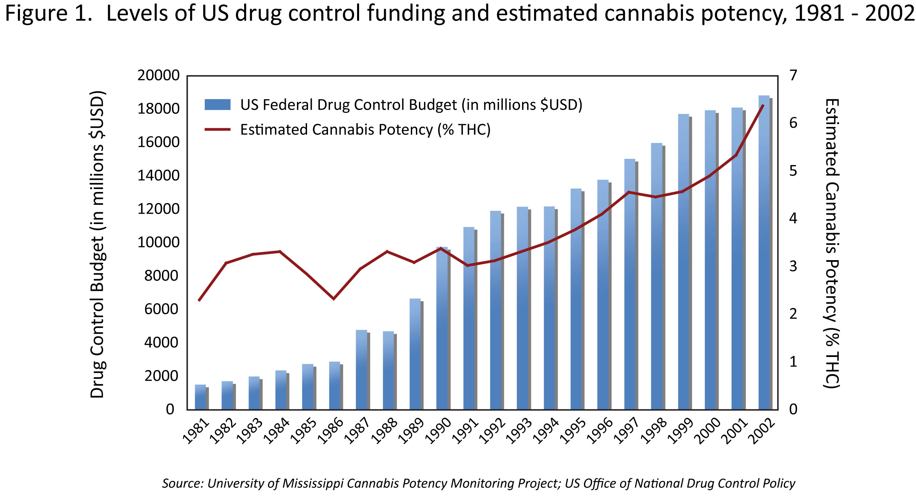

**Box 1: Harms of traditional drug policies listed in the Vienna Declaration.**

* HIV epidemics fuelled by criminalization of people who use illicit drugs and by prohibitions on provision of sterile needles and opioid substitution treatment.
* HIV outbreaks in incarcerated and institutionalized drug users as a result of punitive laws and policies, and lack of HIV prevention services in these settings.
* Undermining of public health systemswhen law enforcement drives drug users away from prevention and care services and into environments where risk of infectious disease transmission (e.g., HIV, hepatitis C, tuberculosis) and other harms is increased.
* Crisis in criminal justice systems as a result of record incarceration rates in several nations. This high rate of incarceration has negatively affected social functioning of entire communities. While racial disparities in incarceration rates for drug offences are evident in countries worldwide, the effect has been particularly severe in the USA, where about one in nine African–American men aged 20–34 years is incarcerated on any given day, mainly because of drug-law enforcement.
* Stigma towards people who use illicit drugs, which reinforces the political popularity of criminalizing drug users and undermines HIV prevention and other health-promotion efforts.
* Severe human-rights violations, including torture, forced labour, inhuman and degrading treatment, and execution of drug offenders in several countries.
* Massive illicit market worth US$320 billion annually. These profits remain entirely outside governmental control. They fuel crime, violence, and corruption in countless urban communities and have destabilized entire countries, such as Colombia, Mexico and Afghanistan.
* Billions of tax dollars wasted on a “war on drugs” approach to drug control that does not achieve its stated objectives, and instead directly or indirectly contributes to the above harms.

**For additional information, see The Vienna Declaration. Available online at:** [**www.viennadeclaration.com**](http://www.viennadeclaration.com/) **(accessed May 3, 2011).**

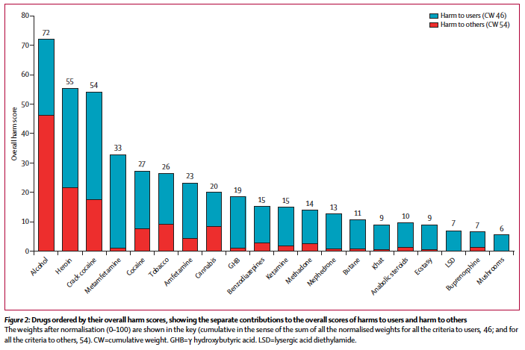

Reprinted with permission from: Nutt, DJ *et al*. Drug harms in the UK: a multicriteria decision analysis. Lancet. 2010 Nov 6;376(9752):1558-65.

REFERENCES