**Defining hospitalist physicians using clinical practice data:**

**a systems-level prevalence study of Canadian hospitalists**

Heather L. White*,Thérèse A. Stukel†,

Walter P. Wodchis‡ & Richard H. Glazier§

*Heather White, MSc (heatherlynn.white@mail.utoronto.ca), is a PhD Candidate at the Institute of

Health Policy, Management and Evaluation, University of Toronto and a student at the Institute for

Clinical Evaluative Sciences, Toronto, Ontario.

†Dr. Stukel, PhD (stukel@ices.on.ca), is a Professor at the Institute of Health Policy, Management and

Evaluation, University of Toronto; a Senior Scientist at the Institute for Clinical Evaluative Sciences;

and an Adjunct Professor at the Dartmouth Institute for Health Policy and Clinical Practice.

‡Dr. Wodchis, PhD (walter.wodchis@utoronto.ca), is an Associate Professor at the Institute of Health

Policy, Management and Evaluation, University of Toronto; an Adjunct Scientist at the Institute for

Clinical Evaluative Sciences; and a Scientist at the Toronto Rehabilitation Institute, Toronto, Ontario.

§ Dr. Glazier, MD, MPH (rick.glazier@ices.on.ca), is a Professor at the Institute of Health Policy,

Management and Evaluation and the Department of Family and Community Medicine, University of

Toronto; a Senior Scientist at the Institute for Clinical Evaluative Sciences; and a Scientist with the

Centre for Research on Inner City Health, St. Michael's Hospital, Toronto, Ontario.

**CORRESPONDING AUTHOR/REPRINT REQUESTS**

Heather L. White

Institute of Health Policy, Management and Evaluation

University of Toronto

74-240 London Road West

Guelph, ON N1H 8N8

Tel: (519) 362-2365

Fax: (416) 864-5485

Email: heatherlynn.white@mail.utoronto.ca (email address may be published)

Word Count Abstract: 272

Word Count Text: 2799

Number Of Tables: 3

Number Of Figures: 2

Additional Tables: 2

**ABSTRACT**

**Background:** Hospitalists have become dominant providers of inpatient care in many North American hospitals. Despite the global growth of hospital medicine, no objective method has been proposed for defining hospitalist physicians and delineating between inpatient practices based on the physician's clinical volumes of care. This paper proposes a method of defining hospitalists using aggregated measures of inpatient volume and uses this to describe the growth, prevalence and practice characteristics of hospital-based physicians working in Ontario, Canada.

**Methods**: Human resource databases and financial insurance claims were used to identify all active fee-for-service physicians who worked in Ontario, Canada between 1996 and 2011. Three measures of inpatient practice volume were constructed from insurance claims reflecting the time physicians spent delivering inpatient care in each fiscal year. We examined how inpatient volumes changed for Ontario physicians since the introduction of hospitalists by medical specialty and described the prevalence of full and part-time hospitalists working in acute-care hospitals in 2010/2011.

Results: Analyses showed a significant increase in the number of hospital-based family physicians practicing in Ontario since 2000 and associated decreases in the number of hospital-based internists and specialists (*p* < 0.001). 620 full-time, 520 part-time, and 2,166 mixed-practice hospitalists were estimated to be working in Ontario hospitals in 2010/11, comprising 13% of the total active physician workforce. Hospitalists were prevalent in all regions and hospital types and collectively delivered over 50% of all inpatient evaluation and care co-ordination for hospitalized residents.

**Interpretation:** Analyses confirmed a substantial increase in hospitalist prevalence in Ontario from 1996 to 2011. A systems-level analysis of clinical practice data is a practical and valid method for defining and identifying hospital-based physicians.

**INTRODUCTION**

Since the first hospitalist programs were established in the late 1990s, the hospitalist movement has grown rapidly in terms of the number of physicians specializing in hospital medicine, the proportion of inpatients cared for by hospital-based physicians and the number of hospitals employing formal hospitalist groups [1-5]. While several studies have reported on the demographics, prevalence and outcomes of care of American hospitalists [1, 3-4, 6-7], fundamental debate remains amongst the medical community on what a hospitalist is, how one should be defined and what (if anything) distinguishes the hospitalist from other hospital-based specialists.

Canadian hospitalists emerged in the late 1990s after cutbacks to physicians reimbursement sparked the exodus of general/family practitioners (GP/FPs) from acute-care delivery and a backlog of "orphaned" inpatients [2, 8-10]. Canada is unique to the hospitalist movement in that the majority of hospitalists are trained in family as opposed to general internal medicine [2-3, 11] and the hospitalist career path is attractive as it provides an opportunity for family physicians to practice higher-acuity medicine while earning a competitive compensation exceeding that of an office-based practice. However, GP/FP hospitalists have less training in inpatient medicine than their American colleagues, spending only two to three months during their residency in hospital rotations [10]. In addition, hospital medicine in Canada is not recognized as a distinct area of focused practice. There are no certification and training guidelines for Canadian hospitalists and the scope and core competencies of a hospitalist practice remain undefined [10].

To date, no population-based data has been published describing the scope of hospital medicine in Canada, the practice characteristics of Canadian hospitalists or how inpatient care for non-hospitalist physicians has evolved in response over time. Three papers have presented demographic data [2-3, 12] but all three used voluntary staffing/member surveys to estimate prevalence, an approach that is methodologically impractical and imprecise to researchers and policy makers. Low responses rates make it difficult to assess the population prevalence of hospital-based physicians and the self-labelling of the hospitalist designation is subjective and not captured in administrative financial, clinical or service utilization databases. Lacking an objective, clinical definition of a hospitalist practice, any physician can define themselves as a hospitalist.

Yet hospital medicine sits at a pivotal intersection for changes occurring in the way inpatient care is funded and delivered across the globe. With several North American, European, Asian and Australasian governing bodies introducing financial incentives that reward hospitals for improved productivity and/or penalize those with lower than expected outcomes, hospital physicians and their institutions must become accountable to the quality of care and services they deliver. If the eventual goal in Canada and elsewhere is to monitor hospitalist performance, a systems-level method is needed for standardizing hospitalist definitions independent of self-identification.

In this paper we propose a practical method of defining and identifying hospital-based physicians which uses insurance billing volumes combined with clinical practice data to measure a physicians' involvement in hospital care. We apply this method at the population-level to look at the growth of hospitalists in the province of Ontario, Canada between 1996 and 2011. We examine how annual inpatient volume has changed for physicians over time in response to the introduction of hospitalists and estimate the current prevalence of full and part-time hospitalists in practice.

**METHODS**

**Study Population**

A retrospective, population-based sample was constructed consisting of all clinically active physicians who practiced in Ontario between April 1, 1996 and March 31, 2011 and submitted professional fees to Ontario's Health Insurance Plan (OHIP), a publically-funded plan which provides basic health care including hospital care to all permanent residents. The cohort was identified using the Institute for Clinical Evaluative Sciences' Physician Database (IPDB), a human resources database containing validated demographic, certification and practice characteristics on all physicians licensed in the province since 1992. Active physicians in a given year were defined according to guidelines developed by the Ontario Physician Human Resources Data Centre which include: (i) maintaining an active licence with the College of Physicians and Surgeons of Ontario, (ii) being 25 to 85 years of age with a valid practice location within the province, (iii) having an OHIP number with active insurance claims, (iv) not being engaged in post-graduate studies and (v) not being identified as retired or inactive for disability, leave, sabbatical or other reason [13].

**Measures**

Demographic, training and practice characteristics of physicians were extracted from the IPDB for each fiscal year. Physician speciality was determined by combining data on both certified and functional speciality, where certified specialty captures the most recent certification information held while functional specialty reflects what the physician actually does in his/her practice, derived from aggregated OHIP billings. Discrepancies were assigned to the specialty recorded most often in the physicians’ insurance claims for a given year. Pediatric surgeons and psychiatrists were combined with adult practitioners respectively and all laboratory specialities, nuclear medicine and diagnostic radiology were considered together.

Individual physicians were then linked to their insurance billings to determine the annual number of patient evaluation-and-management claims billed by the location of care delivery. An evaluation-and-management claim was defined as any visit, consultation, physical assessment, birth attendance, death pronouncement, case-conference or patient/family/group counselling or psychotherapy session billed to OHIP for a hospitalized resident and was used as a proxy indicator of the time physicians spend in direct clinical care and case management. From this data, three measures of the physicians’ annual inpatient volume were tabulated: 1) the total number of inpatient evaluation-and-management claims billed; 2) the proportion of the physicians’ total evaluation-and-management claims generated from the care of hospitalized patients; and 3) the total number of calendar days billed for inpatient care. As the primary role of the hospitalist is to provide direct clinical care and care co-ordination, indicators of procedural volume were not explored.

The number of unique hospitalized patients seen and the proportion of hospitalized patients with whom physicians had a previous medical history (defined as billing one or more insurance claims for a given patient within 24 months prior to the date of index admission) was determined for the most recent fiscal year (2010/11). Hospital characteristics where physicians provided the majority of inpatient care were extracted from the Ontario Hospital Reporting System (OHRS), a database containing annual statistical information on all acute care hospitals in the province.

**Defining, indentifying and validating hospitalist physicians**

In Table 1 we propose a conceptual framework that utilizes clinical practice data and inpatient volumes to define and identify full and part-time hospitalists. We used an approach validated by Kuo et al.,[1] to identify hospitalists based on the proportion of their total evaluation-and-management claims generated from the care of hospitalized patients ( ≥80%) with a minimum total billing volume of ≥100 claims. However, in graphing the distribution of practitioners by total volume, it was clear that total billings was not a sensitive metric for delineating an inpatient practice, identifying too many inactive physicians and not discriminating between full and part-time hospitalists. We expanded Kuo's definition, adding the annual number of inpatient claims billed to separate full and part-time (but strictly) hospital-based physicians. We also propose two novel classifications for mixed-hospital (clinical practice split between outpatient and inpatient practice) and comprehensive community practice physicians. Thresholds were set by graphing the distribution of family practitioners and general internists by each of the volume measures from 1996-2010, looking for where a consistent increase in physician density formed on the right distributions of histograms post 2000 when the hospitalist model gained momentum.

**- Table 1 -**

To test our algorithm, we validated the institution list where hospitalists identified from administrative records billed the majority of inpatient services in 2010/11 against 62 acute care institutions with and 101 institutions without publically disclosed hospitalist programs. The administrative algorithm correctly identified 90% of acute care hospitals known to employ hospitalists (specificity 98%; positive predictive value 97%). The six false negatives linked to small community hospitals which introduced full or pilot hospitalist programs part-way through the 2010/11 fiscal year and the two false positives identified full-time general internists employed in large urban teaching hospitals.

**Statistical Analysis**

After describing the characteristics of physicians who provided inpatient care in Ontario hospitals by year, we calculated and plotted the distribution of physicians according to the total number of inpatient evaluation-and-management claims billed by year and medical specialty. To confirm whether upward or downward trends in volumes were statistically significant over time, the proportion of physicians achieving each billing level (i.e.: ≥ 2,000 inpatient evaluation-and-management claims) in fiscal year *t,* were entered into separate autoregression models with a lag set to 1 [AR(1)]. Volumes billed in 2010/11 were used to identify and describe the current population of inpatient physicians according to Table 1, excluding physicians with low total and inpatient volumes (<100 total evaluation-and-management claims; <10 inpatient claims). SAS.9.2[14] was used for analysis and ethics approval was obtained from Sunnybrook Health Sciences Centre and from the Office of Research Ethics at the University of Toronto.

**RESULTS**

The descriptive characteristics of physicians providing inpatient care from 1996 to 2011 are shown in Table 2. In 1996, 77% of active physicians working in the province provided inpatient care (n=15,275) and almost half of all hospital doctors were family physicians (n=7,418; 48.6%). Beginning in 1998, the proportion of active physicians providing inpatient services began to decline and has continued each fiscal year since. While all medical specialties experienced the exodus of practitioners from hospital care provision, the largest declines occurred amongst family physicians (Table 2; Figure 1). In 1996, 71% of active GP/FPs provided inpatient evaluation-and-management, but by 2010, less than half continued to do so.

**- Table 2 -**

Figure 1 shows the distribution of (a) general/family practitioners, (b) general internists and (c) internal medicine specialists according to the annual volume of inpatient evaluation-and-management claims billed over time. Since 1997 the proportion of GP/FPs providing occasional or no inpatient care increased from 71% to 84% (*p* < 0.001). In turn, full-time hospital-based GP/FPs subsumed the gap in inpatient care provision, increasing in prevalence from 1% of active GP/FPs in 1996 to 3% in 2010, with growth beginning in 2000 (*p* < 0.001). Conversely, the percentage of high inpatient-volume general internists and specialists has decreased over time, indicative of lighter inpatient workloads or more balanced distributions between inpatient and outpatient practice.

**- Figure 1 -**

Despite large declines in number of family physicians providing hospital care over time, the total annual volume of inpatient services delivered by GP/FPs has dropped minimally, comprising 32% of total service volume in 1996, 30% in 2000-2004, and 28% in 2008 (eTable 1). In order to maintain this overall volume of care, fewer GP/FPs have provided a higher volume of inpatient services in each fiscal year (eTable 2). While the average volume of services increased for GP/FPs maintaining hospital privileges, median volumes have decreased indicating that rising inpatient caseloads pertain only to GP/FPs to the right of the median: the GP/FP hospitalists.

Figure 2 shows the current distribution of hospital physicians according to medical specialty and annual inpatient volume, as well as the cumulative distribution of inpatient care/management billings for the province. In 2010/11, 42% percent of all inpatient claims were delivered by high- volume physicians (inpatient claims ≥ 2,000), representing just 2.8% of the total inpatient physician workforce (n=1,143). In contrast, the bulk of the hospital workforce delivered a relatively small volume of care in 2011, with 40% of hospital physicians delivering just 6% of inpatient evaluation-and-management billed for the population of hospitalized residents.

**- Figure 2 –**

Applying the volume definitions from Table 1, we identified 620 full-time and 520 part-time hospitalists working in Ontario in 2010/11. Fifty-three percent of full-time hospitalists were psychiatrists (n=327), 23% were general/family practitioners (n=145) and 10.6% were general internists (n=66). Remaining full-time hospitalists were internal medicine specialists (n=63), surgeons (n=5), pediatricians (n=6), and anesthesiologists (n=8). The majority of part-time hospitalists were psychiatrists (n=221; 43%), anesthesiologists (n=75; 14%) general internists (n=64; 12%) and GP/FPs (n=62; 12%). Remaining analyses are restricted to the general hospitalist practice (family physicians and general internists) although data on additional specialties are available by request.

Table 3 provides the demographic and practice characteristics of full-time and part-time hospitalists trained in family or general internal medicine, along with mixed-hospital and comprehensive community practice physicians for comparison. In 2010/11, full-time general hospitalists delivered 16% of all inpatient evaluation-and management for the province, billing an average of 3,649 evaluation-and-management claims, 614 unique hospitalized patients and 220 days worked in hospital per physician. Using mean volumes, these metrics equate to an average clinical workload of 16.6 patient interactions and 2.8 new patients evaluated per work day, excluding non-billable re-assessments and any additional outpatient services. Part-time hospitalistsevaluated 11.0 inpatients and 2.6 new patients per hospital day worked while mixed-hospital physicians evaluated 11.6 inpatients and 2.3 new patients/day. All full-time hospitalists worked a minimum of 100 calendar days in hospital while part-time hospitalists exceeded 50 days. As expected, hospitalists had little previous medical history with their hospitalized patients, seeing an average of 10.8% of patients within two years prior to admission (11.3% for part-time). In contrast, comprehensive care physicians had seen on average, more than half of their patients prior to hospitalization (51.5%). Characteristics and outcomes of patients managed by hospitalists are explored in a forthcoming publication.

**- Table 3 –**

**DISCUSSION**

This is the first paper to describe the prevalence and characteristics of Canadian hospitalists using population-based data and to describe the emergence of hospital medicine and its impact on remaining inpatient care and delivery for the province of Ontario. By examining changes in physician billing volumes over time, clinical data confirmed the introduction of GP/FP hospitalists to Ontario in the early 21st century and significant growth in the number of full-time general hospitalists practicing each fiscal year since. Our prevalence estimates for the number of hospitalists and hospital medicine programs in Ontario exceed those reported by the Canadian Society of Hospital Medicine’s membership survey (n=110; 26 respectively) [11] and our physician demographics are consistent with those reported elsewhere in the literature [2-3, 11].

To our knowledge, this is also the first paper to propose a conceptual framework for defining and delineating between inpatient practices using actual inpatient practice data. The metrics and descriptive variables used in this study are simple to derive and are often collected at the population-level in developed countries. Our framework for defining hospitalists offers thresholds that align with Kou’s approach currently in practice [1, 15-22] but expand administrative methodology by adding a continuous measure of inpatient volume which allows us to differentiate between daily clinical workloads. By doing so, we move towards more objective and dynamic definitions of a hospitalist practice where volume metrics can be analyzed as continuous predictors of a physicians’ practice and eventually performance, accounting for additional provider characteristics as desired. When we applied Kuo’s definition using an inpatient practice proportion of 80% and a minimum total billing volume of 100 claims, prevalence estimates of hospitalist practitioners were overinflated by 17%, capturing 67 physicians with minimally active practices. This approach while useful for identifying a broad cohort of physicians who are primarily hospital-based, does not differentiate by clinical volume or hospital experience. More importantly, it ignores a large segment of mixed-hospital practitioners whose inpatient volumes and workload appears to parallel if not exceed that of part-time hospitalists.

For ethical reasons, we were unable to link de-identified administrative billings to a known cohort of hospitalist physicians in order to validate our thresholds. While this remains an important next-step towards refining the the clinical definition of a hospitalist practice, we were able to define and characterize a distinct cohort of general physicians who functionally devoted the majority of their practice to the care and management of hospitalized patients. We were able to validate our definitions at the institutional level with high precision and good sensitivity. Our definitions also have face validity triangulated across the three inpatient practice metrics. In addition, we were only able to describe trends in inpatient volume among fee-for-service physicians who comprise approximately 90% of physicians working in Ontario. This limitation is unlikely to affect the calculation of total inpatient volumes or hospitalist estimates for general practitioners as the majority of hospital services for general practitioners are remunerated through fee-for-service billings. Alternate payment plans are primarily used to reimburse community-based physicians and were reported to be uncommon among hospitalists responding to the Canadian Society of Hospital Medicine's member survey [11].

The temporal analysis of inpatient practice data presented in this paper highlights that hospitalists have become integral providers of acute care delivery for the province of Ontario. These results point to the changing nature of hospital care where a small number of generalist providers supply the bulk of inpatient care and case management for Canadians. As hospitalists continue to grow in number across the globe, continuous metrics of volume which reflect the dynamic continuum of an inpatient practice may be useful for defining, identifying and monitoring hospital-based physicians and their performance.

**ACKNOWLEDGMENTS**

This study was supported by the Institute for Clinical Evaluative Sciences (ICES), which is funded by an annual grant from the Ontario Ministry of Health and Long-Term Care (MOHLTC). In addition, HW is supported by a Canada Graduate Scholarship provided through the Canadian Institutes of Health Research (CIHR FRN 96303) and by a doctoral fellowship provided through the Health System Performance Research Network (HSPRN) - a multi-institution collaborative network also supported by the MOHLTC. The opinions, results and conclusions expressed in this manuscript are those of the authors and are independent from the funding sources. No endorsement by ICES, CIHR, HSPRN or the Ontario MOHLTC is intended or should be inferred. The Corresponding Author (HW) had full access to all of the data in the study, wrote the first draft of the manuscript and takes responsibility for the integrity of the data and the accuracy of the data analysis.

**COMPETING INTERESTS**

The authors have no competing interests to declare.

**REFERENCES**

1. Kuo Y-F, Sharma G, Freeman J, Goodwin J. Growth in the care of older patients by hospitalists in the United States. *N Engl J Med.*  2009;360(11):1102-12.

2. Yousefi V, Wilton D. Re-designing hospital care: Learning from the experience of hospital medicine in Canada. Journal of Global Health Care Systems. 2011;1(3):1-10.

3. Soong C, Fan E, Howell EE, Maloney RJ, Pronovost PJ, Wilton D, et al. Characteristics of hospitalists and hospitalist programs in the United States and Canada. *J Clin Outcomes Manag.* 2009;16(2):69-74.

4. Wachter RM. The state of hospital medicine in 2008. *Med Clin North Am*. 2008;92(2):265-73.

5. Wachter R, Bell D. Renaissance of hospital generalists. *BMJ*. 2012;13(344):e652. Epub April 4.

6. Kralovec P, Miller J, Wellikson L, Huddleston J. The status of hospital medicine groups in the United States. *J Hosp Med*. 2006;1(2):75-80.

7. White H, Glazier R. Do hospitalist physicians improve the quality of inpatient care delivery? A systematic review of process, efficiency and outcome measures. *BMC Med*. 2011;9:58.

8. Dawes R, Newman E, Lofsky S, McNestry G, Willet J, Devilla E, et al. Why Ontario physicians are leaving hospital work: results of a 2002 OMA study. *Ont Med Rev*. 2004;3:9.

9. Sullivan P. Enter the hospitalist: new type of patient creating a new type of specialist. *CMAJ*. 2000;162(9):1345-6.

10. Smith SD, Sivjee K. Defining training needs, core competencies and future certification for Canadian hospitalists. *CMAJ*. 2012;184(14):1557-8.

11. Wilton D, Maloney R, editors. The Canadian national hospitalists survey 2007. Refining the Hospitalist Model; 2008; Toronto, Ontario.

12. Srivastava R, Landrigan C, Gidwani P, Harary OH, Muret-Wagstaff, Homer CJ. Pediatric hospitalists in Canada and the United States: a survey of pediatric academic department chairs. *Ambul Pediatr.*. 2001;1(6):338-9

13. Ontario Physician Human Resources Data Centre. Physicians in Ontario 2010. Hamilton: McMaster University, 2010.

14. SAS Institute Inc. SAS Version 9.2. Cary: SAS Institute Inc; 2008.

15. Wachter R. An introduction to the hospitalist model. *Ann Intern Med*. 1999;130(4 pt 2):338-42.

16. Wachter R, Goldman L. The emerging role of "hospitalists" in the American health care system. *N Engl J Med.* 1996;335(7):514-7.

17. Sharma G, Freeman J, Zhang D, Goodwin J. Continuity of care and intensive care unit use at the end of life. *Arch Intern Med.* 2009;169(1):81-6.

18. Craig DE, Hartka L, Likosky WH, Caplan WM, Litsky P, Smithey J. Implementation of a hospitalist system in a large health maintenance organization: the Kaiser Permanente experience. *Ann Intern Med*. 1999;130(4S):355-9.

19. Yousefi V, Evan M. Hospital medicine maturity framework: proposing a novel framework for defining stages of hospital medicine in Canada. *Healthc Q*. 2011;14(4):67-73.

20. Kuo Y, Goodwin J. Effect of hospitalists on length of stay in the medicare population: variation according to hospital and patient characteristics. *J Am* Geriatr Soc. 2010;58(9):16491657.

21. Fletcher K, Sharma G, Zhang D, Kuo Y, Goodwin J. Trends in inpatient continuity of care for a cohort of Medicare patients 1996-2006. *J Hosp Med*. 2011;6(8):438-44.

22. Kuo Y, Goodwin J. Association of hospitalist care with medical utilization after discharge: evidence of cost shift from a cohort study. *Ann Intern Med*. 2011;155(4):152-9.

**Table 1.** Conceptual framework for identifying hospitalist physicians within administrative databases.

|  |  |  |  |  |  |  |  |
| --- | --- | --- | --- | --- | --- | --- | --- |
|  | **Comprehensive Community Practice** | **Mixed-Hospital Practice** | | **Part-time Hospitalist** | | **Full-time Hospitalist** | |
| **Description of Practice** | Physicians practice primarily within the community but provide occasional inpatient care. Physicians also provide long-term care, emergency department and/or home care services as appropriate | Full-time practice is split between outpatient and inpatient care. | Majority of practice is inpatient evaluation-and-management but physician works at a part-time equivalent. Inpatient practice may be general or speciality-based | | Majority of practice is inpatient evaluation-and-management on a full-time basis. Inpatient practice may be general or speciality-based | |  |
| **Scope of Inpatient Practice** | Hospitalized patients are enrolled in the physicians' primary practice either individually or within a team; generally low-risk medical and ALC patients* | Hospitalized patients often come from outside the physician's primary practice through rotating call; general and complex medical; ALC patients | Physicians typically have no previous history with hospitalized patients; general and complex medical; ALC patients;  co-management of specialty patients | | | |  |
| **Compensation Mechanism** | Fee-for-service billing to insurance plans; physicians have no direct financial relationship with hospitals | Fee-for-service billing to insurance plans. Hospitals may 'top up' physicians’ fee-for-service billings | Fee-for-service billings plus negotiated salary stipend or alternative funding plans; hospitals may pay a portion or all of the physicians' income from their operating budgets. Physicians often work as independent contractors to individual hospitals | | | |  |
| **Annual Inpatient Volume**† | <30%of totalvolume is hospital-based and total volume indicates an active, community practice (> 50% of total volume is generated from office, nursing home or home care; total volume ≥100 services; inpatient volume ≥10 services) | 30%-80%of total volume is hospital-based and inpatient volumes reflect an active and substantial inpatient practice  (**≥** 500 inpatient services) | ≥80%of total volume is hospital-based but volumes reflect a part-time caseload. (500-2,000 inpatient services) | | ≥80%of total volume is hospital-based and volumes reflect a full-time caseload  (≥ 2,000 inpatient services) | |  |

*ALC = Alternate level of care; patients waiting in hospital to be transferred to a complex continuing or long-term care setting.

†Inpatient volumes can be left as continuous measures of a physician's hospital experience in regression models, eliminating the need for categorization.

**Table 2.** Descriptive characteristics of physicians proving inpatient care in Ontario hospitals by fiscal year, 1996-2011.

|  |  |  |  |  |  |
| --- | --- | --- | --- | --- | --- |
| **Physician Characteristics** | **1996** | **2000** | **2004** | **2008** | **2010** |
| **Total n (% of all active physicians)** | 15, 275 (76.7) | 14,914 (73.2) | 15,020 (68.9) | 15, 949 (66.8) | 16, 820 (66.1) |
| Mean Age (SD) | 46.5 (11.2) | 47.4 (10.9) | 47.9 (10.8) | 48.5 (11.0) | 48.6 (11.2) |
| Mean Years of Practice (SD) | 20.6 (11.4) | 21.4 (11.2) | 21.8 (11.2) | 22.2 (11.5) | 22.3 (11.8) |
| Gender |  |  |  |  |  |
| Male | 11,660 (76.3) | 11,056 (74.1) | 10,742 (71.5) | 10,981 (68.9) | 11,357 (67.5) |
| Female | 3,615 (23.7) | 3,858 (25.9) | 4,278 (28.5) | 4,968 (31.1) | 5,463 (32.5) |
| Canadian Medical Graduate |  |  |  |  |  |
| Yes | 9,791 (64.1) | 10,542 (70.7) | 11,205 (74.6) | 12,192 (76.4) | 12,763 (75.9) |
| No | 5,430 (35.5) | 4,324 (29.0) | 3,771 (25.1) | 3,719 (23.3) | 4,007 (23.8) |
| Unknown | 54 (0.4) | 48 (0.3) | 44 (0.3) | 38 (0.3) | 50 (0.3) |
| Census Metropolitan Area of Practice |  |  |  |  |  |
| Population > 1,250,000 | 6,426 (42.1) | 6,166 (41.4) | 6,360 (42.3) | 6,671 (41.8) | 7,030 (41.8) |
| Population 500,000 - 1, 249, 999 | 2,594 (17.0) | 2,535 (17.0) | 2,565 (17.1) | 2,757 (17.3) | 2,939 (17.5) |
| Population 100,000 - 499,999 | 3,782 (24.8) | 3,688 (24.8) | 3,497 (23.3) | 4,011 (25.2) | 4,232 (25.2) |
| Population 9,000 - 99,999 | 1,465 (9.6) | 1,480 (9.9) | 1,494 (10.0) | 1,468 (9.2) | 1,558 (9.3) |
| Population < 9,000 | 1,002 6.5) | 1,034 (6.9) | 1,104 (7.3) | 1,042 (6.5) | 1,050 (6.2) |
| Unknown | 6 (0.0) | 11 (0.0) | 0 (0.0) | 0 (0.0) | 11 (0.0) |
| Medical Specialty |  |  |  |  |  |
| Anesthesiology | 722 (4.7) | 761 (5.1) | 871 (5.8) | 1048 (6.6) | 1130 (6.7) |
| Diagnostics* | 502 (3.3) | 508 (3.4) | 579 (3.9) | 628 (3.9) | 728 (4.3) |
| General Internal Medicine | 897 (5.9) | 829 (5.5) | 885 (5.9) | 771 (4.8) | 795 (4.7) |
| General Practice/Family Medicine | 7,418 (48.6) | 6,751 (45.3) | 6,174 (41.1) | 5,894 (37.0) | 5,970 (35.5) |
| Internal Medicine Specialties† | 1,791 (11.7) | 1,950 (13.1) | 2,171 (14.4) | 2,715 (17.0) | 2,975 (17.7) |
| Obstetrics & Gynecology | 558 (3.7) | 563 (3.8) | 581 (3.9) | 641 (4.0) | 668 (4.0) |
| Pediatrics‡ | 626 (4.1) | 673 (4.5) | 728 (4.9) | 850 (5.3) | 936 (5.6) |
| Psychiatry | 1,212 (7.9) | 1,315 (8.8) | 1,417 (9.4) | 1,540 (9.7) | 1,644 (9.8) |
| Surgery§ | 1,549 (10.1) | 1,564 (10.5) | 1,614 (10.7) | 1,862 (11.7) | 1,974 (11.7) |

*Diagnostics include all diagnostic radiology, nuclear medicine and laboratory medicine.

† Specialties include cardiology, clinical immunology, community and geriatric medicine, dermatology, endocrinology, gastroenterology, hematology,

infectious diseases, medical genetics, medical oncology, nephrology, neurology, physical medicine and rehabilitation, radiation oncology, respirology and

rheumatology.

‡ Pediatrics includes general internal pediatrics and all pediatric internal medicine specialties.

§Surgery includes all adult and pediatric surgeons licensed to practice by the Royal College of Physicians and Surgeons of Canada.

**Table 3.** Descriptive characteristicsof hospitalists, mixed-hospital and comprehensive community physicians trained in

family/general internal medicine, fiscal 2010/11.

|  |  |  |  |  |
| --- | --- | --- | --- | --- |
| **Physician Characteristics**\* | **Comprehensive**  **Community** | **Mixed-Hospital** | **Part-time**  **Hospitalist** | **Full-time**  **Hospitalist** |
| **Total N** | 2,478 | 512 | 126 | 211 |
| Mean Age (SD) | 50.6 (11.2) | 46.0 (11.1) | 41.7 (9.2) | 45.7 (10.2) |
| Mean Years of Practice (SD) | 23.9 (11.8) | 19.4 (11.8) | 15.0 (9.7) | 18.5 (10.8) |
| Gender |  |  |  |  |
| Male | 1,670 (67.4) | 325 (63.5) | 76 (60.3) | 117 (55.4) |
| Female | 808 (32.6) | 187 (36.5) | 50 (39.7) | 94 (44.6) |
| Canadian Medical Graduate |  |  |  |  |
| Yes | 2,049 (82.7) | 363 (70.9) | 107 (84.9) | 147 (69.7) |
| No | 429 (17.3) | 149 (29.1) | 19 (15.1) | 64 (30.3) |
| Medical Specialty |  |  |  |  |
| General Practice/Family Medicine | 2,320 (93.6) | 280 (54.7) | 62 (49.2) | 145 (68.7) |
| General Internal Medicine | 145 (6.4) | 232 (45.3) | 64 (50.8) | 66 (31.3) |
| Metropolitan Area of Practice |  |  |  |  |
| Population > 1,250,000 | 639 (25.8) | 208 (40.6) | 42 (33.3) | 87 (41.2) |
| Population 500,000 - 1,499,999 | 240 (9.7) | 80 (15.6) | 33 (26.2) | 26 (12.3) |
| Population 100,000 - 499,999 | 529 (21.4) | 147 (28.7) | 39 (31.0) | 80 (37.9) |
| Population 9,000 - 99,999 | 471 (19.0) | 60 (11.7) | 11 (8.7) | 18 (8.5) |
| Population < 9,000 | 599 (24.2) | 17 (3.3) | 1 (0.8) | 0 (0.0) |
| Hospital Size |  |  |  |  |
| 400+ Beds | 10 (0.4) | 24 (4.7) | 8 (6.4) | 14 (6.6) |
| 300-399 Beds | 213 (8.6) | 97 (18.9) | 46 (36.5) | 44 (20.9) |
| 200-299 Beds | 384 (15.5) | 123 (24.0) | 29 (23.0) | 63 (29.9) |
| 100-199 Beds | 582 (23.5) | 170 (33.2) | 32 (25.4) | 61 (28.9) |
| 1-99 Beds | 1287 (51.9) | 93 (18.2) | 11 (8.7) | 29 (13.7) |
| Unknown | 2 (0.1) | 5 (1.0) | 0 (0.0) | 0 (0.0) |
| Hospital Location |  |  |  |  |
| Urban ( > 400 residents/km2) | 711 (28.7) | 223 (43.5) | 49 (38.9) | 91 (43.1) |
| Mixed-Urban (100-400 residents/km2) | 474 (19.1) | 127 (24.8) | 42 (33.3) | 59 (28.0) |
| Mixed-Rural (20-99 residents/km2) | 820 (33.1) | 117 (22.9) | 28 (2.2) | 45 (21.3) |
| Rural ( < 20 residents/km2) | 471 (19.0) | 43 (8.4) | 7 (5.6) | 16 (7.6) |
| Unknown | 2 (0.1) | 2 (0.4) | 0 (0.0) | 0 (0.0) |
| Hospital Type |  |  |  |  |
| Academic Teaching Hospital | 406 (16.4) | 172 (33.6) | 72 (57.1) | 79 (37.4) |
| Community Hospital | 2072 (83.6) | 340 (66.4) | 54 (42.9) | 132 (62.6) |
| **Average Clinical Workload** |  |  |  |  |
| Mean Inpatient Evaluation-and-Management Claims Billed (SD) | 409 (451) | 2,090 (1,589) | 1,261 (444) | 3,649 (1,962) |
| Mean Unique Hospitalized Patients Seen (SD) | 109 (101) | 408 (309) | 304 (161) | 614 (291) |
| Mean Calendar Days Billed for Hospital Care (SD) | 120 (92) | 180 (80) | 115 (49) | 220 (49) |
| Mean % Hospitalized Patients with Previous Medical History (SD) | 51.5 (30.7) | 20.0 (18.1) | 11.3 (7.0) | 10.8 (7.3) |
| Mean % of Practice Delivering Inpatient Care | 9.1 (7.9) | 54.2 (15.5) | 91.4 (5.9) | 91.5 (5.9) |
| Mean % of Practice Delivering Office-Based Care | 78.9 (17.4) | 36.5 (19.4) | 6.6 (5.5) | 5.8 (4.8) |
| Mean % of Practice Delivering Emergency Department Care | 6.3 (11.2) | 5.8 (11.7) | 1.9 (3.5) | 1.3 (2.9) |
| Mean % of Practice Delivering Long-term Institution Care | 4.7 (12.3) | 3.3 (9.8) | 0.2 (1.0) | 1.4 (3.3) |
| Mean % of Practice Delivering Home-Based Care | 0.9 (3.2) | 0.3 (2.0) | 0.0 (0.0) | 0.0 (0.1) |

*Frequencies with proportions are displayed for categorical variables; means with standard deviations for continuous variables

**FIGURE LEGENDS**

**Figure 1.** Distribution of active Ontario [a] general practitioner/family physicians [b]

general internists [c] internal medicine specialists according to the annual number of inpatient evaluation-and-management claims billed to OHIP, 1996-2011.

**Footnote for Figure 1a-c:** * indicates a significant increase, † a significant decrease, in the proportion of physicians achieving each billing threshold over time based on autoregressive [AR(1)] models, *p* < 0.05.

**Figure 2.** Current distribution of Ontario physicians providing hospital care by medical specialty and annual inpatient volume. Ontario, 2010/11.

**Figure 1.** Distribution of active [a] general practitioner/family physicians [b] general internists [c] internal medicine

specialists according to the annual number of inpatient evaluation-and-management claims billed to OHIP, 1996-2011.

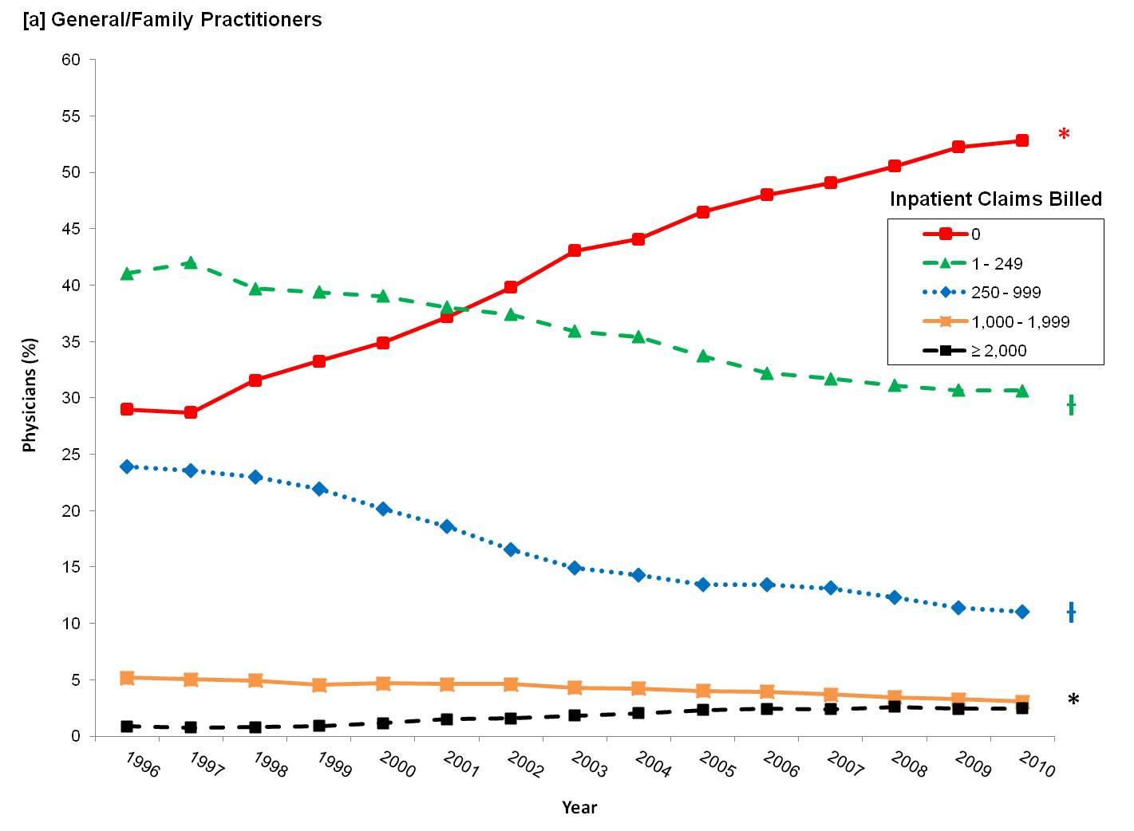

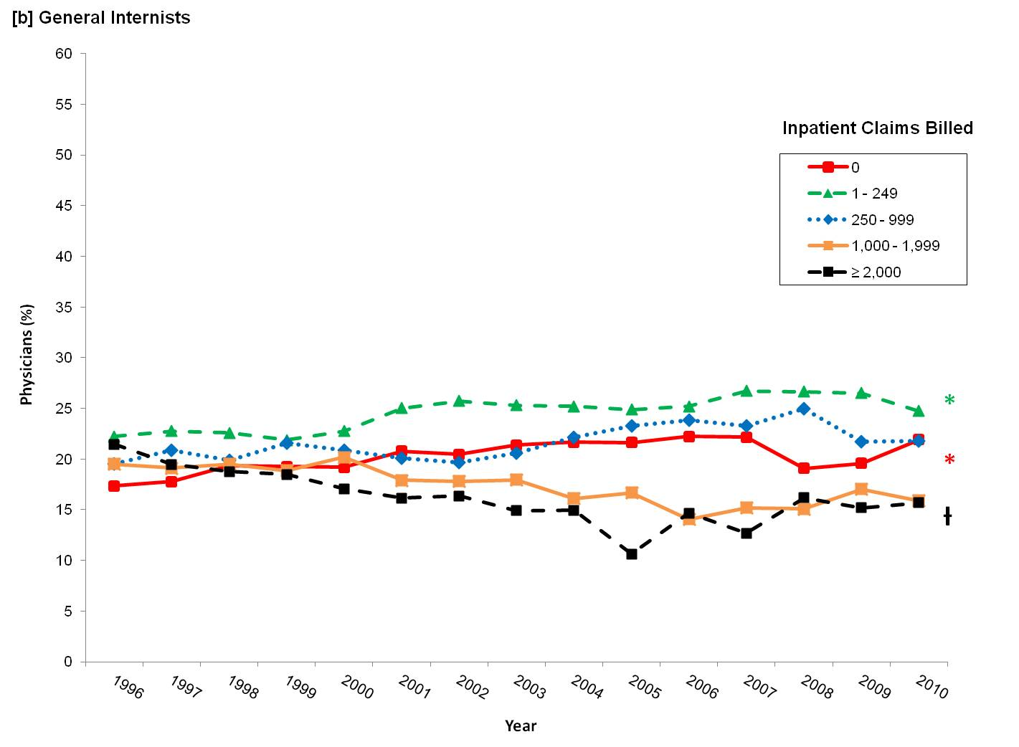

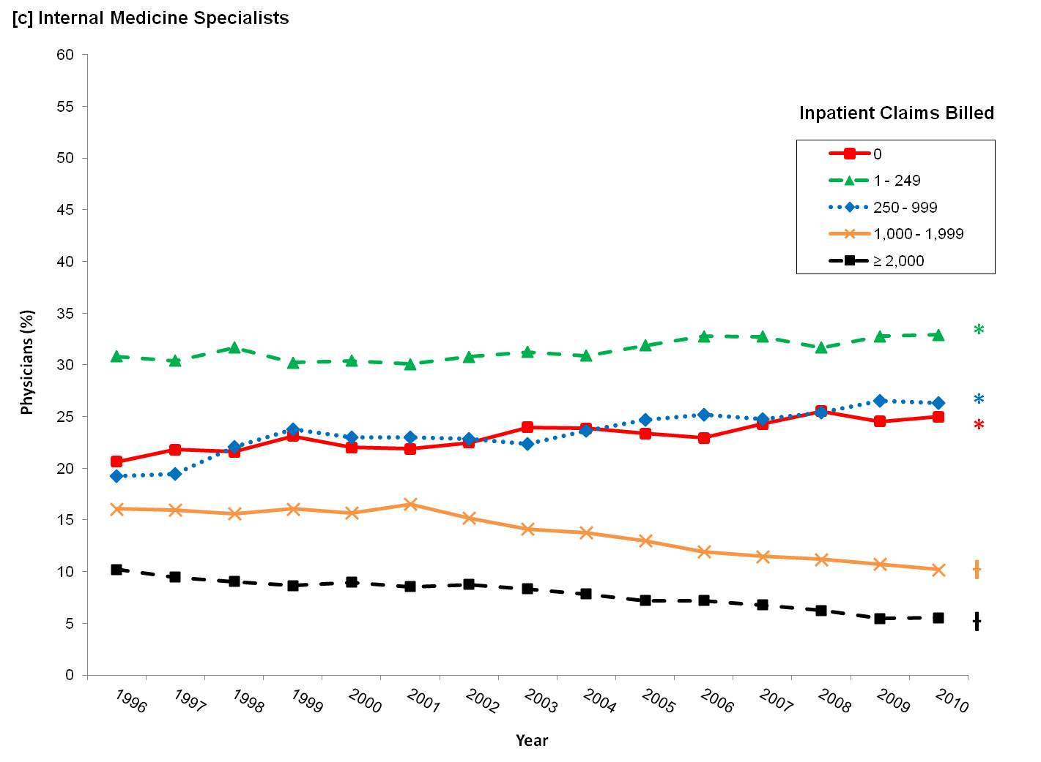

**Figure 2**. Current distribution of Ontario physicians providing hospital care by medical specialty and annual inpatient volume.

Ontario, 2010/11.

