Understanding the essential notion of cloud computing: its Concepts and Technology

Nimish Joshi
Dept. of Electrical & Computer Engineering
University Of Texas at San Antonio
San Antonio, Texas

Abstract— Cloud computing is based on the notion of shared computational, storage, network, and application resources provided by a third party. The aim of this independent study and this report was to understand the elementary concept of cloud computing, along with basics of Linux and python. Moreover this study was also aimed to study the concepts of cloud, its delivery models and applications, virtualization, Linux networking and genesis of open sack architecture. The report also discusses the cloud from technical, and service aspects.
Key Words: Cloud Computing, SaaS, Paas, IaaS, cloud services, resource virtualization, open stack
I. INTRODUCTION

This section gives an introduction to Cloud computing. "Cloud computing is a model for enabling convenient, on demand network access to a shared pool of configurable computing resources (e.g., networks, servers, storage, applications, and services) that can be rapidly provisioned and released with minimal management effort or service provider interaction. Cloud computing has emerged as a popular solution to provide cheap and easy access to externalized IT (Information Technology) resources. An increasing number of organizations (e.g., research centers, enterprises) benefit from Cloud computing to host their applications. Through virtualization, Cloud computing is able to address with the same physical infrastructure a large client base with different computational needs. In contrast to previous paradigms (Clusters and Grid computing), Cloud computing is not application-oriented but service-oriented; it offers on demand virtualized resources as measurable and billable utilities.Fig. 1 shows a basic cloud computing environment.

Any cloud is expected to have these five characteristics that are being described below.

- On-demand self-service.

A consumer can unilaterally provision computing capabilities, such as server time and network storage, as needed automatically without requiring human interaction with each service’s provider.

Broad network access:

Capabilities are available over the network and accessed through standard mechanisms that promote use by heterogeneous thin or thick client platforms (e.g., mobile phones, laptops, and personal digital assistants (PDAs)). C. Resource pooling The provider’s computing resources are pooled to serve multiple consumers using a multi-tenant model, with different physical and virtual resources dynamically assigned reassigned according to consumer demand.
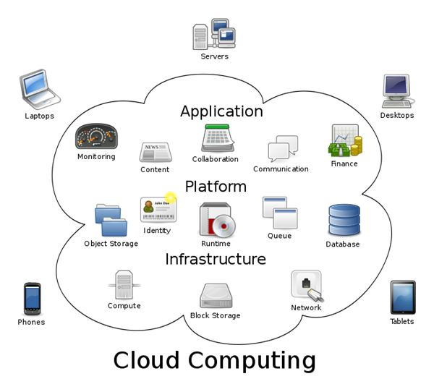
Figure 1: Basic Cloud Computing environment.
There is a sense of location independence in that the subscriber generally has no control or knowledge over the exact location of the provided resources but may be able to specify location at a higher level of abstraction (e.g., country, state, or data center). Examples of resources include storage, processing, memory, network bandwidth, and virtual machines.

- Rapid elasticity

Capabilities can be rapidly and elastically provisioned, in some cases automatically, to quickly scale out and rapidly released to quickly scale in. To the consumer, the capabilities available for provisioning often appear to be unlimited and can be purchased in any quantity at any time.

- Measured Service

Cloud systems automatically control and optimize resource use by leveraging a metering capability at some level of abstraction appropriate to the type of service (e.g., storage, processing, bandwidth, and active user accounts). Resource usage can be monitored, controlled, and reported providing transparency for both the provider and consumer of the utilized service

II. REVIEW OF THE CONCEPT IN LINUX AND PYTHON

- Linux Background:

Linux is a modern, free operating system based on UNIX standards. First developed as a small but self-contained kernel in 1991 by Linus Torvalds, with the major design goal of UNIX compatibility. Its history has been one of collaboration by many users from all around the world, corresponding almost exclusively over the Internet. It has been designed to run efficiently and reliably on common PC hardware, but also runs on a variety of other platforms.
The core Linux operating system kernel is entirely original, but it can run much existing free UNIX software, resulting in an entire UNIX-compatible _{operating} system free from proprietary code. Many, varying Linux Distributions including the kernel, applications, and management tools

- Linux Design:

Linux is a multiuser, multitasking system with a full set of UNIX-compatible tools. Its file system adheres to traditional UNIX semantics, and it fully implements the standard UNIX networking model. Main design goals are speed, efficiency, and standardization. Linux is designed to be compliant with the relevant POSIX documents; at least two Linux distributions have achieved official POSIX certification. The Linux programming interface adheres to the SVR4 UNIX semantics, rather than to BSD behavior

- Linux Kernel Module:

Sections of kernel code that can be compiled, loaded, and unloaded independent of the rest of the kernel. A kernel module may typically implement a device driver, a file system, or a networking protocol. The module interface allows third parties to write and distribute, on their own terms, device drivers or file systems that could not be distributed under the GPL. Kernel modules allow a Linux system to be set up with a standard, minimal kernel, without any extra device drivers built in. Three components to Linux module support: 1.module management. 2. driver registration & 3. Conflict resolution.

- Module Management:

Supports loading modules into memory and letting them talk to the rest of the kernel. Module loading is split into two separate sections. One is - Managing sections of module code in kernel memory & the other is -Handling symbols that modules are allowed to reference
The module requestor manages loading requested, but currently unloaded, modules; it also regularly queries the kernel to see whether a dynamically loaded module is still in use, and will unload it when it is no longer actively needed

- Driver Registration:

Allows modules to tell the rest of the kernel that a new driver has become available. The kernel maintains dynamic tables of all known drivers, and provides a set of routines to allow drivers to be added to or removed from these tables at any time
Registration tables include the following items: Device drivers, File systems, Network protocols & Binary format.

- Scheduling:

The job of allocating CPU time to different tasks within an operating system. While scheduling is normally thought of as the running and interrupting of processes, in Linux, scheduling also includes the running of the various kernel tasks. Running kernel tasks encompasses both tasks that are requested by a running process and tasks that execute internally on behalf of a device driver. As of 2.5, new scheduling algorithm – preemptive, priority-basee.

- File Systems:

To the user, Linux’s file system appears as a hierarchical directory tree obeying UNIX semantics. Internally, the kernel hides implementation details and manages the multiple different file systems via an abstraction layer, that is, the virtual file system (VFS). The Linux VFS is designed around object-oriented principles and is composed of two components:
One is a set of definitions that define what a file object is allowed to look like & the other is the node-object and the file-object structures represent individual files the file system object represents an entire file system.

- Network Structure:

Networking is a key area of functionality for Linux. It supports the standard Internet protocols for UNIX to UNIX communications. It also implements protocols native to non UNIX operating systems, in particular, protocols used on PC networks, such as Apple talk and IPX. Internally, networking in the Linux kernel is implemented by three layers of software: 1) The socket interface 2) Protocol drivers 3) Network device drivers.
The most important set of protocols in the Linux networking system is the internet protocol suite. It implements routing between different hosts anywhere on the network. On top of the routing protocol are built the UDP, TCP and ICMP protocols.

- Using Python Language:

The home for all things Python is http://www.python.org. There you can find easy-to-follow instructions for installing and using Python. I have also came across https://www.codecademy.com, where the fundamental course has been completed. It took me almost 25-30 hours to complete this lesson where the time was distributed over the month. The topics covered are: Python Syntax, Strings and Console Output, Conditionals and Control Flow, Functions, Lists & Dictionaries, Loops, Iteration over Data Structures, Bitwise Operators, and Classes & File Input & File Output.

III. SURVEY AND STUDY OF CLOUD SERVICES, DELIVERY MODELS AND APPLICATION:

- Software as a Service:
Software as a Service (SaaS) is defined as software that is deployed over the internet. With SaaS, a provider licenses an application to customers either as a service on demand, through a subscription, in a “pay-as-you-go” model, or (increasingly) at no charge when there is opportunity to generate revenue from streams other than the user, such as from advertisement or user list sales
SaaS is a rapidly growing market as indicated in recent reports that predict ongoing double digit growth. This rapid growth indicates that SaaS will soon become commonplace within every organization and hence it is important that buyers and users of technology understand what SaaS is and where it is suitable.

- Platform as a Service:
Platform as a Service (PaaS) brings the benefits that SaaS bought for applications, but over to the software development world. PaaS can be defined as a computing platform that allows the creation of web applications quickly and easily and without the complexity of buying and maintaining the software and infrastructure underneath it.
PaaS is analogous to SaaS except that, rather than being software delivered over the web, it is a platform for the creation of software, delivered over the web.

- Infrastructure as a Service:
Infrastructure as a Service (IaaS) is a way of delivering Cloud Computing infrastructure – servers, storage, network and operating systems – as an on-demand service. Rather than purchasing servers, software, datacenter space or network equipment, clients instead buy those resources as a fully outsourced service on demand. As we detailed in a previous whitepaper, within IaaS, there are some sub-categories that are worth noting. Generally IaaS can be obtained as public or private infrastructure or a combination of the two. “Public cloud” is considered infrastructure that consists of shared resources, deployed on a self-service basis over the Internet.
By contrast, “private cloud” is infrastructure that emulates some of Cloud Computing features, like virtualization, but does so on a private network. Additionally, some hosting providers are beginning to offer a combination of traditional dedicated hosting alongside public and/ or private cloud networks. This combination approach is generally called “Hybrid Cloud”.

- Public Cloud:
The most recognizable model of cloud computing to many consumers is the public cloud model, under which cloud services are provided in a virtualized environment, constructed using pooled shared physical resources, and accessible over a public network such as the internet. To some extent they can be defined in contrast to private clouds which ring-fence the pool of underlying computing resources, creating a distinct cloud platform to which only a single organization has access. Public clouds, however, provide services to multiple clients using the same shared infrastructure.
The most salient examples of cloud computing tend to fall into the public cloud model because they are, by definition, publicly available. Software as a Service (SaaS) offerings such as cloud storage and online office applications are perhaps the most familiar, but widely available Infrastructure as a Service (IaaS) and Platform as a Service (PaaS) offerings, including cloud based web hosting and development environments, can follow the model as well (although all can also exist within private clouds). Public clouds are used extensively in offerings for private individuals who are less likely to need the level of infrastructure and security offered by private clouds. However, enterprise can still utilize public clouds to make their operations significantly more efficient, for example, with the storage of non-sensitive content, online document collaboration and webmail.

The public model offers the following features and benefits:

Ultimate scalability, Cost effective, Utility style costing, Reliability, Flexibility & Location independence;

- Private Cloud

A private cloud is a particular model of cloud computing that involves a distinct and secure cloud based environment in which only the specified client can operate. As with other cloud models, private clouds will provide computing power as a service within a virtualised environment using an underlying pool of physical computing resource. However, under the private cloud model, the cloud (the pool of resource) is only accessible by a single organisation providing that organisation with greater control and privacy.
The technical mechanisms used to provide the different services which can be classed as being private cloud services can vary considerably and so it is hard to define what constitutes a private cloud from a technical aspect. Instead such services are usually categorised by the features that they offer to their client. Traits that characterise private clouds include the ring fencing of a cloud for the sole use of one organisation and higher levels of network security. They can be defined in contrast to a public cloud which has multiple clients accessing virtualised services which all draw their resource from the same pool of servers across public networks. Private cloud services draw their resource from a dsitinct pool of physical computers but these may be hosted internally or externally and may be accessed across private leased lines or secure encrypted connections via public networks.

The additional security offered by the ring fenced cloud model is ideal for any organisation, including enterprise, which needs to store and process private data or carry out sensitive tasks. For example, a private cloud service could be utilised by a financial company that is required by regulation to store sensitive data internally and who will still want to benefit from some of the advantages of cloud computing within their business infrastructure, such as on demand resource allocation.
The private cloud model is closer to the more traditional model of individual local access networks (LANs) used in the past by enterprise but with the added advantages of virtualisation. The features and benefits of private clouds therefore are: Higher security and privacy, More control, Cost and energy efficiency, Improved reliability & Cloud bursting

- Hybrid Cloud

A hybrid cloud is an integrated cloud service utilising both private and public clouds to perform distinct functions within the same organisation. All cloud computing services should offer certain efficiencies to differing degrees but public cloud services are likely to be more cost efficient and scalable than private clouds. Therefore, an organisation can maximise their efficiencies by employing public cloud services for all non-sensitive operations, only relying on a private cloud where they require it and ensuring that all of their platforms are seamlessly integrated.
Hybrid cloud models can be implemented in a number of ways:
- Separate cloud providers team up to provide both private and public services as an integrated service
- Individual cloud providers offer a complete hybrid package
- Organisations who manage their private clouds themselves sign up to a public cloud service which they then integrate into their infrastructure

In practice, an enterprise could implement hybrid cloud hosting to host their e-commerce website within a private cloud, where it is secure and scalable, but their brochure site in a public cloud, where it is more cost effective (and security is less of a concern). Alternatively, an Infrastructure as a Service (IaaS) offering, for example, could follow the hybrid cloud model and provide a financial business with storage for client data within a private cloud, but then allow collaboration on project planning documents in the public cloud - where they can be accessed by multiple users from any convenient location.
A hybrid cloud configuration, such as hybrid hosting, can offer its users the following features: Scalability, Cost efficiencies, Security & Flexibility.

IV. VIRTUALIZATION

Virtualization is a methodology for dividing the computer resources to more than one execution environment by applying more concepts like partitioning, time-sharing, machine simulation and emulation.’
Virtualization can be expressed as a brand new trend in IT, which includes autonomic computing and utility computing. This new trend helps the IT environment to manage itself and every available resource is seen as a utility, where a client pays per use. Figure below provides an illustration of the concept of virtualization. It contains three layers: layer 1 comprising of network, layer 2 comprising of virtual infrastructures and layer 3 contains virtual machines where different operating system and applications are deployed. A single virtual infrastructure can support more than one virtual machine, that is, more than one OS and application can be deployed. Physical resources of multiple machines of entire infrastructure are shared in virtual environment. Resources of a single computer are shared across many virtual machines for maximum efficiency. By optimizing resource, flexibility and reduced costs in capital and operations are achieved. A virtual infrastructure consists: hyper visors, virtual infrastructure services and automated solutions to optimize IT process.

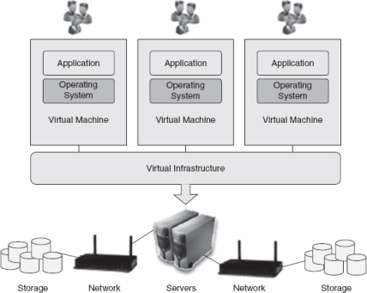
Types of Virtualization:

--Various virtualization types are as follows:
- Server virtualization is a kind of virtualization, used for masking of server resources, which includes number of physical servers, processors and operating systems. The intention of using this method is to spare the complicated server resources and hence increasing the sharing, utilization and maintaining the capacity of servers.
- Network Virtualization is a method where network resources are combine based on available bandwidth. Each channel is assigned to a particular server. By adopting this method of virtualization, a true complexity of network is hidden and managed like partitioning the hard drive. Because of network virtualization, lower TCO, higher return of investment, security and dynamic computing are obtained.
- Storage virtualization is a type of virtualization, where a pool of physical storage from different network of storage devices appears as a single storage device. Usually this kind of virtualization is adopted in SAN (storage area networks). Storage virtualization is advantageous in disaster recovery, business continuity, lower TCO, higher return of investment, dynamic computing, security, testing and development.
- Desktop virtualization supports various computing such as utility and dynamism, testing, development and security.
- Application virtualization allows server consolidation, application and desktop deployment, and business continuity. Apart from this, recovery when disaster, lower TCO with higher ROI, dynamic computing, testing and development are possible.
- Management virtualization allows variety of features which are as follows: server consolidation, centralized policy-based management, business continuity and disaster recovery, lower TCO with higher ROI, utility and dynamic computing, testing and development and security.

Server Virtualization:

The need for server virtualization is consolidation, redundancy, legacy systems and migration.
- Server virtualization reduces space through consolidation. For IT organizations that have large number of servers, the need for single physical space can decrease the workload.
- Server virtualization supports redundancy without purchasing more hardware.
- Legacy systems using server virtualization the outdated systems services can be virtualized, hence the programs work as if it is executed in old systems.
- Migration is a new trend in server virtualization. Migration moves a server environment from one place to another. With the help of suitable hardware and software, it is possible to migrate a virtual server from one physical machine to another in a network.

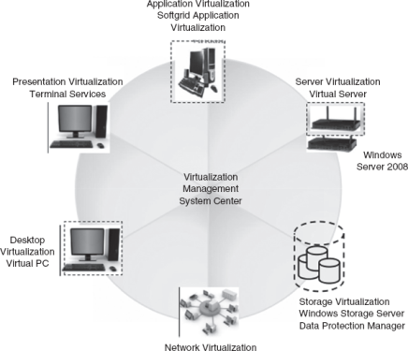

OS Virtualization:

--OS virtualization is probably the easiest model to understand. In this situation, the physical computer system runs a standard unchanged operating system such as Linux, Windows, MacOS-X or Unix. In this mode, running an application is same as any other application, for example, a word processor would run on the system. For starting, stopping and managing every virtual machine and significantly access control on physical hardware resources on behalf of the individual virtual machines, etc., virtualization application is responsible.
Figure provides an illustration of guest OS-based virtualization. As depicted in the figure, the guest operating systems work in virtual machines inside the virtualization application, which in turn, runs on top of the host operating system similar to any other application. This method has the greatest advantage that no modifications are required to either host or guest operating system and no particular CPU hardware virtualization support is required.
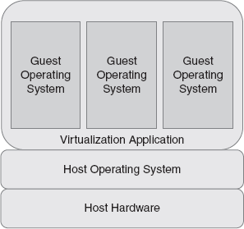
Figure: OS Virtualization

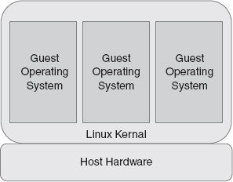
Figure: Kernel Level Virtualization

Above, the first figure provides an overview of the kernel level virtualization architecture. In kernel level virtualization, the host operating system operates on a specially customized kernel, which includes extensions designed to manage and control several virtual machines each have a guest operating system. Unlike shared kernel virtualization each visitor operates their own kernel, even though similar limitations apply, in that the visitor operating systems must have been compiled for the same hardware as the kernel in which they are running. User Mode Linux (UML) and Kernel-based Virtual Machine (KVM) are examples of kernel level virtualization technology.
Hardware virtualization leverages virtualization characteristic construct into the most recent generations of Intel and AMD CPU.
Above, the second figure illustrates the hypervisor approach to virtualization. Under hypervisor level virtualization the host operating system contains an administrative environment to manage and control multiple virtual machines each containing a guest operating system. An administrative operating system and/or management console also runs on top of the hypervisor in addition to the virtual machines which allows the virtual machines to be administered by a system administrator. Hypervisor-based virtualization solutions include Xen, VMware ESX Server and Microsoft’s Hyper-V technology.
To achieve the best performance, management and efficiency of OS virtualization is streamlined. A standard host operating system resides at the bottom that includes Windows and Linux. Virtualization layer with the help of file system and abstraction layer guarantees resource isolation and security. The virtualization layer creates every container appearing as an individual server and holds the workload.

In OS virtualizaiton, nothing exists. All tasks runs from the network using a virtual disk. In the present implementations, this virtual disk is just an image file stored on a distant server, SAN or NAS. The client will be connected to this virtual disk through the network and it will boot with the operating system available in the virtual disk. The two types of virtual disks in most implementations are private virtual disk and shared/common virtual disk.

- Private virtual disk: A private virtual disk acts as a key for a client, he can use it to store information, based on the rights assigned to him. Therefore, when the client’s disk is restarted, the settings are retained, just like working with a physical local hard disk.
- Shared/common virtual disk: Multiple clients use a shared virtual disk simultaneously. During access, changes are stored in to a special cache. But the cache content will be cleared when the client is shut down or restarted.
Working of OS Virtualization
The components for using OS virtualization in the infrastructure are server and client. They are discussed as follows.
The first component is the OS virtualization server. This component initializes which virtual disk and establishes the connection with the client. Apart from this, server can host the storage for the virtual disk locally or the server is connected to the virtual disks via a SAN or File Share.
Client is the second component, which establishes link with first component to run the OS.
Virtual disk have an image of a physical disk from a system which mirrors the configuration of those systems and also the settings. The disk needs to be assigned to the client which uses this disk to start when the virtual disk is created. When a client has a disk assigned, the machine can be started with the virtual disk using the following steps as given in the below figure:
- Step 1—Connecting to the OS virtualization server: Start the machine and set up a connection with the OS virtualization server.
- Step 2—Connecting the virtual disk: During connection establishment between the client and the server, the server goes through its database to check whether the client is known and checks if the virtual disk(s) are allocated to the client. If a disk is allocated, this disk will be associated to the client in the next step.
- Step 3—VDisk connected to the client: Once the preferred virtual disk is chosen, it is connected to the client through the OS virtualization server.
- Step 4—OS is ‘streamed’ to the client: Once the disk is connected to the server, it starts streaming the content of the virtual disk. Many OS provide several approaches to cache this information, for example, the client memory, on the disk of the OS virtualization server and locally on the hard disk of client.
- Step 5—Additional streaming: Once the first part streaming is over, operating system starts as expected (e.g., starting an application which is there within the virtual disk).

Network Virtualization:

The procedure of blending the accessible assets in a mesh by dividing up the accessible bandwidth into channels is called network virtualization. As depicted in below Figure , all subscribers can access all the resources of the network using a single computer. A virtual machine can be configured with one or more virtual Ethernet adapters. Virtual switches which permit virtual machines on the same virtualization hardware host to communicate with everyone through the same protocols that would be used over physical switches, without the need for extra hardware.
Network management is a time-consuming process for a network administrator. Network virtualization can improve productivity and efficiency by performing tasks automatically. Sharing or reallocation of storage space can be done among the servers. Adding or reassigning the storage media such as hard drives and tape drives can be done easily. Network speed, reliability, flexibility, scalability and security can be optimized using network virtualization. Two main scenarios focused by network virtualization are as follows:
- A shared experimental facility, i.e., running multiple experiments at the same time.
- Long-term solution for the future Internet
Virtualization is categorized as either internal or external based on the implementation given by vendors that support the technology.
Following is a common network virtualization scenarios and examples:
- External network virtualization: In this situation, to achieve the objective of improving the efficiency of a large corporate network or data centre by combining one or more local networks or subdivided into virtual networks.
- Internal network virtualization: A single system is configured with containers using Xen/KVM domain and combined with hypervisor control programs, for example, VNIC (Virtual Network Interface Card) to create a ‘network in a box’. Examples of internal network virtualization are NetworkStack project, OpenSolaris network and Microsoft virtual server.

.
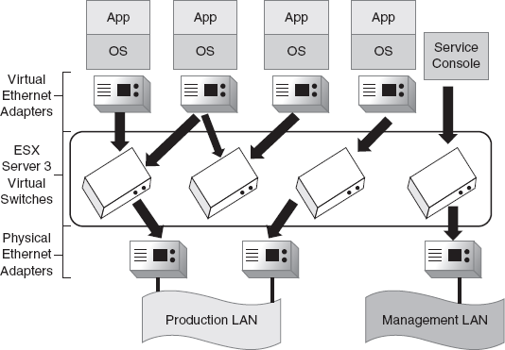

Figure : Network Virtualization

V. UNDERSTANDING NETWORKING IMPLEMENTATION IN LINUX:

There are a number of different protocols that can be used to communicate on a network, but UNIX (and therefore Linux) has historically preferred the TCP/IP protocol set. Linux is ecumenical, though; it can also communicate with Microsoft Windows, Novell Netware and Mac OS through their respective native protocols. This class, however, will concentrate on TCP/IP and leave the others for another time.

Network Interface: Like most things in UNIX, network interfaces are treated as files under the /dev directory. Unfortunately, you can't just cat network devices and expect predictable results; there are special commands for working with them. The first network device we'll discuss is lo, the loopback device. It is used for testing purposes and for accessing servers running on the local machine. That's handy when you want to use software that works with a Web or database server, but you don't want it accessible by everyone on the Internet.

Network Configuration:
When you install most distributions of Linux, the installer detects the first Ethernet card and asks you for configuration information. If you have more than one Ethernet/wireless card, you'll have to add and configure the subsequent cards manually. In Red Hat Linux you can configure networking either by editing the configuration files manually, or with the Network Administration Tool, system-config-network. Be warned, however, that using system-config-network will overwrite the configuration files you've edited by hand, so if you have anything special you've done (for whatever reason) it will be lost.

Network Configuration Files:

/etc/sysconfig/network
--Basic information about the computer; whether or not networking is on and the hostname

/etc/sysconfig/network-scripts/ifcfg-iface
--Configuration information for interface iface, plus ifup and ifdown scripts

/etc/hosts
--IP numbers for “special” machines
/etc/resolv.conf
--Info on domain name servers and search domains

The file /etc/sysconfig/network determines whether or not networking is on and what device acts as the network gateway. (It's possible to have multiple gateways, but this is beyond the scope of this class.) In this example, eth0 is the network connection. Somewhere on the subnet the gateway device is connected to is a gateway router, which must be specified here. At ISU the router's IP address usually has the final number 254, but this is a convention rather than a requirement

/etc/sysconfig/network-scripts
--Configurations for the different network interfaces are located in /etc/sysconfig/network-scripts/ifcfg-iface
--The scripts ifup and ifdown can be used to start and stop interfaces:
1.ifup interface
2.ifdown interface
-Changes to these configurations can be done manually or with the Network Configuration tool (system-config-network).

The manual procedure for modifying network settings is as follows:
- Make changes to the appropriate
/etc/sysconfig/network-scripts/ifcfg-iface file;
- Type /sbin/ifdown iface to shut down the interface.
- Type /sbin/ifup iface to restart the interface; the new settings will be read from the configuration file at startup.
The first line of this file, DEVICE=eth0, tells which device the file governs. Whether or not the machine asks for an IP number at startup is determined by the BOOTPROTO variable; here's it's “none”, which means “don't ask for an address, I already have one”. “ONBOOT=yes” means that the interface should be activated during startup.
If you're using a static IP number, you'll have to include the network, the netmask and the IP address in the ifcfg-eth0 file. Notice that this machine is using a private network address.

/etc/hosts:
-- Normally used only on isolated networks without domain name servers, or for those machines you have to be able to connect to even if the DNS isn't available.

On a typical isolated network:

127.0.0.1 localhost.localdomain localhost
192.168.0.1 pavillion
192.168.0.10 duron fileserver
Second names are called aliases
In the beginning everyone on the Internet copied the hosts file, which contained the IP numbers and names of all the machines on the Internet, to their local hosts file. That's not practical any more, but hosts still has a couple of uses. If you have a small, isolated network you can just put the names in the hosts file and not bother with DNS. And if there are machines that you really need to be able to connect to even when DNS isn't available, put those entries in the hosts file. Your machine will always look there first for an IP number, so it can know those addresses even if it can't connect to a domain name server.
Networking Commands
- Hostname: The Hostname command changes the machine name.
- Ifconfig: The ifconfig command can be used to make changes to network configuration without changing the configuration files. This command is common to most Linux distributions, so it will work even if you don't have system-config-network (or X) on the machine.
- Route: route edits the routing tables, determining which interface packets use to get to which network host.
- Ping: If you can't reach a Web or other server, the first test is to determine if the machine is still there. We do that with ping. The ping command sends a “please answer” packet to the machine, which according to the protocol the machine must answer with a response packet. The ping command reports how long it took the machine to respond to each packet. When you have several responses, press {Ctrl/C} and ping will stop pinging and summarize its results
- Host: host returns the DNS information about a domain name or an IP number. The host command can be used to look up a machine's IP number from its domain name or vice versa.
- TraceRoute: The traceroute command can be used to figure out why you can't reach a machine, or why the connection is slow. It shows every router the connection must pass through and how long it took to get a response from it. If you start getting asterisks, you know where the problem is.
- Netstat: Used to determine network connections by and to your machine. In other words its use to determine what machines your computer is connected to (or vice versa) enter the netstat command. You'll probably want to pipe it to more (as in netstat | more) so you can see what is connected.

VI. UNDERSTANDING THE OPEN STACK ARCHITECTURE:

OpenStack is a collection of open source software projects that enterprises/service providers can use to setup and run their cloud compute and storage infrastructure. Rackspace and NASA are the key initial contributors to the stack. Rackspace contributed their "Cloud Files" platform (code) to power the Object Storage part of the OpenStack, while NASA contributed their "Nebula" platform (code) to power the Compute part. OpenStack consortium has managed to have more than 150 members including Canonical, Dell, Citrix etc.
There are 5 main service families under OpenStack
· Nova - Compute Service, Swift - Storage Service, Glance - Imaging Service, Keystone - Identity Service, Horizon - UI Service.
Open Stack Compute Infrastructure (Nova):
--Nova is the Computing Fabric controller for the OpenStack Cloud. All activities needed to support the life cycle of instances within the OpenStack cloud are handled by Nova. This makes Nova a Management Platform that manages compute resources, networking, authorization, and scalability needs of the OpenStack cloud. But, Nova does not provide any virtualization capabil-ities by itself; instead, it uses libvirt API to interact with supported hypervisors. Nova exposes all its capabilities through a web services API that is compatible with the EC2 API of Amazon Web Services.
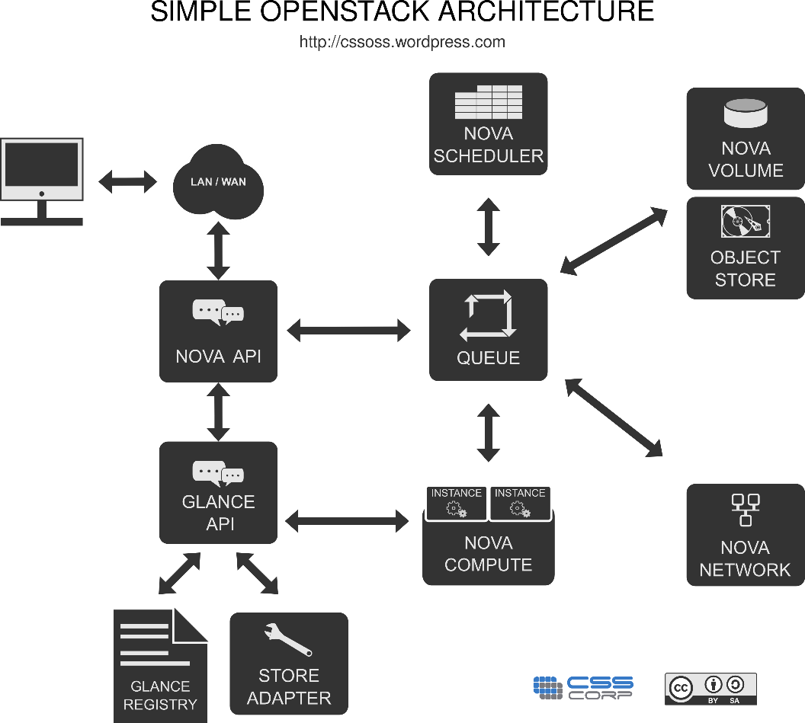

Functions and Features:

· it’s features includes instance life cycle management, Management of compute resources, Networking and Authorization, REST-based API, Asynchronous eventually consistent communication & Hypervisor agnostic.

OpenStack Imaging Service (Glance)

OpenStack Imaging Service is a lookup and retrieval system for virtual machine images. It can be conﬁgured to use any one of the following storage backends:
-Local ﬁlesystem (default)
-OpenStack Object Store to store images
-S3 storage directly
-S3 storage with Object Store as the intermediate for S3 access.
-HTTP (read-only)

OpenStack Storage Infrastructure (Swift):
Swift provides a distributed, eventually consistent virtual object store for OpenStack.

Swift Proxy Server:
The consumers interact with the Swift setup through the proxy server using the Swift API. The proxy server acts as a gatekeeper and receives requests from the world. It looks up the location of the appropriate entities and routes the requests to them. The proxy server also handles failures of entities by rerouting requests to failover entities (handoff entities)

Swift Object Server:
The Object server is a blob store. Its responsibility is to handle storage, retrieval and deletion of objects stored in the local storage. Objects are typically binary ﬁles stored in the ﬁle system with metadata contained as extended ﬁle attributes (xattr).
Note: xattr is supported in several ﬁle systems such as ext3, ext4, XFS, Btrfs, JFS and ReiserFS in Linux. But it is known to work best under XFS, JFS, ReiserFS, Reiser4, and ZFS. XFS is considered to be the best option.

Swift Container server
The container server lists the objects in a container. The lists are stored as SQLite ﬁles. The container server also tracks the statistics like the number of objects contained and the storage size occupied by a container.

Swift Account Server
The account server lists containers the same way a container server lists objects
.
OpenStack Identity Service (Keystone):
Keystone provides identity and access policy services for all components in the OpenStack family. It provides authentication and authorization for all components of Open Stack.
Keytone provides two ways of authentication. One is username/password based and the other is token based. Apart from that, keystone provides the following services:

· Token Service (that carries authorization information about an authenticated user)
· Catalog Service (that contains a list of available services at the users’ disposal)
· Policy Service (that let’s keystone manage access to speciﬁc services by speciﬁc users or groups).

Openstack Administrative Web-Interface (Horizon):

Horizon the web based dashboard can be used to manage /administer OpenStack services. It can be used to manage instances and images, create keypairs, attach volumes to instances, manipulate Swift containers etc. Apart from this, dashboard even gives the user access to instance console and can connect to an instance through VNC
Overall, Horizon features the following:
· Instance Management - Create or terminate instance, view console logs and connect through VNC, Attaching volumes, etc.
· Access and Security Management - Create security groups, manage keypairs, assign ﬂoating IPs, etc.
· Flavor Management - Manage different ﬂavors or instance virtual hardware templates.
· Image Management - Edit or delete images.
· View service catalog.
· Manage users, quotas and usage for projects.
· User Management - Create user, etc.
· Volume Management - Creating Volumes and snapshots.
· Object Store Manipulation – Create & deletes containers .
· Downloading environment variables for a project.

VII. CONCLUSION

In this report, much of the work has been focused on the Linux OS basics, Python, Linux networking and essential components of the clouds, along with the cloud services like SaaS, PaaS, and IaaS. From this independent study, I was able to gain a better understanding of where Cloud Computing fits in the overall scheme of software engineering and the solutions it provides along with basic understanding of Linux and its implementation. By the end of this study, I was able to be able to understand the possibilities for the future of Cloud Computing.

REFERENCES

- https://en.wikibooks.org/wiki/Linux_Networking\
- https://www.youtube.com/watch?v=PEa1xopeufQ
- http://www.tldp.org/HOWTO/NET3-4-HOWTO.html
- http://www.yolinux.com/TUTORIALS/LinuxTutorialNetworking.html
- http://www.tldp.org/LDP/nag2/nag2.pdf
- http://www.linuxfoundation.org/collaborate/workgroups/networking/group
- http://docs.aws.amazon.com/AWSEC2/latest/UserGuide/enhanced-networking.html
- Linux Networking services/ Iowa State University/ it services.
- http://www.openstack.org/ - Main site
- • http://docs.openstack.org/trunk/openstackcompute/admin/content/ch_getting-started-with-openstack.html
- • http://docs.openstack.org/trunk/openstack-compute/admin/bkcompute-adminguide-trunk.pdf
- • http://www.openstack.org/software/start/ - How To Get Started
- With OpenStack
- -https://cssoss.files.wordpress.com/2012/05/openstackbookv3-0_csscorp2.pdf
- https://github.com/mseknibilel/OpenStack-Folsom-Installguide/blob/master/OpenStack_Folsom_Install_Guide_WebVers
- ion.rst - OpenStack Folsom Install Guide
- http://www.packtpub.com/openstack-cloud-computingcookbook/book
- OpenStack Cloud Computing Cookbook
- http://www.openstack.org/blog/tag/training/ -
- OpenStack Architecture Design Guide
- http://www.lulu.com/us/en/shop/openstackfoundation/openstack-architecturedesignguide/paperback/product-21758529.html

