* **Part :1**

#include <stdio.h>

#include <stdlib.h>

#include <math.h>

int counter=0;

int arrayA[48],arrayB[48],C0[48],C1[48],Ci1[48],Ci0[48];

int i,j,k, l, m,n;

int numberofbits;

int delay;

int main()

{

printf("Enter Number of Bits : ");

scanf("%d", &numberofbits);

if((numberofbits>2)&&(numberofbits<=48))

{

for(k=0;k<1000;k++)

{

printf("enter the operand A");

for(i=0;i<numberofbits;i++)

{

arrayA[i]=rand()%2;

}

C0[numberofbits]=0;

Ci0[numberofbits]=0;

Ci1[0]=1;

C1[0]=1;

printf("enter the operand B");

for(i=0;i<numberofbits;i++)

{

arrayB[i]=rand()%2;

}

while(counter<numberofbits)

{

delay++;

for(j=0;j<numberofbits;j++)

{

Ci1[j+1]=(arrayA[j]&arrayB[j])|(C1[j]&(arrayA[j]^arrayB[j]));

Ci0[j+1]=(((~arrayA[j])&(~arrayB[j]))|(C0[j]&(arrayA[j]^arrayB[j])))+2;

printf("Ci1[%d] = %d\n", j, Ci1[j]);

printf("Ci0[%d] = %d\n", j, Ci0[j]);

for(l=0;l<numberofbits;l++)

{

if(((C1[l])^(C0[l]))==1)

{

counter++;

}

else

{

counter=0;

}

}

C1[j]=Ci1[j];

C0[j]=Ci0[j];

printf("C1[%d] = %d\n", j, C1[j]);

printf("C0[%d] = %d\n", j, C0[j]);

}

printf("Counter = %d \n", counter);

}

printf("\nThe carry out c1 is ");

for(n=0;n<numberofbits;n++)

{

printf("%d", C1[n]);

}

printf("\nThe carry out c0 is");

for(m=0;m<numberofbits;m++)

{

printf("%d",C0[m]);

}

printf("\nTotal delay = %d ", delay*2);

}

}

else

printf("Enter the correct size of the operands\n");

return 0;

}

* Output:

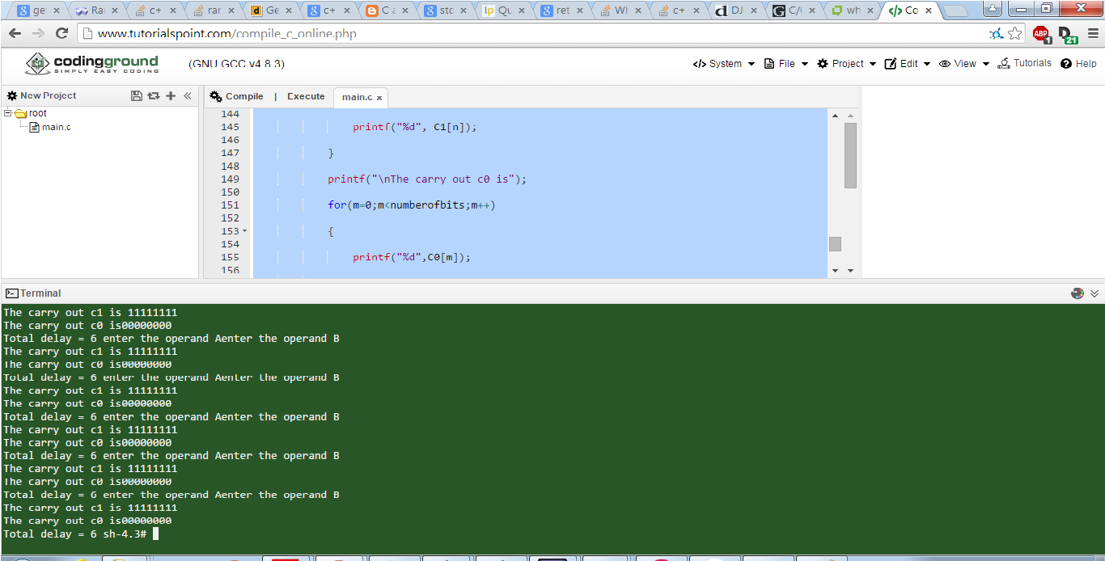

* **Part:2**

#include <stdio.h>

#include <stdlib.h>

#include <math.h>

int counter=0;

int arrayA[48],arrayB[48],C0[48],C1[48],Ci1[48],Ci0[48];

int i,j,k, l, m,n;

int numberofbits;

int delay;

int main()

{

printf("Enter Number of Bits : ");

scanf("%d", &numberofbits);

if((numberofbits>2)&&(numberofbits<=48))

{

//for(k=0;k<1000;k++)

//{

printf("enter the operand A");

for(i=0;i<numberofbits;i++)

{

scanf("%d", &arrayA[i]);

//arrayA[i]=rand()%2;

}

C0[numberofbits]=0;

Ci0[numberofbits]=0;

Ci1[0]=1;

C1[0]=1;

printf("enter the operand B");

for(i=0;i<numberofbits;i++)

{

scanf("%d", &arrayB[i]);

//arrayB[i]=rand()%2;

}

while(counter<numberofbits)

{

delay++;

for(j=0;j<numberofbits;j++)

{

Ci1[j+1]=(arrayA[j]&arrayB[j])|(C1[j]&(arrayA[j]^arrayB[j]));

Ci0[j+1]=(((~arrayA[j])&(~arrayB[j]))|(C0[j]&(arrayA[j]^arrayB[j])))+2;

printf("Ci1[%d] = %d\n", j, Ci1[j]);

printf("Ci0[%d] = %d\n", j, Ci0[j]);

for(l=0;l<numberofbits;l++)

{

if(((C1[l])^(C0[l]))==1)

{

counter++;

}

else

{

counter=0;

}

}

C1[j]=Ci1[j];

C0[j]=Ci0[j];

printf("C1[%d] = %d\n", j, C1[j]);

printf("C0[%d] = %d\n", j, C0[j]);

}

printf("the counter is : %d \n", counter);

}

printf("The carry out c1 is\n");

for(n=0;n<numberofbits;n++)

{

printf("%d\n", C1[n]);

}

printf("The carry out c0 is\n");

for(m=0;m<numberofbits;m++)

{

printf("%d",C0[m]);

}

printf("\nThe total delay is ");

printf("%d\n", delay*2);

//}

}

else

printf("Enter the correct size of the operands\n");

return 0;

}

*************************************************************************

================== OUTPUT =====================

Counter = 100

The carry out c1 is 111110111110000000000000

The carry out c0 is 000001000001111111111111

Total delay = 16

