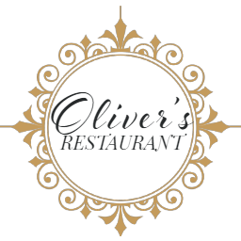

**Lunch Menu**

**Entree**

Calamari fritti coated with rice flour served with salsa verde and lemon garlic aioli

Smoked salmon served with red onion, capers and crème fraiche dressing

Pasta alla Norma, Sicilian eggplant and fresh tomato pasta served with parmesan cheese (V)

Thai fish cake served with lime dressing and mixed salad

**Main**

Fish of the day served with rosti and seasonal vegetable

Pan seared chicken breast served potato, seasonal vegetables & pan juices (g/f)

Sweet potato and pumpkin risotto, peas, parmesan cheese and rocket salad (g/f, v)

Lamb Shank served with mashed potato and vegetables

Porterhouse steak with potatoes and red wine jus

**Sides and Salads $ 9.00**

Green beans, marinated feta, toasted almonds **V**

Garden salad with house dressing

Tuscan spiced homemade chips with aioli

**Dessert**

Panna Cotta with Strawberry Rhubarb Compote

Sticky date pudding topped with butter scotch sauce and vanilla bean ice cream

Homemade apple strudel served with vanilla ice cream and pistachio anglaise

Lemon tart with Chantilly cream and berry coulis

Trio of ice cream served with vanilla wafer and chocolate sauce