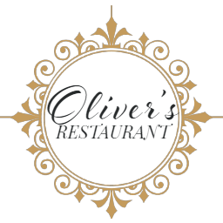Dinner Menu

Entrée

Crispy Fried Calamari with aioli and salad $16.00

Smoked salmon served with red onion, capers and crème fraiche dressing $16.00

Heirloom tomato, goat cheese and spinach tart with capsicum coulis and salad (v) $15.00

Thai fish cakes with tomato and lime salsa and pickled cucumber $18.00

Pasta alla Norma, Sicilian eggplant and fresh tomato pasta with parmesan cheese (V) $18.00

Main

Black Angus steaks served with seasonal vegetables, Italian potatoes & red wine jus

Your choice of:

Eye fillet 200 g $40.00

Porterhouse 220 g $38.00

Fish of the day served with rosti and seasonal vegetable $34.00

Sweet potato and pumpkin risotto, peas, parmesan cheese and rocket salad (g/f, v) $34.00

Pan seared chicken breast served potato, seasonal vegetables & pan juices (g/f) $34.00

Sides and Salads $ 9.00

Green beans, marinated feta, toasted almonds (v)

Garden salad with house dressing

Tuscan spiced homemade chips with aioli

Dessert $12.00

Panna Cotta with Strawberry Rhubarb Compote

Home made apple strudel served with vanilla ice cream and pistachio anglaise

Lemon brulee tart with Chantilly cream and berry coulis

Trio of ice cream served with vanilla wafer and chocolate sauce

Trio of Australian cheese with crackers and dry fruit $18.00