**Synopsis:**

This android application **(World Covid-19 Status app)** is used to display global covid-19 pandemic status information like total confirmed cases, total deaths, total recovered, new deaths, new recovered patients. It also displays any country specific information based on country selected in settings page. User can set the country to see information related to any specific country.

**UI Layout Design:**

**MainActivity UI Layout Design**

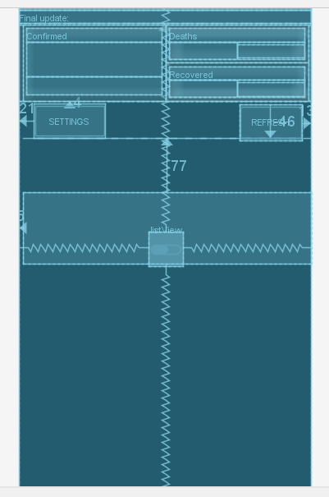

**Settings Screen UI Design Layout**

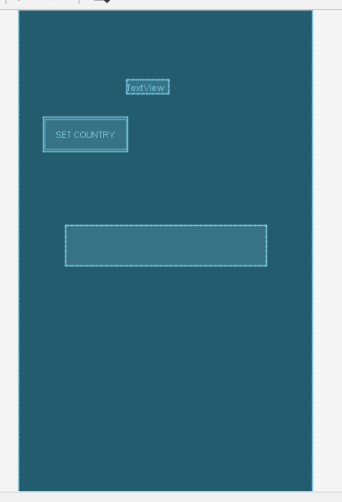

**Project Structure:**

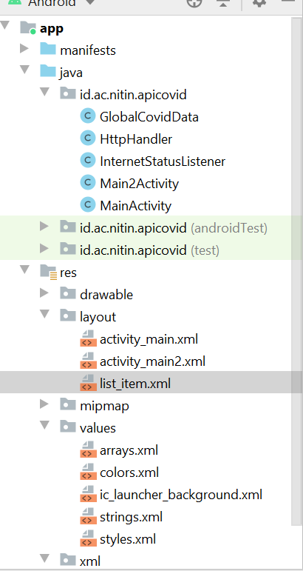

**Major Components Description:**

|  |  |
| --- | --- |
| **File** | **Description** |
| MainActivity | Launcher Main Activity |
| Main2Activity | Settings Activity |
| InternetStatusListner | Dynamic Broadcast Receiver to check connectivity status |
| HttpHandler | HTTP class to fetch json data and convert to string |
| GlobalCovidData | Class for storing global covid-19 info like total confirmed cases, total deaths, total recovered etc. |
| Activity_main.xml | Layout File for MainActivity screen |
| Activity_main1.xml | Layout File for Settings Activity screen |

**Features Used:**

1. **AsyncTask** ( To make service call request as async task to fetch global covid info)
2. **Shared Preference** (To save settings country preference and to save online status)
3. **Firebase Cloud Database** (To save global covid data)
4. **Broadcast Receiver** (To check internet connectivity and if connected then only make service call to fetch json data containing covid-19 info)

**Android App Snapshot:**

**Main Launcher Activity:**

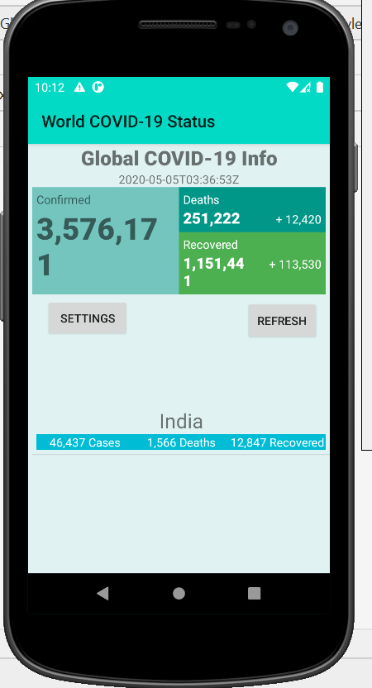

**Settings Activity:**

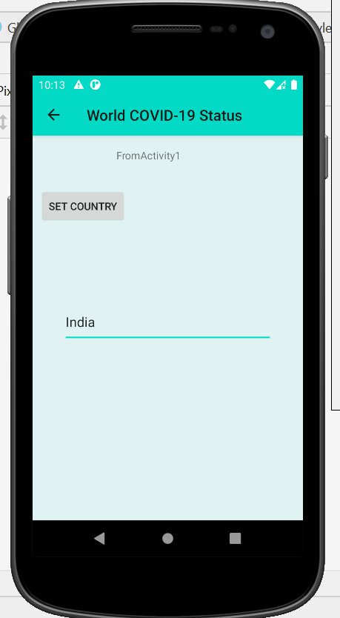

**Progress Bar and Internet Connectivity Status (Online) :-**

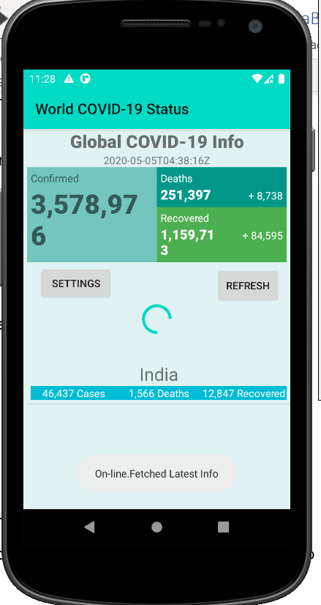

**Internet connectivity Offline Status: -**

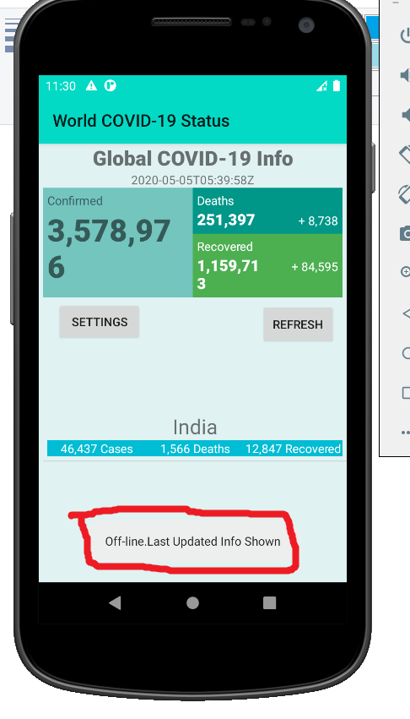

**Firebase Cloud Data (Global Covid Data):**

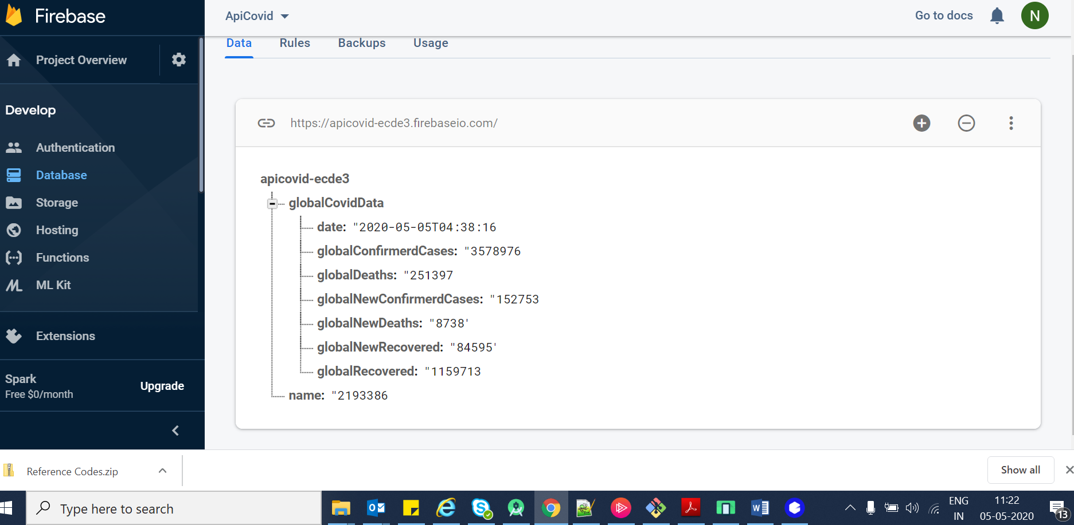

**Android Application Design and Working:**

This Android application main usage is to display global covid-19 information like total confirmed cases, total deaths and total recovered cases. It also displays country specific information.

1. Application makes service call to API endpoint <https://api.covid19api.com/summary> to fetch this data. Service call is made in an **Aysnc Task Function** so that main UI thread is free. **Progress bar** is also shown to the user.
2. HTTP Handler is used to open URL connection and then convert received stream into json string
3. Global Info is fetched from json string and displayed. Also, global information is store into the **Firebase Database.**
4. For Global Info, GlobalCovidData class is defined which contains information like
   1. Global Confirmed Cases
   2. Global New Confirmed Cases
   3. Global Deaths
   4. Global New Deaths
   5. Global Recovered
   6. Global New Recovered
   7. Date
5. Specific country name is fetched from **shared preference** and then information related to only specific country is parsed and displayed on to the screen
6. **List view** is used for displaying country specific info. Currently only one country information is displayed however in incoming json information related to all countries are available and **multiple counties** info can be shown very easily.
7. User can click **Settings** Button on main screen and set the country in the Main2 activity screen.
8. User can also click **Refresh** button to fetch the latest information again by making service call again.
9. **Broadcast Receiver** is defined which will check for internet connectivity and save the online status in **Shared preferences**.
10. While doing Refresh, internet connectivity will be checked and if connected then only service call is made and **Toast message is displayed** for both **offline** and **online** status.

**GitHub Source Code Link for complete app:**

<https://github.com/jnitin/sdpd>

**Summary: -**

Even though application is very simple but fully functional as per assignment. It can be extended very easily to display multiple country list , different countries charts , timeseries data for analytics etc. UI design also can be improved a lot and is very basic. Application source code zip package is attached containing layout files, resource files, string files etc. as required.

**Thanks, and Regards /**

**Name: - Nitin Jain**

**BITS ID: - 2017he12502**