Homework 6
1. Check slide 31 of Function PPT. Develop a program to roll a six sided dice 60,000,000 times and count the time of each face value. The output should be similar as slide 31, each face value should have the same chance.
#include <stdlib.h>
#include <time.h>
#include <stdio.h>

int roll_die(int min, int max) {
return (rand() % (max - min + 1) + min);
}
int roll_dice(int min, int max, int rolls, int *faces) {
for (int i = 0; i < rolls; i++) {
faces[roll_die(min, max) - 1]++;
}
return 1;
}
int output_roll_dice(int min, int max, int rolls) {
srand(time(NULL));
printf("- Rolling die %d times! -\n", rolls);
int num_sides = max - min;
int faces[max - min];
for (int i = 0; i < max - min; i++) {
faces[i] = 0;
}
roll_dice(min, max, rolls, faces);
for (int i = 0; i <= num_sides; i++) {
printf("\nLanded on %d: %d times!", i + min, faces[i]);
}
}
int main() {
output_roll_dice(1, 6 , 60000000);
}

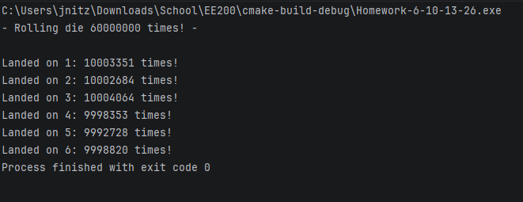

2. Develop a program to play sic bo (Big/Small) gambling game. The dealer roll three six sided dices and get the combination, which should be from 3 to 18. Ask the user to guess big or small. If the combination is <=10, guess small win; If the combination is >=11 guess big win. You can ask user to input 1 for big, 0 for small, it is easier to compare. Play the game 3 times to see if user or the dealer win
#include <stdio.h>
#include <stdlib.h>
#include <time.h>
int get_user_input() {
printf("\nGuess big [1] or small [0]:\n");
int guess;
scanf("%d", &guess);
if (guess != 0 && guess != 1) {guess = -1;}
return guess;
};

int roll_die(int min, int max) {
return (rand() % (max - min + 1) + min);
}
int add_dice(int d1, int d2, int d3) {
printf("The dice are: %d, %d, and %d, which sum up to %d!", d1, d2, d3, d1 + d2 + d3);
return d1 + d2 + d3;
};
int calculate_winner(int guess, int die_sum) {
if (guess && die_sum > 10) {
return 1;
} else {
return 0;
}
}
int game_sic_bo() {
srand(time(NULL));
int guess = get_user_input();
while (guess == -1) {
printf("\nInvalid guess\n");
guess = get_user_input();
}
int sum_die = add_dice(roll_die(1, 6), roll_die(1, 6), roll_die(1, 6));
int winner = calculate_winner(guess, sum_die);
//1: user wins
//2: dealer wins
if (winner == 1) {
printf("\nYou (the user), win!");
} else {
printf("\nYou lose! The dealer wins!");
}
}

int main() {
int num_games = 3;
for (int i = 0; i < num_games; i++) {
game_sic_bo();
printf("\n");
}
}
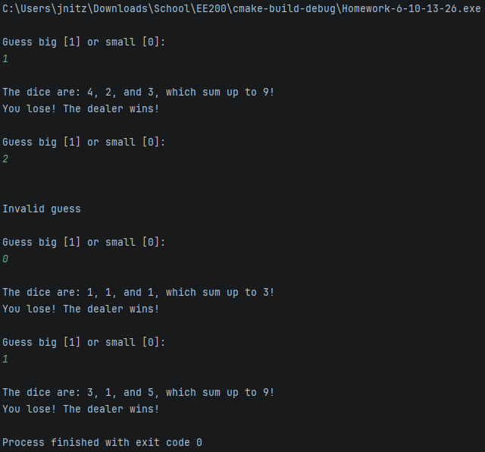

3. The greatest common divisor (GCD) of two integers is the largest integer that evenly divides each of the two numbers. Write a function that returns the greatest common divisor of two integers.
#include <stdio.h>
#include <stdlib.h>
int get_divisors(int num, int* divisors) {
int count = 0;
for (int i = 1; i <= num; i++) {
if (num % i == 0) {
divisors[count++] = i;
}
}
divisors[count] = -1;
return 1;
}
int compare_divisors(int* div1, int* div2) {
int greatest = 1;
int c1 = 0;
int c2 = 0;
while (div1[c1] != -1) {
c2 = 0;
while (div2[c2] != -1) {
if (div2[c2] > div1[c1]) {
break;
}
if (div2[c2] == div1[c1]) {
greatest = div2[c2];
}
c2++;
}
c1++;
}
return greatest;
}

int get_greatest_common_divisor(int n1, int n2) {
int *divisors_1 = malloc(sizeof(int) * 1600);
int *divisors_2 = malloc(sizeof(int) * 1600);
get_divisors(n1, divisors_1);
get_divisors(n2, divisors_2);
int greatest_divisor = compare_divisors(divisors_1, divisors_2);
printf("\nThe greatest common divisor of %d and %d is %d!", n1, n2, greatest_divisor);
}

int main() {
get_greatest_common_divisor(18, 63);
}
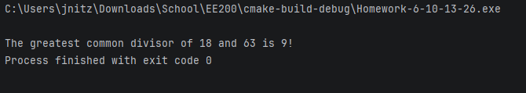

4. Develop a program to predict someone’s love life based on the birthday of the user, and the card the user draws.
int get_bday_sum() {
int day, month, year;
printf("\nEnter the year you were born: ");
scanf("%d", &year);
printf("\nEnter the month you were born (1-12): ");
scanf("%d", &month);
printf("\nEnter the day you were born: ");
scanf("%d", &day);
return (day + month + year);
};
int seed_random(int seed) {
srand(seed);
};
int gen_card_val() {
return (rand() % 13 + 1);
};
int check_rules(int sum, int face_val) {
switch ((sum + face_val) % 2) {
case 0:
(sum % 2 == 0) ? printf("The one is already around"): printf("Very hard");
break;
case 1:
(sum % 2 == 0) ? printf("Late spring"): printf("The one will appear soon");
break;
default:
break;
}
};
int predict_love_life() {
int sum = get_bday_sum();
seed_random(sum);
int card = gen_card_val();
check_rules(sum, card);
}
int main() {
predict_love_life();
}
