Homework 5
- For the following 4 statements, list all the values of J which enable the execution of the statements in for loop body:
for (int j = 2; j <= 17; j += 3) {…}

j = 2, 5, 8, 11, 14, 17

for (int j = 2; j <= 17; j += 3) {
j=j+1;
…
}
j = 2, 6, 10, 14

for (int j = 10; j >= 0; j -= 3) {…}

j = 10, 7, 4, 1

for (int j = 10; j >= 0; j -= 3) {
j=j+1
…
}

j = 10, 8, 6, 4, 2

- Print out the following table using nested loop.
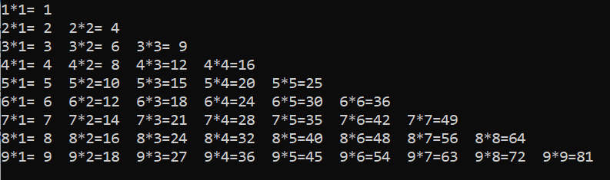
#include <stdio.h>
static int print_multiplication_table() {
for (int i = 1; i < 10; i++) {
for (int j = 1; j < i + 1; j++) {
int result = i * j;
printf("%d * %d = %d ", i, j, result);
}
printf("\n");
}
return 1;
}
int main() {
print_multiplication_table();
}
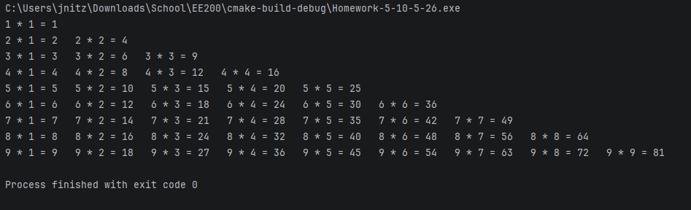
- Develop a guess number game. Generate a random number ask the user to guess. Using rand function to generate the number.
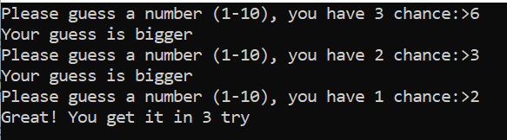
#include <stdio.h>
#include <stdlib.h>
#include <time.h>
static int guessing_game() {
bool running = true;
int num_set;
int num_guess;
int chances = 3;
int guesses = 0;
int max_num = 10;
int min_num = 1;
srand(time(NULL));
printf("A random integer has been chosen (%d - %d)! You have %d chances remaining to guess it!\n", min_num, max_num, chances - guesses);
num_set = (rand() + min_num) % max_num;
while (running) {
printf("\nGuess the integer: \n");
scanf("\n%d", &num_guess);
guesses++;
//yes I know this is a lazy check method, it was just convenient
if (guesses == chances && num_set != num_guess) {
printf("\nThe number was %d! You failed to guess it in %d guesses!", num_set, chances);
return 0;
}
if (num_guess < num_set) {
printf("The number guessed (%d) is less then set integer", num_guess);
} else if (num_guess > num_set) {
printf("The number guessed (%d) is greater then set integer", num_guess);
} else {
printf("Correct! The number was %d! It took you %d guesses!", num_set, guesses);
running = false;
}
}
return 0;
}
int main() {
guessing_game();
}
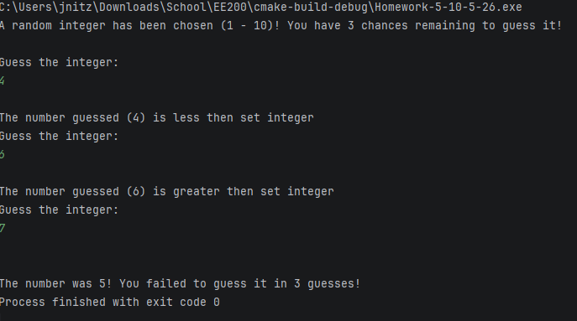
- Develop a function that can convert temperature degree from C to F. Print out the C to F conversion table, using two digit after decimal point
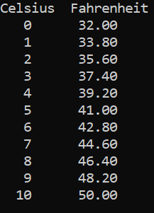
#include <stdio.h>
static double convert_celsius_to_fahrenheit(double celsius) {
return (celsius * 9.0/5.0 + 32);
}
static void celsius_to_fahrenheit(int max) {
int celsius = 0;
printf("Celsius Fahrenheit");
for (;celsius < max; celsius++) {
printf("\n %d %.2f", celsius, convert_celsius_to_fahrenheit(celsius));
}
}
int main() {
celsius_to_fahrenheit(10);
}

