The Fast and the Spurious: A Causal Evaluation of NYPD’s Pursuit Policy, 2022–2025
John Hall
Justin Nix
2026-09-09
Abstract
Objectives: This study examines the consequences of the New York City Police Department’s late-2022 operational shift that sharply expanded vehicle pursuits without a formal policy change. We evaluate whether the surge in pursuits affected motor vehicle collisions, robberies, and shootings, and whether any crime-prevention benefits offset the associated collision costs. Methods: For collision outcomes, interrupted time series (ITS) segmented regression provides direct causal estimates. For crime outcomes, where within-city trends may reflect national forces, we triangulate across a city-level ITS, a generalized synthetic control comparing New York with large U.S. cities, a test of whether crime rose after the February 2025 re-restriction, and descriptive borough- and precinct-level comparisons of where any decline was concentrated. A cost-benefit analysis estimates the threshold of prevented shootings needed for pursuit escalation to break even. Results: Monthly pursuits rose from roughly eight to a peak above 200. Pursuit-related collisions increased proportionally with pursuit volume across all four policy regimes and declined sharply following the February 2025 policy re-restriction. The collision result is the paper’s one causally identified estimate. Crime outcomes provide no evidence of deterrence. The generalized synthetic control finds NYC’s post-2022 shooting trajectory statistically indistinguishable from the national counterfactual, and robbery, if anything, rose relative to comparable cities. The February 2025 reduction in pursuits was not followed by any increase in crime. Descriptive within-city comparisons align: the shooting DiD rests on non-parallel pre-trends, and the robbery DiD runs opposite to deterrence. Conclusions: Pursuit escalation produced clear and attributable collision harms while providing no credible evidence of crime reduction. Cost-benefit estimates suggest the threshold of prevented shootings required to offset these harms was not achieved. Agencies should require affirmative evidence of crime-prevention benefits before expanding pursuit authority.

Introduction
Vehicle pursuits are among the most dangerous activities in American policing. From 2009 to 2023, pursuit-related crashes in the United States killed an average of 423 people per year, and roughly one-third of those killed were bystanders with no involvement in the chase (Rivara and Mack 2004; Hendrix et al. 2026). Adjusting for population and overall crash volume, pursuit fatality risk rose approximately 2% annually over that period, and deaths cluster in identifiable settings — urban areas, nighttime hours, and non-interstate roads (Hendrix et al. 2026; see also Alpert and Anderson 1986; Hill 2002). Police departments have been writing and rewriting pursuit policies for decades, under substantial public pressure and with remarkably little empirical guidance (Alpert et al. 1997b; Hicks 2003).
Despite the stakes, empirical evidence on the effects of pursuit policy changes remains thin. Case studies show that pursuit frequency responds sharply to policy, but none has rigorously estimated the resulting effects on crime, collisions, and public safety using modern causal methods. The question that Rivara and Mack (2004) posed two decades ago — whether “the trade-off of fewer pursuit-related crashes and deaths [is] offset by a higher number of fatal crimes” — remains unanswered.
The New York City Police Department’s experience beginning in late 2022 offers a rare opportunity to address this question. Under Mayor Eric Adams’s quality-of-life enforcement mandate and new Chief of Patrol John Chell, the NYPD dramatically escalated its use of vehicle pursuits without any formal revision to the department’s written Patrol Guide procedure on pursuits. Monthly pursuits rose from an average of eight before the escalation to more than 200 at their peak, a 25-fold increase. Two further policy changes followed. In August 2023, Chief of Department Jeffrey Maddrey issued a compliance memo, and in February 2025, Commissioner Jessica Tisch formally revised the policy to permit pursuits only for felonies and violent misdemeanors. The result is a multi-phase natural experiment in which pursuit intensity varied dramatically across distinct policy regimes within a single jurisdiction.
We exploit this variation to estimate the effects of pursuit escalation on motor vehicle collisions, robberies, and gun violence. For collision outcomes, the causal pathway is direct and theoretically unambiguous: more pursuits create more collision risk. An interrupted time-series (ITS) model provides well-identified causal estimates. The collision finding is the paper’s primary causal contribution.
Crime outcomes pose a harder identification problem because within-city trends may reflect secular forces unrelated to pursuit policy. We therefore triangulate across city- and borough-level time-series analyses, a precinct-level heterogeneity design, and a national comparison. We also examine whether crime increased after the February 2025 restriction sharply reduced pursuits, providing an internal test of the deterrence mechanism.

Background

Vehicle Pursuit Policy in American Policing
Police vehicle pursuits have been a subject of scholarly and legal scrutiny since the mid-1980s, when Alpert and Anderson (1986) described the police vehicle as “the most deadly force” in an officer’s arsenal. Despite the risks, pursuit policy remained largely unregulated through the early 1980s, with most departments permitting officers broad discretion to initiate and continue pursuits (Kennedy et al. 1992). The first wave of reform resulted from mounting civil liability under 42 U.S.C. § 1983, which exposed departments to lawsuits when pursuits resulted in injuries to bystanders or suspects (Alpert et al. 1997a; O’Connor and Norse 2005).
By the late 1990s, pursuit policies had coalesced around three general types (Alpert et al. 1997b; Kenney and Alpert 1997). Judgmental policies grant officers wide discretion to engage in pursuits based on their assessment of the situation. Restrictive policies limit pursuits to specific offense categories (typically violent felonies) and impose conditions related to speed, traffic density, and weather. Discouragement policies formally permit pursuits but establish a strong institutional presumption against them, coupled with mandatory supervisory review and potential discipline. A 1997 national survey of 436 agencies found that 48% had revised pursuit policies within the preceding two years (87% toward greater restrictions), yet variation persisted. Some agencies reported zero annual pursuits, others over 800 (Kenney and Alpert 1997).
The literature describes a consistent pattern. Pursuits usually involve young men fleeing traffic stops or stops involving stolen vehicles. They tend to occur at night on local roads, last less than five minutes, and end when the driver stops, the officer terminates the pursuit, or a crash occurs (Alpert and Dunham 1988, 1989; Crew and Hart 1999; Hoffmann and Mazerolle 2005). An estimated 20–40% end in a crash, 12–41% result in injury, and about 1% result in death (Alpert and Dunham 1988; Kenney and Alpert 1997). Between 1994 and 2002, Rivara and Mack (2004) documented 2,654 fatal pursuit-related crashes in the United States (an average of 295 per year) resulting in 3,146 deaths. Of these, 1,048 (33.3%) were occupants of vehicles entirely uninvolved in the pursuit or pedestrians and cyclists. More recent national data show no improvement. Using Fatality Analysis Reporting System (FARS) records from 2009 through 2023, Hendrix et al. (2026) identified 5,425 fatal pursuit crashes and 6,352 deaths, or about 423 deaths per year. After accounting for population growth and overall crash frequency, they found that fatality risk rose by roughly 2% each year. The South had the highest rate and the Northeast the lowest. Fifty-seven percent of fatal crashes occurred in urban areas, and 70% occurred at night.
The Police Executive Research Forum (PERF), the National Highway Traffic Safety Administration (NHTSA), and the Justice Department’s Office of Community Oriented Policing Services (COPS Office) recently distilled this research into 65 recommendations (Police Executive Research Forum 2023). The report’s central principle is that pursuit policy should balance the risk of immediate apprehension failure against the danger to officers, suspects, and uninvolved bystanders. PERF’s recommended default standard, which limits pursuits to violent crimes and situations posing an imminent threat to public safety, follows the restrictive model that emerged from the liability-driven reforms of the 1990s while placing it within an explicit risk-management framework.
The offense triggering a pursuit often does not justify the risks incurred. Hoffmann and Mazerolle (2005), for example, found that “very few apprehended drivers were charged with crimes more serious than what was known at the time the pursuit was initiated.” However, Alpert and Dunham (1988) remind us that while it is true many pursuits begin with traffic violations, a nontrivial share of apprehended suspects are subsequently charged with serious felonies unrelated to the pursuit itself. This suggests that pursuits sometimes uncover criminality that would not otherwise have been detected, albeit at substantial cost.

Theory and Evidence: Two Channels
Pursuit policy operates through two channels that differ in the strength of the causal claim each supports. Collisions follow mechanically from pursuit volume. Crime effects, by contrast, materialize only if pursuit escalation actually changes offender behavior — a harder identification problem, since within-city crime trends may reflect secular forces unrelated to pursuit policy. The theoretical mechanisms, the evidence base, and the identification burden differ accordingly, and this distinction organizes the discussion below.

The Collision Channel
The argument to constrain officer discretion to pursue emphasizes the potential for collateral harms. Pursuits impose externalities on third parties who were not involved in the precipitating offense. Rivara and Mack (2004) found that 33.3% of pursuit fatalities were occupants of vehicles entirely uninvolved in the pursuit, pedestrians, or cyclists. Hutson et al. (2007) documented similar patterns in a review of pursuit fatalities from 1982 through 2004.
Rigorous evaluation of how pursuit policy shapes this collision channel comes chiefly from a pair of natural experiments in the 1990s. When Dade County, Florida, restricted pursuits to violent felons in 1992, pursuit frequency dropped by 82% and pursuit-related injuries decreased, with no observed increase in crime rates or the number of suspects fleeing from police (Alpert and Madden 1994; Hoffmann and Mazerolle 2005). Conversely, when Omaha, Nebraska, relaxed its pursuit policy in 1993, pursuit frequency increased by over 600% (Alpert et al. 1997a). These cases are suggestive, but they predate modern causal inference methods and lack rigorous comparison groups.
Recent evaluations have added more systematic evidence, including several pre-/post-test designs. The Policing Project at New York University School of Law et al. (2021) conducted a formal cost-benefit analysis of policy changes in two Virginia jurisdictions, finding that Roanoke County’s 2013 adoption of a restrictive policy reduced pursuit frequency and harm without measurable crime increases, while arrest rates for serious offenses were unchanged. Hosking (2021) examined two waves of reform in Queensland, Australia, documenting that restrictive policies reduced pursuit-related injuries without generating the crime consequences that critics predicted, though initial officer resistance weakened implementation. Butler (2018) found that Milwaukee’s 2017 policy liberalization led to a 155% increase in pursuits the following year, accompanied by a rise in pursuit-related collisions. Rivara et al. (2025) studied pursuit outcomes in 64 Washington State agencies from 2019 through 2024. Pursuits often began with traffic violations and posed substantial injury risk. Because the state tightened its rules in 2021–2022 and partially reversed them in 2024, the study period spans several enforcement environments. Aronie and Alpert (2020) synthesized the cumulative evidence to argue that the data “strongly favor a restrictive pursuit policy,” noting that approximately 91% of pursuits are initiated for non-violent offenses and roughly 30% result in a crash. The evidence thus establishes the direction of the relationship. Policy affects pursuit volume, and pursuit volume affects harm. The question for the present study is how precisely those effects can be estimated.

The Crime Channel
The case for broader pursuit authority rests primarily on deterrence theory. General deterrence holds that the credible threat of apprehension discourages potential offenders from fleeing and, more broadly, from committing crimes likely to bring them into contact with police (Senese and Lucadamo 1996). Specific deterrence holds that apprehended and sanctioned offenders are less likely to reoffend, having experienced the costs of criminal activity firsthand. Incapacitation provides a related but distinct mechanism. Arrest and detention temporarily remove suspects from the offending population, reducing crime during the period of confinement. Because pursuit escalation raises the perceived certainty of apprehension without altering sanction severity, it acts on precisely the margin the deterrence literature identifies as most likely to produce a behavioral response (Nagin 2013; Chalfin and McCrary 2017). A null on this margin is therefore more informative than a null on severity would be.
Three complications qualify these mechanisms. First, deterrence through pursuit requires that potential offenders are aware of the prevailing policy and update their behavior accordingly. While formal policy changes may receive limited public attention, a visible, sustained increase in vehicle pursuits may communicate enforcement intensity through experiential channels even without formal announcements (Homant et al. 1994). Second, the deterrence benefit of pursuits depends critically on the apprehension rate. If pursued suspects frequently escape, as they do in roughly 30% of cases (Alpert and Dunham 1988), the deterrence signal is weakened. Third, deterrence theory assumes rational calculation by offenders, yet the population of fleeing drivers is disproportionately young, male, intoxicated, and unlicensed (Rivara and Mack 2004), characteristics associated with impaired risk assessment.
Only a handful of studies have examined how pursuit policies affect crime. Hicks (2006) surveyed state-level pursuit policies and documented substantial variation in restrictiveness but did not link policy variation to outcomes. Wade (2015) developed a pursuit risk classification system but focused on individual pursuit characteristics rather than policy-level effects. Crew and Hart (1999) attempted a cost-benefit framework for pursuit decisions but lacked the outcome data to conduct a full welfare analysis. Cataloging the 44 empirical pursuit studies conducted since 1970, Alpert and Lum (2014) reached a sobering conclusion: none had examined the effect of restrictive policies on general crime rates. Decades of research have documented pursuit patterns and outcomes without producing causal evidence on the question policymakers actually face.
Across these studies, restrictive policies consistently reduce pursuits and pursuit-related harm. The lack of accompanying crime spikes is suggestive, but it is not causal evidence. Prior work cannot distinguish a policy effect from a coincident secular crime decline. The NYPD’s escalation, stabilization, and re-restriction within three years provide an unusually rich setting in which to address this gap.

The NYPD Policy Change
The NYPD’s pursuit escalation unfolded in three distinct phases. The first began in late 2022, alongside John Chell’s appointment as Chief of Patrol in December and Mayor Adams’s broader emphasis on quality-of-life enforcement. Monthly pursuits increased from 32 in November 2022 to 53 in December and 133 in January 2023, exceeding the combined total for 2018 and 2019. Crucially, no formal change to the department’s written vehicle pursuit procedure (PG 212-39) accompanied this shift. Rather, the increase reflected an enforcement posture emphasizing aggressive pursuit of “ghost cars,” ATVs, and vehicles with illegal plates. By the end of the first quarter of 2023, the NYPD recorded 304 pursuits, a roughly 600% increase over the same period the prior year. Chief Chell publicly defended the surge: “People thinking they can take off on us? Those days are over” (Brosnan 2023).
The second phase began in August 2023, when Chief of Department Jeffrey Maddrey circulated an internal memo reminding officers to follow existing Patrol Guide guidelines and emphasizing that pursuits “must be terminated when risks outweigh the danger of delayed apprehension” (Gonen 2023). The memo listed relevant risk factors (e.g., nature of offense, time of day, weather, population density) and stressed supervisory responsibility and possible discipline for noncompliance. However, it did not narrow the offense categories that could trigger a pursuit. The memo therefore reinforced compliance rather than changing policy. Pursuit volume remained high throughout 2024, with quarterly counts approaching 600.
The third phase began in February 2025, when Commissioner Jessica Tisch implemented the first rewrite of the pursuit procedure since the pursuit surge began. The new policy restricted pursuits to felonies and violent misdemeanors, explicitly excluding traffic infractions, violations, and non-violent misdemeanors. It also protected officers from discipline for good-faith decisions to terminate a pursuit and imposed stricter risk-assessment requirements near homes, schools, and playgrounds. The NYPD reported that 67% of 2024 pursuits began when drivers fled traffic stops, scenarios that would no longer satisfy the revised criteria. Pursuits fell 66% in the first two weeks after implementation.

Data and Methods

Data Sources
We draw on five administrative data series from NYC Open Data. Calls for service records (January 2018 through December 2025) identify pursuit-related radio broadcasts, from which we aggregate monthly pursuit event counts. The ITS analysis window begins January 2018. Motor vehicle collision records (2016 through December 2025) report vehicle-level crash involvement; we collapse to the incident level and identify pursuit-related crashes using the pre-crash condition field, which designates “Police Pursuit” as the precipitating circumstance (an administrative classification applied by officers in the collision reporting system). NYPD complaint data (January 2014 through December 2025) provide monthly robbery complaint counts. NYPD shooting incident data (through December 2025) record victim-level shooting events; we deduplicate to the incident level using unique incident keys. Shots-fired complaints (beginning January 2018) capture incidents of gunfire in which no victim was struck. Table 1 summarizes annual totals for each outcome.

Measures
All variables are measured at the monthly level. Vehicle pursuit events reflect counts of pursuit-related calls for service broadcasts, capturing the treatment itself (pre-escalation mean: 7.7 events/month; post-Maddrey mean: 159.3 events/month). Pursuit-related motor vehicle collisions capture incidents involving vehicles in pursuit situations (pre-escalation mean: 5.5 collisions/month). Robberies are drawn from complaint-level robbery reports (pre-escalation mean: 1,168 complaints/month). Shooting incidents are from victim-level records (pre-escalation mean: 99.4 incidents/month). Finally, total gun violence events reflect the sum of shooting incidents and shots-fired reports (pre-escalation mean: 302 events/month). We focus on robberies and shootings as our primary crime outcomes following both empirical convention and practitioner emphasis. NYPD Chief of Patrol John Chell explicitly linked expanded pursuit enforcement to these outcomes, stating that illegal vehicles “cause street violence — robberies and shootings” (Brosnan 2023).

Analytic Strategy
We use segmented ITS to estimate collision effects. For crime, we combine city- and borough-level ITS, a 77-precinct panel, generalized synthetic control, and the February 2025 reversal. We treat the citywide ITS estimate as an upper bound rather than a causal estimate.

Interrupted Time Series (ITS)
The segmented regression model is estimated on monthly data from January 2018 through December 2025 (Wagner et al. 2002; Bernal et al. 2017):
$$Y_{t}=β_{0}+β_{1}T+β_{2}D_{t}+β_{3}P_{t}+\sum_{m=2}^{12}{γ_{m}}{\text{Month}}_{m}+δ{\text{COVID}}_{t}+ε_{t}$$
where $T$ is a linear time trend (months from start), $D_{t}$ is a binary indicator equal to 1 for months on or after October 2022, $P_{t}$ counts months elapsed since the intervention and equals 0 during the pre-intervention period, ${\text{Month}}_{m}$ terms are seasonal fixed effects, and ${\text{COVID}}_{t}$ flags the pandemic period (March 2020 through June 2021). The coefficient $β_{2}$ captures the immediate level shift at the intervention, while $β_{3}$ captures any change in the post-intervention slope. We estimate Newey-West heteroskedasticity- and autocorrelation-consistent (HAC) standard errors with a lag of 6 months (Newey and West 1987), computed via R’s sandwich package. October 2022 is chosen as the intervention date because pursuit volume began its sustained rise in that month following Mayor Adams’s quality-of-life enforcement mandate and Chief of Patrol Chell’s operational directives; pursuit counts quadrupled from Q3 to Q4 2022 and continued rising through 2023. Sensitivity analyses presented in Appendix B confirm that key estimates are robust to moving the break date across September 2022 through January 2023 (one month before to three months after October 2022).

Borough-Level Interrupted Time Series
To examine within-NYC heterogeneity in crime responses, we estimate the same segmented regression model separately for each of the five NYC boroughs:
$$Y_{bt}=β_{0}+β_{1}T+β_{2}D_{t}+β_{3}P_{t}+\sum_{m=2}^{12}{γ_{m}}{\text{Month}}_{m}+δ{\text{COVID}}_{t}+ε_{bt}$$
where subscripts $b$ and $t$ denote borough and month, respectively. The specification is identical to the city-level ITS model, and Newey-West HAC standard errors are computed with lag = 6 throughout for comparability. Under deterrence, boroughs with larger increases in pursuits should show larger crime declines. We present this comparison and the precinct comparison below as descriptive: as the Results show, the groups being compared are not on parallel pre-treatment trajectories, so neither supports a causal estimate of the pursuit effect.

Precinct-Level Panel Analysis
The policy change created citywide variation in pursuit exposure at the precinct level: when the department shifted enforcement posture in October 2022, which precincts actually used the new pursuit authority, and how intensively, depended on local crime patterns and operational circumstances. We describe this cross-sectional variation with a heterogeneous-effects difference-in-differences (DiD) design using a balanced panel of 77 NYPD precincts over 96 months (January 2018–December 2025; N = 7,392 precinct-months).
Heterogeneous-effects DiD design. We classify precincts into high- and low-crime groups based on their mean monthly crime rate during the pre-October 2022 period, split at the median. The rationale is that precincts with higher pre-treatment crime rates are expected to have had greater tactical incentive to pursue fleeing suspects following the escalation (officers in high-crime areas face more pursuit-eligible situations), so baseline crime rate serves as a proxy for differential pursuit exposure. In the post-escalation period (October 2022–December 2025), high-robbery precincts averaged 1.8 pursuit broadcast events per month (SD = 2.6), compared to 0.9 (SD = 1.5) for low-robbery precincts, approximately twice the pursuit rate, consistent with the proxy assumption. Each outcome uses its own pre-treatment baseline (e.g., the robbery analysis groups precincts by their pre-treatment robbery rate). A supplementary quartile dose-response specification assigns precincts to quartiles Q1–Q4 and tests whether the post-treatment crime change varies linearly across the quartile ranking. The intervention date is October 2022 for all precincts, a common break reflecting the citywide policy change.
The DiD scalar estimate is:
$$Y_{pt}=α_{p}+λ_{t}+β⋅({\text{Post}}_{t}×{\text{HighCrime}}_{p})+ε_{pt}$$
where $α_{p}$ are precinct fixed effects, $λ_{t}$ are month-year fixed effects, and $β$ is the DiD estimate: the excess post-intervention change in crime for high-crime precincts relative to low-crime precincts. Standard errors are clustered at the precinct level (G = 77).
The DiD event study specification replaces the scalar interaction with a set of relative-time interactions:
Ypt=αp+λt+k≠−1​δk⋅1[q(t)−q(t0)=k]×HighCrimep+εpt
where $q(t)=⌊t/3⌋$ maps the monthly time index $t$ to its quarterly bin, $t_{0}=$ October 2022, and $k$ indexes quarterly bins relative to the intervention (each bin aggregates three consecutive calendar months), referenced at $k=−1$ (July–September 2022). The Tisch reversal period (January 2025 onward, with the policy taking effect in February 2025) is pooled into a single lump bin ($k=9$). Pre-period $δ_{k}$ coefficients near zero would confirm that high- and low-crime precincts were on parallel crime trajectories before the policy change, the key identifying assumption for this design. Post-period $δ_{k}$ coefficients trace the divergence between groups over time. Standard errors are clustered at the precinct level (G = 77) throughout.

Event Study / Multi-Period Analysis
We define four policy regimes to examine how outcomes evolved across distinct phases. The first is the pre-escalation period, which spans January 2018 to September 2022 and serves as our baseline. The second is the escalation period from October 2022 through July 2023, when pursuits surged. Third is the post-Maddrey phase, which begins with Chief of Department Jeffrey Maddrey’s compliance memo in August 2023 and runs through January 2025. Finally, the post-Tisch phase begins with Commissioner Tisch’s formal policy rewrite in February 2025 and runs through the end of our study period (December 2025).

Generalized Synthetic Control
We apply the generalized synthetic control method (gsynth; Xu (2017)) to panels of large U.S. cities to provide a national comparison for the shooting and robbery outcomes. The shooting panel uses monthly Gun Violence Archive counts as compiled by Sharkey (2026) (January 2014 through December 2025); the robbery panel uses annual FBI Uniform Crime Reports counts (Kaplan 2025) for the 34 cities with complete 2014–2024 coverage. Gsynth generalizes difference-in-differences by fitting an interactive fixed effects model in which a data-selected number of latent factors load differently across units; when cross-validation selects zero factors, as it does here, the estimator reduces to two-way (unit and time) fixed effects. NYC is the single treated unit; the shooting donor pool excludes 24 cities with documented pursuit policy changes between 2018 and 2024 to avoid violations of the Stable Unit Treatment Value Assumption (SUTVA; see Appendix C for the full exclusion list). The number of latent factors is selected by leave-one-out cross-validation, and inference uses 500 parametric bootstrap iterations. As a robustness check, we replicate the shooting analysis with the full top-50-by-population donor panel (including cities with documented pursuit policy changes), which provides a conservative upper bound on the treatment estimate given the potential SUTVA contamination.

Results

Pursuit Activity
Monthly pursuit events increased sharply following the department’s enforcement posture shift in late 2022. In the pre-escalation period (January 2018–September 2022), the NYPD averaged 7.7 pursuit events per month. Pursuit volume rose to a mean of 87.9 during the initial escalation phase (October 2022–July 2023) and continued climbing to 159.3 per month during the Post-Maddrey period (August 2023–January 2025), as the August 2023 compliance memo reinforced existing procedures without restricting eligible offenses. Annually, pursuit events totaled 1,592 in 2023 and 1,930 in 2024, compared with 214 in 2022 (Table 1). The ITS model estimates an immediate level shift of b₂ = 130.9 events per month (SE = 38.9, p = .00118).
The February 2025 restriction reversed the escalation. Monthly pursuits fell from a pre-Tisch mean of 133.8 to 34.1 (-74.5%), consistent with the department’s disclosure that approximately two-thirds of 2024 pursuits (most initiated when drivers fled traffic stops) would not qualify under the new felony-and-violent-misdemeanor threshold. Figure 1 illustrates pursuit volume across all four policy regimes.
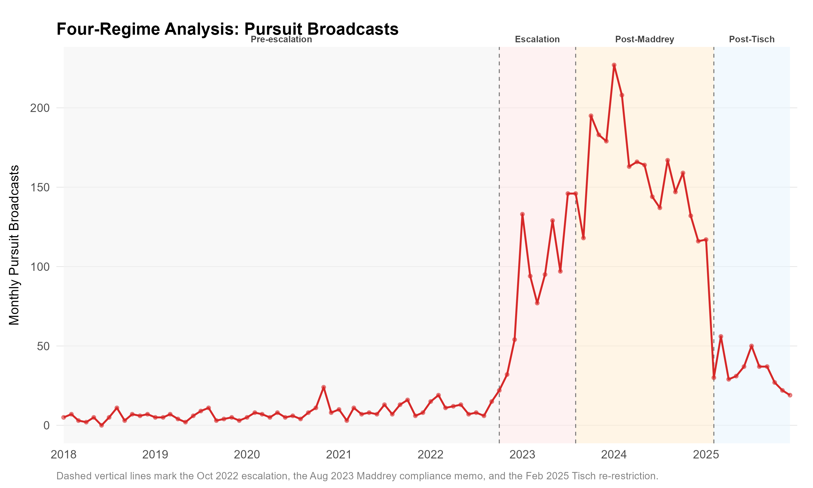
Figure 1: Monthly NYPD pursuit broadcasts across four policy regimes: Pre-escalation (January 2018–September 2022), Escalation (October 2022–July 2023), Post-Maddrey (August 2023–January 2025), and Post-Tisch (February 2025–December 2025). Vertical dashed lines indicate intervention dates.
Table 1 provides annual totals for each outcome across the full study period, offering a pre/post summary of how the key indicators changed alongside the pursuit escalation.
Table 1: Annual Summary of Key Outcomes, 2018–2025
Year | Pursuits | Δ Pursuits | Crashes | Δ Crashes | Robberies | Δ Robberies | Shootings | Δ Shootings | Gun Violence | Δ Gun Violence
2,018 | 61 | — | 58 | — | 12,965 | — | 754 | — | 2,017 | —
2,019 | 64 | +4.9% | 73 | +25.9% | 13,434 | +3.6% | 777 | +3.1% | 2,324 | +15.2%
2,020 | 99 | +54.7% | 69 | -5.5% | 13,187 | -1.8% | 1,532 | +97.2% | 4,479 | +92.7%
2,021 | 109 | +10.1% | 62 | -10.1% | 13,861 | +5.1% | 1,562 | +2% | 5,028 | +12.3%
2,022 | 214 | +96.3% | 84 | +35.5% | 17,439 | +25.8% | 1,294 | -17.2% | 4,162 | -17.2%
2,023 | 1,592 | +643.9% | 318 | +278.6% | 16,922 | -3% | 974 | -24.7% | 3,109 | -25.3%
2,024 | 1,930 | +21.2% | 421 | +32.4% | 16,569 | -2.1% | 904 | -7.2% | 2,917 | -6.2%
2,025 | 492 | -74.5% | 104 | -75.3% | 15,048 | -9.2% | 688 | -23.9% | 2,506 | -14.1%

Pursuit-Related Collisions
Pursuit-related collisions increased substantially following the escalation (see Table 2). The ITS model estimates an immediate level shift of b₂ = 24.6 additional collisions per month (SE = 8.54, p = .00517), with no significant change in the post-intervention slope (p = .306). Prior to the escalation, the NYPD averaged 5.5 pursuit-related collisions per month; this rose to 34.4 per month during the post-Maddrey period, a more than fivefold increase in total crash burden. Although the per-pursuit crash rate fell from 71.5% to approximately 21.6% as lower-risk pursuits were added, the absolute collision toll increased substantially given the scale of the volume increase. The pre-escalation per-pursuit crash rate may also partly reflect administrative underreporting in earlier periods when pursuit tracking was less systematic, which would make the observed decline appear steeper than the underlying behavioral shift.
The per-pursuit rate decline reflects a compositional shift, not reduced harm. Pre-escalation pursuits were heavily selected (only situations serious enough to overcome institutional norms) and consequently ended in collisions at an elevated rate. As volume expanded after October 2022, the marginal pursuit increasingly involved lower-risk situations: fled traffic stops, ATV operators, vehicles with illegal plates. These added pursuits carry lower per-event crash probability, pulling the average rate down. The policy question turns on aggregate harm: a rate of 21.6% applied to approximately 2,867 Post-Maddrey pursuits generates far more collisions than 71.5% applied to approximately 439 pre-escalation pursuits.
The multi-period event study corroborates this pattern closely. Collision counts trended upward throughout the escalation phase (b = 1.58 per month, p = .00486), jumped at the start of the Post-Maddrey period (b = 17.1, p < .001), and declined sharply following the February 2025 restriction (b = -15.2, p < .001). This close correspondence across all four policy regimes is consistent with a direct causal mechanism.

Crime Outcomes
We next examine whether the escalation reduced crime. The city-level interrupted time series and the national synthetic-control comparison, presented here, provide no evidence that the escalation reduced crime relative to the counterfactual; the re-restriction test and the community-level comparisons that follow point the same way.

City-Level Interrupted Time Series
During the pre-intervention window, shooting incidents were trending upward at b₁ = 1.3 incidents per month (p < .001); the counterfactual projection continues this upward trajectory, so the post-intervention estimates reflect deviations from an already-rising baseline. Shooting incidents declined relative to this counterfactual: the ITS estimates an immediate level shift of b₂ = -32.7 incidents per month (SE = 8.82, p < .001), with the post-intervention trend shifting further downward relative to the pre-intervention trend (b₃ = -2.36 per month, p < .001). Aggregate gun violence (shootings plus shots-fired reports) declined similarly, with an immediate level shift of b₂ = -131.5 (p < .001) and a comparable downward shift in the post-intervention trend (b₃ = -7.6 per month, p < .001).
Table 2: Interrupted Time Series Estimates (Newey-West HAC Standard Errors, Lag = 6)
Outcome | Term | Estimate | % of Baselineª | 95% CI | p-value
Pursuits | Level shift | 130.9** | +1700.5% | [54.7, 207.2] | .00118
Pursuits | Slope change | -2.1 | -26.8% | [-5.3, 1.2] | .21452
Collisions | Level shift | 24.6** | +446.5% | [7.8, 41.3] | .00517
Collisions | Slope change | -0.4 | -6.9% | [-1.1, 0.3] | .30632
Robberies | Level shift | -7.7 | -0.7% | [-133.7, 118.2] | .90447
Robberies | Slope change | -13.5*** | -1.2% | [-17.4, -9.6] | < .001
Shootings | Level shift | -32.7*** | -32.9% | [-50, -15.4] | < .001
Shootings | Slope change | -2.4*** | -2.4% | [-2.9, -1.8] | < .001
Gun Violence | Level shift | -131.5*** | -43.5% | [-197.3, -65.6] | < .001
Gun Violence | Slope change | -7.6*** | -2.5% | [-9.5, -5.7] | < .001
ªEstimate as a percentage of the pre-escalation monthly mean for that outcome.
Robbery showed no immediate change (b₂ = -7.7, p = .904), but the post-intervention trend shifted sharply downward relative to the pre-intervention trend (b₃ = -13.5 per month, p < .001), indicating a gradual trajectory shift. The 2022 pre-intervention robbery trend itself reflected the post-COVID normalization noted above and was not uniform across the city, which shapes the pre-period baseline against which the ITS projects forward. Intervention date sensitivity analyses confirm that the key estimates are robust to moving the treatment date from one month earlier to three months later (September 2022 through January 2023). Pre-period placebo tests (within-NYC temporal placebos) produce no comparable signals, ruling out spurious detection within the analysis window; these tests do not, however, rule out national crime-trend confounding. Three concurrent confounders are most plausible: the April 2023 New York State bail reform amendments that restored pretrial detention authority for certain offenses, post-COVID crime normalization following NYC’s 2021 shooting peak, and successive NYPD leadership and strategy changes between 2022 and 2025. The ITS crime estimates should therefore be read as an upper bound on potential deterrence benefits rather than as causal estimates; the generalized synthetic control (next subsection) provides the most direct test of whether the ITS crime decline outpaced national trends, and it did not. Figure 2 displays the segmented regression fits for all four outcomes.
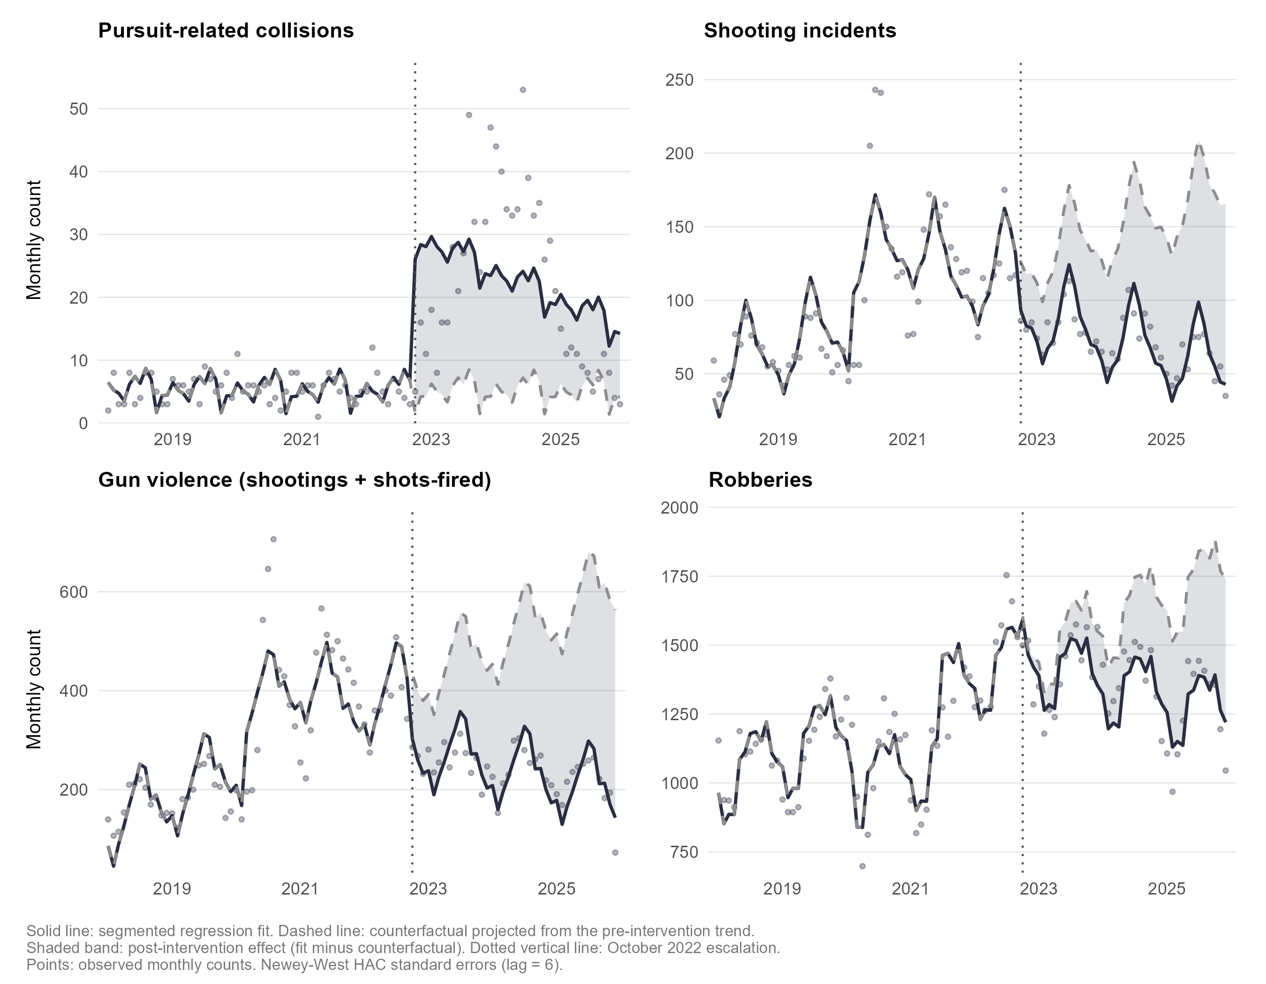
Figure 2: Interrupted time series segmented regression fits for four outcomes, January 2018–December 2025. Top row: pursuit-related collisions (left) and shooting incidents (right). Bottom row: aggregate gun violence, shootings plus shots-fired reports (left), and robberies (right). Solid line: segmented regression fit. Dashed line: counterfactual projected from the pre-intervention trend. Shaded band: the estimated post-intervention effect. Dotted vertical line: the October 2022 intervention. Points: observed monthly counts. Newey-West HAC standard errors (lag = 6).

National Comparison: Generalized Synthetic Control
The within-NYC designs are each limited by the absence of a credible control city. The generalized synthetic control addresses this by constructing a weighted composite of large U.S. cities as NYC’s counterfactual crime trajectory. Our primary outcome is the annualized shooting rate per 100,000 population from Gun Violence Archive data, observed monthly from January 2014 through December 2025; we also estimate the model for robbery. Gun violence as defined elsewhere in this paper, shootings plus shots-fired reports, has no counterpart in the national donor data, which record shootings only, so nationally the gun-violence question reduces to the shooting result. NYC is the single treated unit; all other cities serve as the donor pool.
Design. Leave-one-out cross-validation over $r=0$–5 latent factors selects the specification; inference uses 500 parametric bootstrap iterations. The covariance matrix was singular in the F-test, which is expected with a single treated unit and does not affect point estimates or bootstrap confidence intervals (Xu 2017). To avoid SUTVA contamination (donor cities whose shooting trends were themselves affected by their own pursuit policy changes), we exclude 24 cities with documented city-level or binding state-level pursuit policy changes between 2018 and 2024 (Appendix C). The resulting SUTVA-clean donor pool comprises 75 cities with stable pursuit policies, observed across 144 months. As a robustness check, we replicate the analysis with the full top-50-by-population panel (49 donors). For robbery, the only national donor series available at the city level is annual (FBI Uniform Crime Reports, 2014–2024; 34 cities with complete data (Kaplan 2025)), so the robbery model is estimated on an annual panel with NYC’s five boroughs aggregated to a single unit. Its 2 post-treatment years make it a supporting comparison rather than a primary estimate.
Results. Cross-validation selects $r=0$ latent factors for the SUTVA-clean panel, so the estimator reduces to a two-way (city and month) fixed-effects comparison of NYC against the donor pool; the pre-treatment root mean squared prediction error (RMSPE) is 4.73 per 100,000. The estimated average treatment effect on the treated (ATT) is -0.3 shooting incidents per 100,000 (annualized), and none of the 39 post-treatment months reaches significance at the .05 level. Figure 3 plots NYC’s actual shooting rate against the gsynth counterfactual, and Figure 4 shows the period-by-period ATT gap; the 95% bootstrap confidence interval includes zero throughout the post-treatment window. A full-panel robustness check ($r=1$, 49 donors) yields a similarly null ATT of -1.83 per 100,000. Both specifications point to the same conclusion: NYC’s post-October 2022 shooting trajectory is statistically indistinguishable from the national-trend counterfactual.
Following the recommendation of Abadie et al. (2015) for comparative synthetic-control studies, inference about the presence of an effect rests primarily on placebo-in-space permutation tests rather than the model-based bootstrap interval reported above. We re-estimate the SUTVA-clean gsynth model with each donor city treated in turn as the pseudo-treated unit, then rank NYC’s own average post-treatment ATT and its pre/post mean-squared-prediction-error (MSPE) ratio against this donor-city distribution. NYC’s ATT ranks 73 of 76 cities (two-sided permutation p = .961), and its MSPE ratio ranks 36 of 76 (one-sided permutation p = .474); both are squarely within the distribution expected if NYC’s shooting trajectory were no different from an arbitrary donor city’s. The permutation test corroborates the bootstrap-based null result without relying on the bootstrap’s distributional assumptions.
Robbery. On the annual panel, cross-validation again selects zero factors. The estimated ATT is 70.1 robberies per 100,000, or about 41% of NYC’s pre-escalation robbery rate. The positive point estimate means that NYC’s robbery rate rose relative to the synthetic control rather than falling (95% bootstrap CI [-71.7, 211.9]). The pre-treatment fit shows NYC’s robbery rate already diverging upward from the donor pool before October 2022, the same non-parallel-trend pattern documented for the community-level comparisons below, so the robbery estimate carries the same caveat. It provides no evidence of a deterrent effect on robbery and, if anything, points the other way.
What the comparison can rule out. Because the headline national result is a null, the relevant question is how large a true effect it could have missed. Table 3 states each estimate and its 95% confidence interval as a percentage of NYC’s own pre-escalation base rate. The shooting comparison is imprecise: the interval reaches roughly two times the baseline shooting rate in either direction, so on its own it cannot exclude a moderately sized deterrent effect. That imprecision follows from the outcome itself: shootings are comparatively rare, and the annualized city-level rate is volatile, so even the two-way fixed-effects counterfactual leaves a pre-treatment prediction error near 87% of the base rate. The robbery interval, for an outcome roughly 10 times more common, is correspondingly tighter: it runs from -42% to 125% of the base rate and rules out a robbery reduction larger than about two-fifths of the base rate. For each outcome the point estimate is at or above zero. The precision to exclude a small deterrent effect therefore comes not from any single national interval but from the convergence of evidence: the near-zero and wrong-signed point estimates here, the placebo-in-space test, the within-NYC time series, and the re-restriction that produced no crime rebound.
Table 3: National Comparison Estimates as a Percentage of NYC’s Pre-Escalation Base Rate
Outcome | Base rate (/100k) | ATT (/100k) | ATT (% of base) | 95% CI (/100k) | 95% CI (% of base)
Shootings (monthly panel) | 10.9 | -0.3 | -3% | [-23.3, 22.7] | [-215%, +209%]
Robbery (annual panel) | 169.1 | +70.1 | +41% | [-71.7, 211.9] | [-42%, +125%]
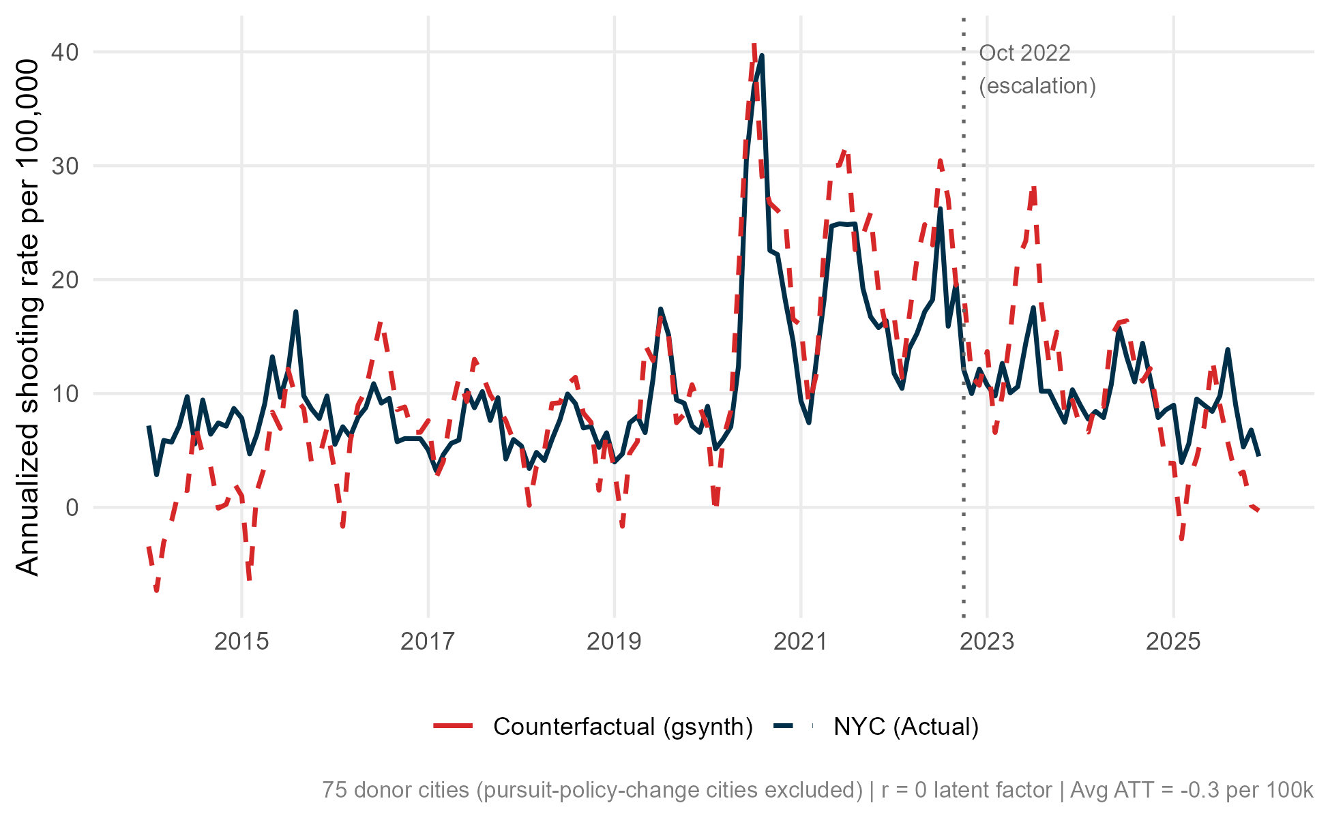
Figure 3: NYC actual shooting rate versus gsynth counterfactual, January 2014–December 2025. Solid line: NYC observed annualized rate per 100,000. Dashed line: gsynth counterfactual constructed from 75 SUTVA-clean donor cities. Vertical dotted line marks the October 2022 pursuit escalation.
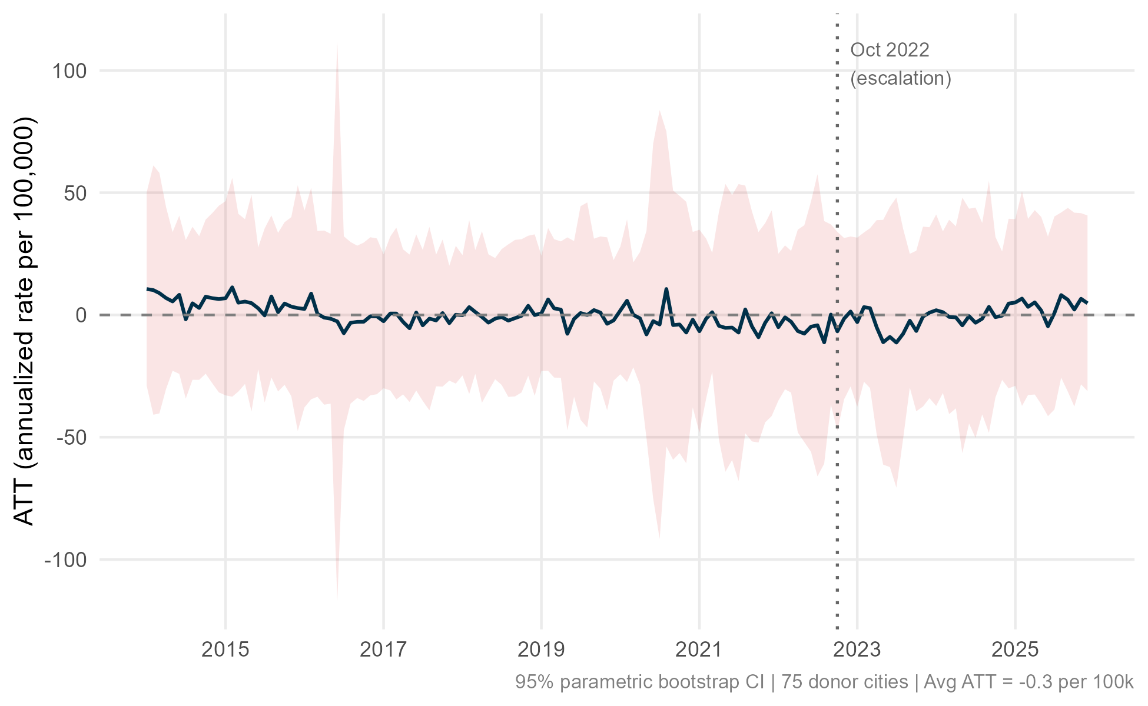
Figure 4: Period-by-period average treatment effect on the treated (ATT) with 95% parametric bootstrap confidence intervals, October 2022–December 2025. The zero line falls within the confidence interval for all 39 post-treatment months, indicating no significant treatment effect in any month.

Re-restriction: The Reverse Experiment
The February 2025 restriction offers an internal test of deterrence. It sharply reduced pursuits within the same department, well after the initial escalation, so crime trends before and after can be compared without relying on another jurisdiction. We estimate the post-Tisch effects using a multi-period segmented regression model that extends the city-level ITS specification to accommodate four distinct slope regimes, with the Tisch indicator entering as both a level shift and a slope change from February 2025 onward. The February restriction was publicly announced (New York City Police Department 2025), strengthening this falsification: a public reversal should cause deterrent effects to decay faster than a change communicated only through observed behavior, making any resulting crime upturn more detectable. The four-regime event study reveals heterogeneous trajectories. For collisions, the pattern tracks pursuit volume across all phases (as described above). For crime outcomes, the most informative comparison is the Tisch reversal: if pursuit escalation deters crime through credible apprehension threat, then the re-restriction that reduced monthly pursuits by 74.5% should produce a corresponding crime increase.
Table 4: Mean Monthly Outcomes by Policy Regime
Regime | Months | Pursuits | Crashes | Crash Rateª | Robberies | Shootings
Pre-escalation (Jan 2018–Sep 2022) | 57 | 7.7 | 5.5 | 71.5% | 1,168.2 | 99.4
Escalation (Oct 2022–Jul 2023) | 10 | 87.9 | 16.6 | 18.9% | 1,368.7 | 84.6
Post-Maddrey (Aug 2023–Jan 2025) | 18 | 159.3 | 34.4 | 21.6% | 1,400.6 | 74.1
Post-Tisch (Feb 2025–Dec 2025) | 11 | 34.1 | 8.1 | 23.7% | 1,267.4 | 58.0
ªPursuit-related crashes as a percentage of pursuit events.
The February 2025 restriction did not increase crime (see Table 4). Following the February 2025 restriction, robberies declined by 8.8% from their pre-Tisch mean, the opposite of what a deterrence model predicts. Shooting incidents fell by 25.5%, and aggregate gun violence declined by 15.9%. The multi-period model confirms that the post-Tisch shooting trajectory continued downward (b = -7.2 per month, p = .00603), while the post-Tisch level shift for shootings was not statistically distinguishable from zero (b = 8, p = .657).

Community-Level Heterogeneity
This section asks where within New York City the crime decline was concentrated, comparing trends across boroughs and across precincts grouped by pre-intervention crime level. The groups being compared were already on non-parallel pre-treatment trajectories, so these comparisons are descriptive, not causal, and we place them last because they carry the weakest identification.

Borough-Level Interrupted Time Series
Estimating the ITS model separately for each of the five NYC boroughs reveals substantial heterogeneity in crime responses. For shooting incidents, all five boroughs show negative level shifts (b₂) at October 2022, but the magnitude varies considerably. The Bronx, which experienced the highest post-escalation pursuit volume relative to baseline (approximately a 20-fold increase), shows the largest immediate reduction (b₂ = -12.1, SE = 3.5, p < .001), while Staten Island, with the lowest absolute post-escalation pursuit volume, shows a near-zero and non-significant reduction (b₂ = -0.5, SE = 0.5, p = .297). However, the relationship between pursuit intensity and crime reduction is not monotonically ordered: Queens recorded the highest raw pursuit volume in the post-escalation period yet achieved a shooting reduction (b₂ = -6.6, p = .00116) comparable to Manhattan (b₂ = -5.9, p = .0011), despite Manhattan having roughly one-third the pursuit activity. The slope-change coefficient (b₃) is negative for all five boroughs for shooting incidents, reflecting a sustained post-intervention decline.
For robbery, the pattern is more heterogeneous and does not track pursuit intensity: Manhattan shows the largest negative level shift (b₂ = -37, SE = 10.5, p < .001) despite moderate pursuit activity, while Staten Island, the lowest-pursuit borough, registers a statistically significant positive level shift (b₂ = 8.1, SE = 2.1, p < .001). Neither the level-shift pattern nor the slope-change pattern for robbery is consistent with a deterrence mechanism operating through borough-level pursuit intensity.
Figure 5 displays the borough-level ITS fits for all four outcomes across all five boroughs. The five-by-four grid (rows = boroughs, columns = outcomes) reports the immediate level-shift coefficient (b₂) and Newey-West p-value in each panel.
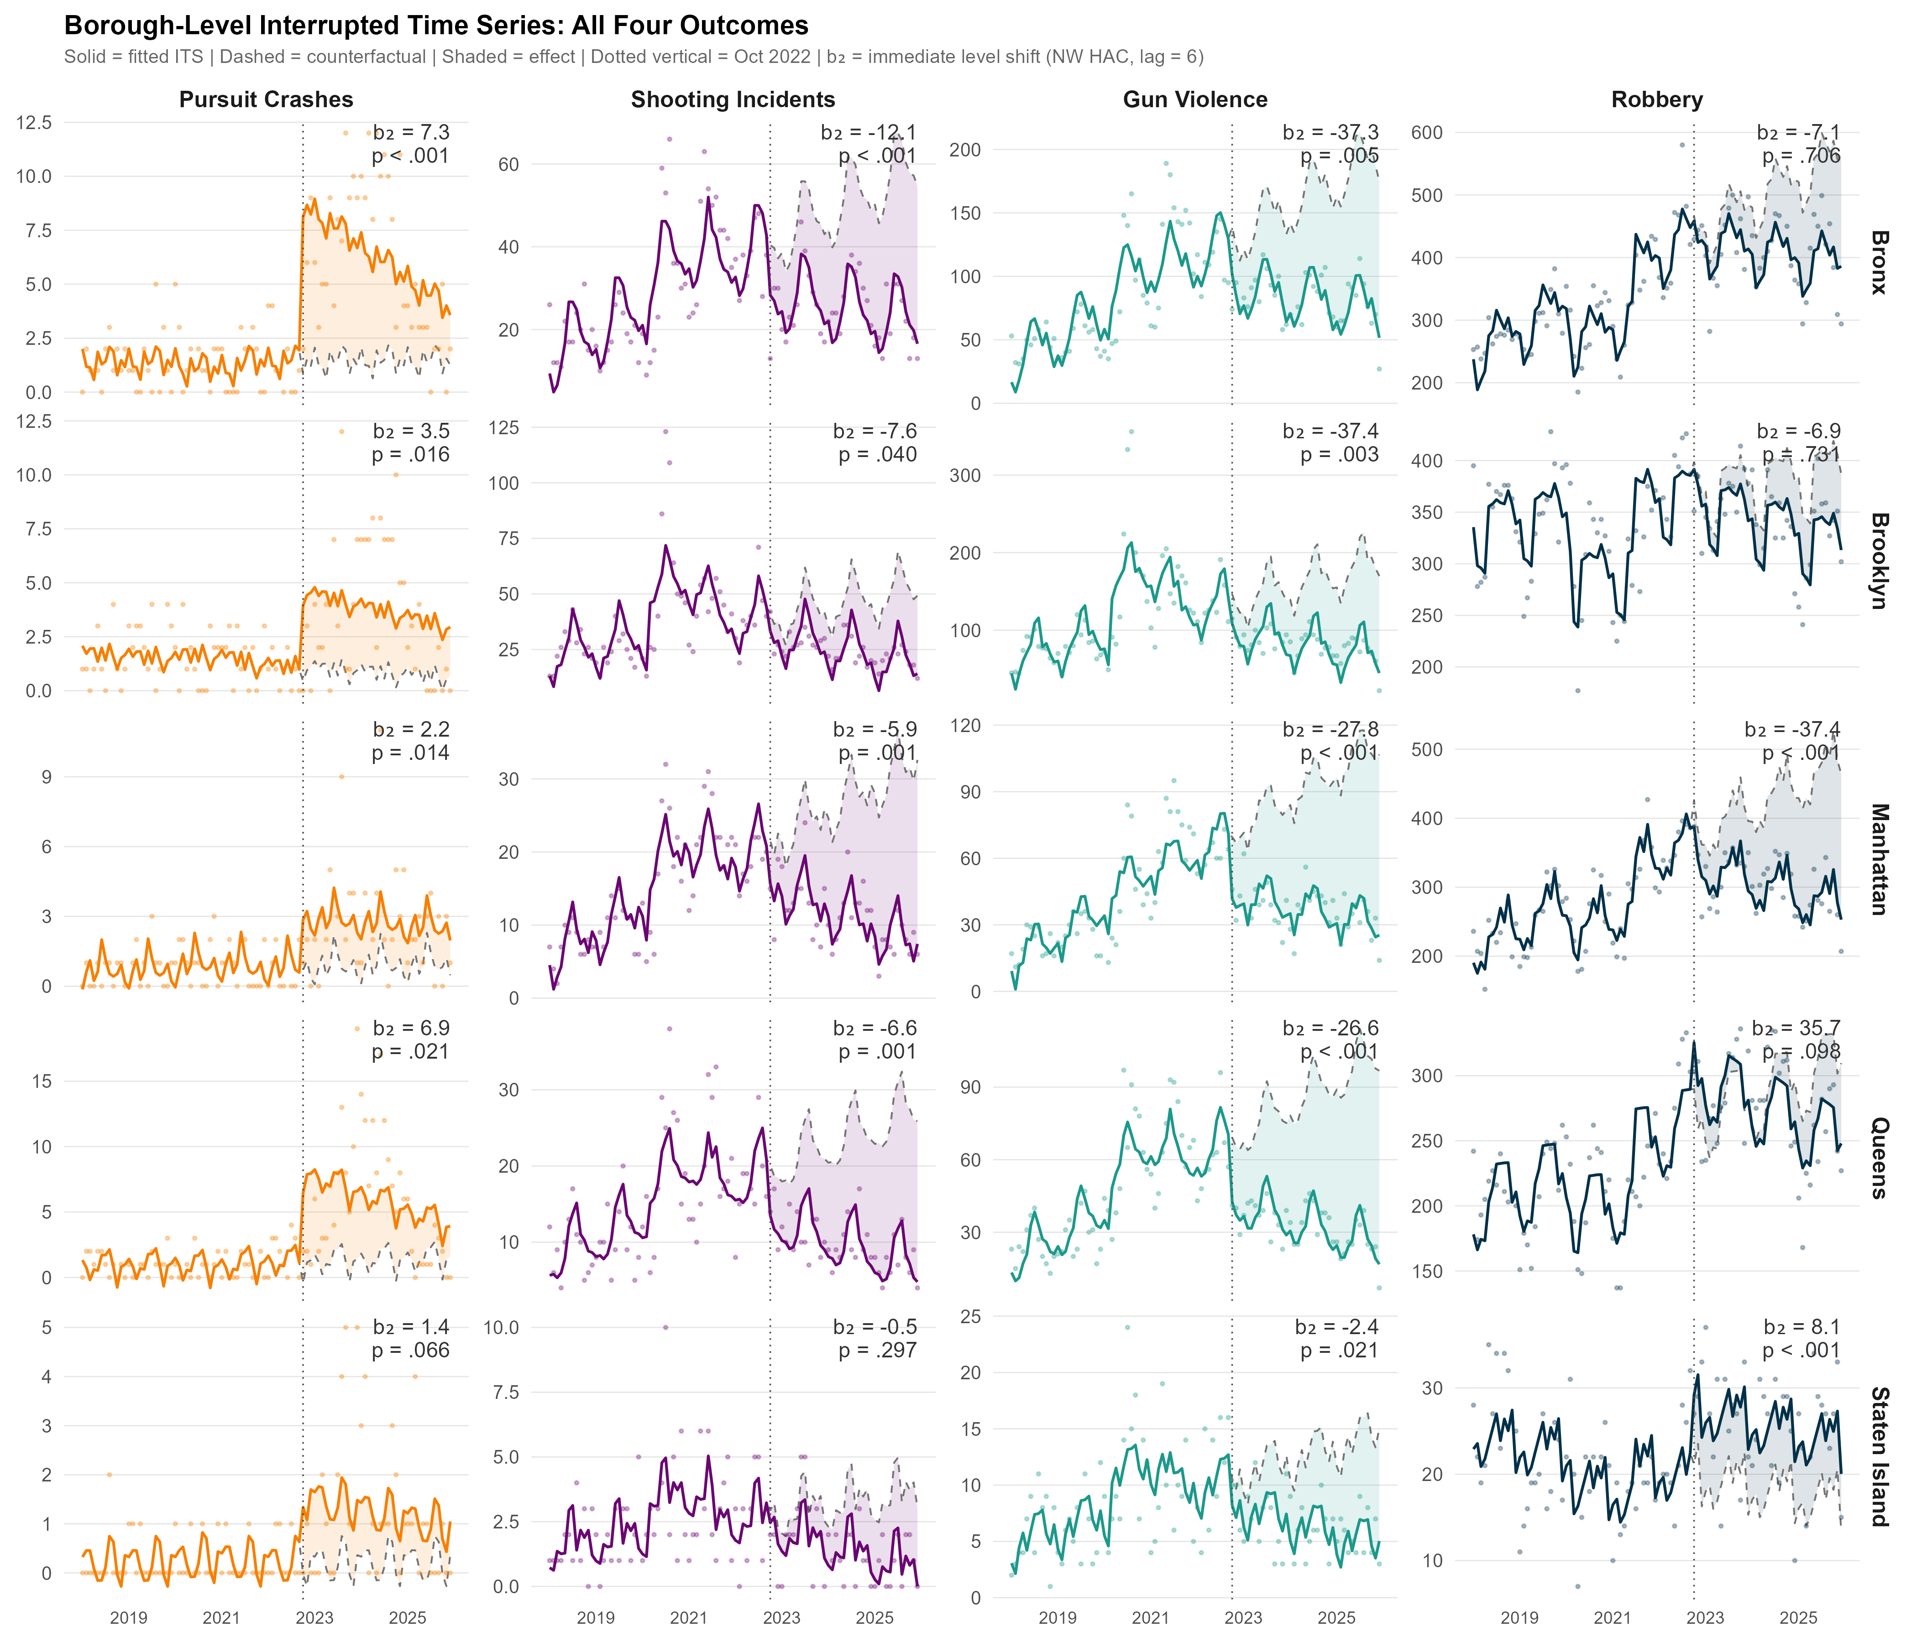
Figure 5: Borough-level interrupted time series fits for all four outcomes, January 2018–December 2025. Rows correspond to boroughs (Bronx, Brooklyn, Manhattan, Queens, Staten Island); columns correspond to outcomes (pursuit-related collisions, shooting incidents, gun violence, robbery). Each panel shows the observed monthly counts (points), segmented regression fit (solid line), counterfactual projection from the pre-intervention trend (dashed line), and shaded post-intervention effect band. Each panel’s upper right corner reports the immediate level-shift estimate b₂ and its Newey-West p-value (lag = 6). Vertical dotted line marks October 2022.
Collisions track pursuit volume closely across boroughs; crime reductions do not. If apprehension threat were the mechanism, the Bronx (~20-fold pursuit increase) would show substantially larger reductions than Manhattan (~15-fold), but the gap in crime reductions does not match the gap in escalation. Borough-specific confounding prevents a strong causal reading of this pattern; the precinct-level comparison below examines the same spatial question at finer resolution.

Precinct-Level Heterogeneity
The 77-precinct panel offers the finest spatial resolution for describing where the crime decline was concentrated. Each outcome uses its own pre-treatment median to split precincts into high and low groups (Figure 6); the split is fixed in the pre-intervention window (January 2018–September 2022) and cannot be contaminated by post-treatment dynamics.
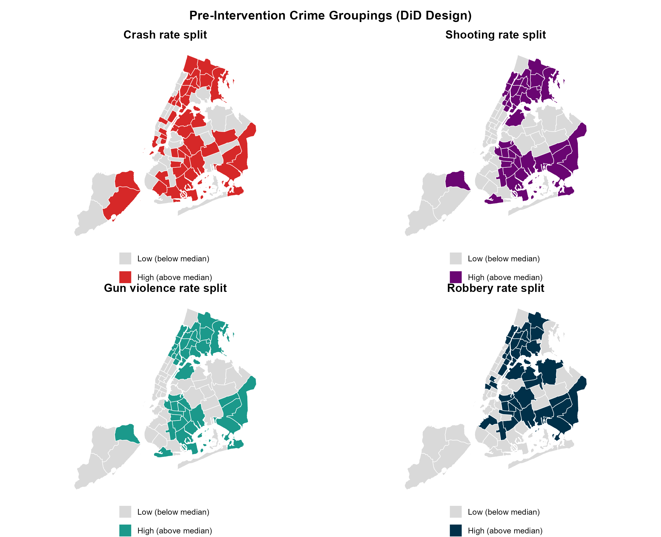
Figure 6: Pre-intervention groupings for the heterogeneous-effects DiD design across all four outcomes. Top row: pursuit-related collisions (left) and shooting incidents (right); bottom row: gun violence (left) and robberies (right). Dark color = high pre-treatment rate (above median); light gray = low pre-treatment rate. Each outcome uses its own outcome-specific grouping variable. The panel covers all 77 NYPD precincts (G = 77 clusters in the DiD model). The gun violence and shooting groupings assign the majority of precincts to the same category, reflecting the strong within-precinct correlation between shooting incidents and shots-fired reports.
Cross-precinct comparison. We compare post-2022 crime trajectories across precincts grouped by their pre-intervention baseline crime rate. Under a deterrence mechanism, precincts that already had more crime, and presumably saw more pursuits after October 2022, would show larger crime declines than lower-crime precincts. The DiD scalar summarizes this gap: the post-October 2022 change in crime in higher-crime precincts relative to lower-crime precincts, net of all precinct-level baselines and citywide monthly shocks. We report it as a description of the spatial pattern, not as a causal estimate; the pre-trend evidence below shows why. For shooting incidents, the DiD estimate is b = -0.604 (SE = 0.076, p < .001), indicating that high-crime precincts experienced nominally larger shooting reductions than low-crime precincts in the post-intervention period. For robbery, the DiD estimate is b = 2.25 (SE = 0.92, p = .0169), a positive and statistically significant result directly inconsistent with deterrence. If high-crime precincts were experiencing faster secular crime declines than low-crime precincts (the most plausible confound, given post-pandemic mean-reversion), this would push the shooting DiD coefficient toward more negative values and the robbery coefficient toward zero. The robbery estimate is positive and significant despite this expected bias direction, which makes it hard to explain as a measurement artifact and points the opposite way from deterrence.
The quartile dose-response specifications confirm these patterns: each one-quartile step up in pre-treatment shooting rate is associated with a further reduction of 0.3 shootings per month (b = -0.3, p < .001), while each robbery-quartile step is associated with 1.36 additional robberies per month (p = .00195). For collisions, the highest-crash-quartile precincts show a positive and significant post-intervention DiD (b = 0.224, p = .00336), consistent with the expected mechanism: precincts that already had higher collision rates saw the largest absolute increases as pursuit volume expanded department-wide. This collision quartile gradient reflects higher pursuit activity in precincts that had already demonstrated higher crash risk under prior pursuit procedures. The positive robbery DiD estimate should be read alongside the citywide ITS slope: the ITS captures a genuine NYC-wide robbery decline, but this design shows the decline was not concentrated in higher-crime precincts as a deterrence mechanism would predict. If anything, the cross-precinct gradient ran the wrong way.
The event study plots (Figure 7) trace the quarterly DiD coefficients, the evolving difference between high- and low-crime precincts relative to the quarter before intervention (bin $−1$ = July–September 2022), for all four outcomes. Pre-period coefficients reveal that the parallel trends assumption is not satisfied for shooting incidents or robbery. A joint Wald F-test on all pre-treatment lead coefficients rejects the null of parallel trends for shooting incidents ($F$(7, 76) = 5.37, $p$ < .001) and robbery ($F$(7, 76) = 5.49, $p$ < .001). Pre-period divergence for gun violence follows a pattern similar to shootings, reflecting the strong correlation between the two outcomes at the precinct level. For pursuit crashes, the pre-period coefficients are generally flat, and the same joint Wald F-test fails to reject parallel trends ($F$(7, 76) = 1.33, $p$ = .247), consistent with parallel trends between high- and low-crash precincts before October 2022 and with the collision ITS being the better-identified result. This pre-period divergence, evident before any pursuit policy change for crime outcomes, indicates that high- and low-crime precincts were already on non-parallel trajectories, most likely reflecting differential rates of secular crime decline. The DiD crime estimates therefore cannot be given a causal interpretation under the standard parallel trends assumption.
The nominally negative shooting DiD estimate more plausibly reflects faster mean-reversion in the post-pandemic crime cycle among high-crime precincts than a deterrence effect of pursuit escalation (McCrain et al. 2026). For both crime outcomes the pre-period divergence runs in the same direction a deterrence prediction would, so that estimate is uninformative as evidence for deterrence. The robbery DiD estimate is positive and significant despite this, running opposite to deterrence regardless of the parallel trends issue.
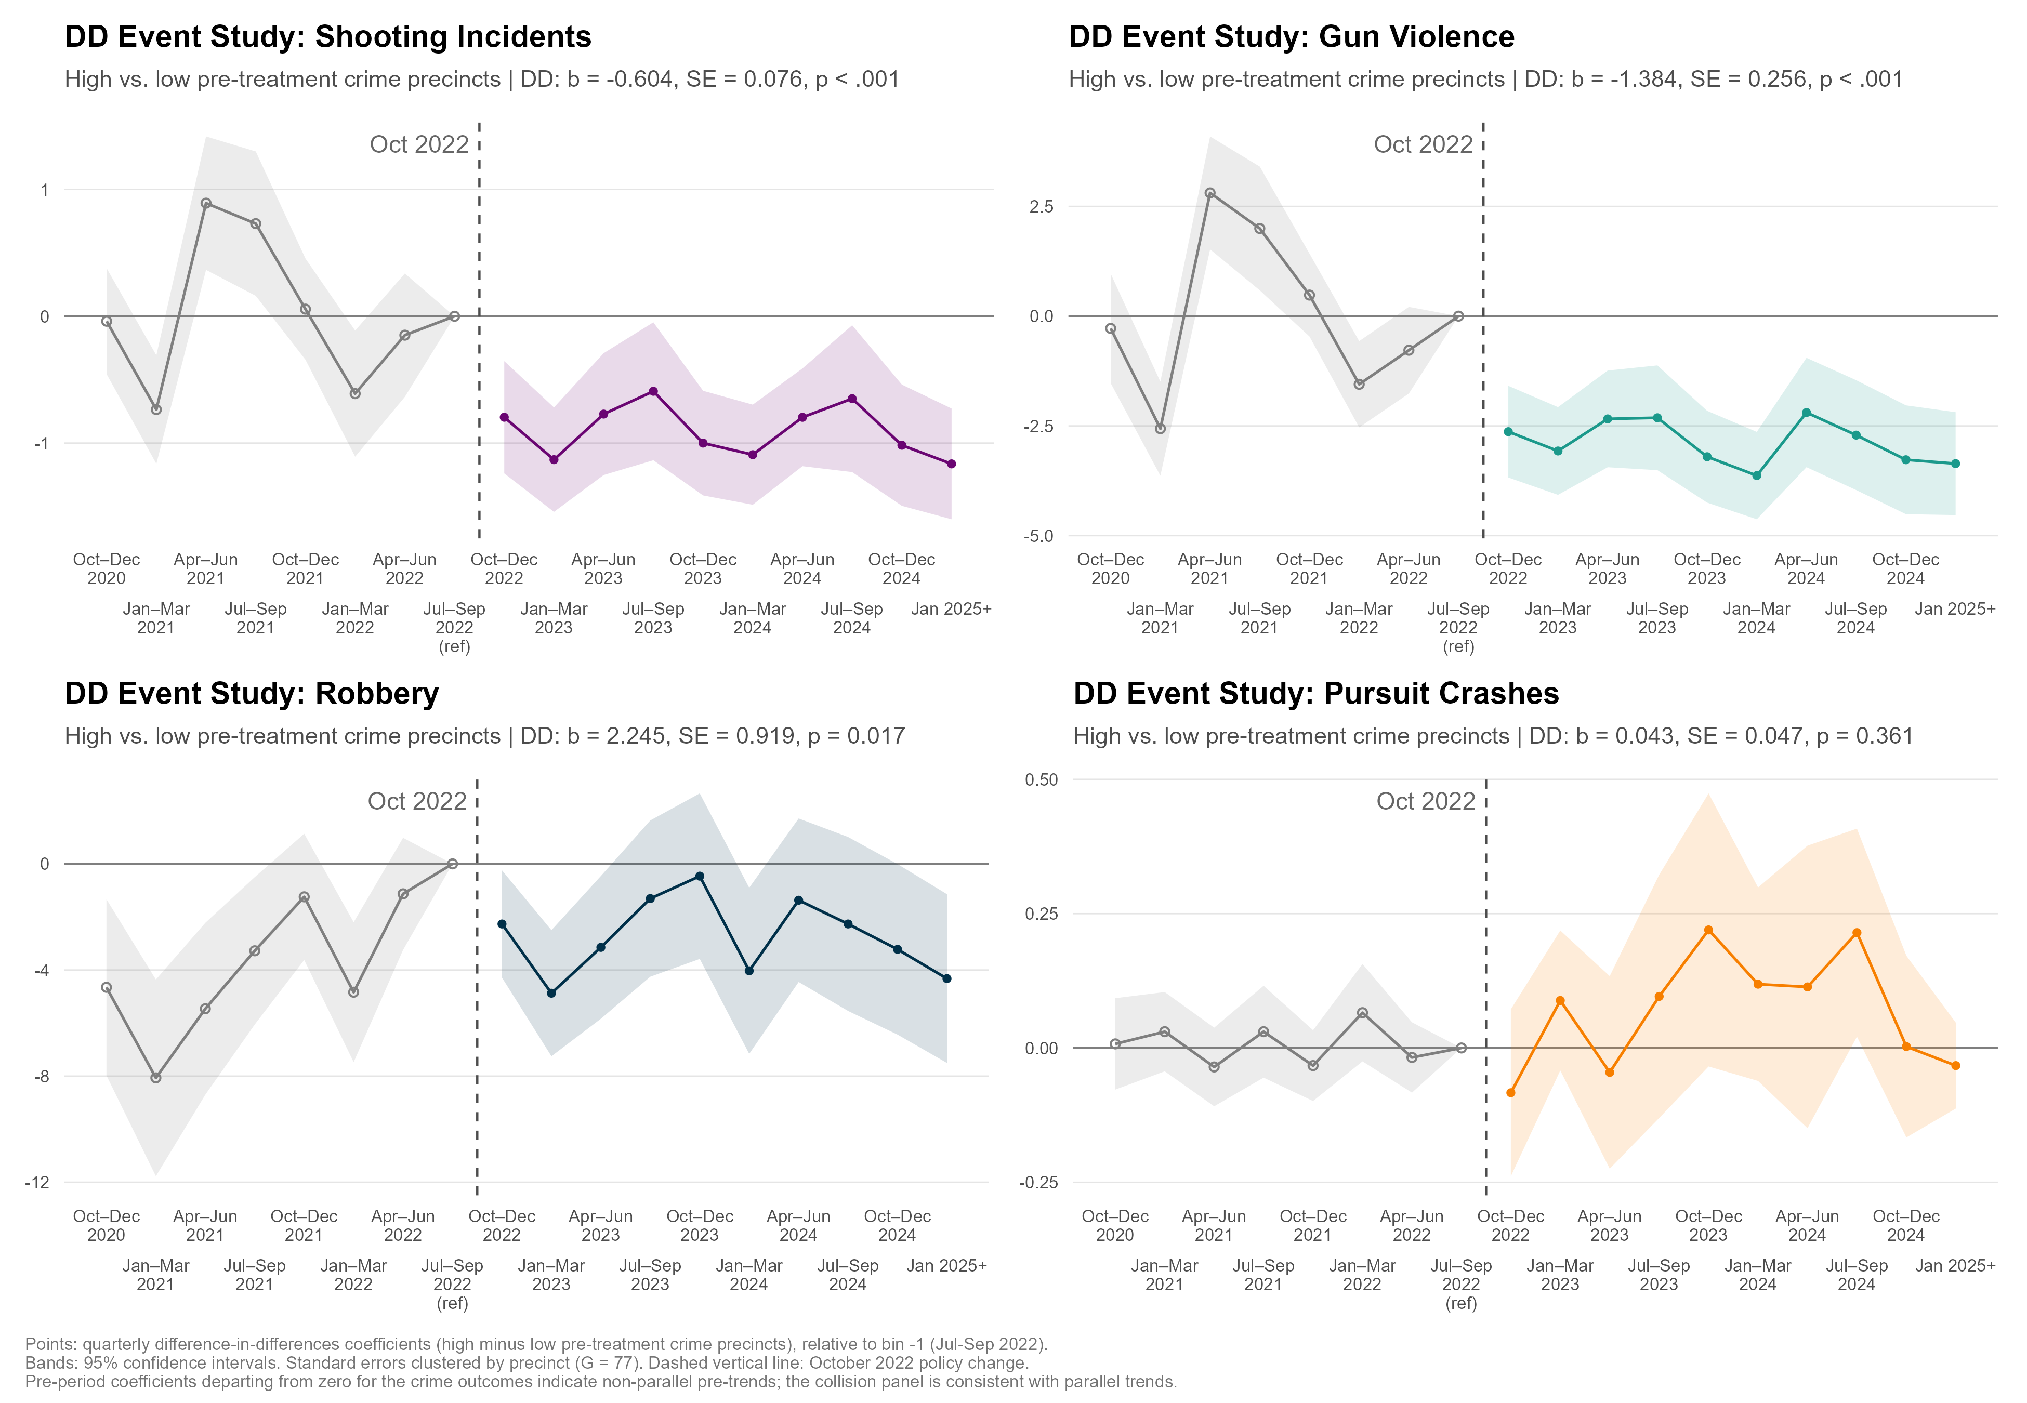
Figure 7: Precinct-level heterogeneous-effects DiD event study, all four outcomes. Top row: shooting incidents (left) and gun violence (right); bottom row: robbery (left) and pursuit-related collisions (right). X-axis shows three-month (quarterly) bins relative to the October 2022 policy change; bin −1 (July–September 2022) is the reference quarter. Points show the estimated DiD coefficient for each quarterly bin. The Maddrey compliance memo falls in bin 3 (July–September 2023); bin 9 covers January 2025 onward; the Tisch policy rewrite officially took effect in February 2025 but is included in this lump bin as she announced it in mid-January. Pre-period coefficients reveal non-parallel trends for crime outcomes before the intervention, undermining the parallel trends assumption required for causal interpretation; collision pre-period coefficients are consistent with parallel trends. Standard errors clustered by precinct (G = 77). Note for the pursuit-related collisions panel: high-crash precincts are expected to exhibit larger collision increases after the policy change (reflecting higher pursuit activity), not crime reductions; the directional prediction for collisions differs from the crime outcome panels.

Cost-Benefit Analysis
The collision costs are large enough that a meaningful share of the observed crime decline would have to be causally attributable to pursuit policy for the escalation to produce a net societal benefit. We formalize this with a partial cost-benefit analysis (CBA) from a societal perspective, valuing all costs and benefits regardless of who bears them (see Table 5). It is a sensitivity exercise: it quantifies the minimum causal attribution share at which benefits exceed costs, and does not assert that the observed crime reduction equals the pursuit-deterrence benefit.
Costs comprise excess pursuit-related collision externalities, defined as crashes above the pre-escalation monthly baseline and summed over the post-escalation study period. We value these costs using Federal Highway Administration (FHWA) unit-cost schedules. Fatalities are estimated at 1.0% of pursuit-related crashes in the central scenario, with rates of 0.5% and 1.5% used as lower and upper bounds (Kenney and Alpert 1997; Rivara and Mack 2004; Hendrix et al. 2026). This 1.0% figure is conditioned on a pursuit-related collision having already occurred; it should not be conflated with the smaller per-pursuit fatality rates reported elsewhere in the pursuit literature (well below 1%, depending on study and era), which use the full universe of pursuits (most of which do not end in a collision) as the denominator. The two statistics answer different questions: one asks how often a collision that has already happened proves fatal, the other how often a pursuit, collision or not, ends in death. Each fatality is valued using a value of a statistical life (VSL) of $12.5 million, consistent with 2022 U.S. Department of Transportation guidance (U.S. Department of Transportation 2022). Injuries are estimated to occur in 35% of crashes, with 1.5 injuries per injury crash, and are valued using a blended serious- and minor-injury unit cost (Alpert and Dunham 1988; Kenney and Alpert 1997). Property damage is valued using the FHWA per-crash schedule.
On the benefit side, we use the ITS-estimated shooting decline as an upper bound. Under full attribution ($θ=1$), the entire within-NYC decline is credited to pursuit escalation. Each prevented shooting is valued at $1.25 million, or 10% of the assumed VSL. We then define the attribution share, $θ∈[0,1]$, as the fraction of the ITS-estimated shooting decline caused by pursuit escalation and calculate the break-even value, $θ^{*}$, at which shooting-prevention benefits equal collision costs.
Under the low scenario, which assumes a fatality rate of 0.5%, collision costs are smaller and a lower attribution share is required to break even. Under the high scenario, which assumes a fatality rate of 1.5%, collision costs are greater and the required attribution share rises.
Across the post-escalation period, the model estimates approximately 676 excess pursuit-related collisions above the pre-escalation baseline, generating an estimated 6.8 additional fatalities and 355 additional injuries. Valued at central VSL assumptions, total collision costs amount to $168,906,524, comprising approximately $84,500,000 in fatality costs, $70,980,000 in injury costs, and $13,520,000 in property damage. These estimates may be conservative: investigative reporting by Gonen (2025) documented approximately 20 fatalities directly linked to NYPD pursuits over the study period (a figure higher than the actuarial estimate used here), suggesting that the central-scenario fatality cost is plausibly a lower bound.
Table 5: Cost-Benefit Analysis: Collision Costs and Break-Even Attribution by Scenario
Scenario | Crash Costs | Break-Even Attribution (%)ª
Low | $126,679,893 | 3%
Central | $168,906,524 | 4%
High | $211,133,155 | 5%
a Break-Even Attribution (%) is the minimum fraction of the ITS-estimated shooting decline that must be causally attributable to the pursuit escalation for shooting-prevention benefits to equal total collision costs. Values vary across scenarios because collision costs scale with VSL assumptions while the full-attribution benefit is fixed. Under the central scenario, this threshold corresponds to approximately 121 prevented shootings over the study period.
The break-even threshold is low in absolute terms (approximately 121 prevented shootings over the study period, equivalent to a causal attribution share of approximately 4% of the ITS-estimated shooting decline under central VSL assumptions), yet the available evidence does not establish that even this minimal threshold is met through pursuit deterrence. Under full causal attribution (the theoretical upper bound), shooting-prevention benefits would substantially exceed collision costs (central benefit-cost ratio [BCR]: 25:1), but this assumption is directly contradicted by the convergent evidence above. The generalized synthetic control is the most direct evidence on this question: NYC’s post-2022 shooting trajectory is statistically indistinguishable from the synthetic counterfactual, so the ITS shooting decline is largely what the national trend predicted, and the likely causal attribution share is near zero. A break-even-sized effect (roughly three to four prevented shootings per month) is within the resolution of the within-NYC time series, but that series cannot separate a pursuit effect from the concurrent secular decline, and the national comparison finds no decline beyond the counterfactual to attribute.

Discussion
Collisions rose and fell with pursuit activity across all four policy regimes, supporting the direct mechanism through which more pursuits create more opportunities for crashes. Although the crash rate per pursuit declined as lower-risk incidents entered the mix, the increase in pursuit volume produced substantially greater aggregate harm.
Several convergent findings cut against a deterrence interpretation. The precinct shooting estimate cannot be interpreted causally because the groups followed non-parallel pre-treatment trends, while the robbery estimate runs opposite to the predicted direction. More broadly, a national secular crime decline, documented across 40 large U.S. cities through 2025 and including a 21% drop in homicide rates (Lopez and Boxerman 2026), dominated NYC’s aggregate trajectory.
Borough-level heterogeneity provides little additional support for deterrence. Crime reductions did not scale monotonically with pursuit intensity for either outcome, although borough-specific confounding prevents a strong causal inference from that pattern.
The Tisch reversal provides independent evidence against a large, immediate deterrence effect. Crime did not rise after pursuits fell sharply, but the test is not immune to the national-trend confound affecting the city-level ITS. Continued secular decline could conceal a modest deterrence-decay effect, so the reversal rules out a large rebound more convincingly than a smaller one.
The collision costs are substantial (approximately $168,906,524 under central assumptions) and directly attributable to the policy change. There is no comparable evidence of benefits. The break-even threshold (approximately 121 prevented shootings over the study period) is low but unmet, and thus the available evidence is consistent with a causal share near zero.

Limitations
The precinct DiD cannot support a causal estimate of crime effects because high- and low-crime precincts followed non-parallel pre-treatment trajectories. Pre-treatment grouping avoids classifying precincts by a post-treatment variable, but it does not solve this underlying identification failure. The design should therefore be read as a reduced-form comparison of group trajectories, not an estimate of the effect of pursuit counts.
A second and consequential limitation is that the pursuit escalation occurred simultaneously with a broader shift in NYPD enforcement posture under Mayor Adams’s quality-of-life mandate. Vehicle pursuits were one visible element of a multi-pronged strategy that also encompassed changes in discretionary traffic-stop volume, field interview activity, and drug enforcement. If these concurrent enforcement changes also affected crime (and there is reason to believe they did, given the borough-level similarity in crime outcomes across widely differing pursuit volumes), then none of the crime analyses in this paper can cleanly isolate pursuit-specific effects. Data on NYPD stop-question-frisk activity and discretionary traffic-stop volume exist on NYC Open Data but are not included in the present analysis; incorporating such controls is a natural extension for future work. In their absence, all crime results, including the null findings, should be read as estimates of the combined effect of the 2022–2023 enforcement posture shift rather than as estimates of pursuit policy in isolation. The borough-level ITS assumes that heterogeneity in crime responses across boroughs reflects variation in pursuit intensity rather than other borough-specific factors; unmeasured borough characteristics (e.g., changes in community policing, socioeconomic shocks) could confound the within-NYC comparison. Borough-level pursuit counts also contain measurement error from cross-boundary pursuits, events that begin in one borough and conclude in another, which attenuates the precision of borough-specific exposure estimates. ITS sensitivity analyses confirm robustness to intervention dates from September 2022 through January 2023, and temporal placebos yield no comparable signals. Finally, individual-level pursuit records linking specific pursuit outcomes to officer, suspect, and bystander characteristics are not publicly available, precluding finer-grained analysis of who bears the costs and who might reap the benefits of pursuit policy.
The usual concerns about administrative data also apply. Our pursuit activity measure captures only incidents that officers broadcast over the radio, as required by Patrol Guide procedure. If officers engaged in vehicle pursuits without broadcasting during the study period, those events would be absent from our counts, making our estimates a conservative lower bound on true pursuit volume. If ghosted pursuits were more common in the pre-escalation period, when command attention to pursuits was lower, our pre-period counts would be underestimates, making the escalation appear larger than it was (Pfeiffer and Alpert 2020). This measurement limitation is bounded in a way that matters for interpreting the collision findings specifically: an unreported pursuit is a different kind of event, not just an unlogged one. Patrol Guide procedure requires broadcasting precisely so that other units can converge on the pursuit; a broadcast pursuit is, by design, a multi-unit event, while an unreported pursuit typically remains a single officer trailing a fleeing vehicle. Because the collision mechanism documented above operates largely through the additional vehicles a broadcast draws into the pursuit, ghosted pursuits are not simply undercounted instances of the same risk: a single unit pursuing generates categorically less collision exposure than the five or six units a broadcast pursuit can attract. Their omission from our counts is therefore unlikely to understate the collision externality we attribute to broadcast pursuit volume, even though it does understate raw pursuit frequency. The Tisch falsification evidence, however, does not depend on counting pre-period pursuits and is therefore unaffected by this concern. We have no reason to believe that unreported pursuits would cluster systematically around the intervention dates in a way that would account for the dramatic swings we observe in the data.

Policy Implications
The policy implications are asymmetric in the same direction as the evidence. Collision costs are demonstrably real; crime prevention benefits remain unclear. The break-even threshold is low enough in absolute terms (the equivalent of preventing roughly three to four shootings per month over the three-year study period) that a genuine deterrence effect, if it existed, should in principle be detectable. The DiD evidence and the Tisch falsification both point away from this. The causal attribution framework developed here offers a portable decision template: compute the break-even causal share under local cost and crime parameters, assess whether local crime trends outperform a credible national or regional benchmark, and treat within-jurisdiction declines as presumptively attributable to national trends absent that comparative evidence. The NYPD’s experience, with its four distinct policy regimes and built-in falsification test, is unusually rich, but the framework applies wherever administrative data on pursuit activity and crime outcomes can be assembled. Jurisdictions considering expanding officers’ discretion to engage in pursuits should require affirmative evidence of crime prevention benefits (at minimum, crime trajectories that outperform contemporaneous regional trends) rather than assuming them from within-jurisdiction time trends alone.
The null crime findings carry implications for how departments should weigh pursuit authority against competing enforcement strategies. Hot-spots policing (Turchan and Braga 2024) and focused deterrence (Kennedy 2008) have accumulated systematic evidence of crime-reduction effects that, even at the lower end of estimated effect sizes, would exceed the break-even threshold estimated here. If the primary mechanism sought from expanded pursuit authority is deterrence of serious offending, the evidence base consistently favors strategies that produce more detectable deterrence effects at lower collateral-harm cost. Whether NYC’s concurrent enforcement changes under the Adams mandate contributed to the observed 2022–2025 crime declines, and if so which components, remains an open question that future research with individual-level administrative data could address. For now, the evidence does not support treating vehicle pursuit escalation as a principal crime-reduction tool when better-evidenced alternatives exist.
For agencies currently operating under permissive pursuit policies, these findings point toward investment in two areas: data infrastructure and pursuit alternatives. Police Executive Research Forum (2023) recommends that agencies implement real-time pursuit reporting linked to officer, suspect, and outcome characteristics; such records would enable the individual-level analysis that aggregate administrative data cannot support. Pursuit alternatives (e.g., tire deflation devices, GPS tagging technology, and aerial support) offer pathways to apprehension without generating the collision externalities documented here (Police Executive Research Forum 2023). The Tisch partial re-restriction offers a promising natural experiment in precisely this direction: with a longer post-restriction observation window, expanded comparison data, and individual-level pursuit records, future research may be able to estimate the effects of the new policy regime with greater precision.

Conclusion
The NYPD’s pursuit escalation clearly increased pursuit-related collisions but produced no credible evidence of offsetting crime reduction. The precinct shooting estimate is undermined by non-parallel pre-trends, the robbery estimate runs opposite to deterrence, the national comparison finds no significant departure from the counterfactual, and crime did not rise after the February 2025 restriction sharply reduced pursuits. The collision costs are demonstrable; the crime-prevention benefits are not.
Whether this pattern persists over a longer post-restriction period and extends to other jurisdictions remains an open question. For now, agencies should not assume that expanded pursuit authority deters crime at a scale sufficient to offset its harms. The break-even framework provides a concrete standard against which stronger future evidence can be judged.

References
Abadie A, Diamond A, Hainmueller J (2015) Comparative politics and the synthetic control method. American Journal of Political Science 59:495–510
Alpert GP, Anderson PR (1986) The most deadly force: Police pursuits. Justice Quarterly 3:1–14
Alpert GP, Clarke AC, Smith WC (1997a) The constitutional implications of high-speed police pursuits under a substantive due process analysis: Homeward through the haze. University of Memphis Law Review 27:599–662
Alpert GP, Dunham RG (1988) Research on police pursuits: Applications for law enforcement. American Journal of Police 7:123–132
Alpert GP, Dunham RG (1989) Policing hot pursuits: The discovery of aleatory elements. Journal of Criminal Law and Criminology 80:521–539
Alpert GP, Kenney DJ, Dunham R (1997b) Police pursuits and the use of force: Recognizing and managing “the pucker factor” — a research note. Justice Quarterly 14:371–385. https://doi.org/10.1080/07418829700093371
Alpert GP, Lum C (2014) Police pursuit driving: Policy and research. [Springer Science; Business Media], New York, NY
Alpert GP, Madden T (1994) Police pursuit driving: An empirical analysis of critical decisions. American Journal of Police 13:23–46
Aronie J, Alpert GP (2020) 16 to a dealer’s 10: Could blackjack odds help inform police pursuit policies?
Barnum TC, Nagin DS, Pogarsky G (2021) Sanction risk perceptions, coherence, and deterrence. Criminology 59:195–223. https://doi.org/10.1111/1745-9125.12266
Bernal JL, Cummins S, Gasparrini A (2017) Interrupted time series regression for the evaluation of public health interventions: A tutorial. International Journal of Epidemiology 46:348–355
Brosnan E (2023) NYPD chief attributes more car chases to rise in “ghost vehicles”
Butler LKW (2018) 2018 City of Milwaukee fire and police commission vehicle pursuit report. City of Milwaukee Fire; Police Commission
Chalfin A, McCrary J (2017) Criminal deterrence: A review of the literature. Journal of Economic Literature 55:5–48
Crew Jr Robert E., Hart Jr Robert A. (1999) Assessing the value of police pursuit. Policing: An International Journal of Police Strategies & Management 22:58–73
Gonen Y (2023) NYPD chief circulated internal memo on car chases and safety
Gonen Y (2025) 20 people died in NYPD car chases. Now the new police commissioner is cracking down
Hendrix A, Martin T, Gazzetta JO, Nuñez JD (2026) Police pursuit fatalities in the US, 2009 to 2023. JAMA Network Open 9:e264340. https://doi.org/10.1001/jamanetworkopen.2026.4340
Hicks WL (2003) Police vehicular pursuits: An overview of research and legal conceptualizations for police administrators. Criminal Justice Policy Review 14:75–95. https://doi.org/10.1177/0887403402250925
Hicks WL (2006) Police vehicular pursuits: A descriptive analysis of state agencies’ written policy. Policing: An International Journal of Police Strategies & Management 29:106–124. https://doi.org/10.1108/13639510610648511
Hill J (2002) High-speed police pursuits: Dangers, dynamics, and risk reduction. FBI Law Enforcement Bulletin 71:14–19
Hoffmann G, Mazerolle P (2005) Police pursuits in queensland: Research, review and reform. Policing: An International Journal of Police Strategies & Management 28:530–545. https://doi.org/10.1108/13639510510614591
Homant RJ, Kennedy DB, Howton JD (1994) Risk taking and police pursuit. The Journal of Social Psychology 134:213–221
Hosking PK (2021) Policy reform and resistance: A case study of police pursuit policy change in Queensland, Australia. PhD thesis, Griffith University
Hutson HR, Rice PL Jr., Chana JK, et al (2007) A review of police pursuit fatalities in the United States from 1982–2004. Prehospital Emergency Care 11:278–283. https://doi.org/10.1080/10903120701385414
Kaplan J (2025) Uniform crime reporting (UCR) program data: Offenses known and clearances by arrest, 1960–2024
Kennedy DB, Homant RJ, Kennedy JF (1992) A comparative analysis of police vehicle pursuit policies. Justice Quarterly 9:227–246
Kennedy DM (2008) Deterrence and crime prevention: Reconsidering the prospect of sanction. Routledge, London
Kenney DJ, Alpert GP (1997) A national survey of pursuits and the use of police force: Data from law enforcement agencies. Journal of Criminal Justice 25:315–323. https://doi.org/10.1016/S0047-2352(97)00016-0
Lopez E, Boxerman B (2026) Crime trends in U.S. Cities: Year-end 2025 update. Council on Criminal Justice, Washington, DC
MacDonald JM, Alpert GP (1998) Public attitudes toward police pursuit driving. Journal of Criminal Justice 26:185–194. https://doi.org/10.1016/S0047-2352(97)00080-9
McCrain J, Adams IT, Nix J (2026) Regression to the mean in place-based crime prevention. CrimRxiv
Mourtgos SM, Adams IT, McLean K, Alpert GP (2026) Risk and public judgments on police pursuits: A nationally representative conjoint experiment. Police Quarterly 29:412–436. https://doi.org/10.1177/10986111251412794
Nagin DS (2013) Deterrence in the twenty-first century: A review of the evidence. Crime and Justice 42:199–263
New York City Police Department (2025) Commissioner tisch announces new vehicle pursuit policy
Newey WK, West KD (1987) A simple, positive semi-definite, heteroskedasticity and autocorrelation consistent covariance matrix. Econometrica 55:703–708. https://doi.org/10.2307/1913610
O’Connor PT, Norse WL Jr. (2005) Police pursuits: A comprehensive look at the broad spectrum of police pursuit liability and law. Mercer Law Review 57:511–552
Pfeiffer MA, Alpert GP (2020) Developing methodology for finding ghosted police vehicle pursuits. Translational Criminology
Pogarsky G, Roche SP, Pickett JT (2017) Heuristics and biases, rational choice, and sanction perceptions. Criminology 55:85–111. https://doi.org/10.1111/1745-9125.12129
Police Executive Research Forum (2023) Vehicular pursuits: A guide for law enforcement executives on managing the associated risks. Office of Community Oriented Policing Services, Washington, DC
Policing Project at New York University School of Law, Gillooly J, Owens E, Mueller-Smith M (2021) Measuring the costs and benefits associated with vehicle pursuit policies in Roanoke City and Roanoke County, VA. New York University School of Law
Rivara FP et al (2025) Vehicular pursuits in Washington State. Harborview Injury Prevention; Research Center, University of Washington
Rivara FP, Mack CD (2004) Motor vehicle crash deaths related to police pursuits in the United States. Injury Prevention 10:93–95. https://doi.org/10.1136/ip.2003.004853
Senese JD, Lucadamo T (1996) To pursue or not to pursue? That is the question: Modeling police vehicular pursuits. American Journal of Police 15:55–78
Sharkey P (2026) AmericanViolence.org: City, fatal and nonfatal shootings
Turchan B, Braga AA (2024) The effects of hot spots policing on violence: A systematic review and meta-analysis. Aggression and Violent Behavior 79:102011
U.S. Department of Transportation (2022) Revised departmental guidance on valuation of a statistical life in economic analysis
Wade LM (2015) High-risk pursuit classification: A categorical analysis of variables from Georgia police pursuits. Criminal Justice Policy Review 26:278–292. https://doi.org/10.1177/0887403413516000
Wagner AK, Soumerai SB, Zhang F, Ross-Degnan D (2002) Segmented regression analysis of interrupted time series studies in medication use research. Journal of Clinical Pharmacy and Therapeutics 27:299–309
Xu Y (2017) Generalized synthetic control method: Causal inference with interactive fixed effects models. Political Analysis 25:57–76. https://doi.org/10.1017/pan.2016.2

Appendix A: Design Map

Table A1: Design Map
This table maps each design used in the paper to its identifying assumption and to what it can and cannot show.
Design | Outcome(s) | Identifying Assumption | Shows | Cannot Show
City ITS | Collisions | Counterfactual trend continuation; pursuit-crash administrative coding | Collision burden of the escalation | Administrative undercounting in pursuit-crash coding
City ITS | Crime | Pre-trend continuation | Within-NYC change; full-attribution upper bound | Policy effect vs. national/secular trends
Borough ITS | All four outcomes | Heterogeneity tracks pursuit intensity | Dose-scaling mechanism check across boroughs (non-monotonic in practice) | Borough-specific confounds
Precinct DiD | Crime + crashes | Parallel trends across baseline-crime groups | Exposure gradient (descriptive for crime) | Causal crime effects (pre-trends fail)
Generalized Synthetic Control | Shootings; robbery | Two-way FE / latent-factor counterfactual; SUTVA-clean donors | Whether NYC’s crime trajectory outperformed comparable cities (it did not) | A deterrent effect smaller than the interval: about two times the base rate for shootings, two-fifths for robbery
Re-restriction ITS (Tisch) | All four outcomes | Post-Maddrey baseline continuation | Symmetric collision response to the pursuit reduction; absence of a short-run deterrence rebound | Gradual deterrence decay masked by secular trend
Cost-Benefit Analysis | — | ITS crime decline as full-attribution benchmark | Break-even causal share $θ^{*}$ | Confirmation that the break-even threshold is met

Appendix B: Supplemental Regression Tables

Table B1: Borough-Level ITS Coefficients — All Four Outcomes
Newey-West HAC standard errors (lag = 6). b₂ = immediate level shift at October 2022; b₃ = change in post-intervention slope. Significance: *** p < .001, ** p < .01, * p < .05.
Table 6: Table B1. Borough-Level ITS Coefficients — All Four Outcomes
Outcome | Borough | Level Shift b2 (SE) | Slope Change b3 (SE)
Gun Violence | Bronx | -37.26** [p .005] (SE = 12.81) | -2.27*** [p < .001] (SE = 0.39)
Gun Violence | Brooklyn | -37.41** [p .003] (SE = 12.01) | -2.31*** [p < .001] (SE = 0.35)
Gun Violence | Manhattan | -27.81*** [p < .001] (SE = 7.24) | -1.41*** [p < .001] (SE = 0.19)
Gun Violence | Queens | -26.64*** [p < .001] (SE = 4.73) | -1.40*** [p < .001] (SE = 0.14)
Gun Violence | Staten Island | -2.36* [p .021] (SE = 1.00) | -0.20*** [p < .001] (SE = 0.04)
Pursuit Crashes | Bronx | 7.28*** [p < .001] (SE = 1.73) | -0.13 [p .100] (SE = 0.08)
Pursuit Crashes | Brooklyn | 3.51* [p .016] (SE = 1.43) | -0.03 [p .649] (SE = 0.07)
Pursuit Crashes | Manhattan | 2.16* [p .014] (SE = 0.86) | -0.02 [p .595] (SE = 0.03)
Pursuit Crashes | Queens | 6.86* [p .021] (SE = 2.92) | -0.12 [p .304] (SE = 0.11)
Pursuit Crashes | Staten Island | 1.37 [p .066] (SE = 0.74) | -0.02 [p .512] (SE = 0.03)
Robbery | Bronx | -7.11 [p .706] (SE = 18.78) | -4.52*** [p < .001] (SE = 0.85)
Robbery | Brooklyn | -6.88 [p .731] (SE = 19.95) | -1.75** [p .002] (SE = 0.55)
Robbery | Manhattan | -37.40*** [p < .001] (SE = 10.45) | -4.57*** [p < .001] (SE = 0.47)
Robbery | Queens | 35.74 [p .098] (SE = 21.37) | -2.56*** [p < .001] (SE = 0.60)
Robbery | Staten Island | 8.05*** [p < .001] (SE = 2.09) | -0.04 [p .708] (SE = 0.09)
Shooting Incidents | Bronx | -12.08*** [p < .001] (SE = 3.46) | -0.68*** [p < .001] (SE = 0.14)
Shooting Incidents | Brooklyn | -7.64* [p .040] (SE = 3.66) | -0.72*** [p < .001] (SE = 0.10)
Shooting Incidents | Manhattan | -5.85** [p .001] (SE = 1.73) | -0.51*** [p < .001] (SE = 0.06)
Shooting Incidents | Queens | -6.62** [p .001] (SE = 1.96) | -0.38*** [p < .001] (SE = 0.05)
Shooting Incidents | Staten Island | -0.48 [p .297] (SE = 0.46) | -0.07*** [p < .001] (SE = 0.02)

Table B2: Precinct-Level DiD Event Study Coefficients — Shooting Incidents
Estimates from feols(shooting_incidents ~ i(rel_time, high_crime_shoot, ref = -1) | pct + month_date, cluster = ~pct). t = 0 corresponds to October 2022. Standard errors clustered by precinct (G = 77). * = 95% CI excludes zero.
Table 7: Table B2. DiD Event Study Coefficients — Shooting Incidents
Bin | Quarter | Period | Estimate | Std. Error | 95% CI
-8 | Oct–Dec 2020 | Pre | -0.039 | 0.2097216 | [-0.457, 0.379]
-7 | Jan–Mar 2021 | Pre | -0.736* | 0.2147780 | [-1.164, -0.308]
-6 | Apr–Jun 2021 | Pre | 0.892* | 0.2641933 | [0.366, 1.418]
-5 | Jul–Sep 2021 | Pre | 0.73* | 0.2858356 | [0.161, 1.3]
-4 | Oct–Dec 2021 | Pre | 0.056 | 0.2002749 | [-0.342, 0.455]
-3 | Jan–Mar 2022 | Pre | -0.61* | 0.2497241 | [-1.108, -0.113]
-2 | Apr–Jun 2022 | Pre | -0.149 | 0.2441653 | [-0.635, 0.337]
0 | Oct–Dec 2022 | Post | -0.796* | 0.2222759 | [-1.239, -0.354]
1 | Jan–Mar 2023 | Post | -1.131* | 0.2066896 | [-1.543, -0.719]
2 | Apr–Jun 2023 | Post | -0.771* | 0.2412181 | [-1.252, -0.291]
3 | Jul–Sep 2023 | Post | -0.592* | 0.2730577 | [-1.135, -0.048]
4 | Oct–Dec 2023 | Post | -1* | 0.2071978 | [-1.413, -0.588]
5 | Jan–Mar 2024 | Post | -1.092* | 0.1981458 | [-1.486, -0.697]
6 | Apr–Jun 2024 | Post | -0.797* | 0.1935409 | [-1.182, -0.411]
7 | Jul–Sep 2024 | Post | -0.65* | 0.2906372 | [-1.229, -0.071]
8 | Oct–Dec 2024 | Post | -1.017* | 0.2400211 | [-1.495, -0.539]
9 | Jan 2025+ | Post | -1.164* | 0.2192625 | [-1.601, -0.727]

Table B3: Precinct-Level DiD Event Study Coefficients — Gun Violence
Estimates from feols(gun_violence_count ~ i(rel_time, high_crime_gunviol, ref = -1) | pct + month_date, cluster = ~pct). Gun violence is defined as the sum of shooting incidents and shots-fired reports. t = 0 corresponds to October 2022. Standard errors clustered by precinct (G = 77). * = 95% CI excludes zero.
Table 8: Table B3. DiD Event Study Coefficients — Gun Violence
Bin | Quarter | Period | Estimate | Std. Error | 95% CI
-8 | Oct–Dec 2020 | Pre | -0.28 | 0.6259395 | [-1.526, 0.967]
-7 | Jan–Mar 2021 | Pre | -2.563* | 0.5374695 | [-3.634, -1.493]
-6 | Apr–Jun 2021 | Pre | 2.807* | 0.6455061 | [1.521, 4.092]
-5 | Jul–Sep 2021 | Pre | 1.996* | 0.7075146 | [0.587, 3.406]
-4 | Oct–Dec 2021 | Pre | 0.48 | 0.4739410 | [-0.464, 1.424]
-3 | Jan–Mar 2022 | Pre | -1.552* | 0.4932361 | [-2.534, -0.57]
-2 | Apr–Jun 2022 | Pre | -0.776 | 0.4951810 | [-1.762, 0.21]
0 | Oct–Dec 2022 | Post | -2.631* | 0.5241768 | [-3.675, -1.587]
1 | Jan–Mar 2023 | Post | -3.071* | 0.5015741 | [-4.07, -2.072]
2 | Apr–Jun 2023 | Post | -2.34* | 0.5529216 | [-3.442, -1.239]
3 | Jul–Sep 2023 | Post | -2.315* | 0.5988363 | [-3.508, -1.122]
4 | Oct–Dec 2023 | Post | -3.202* | 0.5247367 | [-4.247, -2.157]
5 | Jan–Mar 2024 | Post | -3.631* | 0.4995108 | [-4.626, -2.636]
6 | Apr–Jun 2024 | Post | -2.195* | 0.6251015 | [-3.44, -0.95]
7 | Jul–Sep 2024 | Post | -2.71* | 0.6281913 | [-3.961, -1.459]
8 | Oct–Dec 2024 | Post | -3.271* | 0.6221502 | [-4.51, -2.032]
9 | Jan 2025+ | Post | -3.359* | 0.5880461 | [-4.53, -2.188]

Table B4: Precinct-Level DiD Event Study Coefficients — Robberies
Estimates from feols(robbery_count ~ i(rel_time, high_crime_rob, ref = -1) | pct + month_date, cluster = ~pct). t = 0 corresponds to October 2022. Standard errors clustered by precinct (G = 77). * = 95% CI excludes zero.
Table 9: Table B4. DiD Event Study Coefficients — Robberies
Bin | Quarter | Period | Estimate | Std. Error | 95% CI
-8 | Oct–Dec 2020 | Pre | -4.653* | 1.667686 | [-7.975, -1.332]
-7 | Jan–Mar 2021 | Pre | -8.067* | 1.861192 | [-11.774, -4.361]
-6 | Apr–Jun 2021 | Pre | -5.462* | 1.626128 | [-8.701, -2.223]
-5 | Jul–Sep 2021 | Pre | -3.277* | 1.394739 | [-6.055, -0.499]
-4 | Oct–Dec 2021 | Pre | -1.243 | 1.194454 | [-3.622, 1.136]
-3 | Jan–Mar 2022 | Pre | -4.838* | 1.324231 | [-7.475, -2.2]
-2 | Apr–Jun 2022 | Pre | -1.13 | 1.060108 | [-3.241, 0.982]
0 | Oct–Dec 2022 | Post | -2.266* | 1.015219 | [-4.288, -0.244]
1 | Jan–Mar 2023 | Post | -4.876* | 1.193000 | [-7.252, -2.5]
2 | Apr–Jun 2023 | Post | -3.148* | 1.350905 | [-5.838, -0.457]
3 | Jul–Sep 2023 | Post | -1.307 | 1.478814 | [-4.253, 1.638]
4 | Oct–Dec 2023 | Post | -0.463 | 1.566598 | [-3.583, 2.657]
5 | Jan–Mar 2024 | Post | -4.031* | 1.571786 | [-7.161, -0.9]
6 | Apr–Jun 2024 | Post | -1.37 | 1.547643 | [-4.453, 1.712]
7 | Jul–Sep 2024 | Post | -2.266 | 1.646324 | [-5.545, 1.013]
8 | Oct–Dec 2024 | Post | -3.222* | 1.613809 | [-6.436, -0.008]
9 | Jan 2025+ | Post | -4.324* | 1.597217 | [-7.506, -1.143]

Table B5: Precinct-Level DiD Event Study Coefficients — Pursuit-Related Collisions
Estimates from feols(collision_count ~ i(rel_time, high_crash, ref = -1) | pct + month_date, cluster = ~pct). Note: high-crash precincts are expected to show larger collision increases post-policy (more pursuit activity), not larger crime reductions — the directional prediction for crashes differs from crime outcomes.
Table 10: Table B5. DiD Event Study Coefficients — Pursuit-Related Collisions
Bin | Quarter | Period | Estimate | Std. Error | 95% CI
-8 | Oct–Dec 2020 | Pre | 0.008 | 0.04269679 | [-0.077, 0.093]
-7 | Jan–Mar 2021 | Pre | 0.03 | 0.03702846 | [-0.043, 0.104]
-6 | Apr–Jun 2021 | Pre | -0.035 | 0.03671805 | [-0.108, 0.038]
-5 | Jul–Sep 2021 | Pre | 0.03 | 0.04294260 | [-0.055, 0.116]
-4 | Oct–Dec 2021 | Pre | -0.033 | 0.03308874 | [-0.099, 0.033]
-3 | Jan–Mar 2022 | Pre | 0.066 | 0.04549284 | [-0.025, 0.156]
-2 | Apr–Jun 2022 | Pre | -0.018 | 0.03285328 | [-0.083, 0.048]
0 | Oct–Dec 2022 | Post | -0.083 | 0.07799513 | [-0.239, 0.072]
1 | Jan–Mar 2023 | Post | 0.088 | 0.06539569 | [-0.042, 0.219]
2 | Apr–Jun 2023 | Post | -0.045 | 0.09000353 | [-0.225, 0.134]
3 | Jul–Sep 2023 | Post | 0.096 | 0.11363032 | [-0.13, 0.322]
4 | Oct–Dec 2023 | Post | 0.22 | 0.12759992 | [-0.034, 0.474]
5 | Jan–Mar 2024 | Post | 0.119 | 0.09041534 | [-0.061, 0.299]
6 | Apr–Jun 2024 | Post | 0.114 | 0.13201180 | [-0.149, 0.377]
7 | Jul–Sep 2024 | Post | 0.215* | 0.09720136 | [0.021, 0.408]
8 | Oct–Dec 2024 | Post | 0.003 | 0.08487598 | [-0.167, 0.172]
9 | Jan 2025+ | Post | -0.033 | 0.04010196 | [-0.113, 0.047]

Table B6: ITS Sensitivity to Alternative Intervention Dates
ITS estimates under five intervention dates, September 2022 through January 2023, bracketing the primary specification (October 2022). b₂ = immediate level shift; b₃ = change in post-intervention slope. Newey-West HAC standard errors (lag = 6) in parentheses. *** p < .001, ** p < .01, * p < .05.
Table 11: Table B6. ITS Sensitivity to Alternative Intervention Dates
Date | Pursuit Collisions — b₂ | Pursuit Collisions — b₃ | Shooting Incidents — b₂ | Shooting Incidents — b₃
Sep 2022 | 21.93 (8.74)* | -0.29 (0.37) | -30.48 (8.9)*** | -2.45 (0.25)***
Oct 2022 | 24.56 (8.54)** | -0.38 (0.37) | -32.67 (8.82)*** | -2.36 (0.27)***
Nov 2022 | 26.55 (8.42)** | -0.48 (0.37) | -31.26 (10.07)** | -2.31 (0.28)***
Dec 2022 | 27.12 (8.69)** | -0.58 (0.36) | -30.72 (11.09)** | -2.26 (0.3)***
Jan 2023 | 28.92 (8.49)** | -0.7 (0.35) | -31.49 (11.47)** | -2.19 (0.31)***
Bold row = primary specification. b₂ = immediate level shift at intervention; b₃ = change in post-intervention slope.

Table B7: Cross-City Placebo Tests (Shooting Incidents)
ITS segmented regression applied to shooting incident rates (per 100,000 population per month) in NYC and three comparison cities, using October 2022 as the pseudo-intervention date. A clean placebo requires that b₂ and b₃ are both statistically indistinguishable from zero in the non-NYC cities; statistically significant b₂ or b₃ coefficients in a city that did not experience a pursuit policy change would suggest the October 2022 pseudo-intervention picks up other concurrent shocks rather than a pursuit-specific signal. Newey-West HAC standard errors (lag = 6) in parentheses. *** p < .001, ** p < .01, * p < .05.
Table 12: Table B7. Cross-City Placebo Tests — Shooting Incidents (per 100,000 per month)
City | Pre-trend (b₁) | Level shift (b₂) | Slope change (b₃)
NYC | 0.02 (0)*** | -0.4 (0.11)*** | -0.03 (0)***
Baltimore | 0 (0.01) | 0.62 (0.83) | -0.26 (0.05)***
Boston | -0.01 (0)* | 0 (0.25) | 0 (0.01)
Philadelphia | 0.06 (0.01)*** | -1.5 (0.35)*** | -0.17 (0.02)***
Bold row = treated city. Outcome expressed as shooting incidents per 100,000 population per month. Pre-period placebo tests using randomly-assigned pseudo-intervention dates within the pre-period (not shown) produce no comparable signals within the NYC analysis window.

Appendix C: Generalized Synthetic Control

Table C1: Cities Excluded from SUTVA-Clean Donor Pool
The cities listed below were excluded from the SUTVA-clean gsynth donor pool because of documented city-level or binding state-level pursuit policy changes between 2018 and 2024. Design, results, and figures for the generalized synthetic control analysis are reported in the National Comparison section of the main text.
City | Reason for Exclusion
Atlanta | Zero-chase policy, January 2020
Chesapeake | Revised pursuit policy, November 2023
Chicago | Tightened 2020, revised 2022
Cincinnati | Violent felonies only, February 2023
Fort Wayne | IN statewide minimum standards, January 2023
Houston | Banned Class C vehicle pursuits, September 2023
Indianapolis | IN statewide minimum standards, January 2023
Jersey City | NJ AG statewide directive, 2021–2022
Lexington-Fayette | KY statewide written-policy mandate, 2020
Long Beach | Special Order 2023-5, June 2023
Louisville/Jefferson County | Loosened July 2019 + KY state mandate 2020
New Orleans | Policy revised August 2019 and February 2024
Newark | NJ AG statewide directive, 2021–2022
Oakland | 50 mph speed cap, December 2022
Oklahoma City | Tightened, June 2022
Portland | Overhaul, January 2024
San Francisco | Prop E loosened, March 2024
San Jose | Dept. Order 2022-037, 2022
Seattle | WA state HB 1054/SB 5352/I-2113, 2021–2024
Spokane | WA state law changes, 2021–2024
Stockton | Voters loosened, late 2024
Tampa | Revised after fatal crash, 2022
Toledo | New policy, mid-2024
Washington | Restricted 2022; loosened 2024

Table C2: Vanilla Synthetic Control, Borough-Level Robbery Rate
As a robustness check on the gsynth results reported in the National Comparison section, we also estimated a conventional (“vanilla”) synthetic control (Abadie et al. 2015) separately for each NYC borough, using the tidysynth implementation with a national donor pool of 34 U.S. cities reporting complete 2014–2024 robbery data (Kaplan 2025). The optimization converges for three of five boroughs; for the Bronx and Staten Island the weight-optimization problem is computationally singular given this donor pool and predictor set, and no estimate is reported for either. Table C2 presents results for the three estimable boroughs. We also estimated an analogous shooting-outcome vanilla SCM using agency-reported shooting data, but that donor pool shrinks to seven cities with complete pre/post coverage, and the result is fully degenerate (a single donor city, Boston, receives 100% of the synthetic control weight for every borough), so it is not reported in tabular form here. Consistent with the borough-level ITS and precinct-level DiD findings in the main text, the robbery vanilla-SCM results show no clear dose-response relationship with pursuit intensity across boroughs, and only Queens reaches conventional statistical significance.
Table 13: Table C2. Vanilla Synthetic Control: Robbery Rate by Borough
Borough | Top Donor (Weight) | Pre-Treatment MSPE | Post-Treatment Gap | Fisher's Exact p
Brooklyn | Seattle (41%) | 51.6 | -20.4 | .314
Manhattan | Denver (73%) | 352.4 | +29.0 | .400
Queens | San Diego (38%) | 31.1 | +33.9 | .029
Bronx and Staten Island are omitted: the SCM weight optimization was computationally singular for both boroughs given this donor pool and predictor set. Donor pool: 34 U.S. cities with complete 2014-2024 Kaplan UCR robbery data. Pre-Treatment MSPE = mean squared prediction error of the synthetic fit prior to October 2022; Post-Treatment Gap = mean actual-minus-synthetic robbery rate (per 100,000) over 2023-2024; Fisher's Exact p from placebo-based permutation inference.

The public has expressed ambivalence about this trade-off: MacDonald and Alpert (1998) found that while citizens support police pursuits in principle, support dwindles when pursuits involve minor offenses or result in bystander injuries. In a recent survey experiment, Mourtgos et al. (2026) demonstrated that public judgments of pursuit appropriateness are sensitive to both the severity of the triggering offense and the risk to bystanders.
Research on perceptual deterrence provides more specific theoretical mechanisms for this limitation. Pogarsky et al. (2017) demonstrated that potential offenders rely on cognitive heuristics (e.g., anchoring, availability, and question substitution) rather than coherent probability estimates, especially under time pressure. Barnum et al. (2021) further showed that person-specific cognitive biases can decouple perceived apprehension risk from actual enforcement intensity, a decoupling most acute for the young, impulsive, intoxicated population disproportionately represented among fleeing drivers.
Note that the 105th Precinct was split into two (the 105th and the 116th) in December 2024; for this analysis, we treat it as a single unit throughout the study period.
This classification is constructed entirely from pre-intervention data and is therefore predetermined with respect to the policy change. Critically, using post-treatment pursuit counts as the grouping variable would be endogenous: pursuit intensity itself is an outcome of the policy, and precincts with higher crime would be expected to generate more pursuits under any enforcement posture. By fixing the grouping on pre-intervention crime rates, we ensure that the identifying contrast cannot be contaminated by post-treatment changes in pursuit behavior or crime dynamics.
Bin $k=9$ is anchored to the quarterly structure defined relative to the October 2022 intervention and so does not align exactly with the February 2025 effective date used for the post-Tisch regime elsewhere in this paper (see Event Study / Multi-Period Analysis below); it therefore includes January 2025 (one month of Post-Maddrey data) alongside the actual post-Tisch months. It also pools all months from January 2025 through the end of the study period, rather than a single quarter, to maintain adequate within-bin precinct-months near the end of the panel.
Cross-validation under the current gsynth version selects $r=0$. Forcing $r=3$, the specification an earlier gsynth version selected for these data, yields an ATT of 1.96 per 100,000 (95% CI [-23.3, 27.3]), likewise not distinguishable from zero.
As a sensitivity check, we also estimated a conventional synthetic control model separately for each borough’s robbery rate against a national donor pool; results (Appendix C, Table C2) show the same absence of a dose-response pattern with pursuit intensity found here.
As a further check on this limitation, we regressed each outcome on precinct-month pursuit counts with precinct and month fixed effects, with standard errors clustered by precinct, and then added two increasingly demanding controls for area-level secular trends: precinct-specific linear time trends and precinct × year fixed effects. In the baseline specification, both shootings (b = −0.024, SE = 0.011, p = .03) and robbery (b = 0.330, SE = 0.139, p = .02) are significantly associated with pursuit counts. However, both attenuate with precinct-specific linear trends (shootings: b = −0.022, p = .03; robbery: b = 0.215, p = .02) and lose significance once the precinct × year fixed effects are added (shootings: b = −0.016, SE = 0.013, p = .25; robbery: b = 0.087, SE = 0.083, p = .30). Collisions remain positive and significant across all three specifications (baseline: b = 0.089, p < .001; linear trends: b = 0.081, p < .001; precinct × year FE: b = 0.055, p = .002). This pattern (crime associations that weaken and disappear as area-level trend controls strengthen, while the collision association does not) is consistent with our broader argument that the within-precinct crime evidence reflects confounded area-level trends rather than a causal pursuit effect. It does not, however, resolve the potential contemporaneous simultaneity problem: a same-month crime shock could still drive that month’s pursuit count under any of these specifications, so a null result here rules out a robust association, not simultaneity itself.

