

BIU APB4 Interface Design Specification



Document Number
Date Issued
Copyright© 2011-2012 Andes Technology Corporation.  All rights reserved. |  | 

Copyright Notice
Copyright© 2012 Andes Technology Corporation. All rights reserved.
Words and logos marked with ™ are registered trademarks owned by Andes Technology Corporation. Other brands and names mentioned herein may be the trademarks of their respective owners.
This document contains confidential information of Andes Technology Corporation. Use of this copyright notice is precautionary and does not imply publication or disclosure. Neither the whole nor part of the information contained herein may be reproduced, transmitted, transcribed, stored in a retrieval system, or translated into any language in any form by any means without the written permission of Andes Technology Corporation
The product described herein is subject to continuous development and improvement; information herein is given by Andes in good faith but without warranties.
This document is intended only to assist the reader in the use of the product. Andes Technology Corporation shall not be liable for any loss or damage arising from the use of any information in this document, or any incorrect use of the product.

Contact Information
Should you have any problems with the information contained herein, please contact Andes Technology Corporation
by email support@andestech.com
or online website https://es.andestech.com/eservice/
for support giving:
-  the document title
-  the document number
-  the page number(s) to which your comments apply
-  a concise explanation of the problem
General suggestions for improvements are welcome.

Revision History
Rev. | Effective Date | Revised Chapter-Section | Revised Content | Author
0.1 | 2011/1/9 | All | 1. initial draft | Kane

Table of Contents
Copyright Notice i
Contact Information i
1. Overviews 1
2. APB4 bus transfer 2
2.1. Write transfer with no wait state 2
2.2. Write transfer with wait states 2
2.3. Read transfer with no wait state 3
2.4. Read transfer with wait states 4
2.5. Read/Write transfers fail 4
3. N8 BIU (Bus Interface Unit) design implementation for APB4 6
3.1. Signal descriptions 6
3.2. Design Modifications 7
3.2.1. Design change on APB4 signals 7
3.2.2. System configuration for APB2 and APB4 9
4. Verification plan for APB4 interface 11

List of Tables
Table- 1 Signal Descriptions for APB4 protocol 6
Table- 2 RTL configuration parameter 10

List of Figures
Figure- 1 waveform of write transfer with no wait state 2
Figure- 2 waveform of write transfer with wait states 3
Figure- 3 waveform of read transfer with no wait state 3
Figure- 4 waveform of read transfer with wait states 4
Figure- 5 waveform of APB write transfer fail 4
Figure- 6 waveform of APB read transfer fail 5
Figure- 7 design change on pready related signals 8
Figure- 8 waveform of PREADY related signals 8

Typographical Convention Index
Document Element | Font | Font Style | Size | Color
Normal | Georgia | Normal | 12 | Black
Code | Lucida Console | Normal | 11 | Indigo
USER VARIABLE | Lucida Console | ALL-CAPS | 11 | INDIGO
Note/Warning | Georgia | Normal | 12 | Red
Hyperlink | Georgia | Bold + Underlined | 12 | Blue

Overviews
The AMBA APB (Advanced Peripheral Bus) protocol defines the basic data transaction protocol interface which is used for connecting low-bandwidth peripherals. The APB protocol relates a signal transition to the rising edge of the clock, and every transfer takes at least two cycles.
In original design of N801S BIU module, APB interface is implemented based on “AMBA 2 APB Specification” (APB2) with two extension signals: PWAIT and PBE. (N801s-data sheet, ch3.5) These two signals are used for creating transfer wait state and enabling byte transfer on APB bus. In the following revision of official AMBA APB bus protocol APB3 and APB4, four new signals are defined to support a more flexible APB bus transaction: PREADY, PSLVERR, PPROT, and PSTRB. For a more detail information on APB4 bus protocol, please refer to the official AMBA APB protocol specification.
In this design specification, the APB interface is designed based on AMBA APB4 protocol. The functionality of our additional signals PWAIT and PBE are also kept, configurable by system design macro definitions.

APB4 bus transfer
In this chapter, several typical types of APB4 bus transfer are introduced.

Write transfer with no wait state

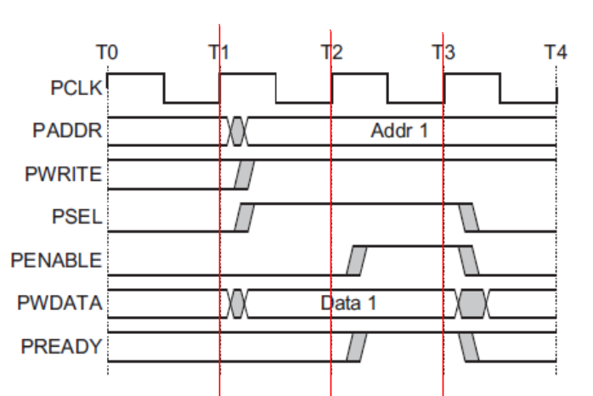
Figure- waveform of write transfer with no wait state

At T1, a write transfer starts with address PADDR, write data PWDATA, write signal PWRITE, and select signal PSEL - Setup phase (address).
At T2, enable signal PENABLE, and ready signal PREADY, are registered at the rising edge of PCLK.
When asserted, PENABLE indicates the start of the Access phase (data) of the transfer. When asserted, PREADY indicates that the slave can complete the transfer at the next rising edge of PCLK. PADDR, PWDATA, and control signals all remain valid until the transfer completes at T3, the end of the Access phase.

Write transfer with wait states

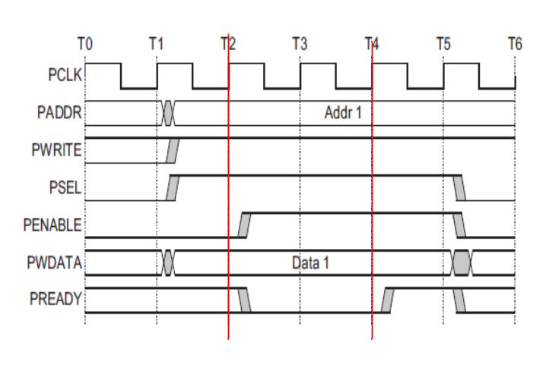
Figure- waveform of write transfer with wait states

During an Access phase, when PENABLE is HIGH, the slave extends the transfer by driving PREADY LOW. Other signals remain unchanged while PREADY remains LOW. PREADY can take any value when PENABLE is LOW.

Read transfer with no wait state

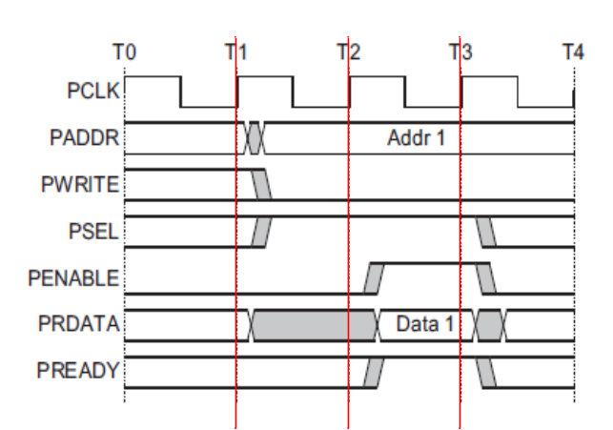
Figure- waveform of read transfer with no wait state

The timing of address, write, select, and enable signals are the same as write transfer. The slave must return the read data before the end of the read transfer.

Read transfer with wait states

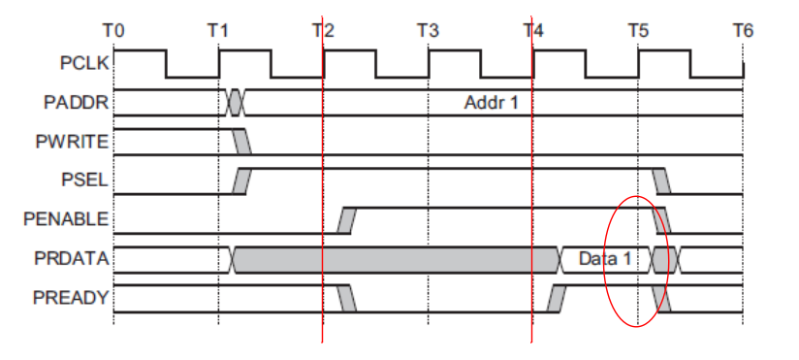
Figure- waveform of read transfer with wait states

The transfer is extended if PREADY is driven LOW during an Access phase. Other signals remain unchanged while PREADY remains LOW.

Read/Write transfers fail

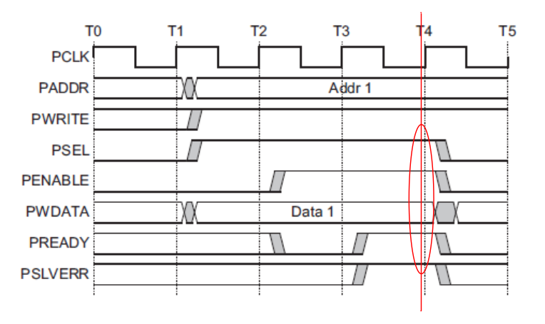
Figure- waveform of APB write transfer fail

PSLVERR is only considered valid during the last cycle of an APB transfer, when PSEL, PENABLE, and PREADY are all HIGH. - An error condition on an APB transfer. Figure- shows an error condition on write transactions.
APB peripherals are not required to support the PSLVERR pin. This is true for both existing and new APB peripheral designs.

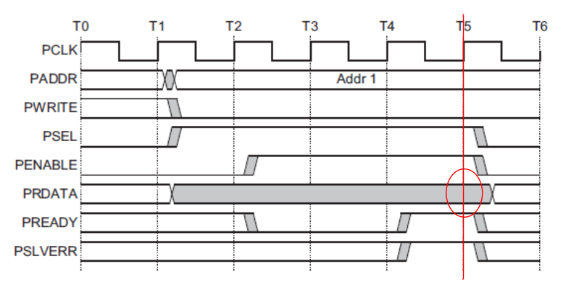
Figure- waveform of APB read transfer fail

Figure- shows a read transfer can also complete with an error response, indicating that there is NO valid read data available.
If there is any error on Read transactions:
  - Slave can return invalid data.
  - There is no requirement for the peripheral to drive the data bus to all 0s.

N8 BIU (Bus Interface Unit) design implementation for APB4

Signal descriptions

Table- shows the bus interface signals for APB4 protocol only. For the overall interface signals of BIU design, please refer to the design specification of BIU module.

Table- Signal Descriptions for APB4 protocol
Signal | Source | Description
PCLK | Clock source | APB Clock signal.
PRESETn | System bus | Reset (Active LOW).  Directly connected to the system bus reset signal.
PADDR | Core/APB bridge | APB address bus (up to 32 bits wide).
PSELx | Core/APB bridge | Slave selection.  There is a PSELx signal for each slave.This signal indicates that the slave device is selected and that a data transfer is required.
PWRITE | Core/APB bridge | Direction.  Write (HIGH) / Read (LOW)
PENABLE | Core/APB bridge | Enable.  This signal indicates the second and subsequent cycles of an APB transfer.
PWDATA | Core/APB bridge | Write data (up to 32 bits wide).  This bus is driven by the peripheral bus bridge unit during write cycles when PWRITE is HIGH.
PRDATA | Slave interface | Read Data. (up to 32 bits wide).  The selected slave drives this bus during read cycles when  PWRITE is LOW.
PREADY | Slave interface | Ready.  The slave uses this signal to extend an APB transfer.
PSLVERR | Slave interface | A transfer failure.  APB peripherals are not required to support the PSLVERR pin. This is true for both existing and new APB peripheral designs.  Pull-down by default.
PPROT | Core/APB bridge | Protection type.  A protection signal to support both non-secure and secure transactions on APB.
PSTRB | Core/APB bridge | Byte writes strobes.  There is one write strobe for each eight bits of the write data bus. Therefore, PSTRB[n] corresponds to PWDATA[(8n + 7):(8n)]. For read transfers the bus master must drive all bits of PSTRB to LOW.

Design Modifications

Design change on APB4 signals

PREADY
- Signal requirement:
1. Input of CPU core.
2 The slave drives PREADY Low when PENABLE is HIGH (access phase) to extend an APB transfer.
3. PREADY can take any value when PENABLE is LOW.

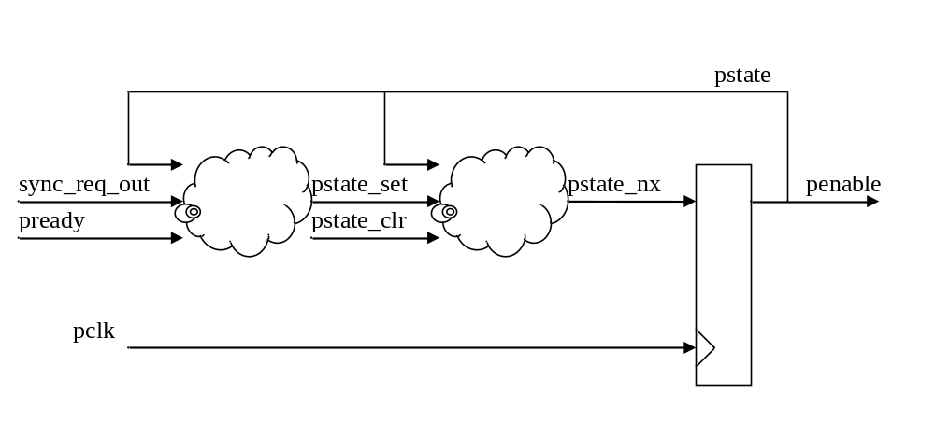
Figure- design change on pready related signals

assign pstate_set = sync_req_out & (~pstate) ;
assign pstate_clr = pstate & pready ;
assign pstate_nx = (~pstate_clr) & (pstate_set | pstate) ;

assign g_pclk_cmd_d1_clk_en = pstate_set ;
assign sync_addr_grant_in = ~pstate ;

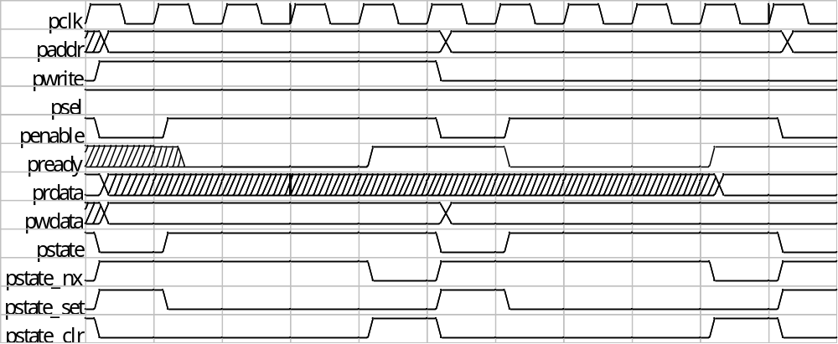
Figure- waveform of PREADY related signals

PSLVERR
Signal requirement:
1. Input of CPU core.
2. Indicating any bus read/write transfer fail.
3. This input pin will be force to zero is using original Andes APB2 protocol interface.

bus_error = (PENABLE & PREADY & PSLVERR) ;

PPROT
Signal requirement:
1. Output of CPU core
2. PPROT[0]: Normal or privileged.
3. PPROT[1]: Secure or non-secure.(no support)
4. PPROT[2]: Data or Instruction.
5. This output pin will be force to all zeros is using original Andes APB2 protocol interface.

PPROT[0] = reg_psw_pom[0]; // hprot_out[1]
PPROT[1] = 1’b0 ;
PPROT[2] = ((sync_req_id_out == FCU_ID)); // hprot_out[0]

PSTRB
Signal requirement:
1. Output of CPU core
2. Byte write strobe; tie to all zero if it is a read transfer

PSTRB = (PWRITE) ? ((pstate) ? bwe_out_d1 : sync_bwe_out)
: 4’d0 ;

System configuration for APB2 and APB4

In the original BIU design, system bus interface can be configured to use either AHBLite or APB protocol. In the modified BIU design of N801S core, RTL code can be configured to use AHBLite, APB2, or APB4 protocol.
Table- is the system configuration parameter for enabling APB4 protocol. Defining this parameter will enable the extension function of APB4. Otherwise the interface function will remain as APB2.

Table- RTL configuration parameter
Parameter Name | Description
NDS_BIU_APB4_EN | Enabling the functionality of APB4 interface protocol. Otherwise keep APB2.

Verification plan for APB4 interface
- PREADY signal generation
- Inverted from pwait
- Random wait state
- Random number of wait cycles.
- Read or write transaction.
- PREADY is asserted in either APB address phase or data phase.
- PSTRB
- Original test patterns
- No effect on read transaction
- PPROT
- Original test patterns
- PSLVERR
- Original test patterns

