

BIU APB4 Interface Design Specification



Document Number
Date Issued
Copyright© 2011-2012 Andes Technology Corporation.  All rights reserved. |  | 

Copyright Notice
Copyright© 2012 Andes Technology Corporation. All rights reserved.
Words and logos marked with ™ are registered trademarks owned by Andes Technology Corporation. Other brands and names mentioned herein may be the trademarks of their respective owners.
This document contains confidential information of Andes Technology Corporation. Use of this copyright notice is precautionary and does not imply publication or disclosure. Neither the whole nor part of the information contained herein may be reproduced, transmitted, transcribed, stored in a retrieval system, or translated into any language in any form by any means without the written permission of Andes Technology Corporation
The product described herein is subject to continuous development and improvement; information herein is given by Andes in good faith but without warranties.
This document is intended only to assist the reader in the use of the product. Andes Technology Corporation shall not be liable for any loss or damage arising from the use of any information in this document, or any incorrect use of the product.

Contact Information
Should you have any problems with the information contained herein, please contact Andes Technology Corporation
by email support@andestech.com
or online website https://es.andestech.com/eservice/
for support giving:
-  the document title
-  the document number
-  the page number(s) to which your comments apply
-  a concise explanation of the problem
General suggestions for improvements are welcome.

Revision History
Rev. | Effective Date | Revised Chapter-Section | Revised Content | Author
0.3 | 2012/6/5 | ch2, ch3 | 1. remove original ch.2 | Kane
0.2 | 2012/5/17 | ch2, ch3, ch5 | - Adding description for Andes APB2 extension interface.  - Adding Ch.5 | Kane
0.1 | 2012/1/9 | All | 1. initial draft | Kane

Table of Contents
Copyright Notice i
Contact Information i
1. Overviews on BIU APB Interface 1
2. N8 BIU (Bus Interface Unit) Interface for APB4 2
2.1. Signal descriptions 2
2.2. Andes APB extension 3
3. Design Implementations for APB4 4
3.1. PREADY 4
3.2. PSLVERR 5
3.3. PPROT 5
3.4. PSTRB 6
4. Verification Plan for APB4 7
5. System Integration 8

List of Tables
Table- 1 Signal Descriptions for APB4 protocol 2
Table- 2 Signal Descriptions for additional signals for Andes APB2 extension 3

List of Figures
Figure- 1 design change on pready related signals 4
Figure- 2 waveform of PREADY related signals 5

Typographical Convention Index
Document Element | Font | Font Style | Size | Color
Normal | Georgia | Normal | 12 | Black
Code | Lucida Console | Normal | 11 | Indigo
USER VARIABLE | Lucida Console | ALL-CAPS | 11 | INDIGO
Note/Warning | Georgia | Normal | 12 | Red
Hyperlink | Georgia | Bold + Underlined | 12 | Blue

Overviews on BIU APB Interface

In previous version design of N8 series BIU module, APB interface is implemented based on “AMBA 2 APB Specification” with two extension signals: PWAIT and PBE. This implementation is also called “Andes APB Extension” interface. The two signals are used for creating transfer wait state and enabling byte transfer on APB bus.
In the following revision of official AMBA APB bus protocol APB3 and APB4, four new signals are defined to support a more flexible APB bus transaction: PREADY, PSLVERR, PPROT, and PSTRB. For a more detail information on APB4 bus protocol, please refer to the official AMBA APB protocol specification.
In this design specification, the APB interface is designed based on AMBA APB4 protocol. The functionality of our additional signals PWAIT and PBE are also kept, configurable by system design macro definitions.

Signal Descriptions

Basic APB4 Signals
Table- shows the I/O interface of APB bus with APB4.

Table- Signal Descriptions for APB4 protocol
Signal | I/O | Width | Description
NDS_APB_SUPPORT

PCLK | Input | 1 | APB Clock signal.
PRESETn | Input | 1 | Reset (Active LOW).  Directly connected to the system bus reset signal.
PADDR | Output | ADDR_MSB - 1 | APB address bus (up to 32 bits wide).
PSEL | Output | 1 | APB select signal.
PWRITE | Output | 1 | Transfer direction.  Write (HIGH) / Read (LOW)
PENABLE | Output | 1 | Enable.  This signal indicates the second and subsequent cycles of an APB transfer.
PWDATA | Output | 32 | Write data (up to 32 bits wide).  This bus is driven by the peripheral bus bridge unit during write cycles when PWRITE is HIGH.
PRDATA | Input | 32 | Read Data. (up to 32 bits wide).  The selected slave drives this bus during read cycles when  PWRITE is LOW.
PREADY | Input | 1 | Ready.  The slave uses this signal to extend an APB transfer (asserted LOW to indicate additional wait cycles).
PSLVERR | Input | 1 | A transfer failure.  APB peripherals are not required to support the PSLVERR pin. This is true for both existing and new APB peripheral designs.  Pull-down by default.
PPROT | Output | 3 | Protection type.  A protection signal to support both non-secure and secure transactions on APB.
PSTRB | Output | 4 | Byte writes strobes.  There is one write strobe for each eight bits of the write data bus. Therefore, PSTRB[n] corresponds to PWDATA[(8n + 7):(8n)]. For read transfers the bus master must drive all bits of PSTRB to LOW.

Andes APB extension
Table- shows the additional two signals for Andes APB extension. Andes APB extension is the standard APB2 interface plus two signals: PWAIT & PBE.
  - PWAIT: APB transfer wait signal. PWAIT is driven HIGH when PENABLE is HIGH to indicate additional wait cycle at access phase (the inverse of PREADY).
  - PBE[3:0]: APB bytes enable signal. When asserted HIGH, each bit of PBE indicates the corresponding byte of either read or write data bus contains valid data.

Table- Signal Descriptions for additional signals for Andes APB extension
Signal | I/O | Width | Description
NDS_APB_EXTENSION
PWAIT | Input | 1 | Transfer wait.  The slave uses this signal to extend an APB transfer (asserted HIGH to indicate additional wait cycles).
PBE | Output | 4 | Bytes enable.  When asserted HIGH, each bit of PBE indicates the corresponding byte of either read or write data bus contains valid data.

Design Implementations for APB4

PREADY
- Signal requirement:
1. Input of CPU core.

2. PREADY is driven LOW when PENABLE is HIGH (at access phase) to extend an APB transfer.
3. PREADY can take any value when PENABLE is LOW.

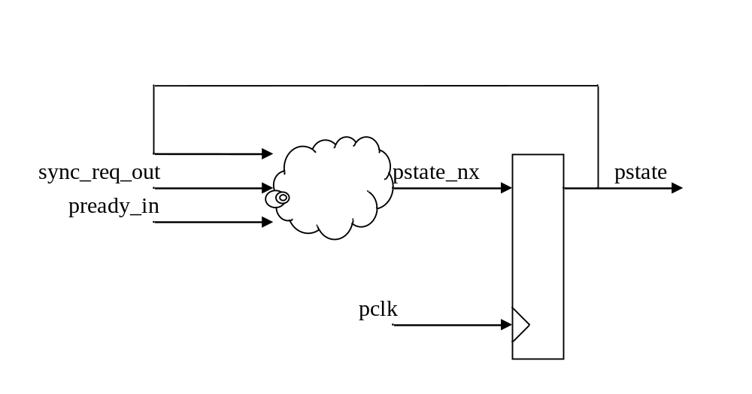
Figure- design change on pready related signals

assign pstate_set = sync_req_out & (~pstate) ;
assign pstate_clr = pstate & pready_in ;
assign pstate_nx = (~pstate_clr) & (pstate_set | pstate) ;

always @(posedge pclk or negedge preset_n) begin
if (!preset_n)
pstate <= 1'b0;
else
pstate <= pstate_nx;
end

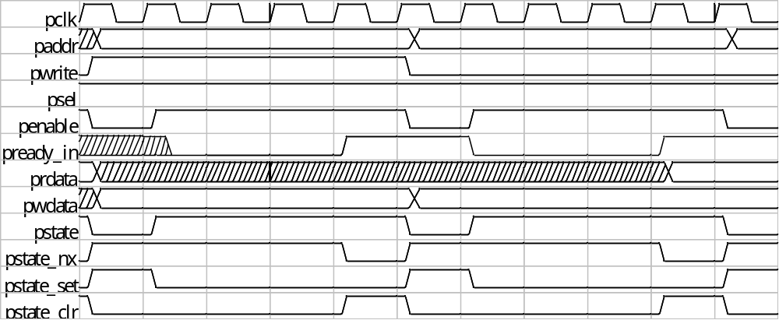
Figure- waveform of PREADY related signals

PSLVERR
Signal requirement:
1. Input of CPU core.
2. Indicating any bus read/write transfer fail.

sync_bus_error_in = (pstate & pready_in & pslverr) ;

PPROT
Signal requirement:
1. Output of CPU core
2. PPROT[0]: Normal or privileged.
3. PPROT[1]: Secure or non-secure.(no support)
4. PPROT[2]: Data or Instruction.

PPROT[0] = reg_psw_pom[0];
PPROT[1] = 1’b0 ;
PPROT[2] = ((sync_req_id_out == FCU_ID)) ;

PSTRB
Signal requirement:
1. Output of CPU core
2. Byte write strobe; tie to all zero if it is a read transfer

PSTRB = (PWRITE) ? ((pstate) ? bwe_out_d1 : sync_bwe_out)
: 4’d0 ;

Verification Plan for APB4
- Slave model supporting APB4.
- PREADY signal generation

- Random wait state
- Random number of wait cycles.
- Read or write transaction.
- PREADY is asserted in either APB address phase or data phase.
- PSTRB
- Original test patterns
- No effect on read transaction
- PPROT
- NEW
- PSLVERR
- NEW

System Integration
If user is using Andes extended APB2 interface (`define NDS_APB_EXTENSION), the PWAIT and PBE signals will exist in the port list along with PREADY, PSTRB, and other APB4 signals. Followings are the guidelines to handle these signals properly:
- PREADY/PWAIT
- Input
`ifdef NDS_APB_EXTENSION
assign pready_in = pready & ~pwait; /* with APB extension */
`else
assign pready_in = pready; /* APB4 only */
`endif
  - With APB extension
    - If using PREADY, tie PWAIT to LOW.
    - If using PWAIT, tie PREADY to HIGH.
- PSTRB/PBE
- Output – floating connection to the unused signals.
`ifdef NDS_APB_EXTENSION
assign pbe = (pstate) ? be_out_d1 : sync_be_out;
`endif
- PSLVERR
- Input – tie to LOW if not using.
- PPROT
- Output – floating connection if not using.

