Introduction
This document describes the basic component and design methodology of the bus interface unit (BIU) for Panther.

Features
- AXI instruction and data channels
  - AMBA™ AXI4
  - Configurable address width: 24 to 64-bit
  - Data width: 64-bit
- Synchronous bus clock domain
  - Single “core clock” input
  - Clock phase enable signal
- Synchronous FIFO queue for bus command/data
- Simplified cacheability indication
  - From $MR3(TLB_DATA) to AR/WCACHE[3:0] for memory type encoding (AXI4)
- Interface changing between BIU and other internal modules
  - Add wait-cycle to return data phase (ready-valid (ack) handshaking protocol)
- Snooping Control Unit (SCU) integration
  - Integrate with ACU (Andes Coherence Unit; external)
  - Snoop address/response/data channels
  - Snooped entry canceling channel

Block Diagram
Figure 1 shows the block diagram of the bus interface unit (BIU) along with the snoop control unit (SCU). The BIU module is composed of two data paths:
- AXI bus access path
- Snooping control access path.

AXI_wrapper
BIU_PATH
SCU
MMU/LSU/FCU/LDMA/EDM/PCU/PFM
AXI
sync_fifo
Figure 1 Overview of the Bus Interface Unit (with SCU)

AXI Bus Access
BIU is for instruction fetching and data accessing to the external bus (AXI). It can access the bus with multiple synchronous clock ratios. The AXI bus access path has three sub-blocks: BIU_PATH, sync_fifo, and AXI_wrapper.

- BIU_PATH
BIU_PATH module is for exchanging control/data with other internal components that needs to access the AXI bus. A ready-valid (ack) handshaking protocol is needed to insert wait cycles between BIU and other modules. The bus access request is arbitrated by BIU_PATH and sent into the synchronous FIFO queue. The bus read data is also store into the FIFO and then sent back to internal modules.

- SYNC_FIFO
For each command/read data/write data channels, synchronous FIFO queues (with configurable width/depth) are needed to buffer the command and data. The FIFOs take single clock input (core_clk) and qualify the clock phase enable signal (bus_clken) for read/write strobe.

- AXI_wrapper
The AXI_wrapper issues the read/write access to the AXI bus. It supports the AMBA AXI4 bus protocol.

Snooping Control Access
The snooping control access path is used to issue/receive the snooping request/response from the external Andes Coherent Unit (ACU). It has three access channels: snoop address, snoop response, and snoop data. The internal snoop request is from LSU (load store unit).

Another access channel may be needed in order to cancel the in-queue FIFO entry if it has been snooped by another core on-the-fly.

Micro-Architecture

Ready-Valid (ack) Handshaking Protocol
For interface between BIU and core’s internal modules, wait cycles for return data phase is needed. The “ready-valid (ack) handshaking protocol” performs the transaction by:

“Write transaction - request”:
- Transfer request with write command (cmd==1).
- Write address with write data and ready
- The command/data are hold until BIU returns ack.
“Write transaction – ack”:
- Command granted
- Acknowledge write data

The command/data are hold until BIU returns ack. Figure 2 shows the waveform of two single write transaction.

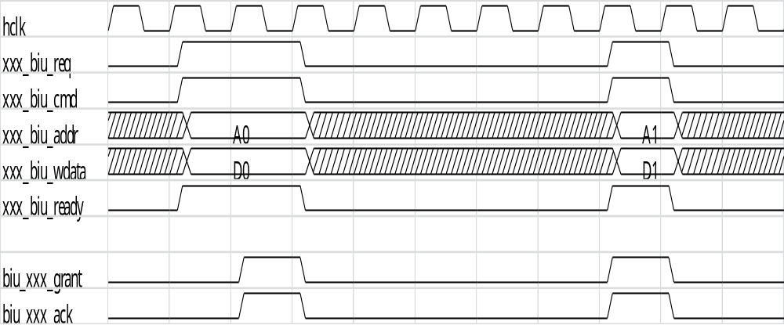
Figure 2 Write transaction

“Read transaction - request”:
- Transfer request with write command (cmd==0).
- Read address
- The command is hold until BIU returns ack.
“Read transaction – grant”:
- Command granted
“Read transaction – data-ack”:
- Read data
- Read data acknowledge
“Read transaction – data-ready”:
- Source module is ready to receive the read data
- Source module does not have to receive the response data immediately (when “ack” is asserted)
- No pre-allocated buffer is needed for the source module, reduce area overhead

Figure 3 shows the waveform of two single write transactions with wait cycles.

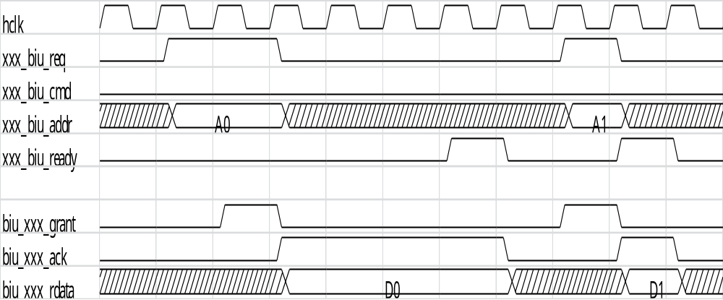
Figure 3 Read transaction

If a source module wants to issue back-to-back requests, the subsequent transaction can only be issue after the previous data phase has completed. Figure 4 shows a back-to-back sequence of a read transaction followed by a write transaction.

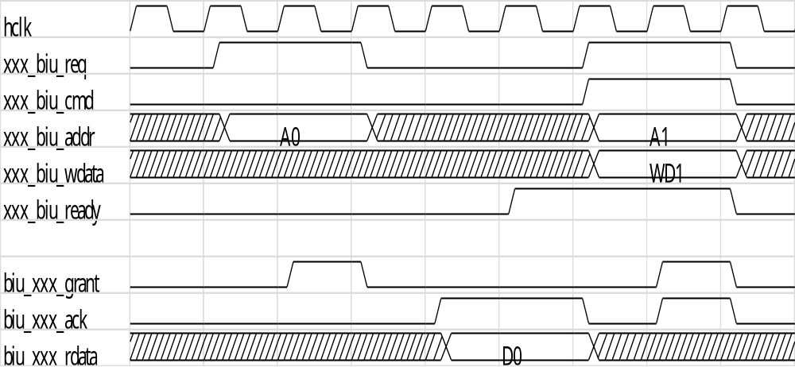
Figure 4 Back-to-back Read-Write transaction

Cacheability Indication
- Use “C” field from $MR3 (TLB_DATA)
- Translate to output AR/WCACHE[3:0] for memory type encoding (AXI4)
- REF: bug#6608 bug#11341

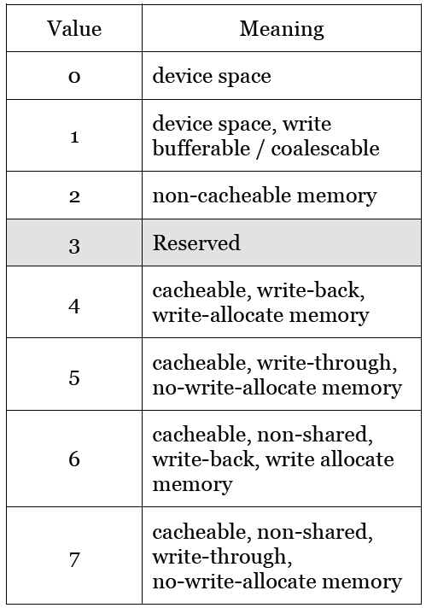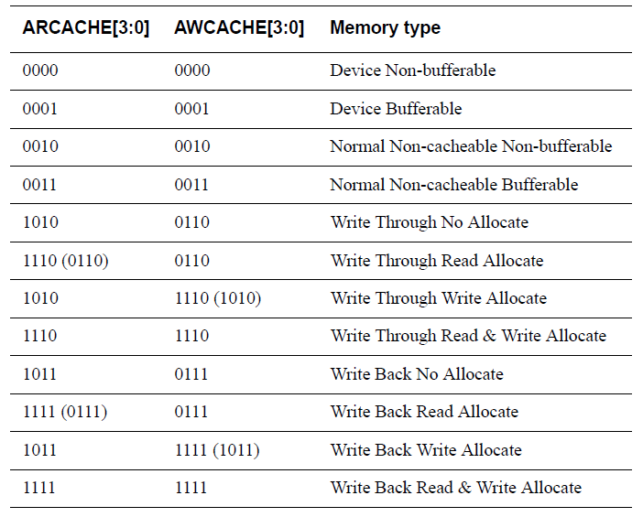

Snooped Entry Canceling Channel
How to cancel WB command/data queue entry after hit by snoop from other cores?
- In-queue
- Not observed by AXI interface (not top)

ACU

BIU

SCU

LSU

wb_fifo_0
wb_fifo_1
wb_fifo_2
wb_fifo_3
wb_fifo_0
wb_fifo_1
wb_fifo_2
wb_fifo_3
Cancel FIFO entry
Provide snoop data

Appendix

Table 1

