Micro-Architecture for Cache Controller, Load/Store Unit, Memory Management Unit and Bus Interface Unit
Written by Arthur Wen
- Cache Controller
There are two cache controllers in WhiTiger. One is instruction cache controller, and the other is data cache controller. Below sections show you the details.
Note that there are some special cache management instructions defined in WhiTiger ISA. Instruction ‘isync’ needs to send to both I-cache and D-cache controllers and have to wait for each other’s completion.

  - Cache Management Instructions
ps: the following cache instructions are extracted from Chuan-Hua’s cache document
    - CacheControl (CCTL)
Instruction: CacheControl (CCTL) – A32 (baseline)
Pseudo-op of “MTFR CacheSR, Ra, SubType”
Format: CCTL Ra, SubType
Purpose: Perform various operations on processor caches. This instruction is typically used by software to maintain cache coherence for shared memory.
Description:
This instruction is used to perform cache control operations based on the SubType field. The definition for the SubType field is listed in the following table. Some CCTL operations can be used with user privilege to assist in coherence and synchronization management.

SubType | Operation | Ra Type | User Privilege | Compliance
0 | Invalidate L1D cache | Index | - | Required
1 | Invalidate L1D cache | VA | Yes | Required
2 | Write Back L1D cache | Index | - | Required
3 | Write Back L1D cache | VA | Yes | Required
4 | Write Back & Invalidate L1D cache | Index | - | Required
5 | Write Back & Invalidate L1D cache | VA | Yes | Required
6 | Load and Lock L1D cache | VA | - | Optional
7 | unlock L1D cache | VA | - | Optional
8 | Read tag and data L1D cache | Index | - | Optional
9 | Write tag L1D cache | Index | - | Optional
10 | Load and Lock L1I cache | VA | - | Optional
11 | unlock L1I cache | VA | - | Optional
12 | Invalidate L1I cache | Index | - | Required
13 | Invalidate L1I cache | VA | Yes | Required
14 | Read tag and data L1I cache | Index | - | Optional
15 | Write tag L1I cache | Index | - | Optional

The content of the register Ra is used to find the correct cache location for the cache operation. It is used in the following two ways:

Ra Type | Usage
Index | The content of Ra is used directly as a (Index, Way) pair to access the cache location without going through any translation mechanism. The real format for the (Index, Way) pair in the content of Ra is per cache implementation-dependent. However, it should have a general form shown in Figure 1. Software could discover the real format by consulting the Cache Type Configuration Registers in the Andes processor core.
VA | The content of Ra is used as a virtual address to access the cache. The address goes through the same address translation mechanism in the processor pipeline as the address of a load/store instruction for D cache or an instruction fetch for I cache. And the specified operation is only performed if the address hits in the corresponding cache. If the cache is missed, no specific operation is performed.

Index
Way
Bytes in Cache Block
(BCB)
0
A
B
C
Fig. 1 Index type format for Ra of CCTL instruction
A = Log2(BCB)
B = Log2(Cache size / # of ways)
C = Ceiling(Log2(Cache size))
The operations of the cache control instruction can be grouped and described in the following categories:
- Invalidate cache block
This operation unlocks the cache line and sets the state of the cache line to invalid. It is implementation-dependent on how this instruction affects other states of the cache line such as “way selection”.
- Write back cache block
If the cache line state is valid and dirty in a write-back cache, this operation writes the cache line back to memory. It does not affect the lock state of the cache line.
- Write back & invalidate cache block
If the cache line state is valid and dirty in a write-back cache, this operation writes the cache line back to memory, and then performs a cache block invalidating operation described in (1).
- Load and Lock cache block
If the desired cache line is not present in the cache, this operation fills the cache line into the cache and then sets the lock state of the cache line. If the desired cache line is present in the cache, only the lock state will be set. A locked cache line will not be replaced when a cache miss/fill event happens. A locked cache line can only be unlocked using a cache invalidate or unlock operation. Since this cache line lock operation is defined under the implementation assumption of a multi-way set-associative cache, the support of this operation is implementation dependent. And if this instruction is supported for a multi-way set-associative cache, only up to “way-1” cache lines in a cache set can be locked using this instruction. If software wants to get a predictable behavior, care must be taken to avoid locking more than “way-1” cache lines in a cache set.
- Unlock cache block
This operation clears the lock state of the cache if the desired cache line is present in the cache.
- Read tag and data from cache
This operation reads the contents of cache line tag and data into system registers. The format and encoding of these system registers are implementation dependent. The content of Ra specifies the index and way of the target cache line.
- Write tag to cache
This operation writes the cache line tag from a system register. The content of Ra specifies the index and way of the target cache line.

Operations:

If (SubType is not supported)
Exception(Reserved Instruction);
If (RaType(SubType) == VA) {
VA = (Ra);
PA = AddressTranslation(VA);
VA_cache_control(SubType, PA);
} else {
{Idx,way} = (Ra)
Idx_cache_control(SubType, Idx, way);
}

Exceptions:
TLB fill exception, Non-Leaf PTE not present exception, Leaf PTE not present exception, Read protection violation exception, TLB VLPT miss exception, Imprecise bus error exception, Reserved instruction exception

Privilege level: Depends on operation types.
Usage (Note)

    - Instruction Data Coherence Synchronization (ISYNC)
Instruction: Instruction Data Coherence Synchronization (ISYNC) – A32 (baseline)
Format: ISYNC Ra
Purpose: Make sure instruction data updated in the cache line address specified by Ra can be observed by the instruction fetch event performed after a sequence of MSYNC and instruction hazard clearing instruction (HBI or IRET).

Description:

This instruction is used to guarantee that any instruction data updated before this instruction can be properly observed by an instruction fetch event after a sequence of MSYNC and instruction hazard clearing instruction. This instruction alleviates the Andes architecture implementation from implementing coherence logic between instruction and data cache in order to handle self-modifying code.

Software is required to use this instruction and the correct instruction sequence, after generating new instruction data, to synchronize the updated data between I and D caches in order to correctly execute the newly modified instruction later defined after a MSYNC and an instruction hazard clearing instruction. If this instruction and the correct instruction sequence are not used in the above situation, the Andes implementation may still fetch and execute the old instruction data after any period of time.

After updating instruction data, this instruction initiates a data cache write-back operation and an instruction cache invalidating operation. The subsequent MSYNC instruction makes sure all such data cache write-back operations are complete without getting delayed by the write buffer between the data cache and the memory. The instruction hazard clearing instruction ensures that all subsequent instruction fetches start after the completion of all above operations.

The content of Ra specifies the virtual address of the data cache line which contains the instruction data. It goes through the same address mapping mechanism as those associated with load and store instructions. Thus, address translation and protection exceptions could happen for this instruction.

Operation:
VA = (Ra)
PA = AddressTranslation(VA)
SynchronizeAllCaches(PA)

Exceptions:
TLB fill exception, Non-Leaf PTE not present exception, Leaf PTE not present exception, Read protection violation exception, TLB VLPT miss exception, Imprecise bus error exception, Machine check exception

Privilege level: User and above

    - Memory Data Coherence Synchronization (MSYNC)
Instruction: Memory Data Coherence Synchronization (MSYNC) – A32 (baseline)
Format: MSYNC SubType
Purpose: This is a collection of Memory Barrier operations to ensure completion (locally or globally) of certain phase of memory load/store operations. This instruction is used to order loads and stores for synchronizing memory accesses between two and more Andes cores or an Andes core and the other Direct Memory Access agent.

Description:
This instruction is used for any non-strongly ordered load and store operations where software wants to ensure certain memory access order from these operations assuming that the hardware implementation will not automatically ensure the required ordering behavior. Hardware implementation is free to enforce more ordering behavior. And in such a case, this instruction becomes a NOP.

The following table lists the SubTypes:
SubType | Name
0 | Memory Fence
1 | Drain Write Buffer
2 - above | Reserved

If a Reserved SubType is used in this instruction, a Reserved Instruction Exception will be generated.

- SubType 0, Memory Fence:
For an implementation which does not support coherent caches, this operation ensures that all loads and non-dirty stores before this instruction completes before all loads and stores after this instruction can start. Non-dirty store includes non-cacheable store, and cacheable store which has been written back implicitly or explicitly.

For an implementation which support coherent caches, this operation ensures that all loads and stores before this instruction completes before all loads and stores after this instruction can start.

Completeness for a load means the destination register is written. Completeness for a store means the stored value is visible to all memory access agents in the system.

This operation does not enforce any ordering between load and store instructions and instruction fetches.

- SubType 1, Write Memory Fence:
For an implementation which does not support coherent caches, this operation ensures that all non-dirty stores before this instruction completes before all loads and stores after this instruction can start. Non-dirty store includes non-cacheable store, and cacheable store which has been written back implicitly or explicitly.

For an implementation which support coherent caches, this operation ensures that all stores before this instruction completes before all loads and stores after this instruction can start.

Completeness for a store means the stored value is visible to all memory access agents in the system.

This operation does not enforce any ordering between load and store instructions and instruction fetches.

Operation:
MemoryDataSynchronization(SubType)

Exceptions:
Reserved instruction exception

Privilege level: User and above

  - Instruction Cache
    - Instruction Cache Attribute
Instruction cache stores the instructions that are tended to be executed by the processor. To make it flexible for different needs, below attributes are defined.

ASSOCIATIVITY: 1, 2, 4
DATA: 32 bits
LINE_SIZE: 16B or 32B
SIZE : 8KB, 16KB, 32KB, 64KB

The size and content in the cache is defined as follows:
Data Array : LINE_SIZE x ASSOCIATIVITY
LRU Array: 6 bits (indicates 1 of 24 states)
Pseudo LRU Array: 3 bits
Tag per way : 22b: { PA[31:12], valid, lock }
Data per Way: 32b

    - Instruction Cache Interface with Instruction Fetch Unit
ifu_icache_req_f0
ifu_icache_va_f0
icache_ifu_stall_f0
icache_ifu_hit_f2
icache_ifu_data_f2
icache_ifu_tag_f2

hit
Data/tag_F2
PA
Va_f0
Req_f0
A
X
B
PB
PC
X
C
D
E
X
I$_biu_req
stall
I$_biu_last
F
Biu_I$_ack
PD
PE
G
Va_f1
A
X
B
C
D
E
G
F
PF
PG
X

    - Instruction Cache Arbiter
WAIT
I-FB
Flush
I-Cache instruction
IF1
Recovery
IF0
Fetch
RESET
no_req && if1_valid
no_req && !if1_valid
some_req

    - Block Diagram of Instruction Cache Controller

I-cache arbiter
Icache
Icache
Icache
Icache
I-FB flush
I-cache inst
Queue
hit
F0
F1
F2
F0 fetch
Icache miss biu request
To BIU
Icache_If_stall
IFB
IFB tag/data
To IFU
FB
Icache
WS
LRU policy manager
Instruction
Issue unit
I-cache tag
Invalidate/write

  - Data Cache
    - Data Cache Attribute
Data cache stores the data that is tended to be accessed by the processor. To make it flexible for different needs, below attributes are defined in config.v

ASSOCIATIVITY : 4
DATA: 32 bits
LINE_SIZE: 16B or 32B
SIZE: 4KB, 8KB, 16KB, 32KB, 64KB

`ifdef DCACHE16KB
`ifdef CACHELINE16B // cacheline = 16B
`define DCACHE_INDEX_MSB 11
`define DCACHE_INDEX_LSB 4
`define DCACHE_INDEX_BITS 8
`else // cacheline = 32B
`define DCACHE_INDEX_MSB 11
`define DCACHE_INDEX_MSB 5
`define DCACHE_INDEX_BITS 7
`endif
`endif

`ifdef DCACHE32KB
`ifdef CACHELINE16B // cacheline = 16B
`define DCACHE_INDEX_MSB 12
`define DCACHE_INDEX_LSB 4
`define DCACHE_INDEX_BITS 9
`else // cacheline = 32B
`define DCACHE_INDEX_MSB 12
`define DCACHE_INDEX_MSB 5
`define DCACHE_INDEX_BITS 8
`endif
`endif

The size and content in the cache is defined as follows:
Data Array: 16 bytes or 32 bytes
Tag Array: 22b {PA[31:12], valid, lock}
LRU+Dirty : 6b LRU + (4b Dirty) (use FF to implement asynchronous RAM)
Pseudo LRU+Dirty : 3b LRU + (4b Dirty) (use FF to implement asynchronous RAM)

    - Data Cache Interface
inst_dcache_req, inst_dcache_cmd, inst_dcache_ack, inst_dcache_addr, inst_dcache_wr_en, inst_dcache_wr_data, inst_dcache_rd_data (to dcache arb)

fb_dcache_req, fb_dcache_cmd, dcache_fb_ack, fb_dcache_addr, fb_dcache_wr_en, fb_dcache_wr_data

dirtywb_dcache_req, dirtywb_dcache_cmd, dcache_dirtywb_ack, dirtywb_dcache_addr, dcache_dirtywb_rd_data

lsu_cmd_valid_e2
lsu_dcache_index_e2
store_valid_wb
lsu_dcache_index_wb

lsu_dcache_data_index_e1
lsu_dcache_tag_index_e1

lsu_dcache_ws_index_e3
lsu_dcache_ws_we_e3
lsu_dcache_ws_valid_e3

    - Data Cache Arbiter
Data cache arbiter is responsible for managing the ownership of data cache access. There are basically 5 kinds of request to be managed. 1. Address generation unit (AGU): D-cache lookup. 2. D-cache store at DA2 stage. 3. D-cache Dirty write back request. 4. Fill buffer (FB) request. 5. Cache instruction execution. Item1 and 2 are done implicitly by properly analyzing resource allocation table. Item 3~5 are done by external D-cache arbiter. The default owner of d-cache is the AGU. When there is any request from other sources, the ownership can be switched by issuing dcache_ag_stall signal to AGU. It will stall AGU. When the ownership is switched back to AGU, the D-cache address needs to be set to the address in DA1 stage if there is a valid command pending in DA1. Below state diagram shows you some details.

WAIT
FB
Flush
D$ dirty
writeback
D-Cache instruction
DA1/WB
Recovery
AGU lookup
RESET
no_req && da1_wb_valid
no_req && !da1_wb_valid
some_req
    - Block Diagram of Data Cache Controller

D-cache arbiter
Dcache
Dcache
Dcache
Dcache
FB flush
Dcache dirty Writeback
AG
DA1
DA2
AGU lookup
D-cache inst
D-cache inst
D-cache inst
From Instruction Issue Unit

  - Replacement Policy Manager
    - LRU Replacement
LRU Replacement policy manager is responsible for updating the status of cacheline in the cache and also choosing the right cacheline to be replaced. There are several events that will update the status of cacheline.
• When there is a cache hit, the associated cacheline is updated to be the most recently used(MRU).
• When there is a cache refill, the filled cacheline is updated to be the MRU.
• When executing CACHE instructions, the update of the LRU bits depends on the type of operation to be performed: (TBD)
• Index (Writeback) Invalidate: Least-recently used (LRU)
• Index Load Tag: No update.
• Index Store Tag, WST=0: Most-recently used if valid bit is set in TagLo CP0 register. Least-recently used if
valid bit is cleared in TagLo CP0 register.
• Index Store Tag, WST=1: Update the field with the contents of the TagLo CP0 register (refer to Table 8-4 for
the valid values of this field).
• Index Store Data: No update.
• Hit Invalidate: Least-recently used if a hit is generated, otherwise unchanged.
• Fill: Most-recently used.
• Hit (Writeback) Invalidate: Least-recently used if a hit is generated, otherwise unchanged.
• Hit Writeback: No update.
• Fetch and Lock: For instruction cache, no update. For data cache, most-recently used.

      - LRU Implementation
        - Introduction
The implementation of the 4-way LRU Replacement policy manager is elaborated through the following sub-section. The LRU way-select(WS) cache array is initialized to {“00”, “01”, “10”, “(11)” } which indicates that ways from left-to-right (way-0 to way-3) is in LRU-to-MRU order. The way-3 value in parenthesis is not saved in the cache, instead, it is calculated by XORing the other three 2-bit pairs, i.e., “(11)” = “00” xor “01” xor “10”. Whenever there is access hit in data cache, MRU_update is generated. There are 4 hit signals defined for the update event, i.e., hit0, hit1, hit2 and hit3. The hitn signal indicates that the way-n will be moved to the right-most field of this array entry.

        - MRU update
Assuming that the content in the WS cache is { W0, W1, W2, (W3) } where W0-W3 are 2-bit value indicating the way number from LRU to MRU from left to right.
When there is a MRU update, the selected way will be moved to the right-most field.
{ W0, W1, W2, W3 } -> { W1, W2, W3, W0 } when hit0 is true
{ W0, W2, W3, W1 } when hit1 is true
{ W0, W1, W3, W2 } when hit2 is true
{ W0, W1, W2, W3 } when hit3 is true
W0 can be transited to W1 or W0
W1 -> W2 or W1
W2 -> W3 or W2
W3 -> W0, W1, W2 or W3

For cache hit, below operations are performed.
E0 = hit1 || hit3;
E1 = hit2 || hit3;
W3 = W0 ^ W1 ^ W2;
New_W0 = (hit0 ? W1 : W0 );
New_W1 = (hit0 || hit1) ? W2 : W1;
New_W2 = (hit3 ? W2 : W3);
(New_W3) = ({E1, E0} == 2’b00 ? W0 :
{E1, E0} == 2’b01 ? W1 :
{E1, E0} == 2’b10 ? W2 :
W3 ); // {E1, E0} == 2’b11

For cache miss, below operations are performed.
replace_hit0 = (W0==2’b00);
replace_hit1 = (W0==2’b01);
replace_hit2 = (W0==2’b10);
replace_hit3 = (W0==2’b11);
replace_hit01 = replace_hit0 || replace_hit1;
replace_hit23 = replace_hit2 || replace_hit3;
replace_New_W0 = (replace_hit0 ? W1 : W0 );
replace_New_W1 = (replace_hit01) ? W2 : W1;
replace_New_W2 = (replace_hit3 ? W2 : W3);

    - Pseudo LRU Implementation
The implementation of Pseudo LRU is based on the priority binary tree as shown in below figure.

LRU[2]
LRU[0]
LRU[1]
0

1
2
3
0

0

1
1
1
0
Lru[n] is the current content stored in LRU array. New_lru[n] is the new LRU content to be written into LRU array under cache hit condition. Replace_new_lur is the new LRU content to be written into LRU array under cache miss condition.
For cache hit, below operations are done.
New_lru[2] = hit01;
New_lru[1] = hit2 || ( hit01 && lru[1] );
New_lru[0] = hit0 || (~hit01 && lru[0]);

For cache miss, replacement is done as follows:
replace_hit0 = !lru[2] && !lru[0];
replace_hit1 = !lru[2] && lru[0];
replace_hit2 = lru[2] && !lru[1];
replace_hit3 = lru[2] && lru[1];
replace_hit01 = replace_hit0 || replace_hit1;
replace_hit23 = replace_hit2 || replace_hit3;

replace_new_lru[2] = replace_hit01;
replace_new_lru[1] = replace_hit2 || (replace_hit01 && lru[1]);
replace_new_lru[0] = replace_hit0 || (~replace_hit01 && lru[0])

    - Pseudo Random Implementation
Whenever there is a D-cache replacement to be done, below operation is performed to determine which way to be replaced.
Hash_index = { previous_va_index_even ^ current_va_index_even,
previous_va_index_odd ^ current_va_index_odd }
WS2
WS3
WS1
WS0
RESET
Hash_index =0
Hash_index =1
Hash_index =2
Hash_index =0
Hash_index =0
Hash_index =3
    - Conflict Resolution for Replacement Policy
When all entries are locked and a replacement is requested, we will need to choose a scheme to handle this. Below shows you the schemes we have so far.

      - Exception-Based Handling
When entries are all locked, a software exception will be generated and will let OS to handle this. Note that the exception handler and related data/codes need to be locked in I-cache, D-cache and TLB; otherwise, deadlock might happen under worst case scenario.

      - Un-cacheable-Based Handling
When entries are all locked, hardware will not replace any entry, instead, it will just convert cacheable access to non-cacheable access.

      - Random/LRU Replacement Handling
When entries are all locked, hardware will replace one locked entry based on LRU/random policy and treat it as unlocked case.

- Address Generation (AG) Unit and Load/Store Unit
  - Block Diagram
AG
/ E1
WB
shifter
and
adder
OPA
OPB
SI
index
D-cache
Tag
D-cache
Data
VA
Post-inc Buffer
LDB1
LDB2
D-uTLB
Tag/Data
D-cache
WS
SB
SB/SB1/SB4/FB data
SB/SB1/
SB4/FB
Tag
D$
(Data)
cmp
PA
store data
From BIU
Ld/st miss
Dcache_stall
bypass
bypass
bypass
From BIU
Ld miss
Align
logic
cmp
hit
Write
queue
To
BIU
from
SB
WT/
UNC
Dirty
WB
LRU
bypass
OPA
Postinc
MTLB
D-cachemiss
To
BIU
PA
FB
Data
tag
SB1
SB4
To
WB
SB1
Rt_5
bypass
from
ALU
DA2
/ E3
Endian
logic
Endian logic
Post-inc Buffer
Post-inc Buffer
hit
WBD
WBD
optional
optional
dirty
Replacement
manager
optional
DA1
/ E2

  - Address Generation Unit
    - Introduction
Address generation unit is responsible for calculating the address for load/store instructions. In AG stage, it takes operand A (OPA), operand B (OPB) and shift index (SI) as inputs and will do two kinds of address calculations. One address calculation is to calculate OPA+(OPB<<SI). The other is to use OPA as address and calculate post increment on OPA, i.e., OPA = OPA + (OPB<<SI).

    - Interface from Register File
Register file generates valid, signed-extension, load/store command type, transfer type, OPT, OPA, OPB and shift index. See the details in Interface signals section.
2-bit Load sequence number (LSN) from register file is defined for dependency checking for load to use situation. This LSN will be passed to the DA1, DA2 stages. When the load value is ready, DA2 stage will send an acknowledge signal back to register file stage with a sequence number associated with it. RF stage uses this sequence number to determine when the dependency is resolved.

    - Stall Events
There are two kinds of stall in AG unit. The first is from data cache arbiter and the other is from DA1 unit. Data cache arbiter generates dcache_ag_stall to indicate that it’s servicing other request and therefore the AG unit has to stall. DA1 generates da1_ag_stall to indicate it is stalled and therefore backpressure to AG unit. All the stall events need to send back to RF stage to stall it.

    - Post Increment on OPA
When the incoming load/store instruction requires post-increment on OPA, the post-increment buffer will be written in DA1 stage and it will be used to bypass the latest result of OPA for register file access.

    - Interface Signals
core_reset_n,
core_clk,
// global registers
reg_asid,
reg_default_page_size, // default page number : 0 = 4k, 1=8k
// register file interface
rf_ag_valid_e1, // 1=valid command 0 = invalid command
ag_rf_stall, // ag want to stall rf
rf_ag_se_e1, // 1= sign extension to op_t 0 = no sign extention to op_t
rf_ag_load_store_n_e1, // 1= load instruction 0= store instruction
rf_ag_load_seq_num_e1, // sequence number associated with load instruction for
// dependency check in RF stage (load-to-use)
rf_ag_transfer_type_e1, // 0=byte transfer, 1= halfword transfer,
// 2 = word transfer, 3= entire cacheline(for prefetch cmd)
Rf_ag_ls_seg_e1, // 00: first, 01: middle, 10: last, 11: single // for LDM/STM
Rf_ag_dcache_valid,
Rf_ag_dcache_cmd, // 0000:

rf_ag_op_t_index_e1, // target operand index
rf_ag_op_t_e1, // target operand content
rf_ag_op_a_index_e1, // indicate which GPR is in OPA
rf_ag_op_a_e1, // OPA content
rf_ag_op_b_e1, // OPB content for address calculation
rf_ag_op_b_si_e1, // OPB shift index for address calculation
rf_ag_addr_type_e1, // 0 : address=op_a + (op_b << si)
// 1: address = op_a; op_a = op_a + (op_b << si);
// address gen to da1 interface
ag_da1_valid_e2, // valid command from ag to da1
da1_ag_stall, // da1 wants to stall ag
ag_da1_se_e2, // signed extension on op_t
ag_da1_op_a_wr_e2, // for post increment
ag_da1_op_a_index_out_e2, // for post increment
ag_da1_op_a_wr_data_e2, // for post increment
ag_da1_va_e2,
ag_da1_load_store_n_e2,
ag_da1_load_seq_num_e2, // load sequence number
ag_da1_op_t_index_e2, // load/store commands
ag_da1_op_t_e2, // for load
// Data Cache access
ag_dcache_req_e1,
ag_dcache_index_e1,
dcache_ag_stall // data cache is busy
// interruption invalidate
interruption_invalidate_wb // interruption invalidate

  - Load/Store Unit
Load/store unit is responsible for loading memory content to register or store register content to memory. There are three pipeline stages associated with load/store unit. One is data access1 stage, another is data access2 stage, and the other is WB stage. Below subsections shows you some more details.

    - Data Access 1 Stage
Data access1 stage performs DTLB hit/miss check and everything runs smoothly if hit occurs. When D-uTLB miss occurs, DA1 stalls AG unit. On D-uTLB miss, MTLB request will be generated to get the TLB information and write it to D-uTLB as data returns from MTLB. After D-uTLB is updated, the DTLB hit becomes active and un-stall AG unit. At the same time, DA1 pushes a command to DA2 for further processing. (However, if DA2 is stalling DA1 while D-uTLB is updated, DA1 & AG will be stalled too. DA1 will push a command to DA2 once DA2-to-DA1 stall is gone.)

    - Data Access 2 Stage
Data access2 stage performs Dcache hit/miss check and will stall DA1 if there is a miss detected. Under cache miss condition, for Load operation, data will be fetched from external memory (or LM) through BIU into Load Buffer 2 (LDB2) and will also write it into fill buffer (FB) if it’s cacheable and FB is not full. The LDB tag/data will be bypassed to ALU or Store instruction pipeline. The data in FB will be written into data cache when there is a chance. If WB stage is stalled while Load data is returned from BIU, data will be stored in LDB1 first and will be pushed to WB stage when WB stall is gone. For store operation, if it’s non-cacheable, data will be stored to external memory (or LM) directly. If it’s cacheable, fill buffer (FB) will be allocated to hold the fill data when it returns from external memory (or LM) through BIU. Data in FB will be stored in data cache when there is a chance or all FB are filled. If there is no free place to fill in data cache, a replacement will be performed based on LRU/Pseudo LRU/Pseudo random scheme. Dirty line won’t be written back to external memory (or LM) until all FB entries are filled into data cache and then will generate a miss fill request to fill in one FB (This is to make sure that the FSB entries when retired, it will be still in D-cache). The data/tag in FB will be bypassed to Load instruction pipeline. When FB is full, a FB writeback request will be generated to flush its content back to data cache. (After flushing content in FB, data cache arbiter needs to recover data cache output back to DA1’s (or SB1’s) pending address if DA1 (or SB1) has valid address in it.) The data in Write Queue (WQ) has to be checked for the incoming load instruction and will stall load pipeline if loaded data is in WQ. (We don’t bypass content in WQ back to load pipeline.)
PS: If exception happens in WB stage, since LRU/dirty bit had been written in DA2 stage, it would be no way to undo the LRU/dirty write. This is the potential problem with this design. (Exception in WB will only happen in ICE application? Interrupt should wait for pipeline to be flushed before it can be serviced.)
    - Write-back Stage
In write-back stage, it will be determined to write back data to D-cache or just invalidate this transaction when there is an exception detected.

    - Resource Allocation Analysis
Load/Store Unit design uses two kinds of arbitration scheme. One is implicit arbitration, the other is explicit arbitration. Implicit arbitration is done by resource allocation analysis and tries to avoid resource contention. Therefore, at a specific time, only one entity is accessing the specific resource and therefore no arbitration is necessary. Explicit arbitration scheme is performed only when the implicit arbitration fails to handle some specific situation. Below sections show the resource allocation analysis for load/store unit.

      - Load/Store resource allocation table
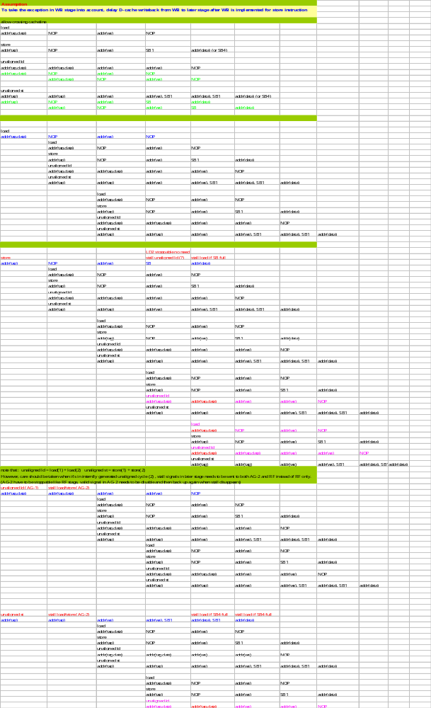
      - Load/Store resource allocation table
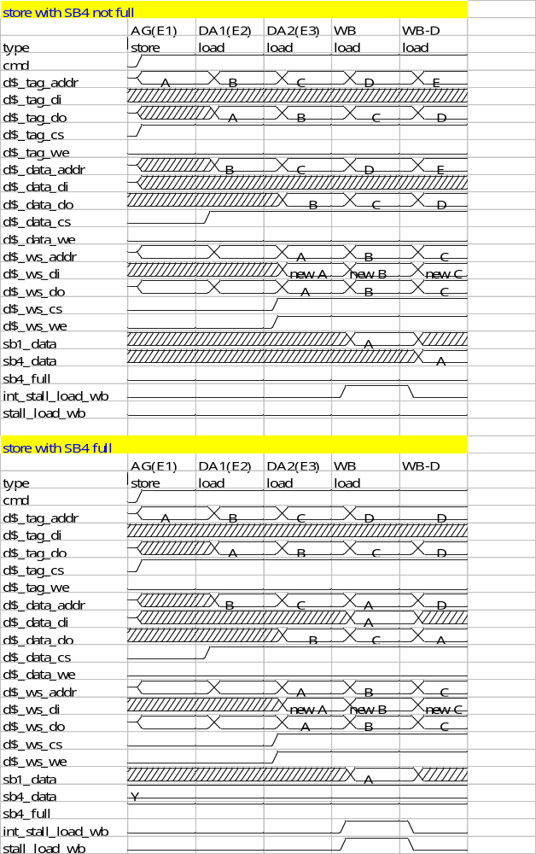

- Memory Management Unit (MMU)
  - Introduction
MMU is responsible for virtual address to physical address conversion. It interfaces to Instruction Fetch Unit (IFU) and Load/Store Unit (LSU). For IFU, there is an I-uTLB for fast instruction address conversion lookup. For LSU, there is a D-uTLB for fast data address conversion lookup. If either one can’t find the address conversion information, a TLB lookup request will be sent to Main TLB (M-TLB) which is a bigger TLB defined in MMU. If TLB miss happens in M-TLB, hardware page table walker (HPTWK) scheme will be kicked off. The following sections show you the interface for MMU.

  - Virtual Address Translation Process
Below diagram shows you the virtual address translation process.

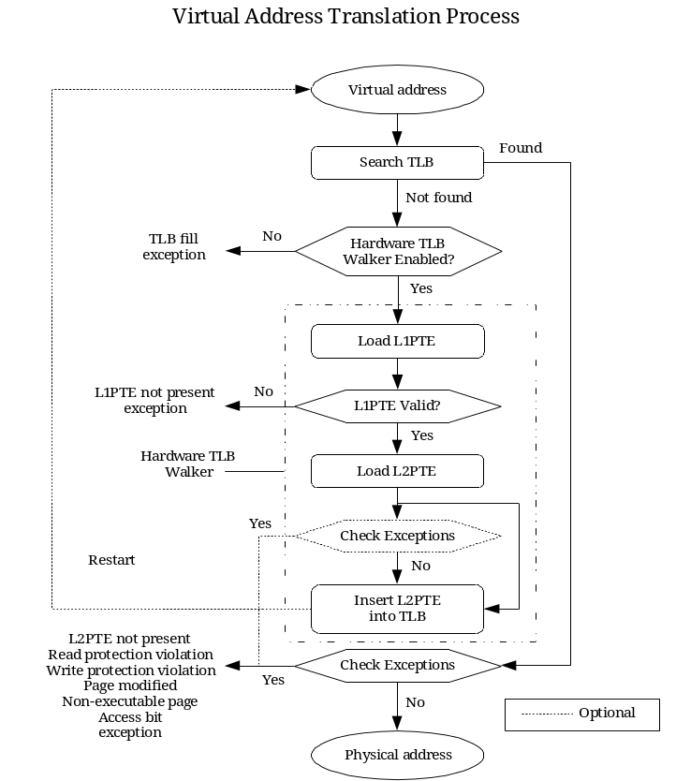

ps: this translation process is extracted from Chuan-Hua’s MMU document

  - Block Diagram

I-uTLB
M-TLB
D-uTLB
HPTWK
Bus Interface Unit
IFU
LSU
AHB bus
MMU
E1(AG)
E2(DA1)
E3(DA2)
M-TLB arbiter
WB
WBD
M-TLB data
M-TLB tag
M-TLB req
M-TLB data
M-TLB tag
LDB for Sysreg
System register
TLB command from IIU

  - TLB
  - Instruction uTLB (I-uTLB)
    - I-uTLB Attribute
Instruction uTLB(I-uTLB) is a 4/8-entry fully-associative cache that stores address translation for instruction fetch. The I-uTLB only stores the information for default page size or 1MB page size address translation. Default page size is defined by D bit in MMU_control register.
When D=0, default page size is 4KB. When D=1, default page size is 8KB. S tag in TLB entry defines the actual page size associated with that entry. S=0: default page size; S=1 : 1MB page size;
Below shows you the details:

ATTRUBITE: DEPTH : 4/8
Content per entry:
VPN[31:12], ASID[7:0], G, PA[31:12], C[2:0], M[2:0], S, Valid, Lock

    - I-uTLB Interface
if_iutlb_req, if_iutlb_va, if_iutlb_ack, if_iutlb_nack, if_iutlb_stall, if_iutlb_rdata (read access from Instruction fetch unit) : nack is for exception case.

iutlb_mtlb_req, iutlb_mtlb_va, iutlb_mtlb_ack, iutlb_mtlb_nack, iutlb_mtlb_rdata (read access to M-TLB to fill a I-uTLB entry) nack is for exception case

    - D-uTLB Operation
There are several kinds of operation associated with I-uTLB. The first is I-uTLB lookup from F0, the 2nd is I-uTLB fill request under I-uTLB miss condition and the others are invalidate/lock/unlock requests. Besides, I-uTLB replacement policy is based on pseudo LRU scheme. However, if there is a lock attribute associated with an entry, it will not be replaced unless all the entries are locked. Instead, an unlocked entry will be replaced. The replacement rule is based on below priority order: Invalid entry > unlocked entry > locked entry.

  - Data uTLB
    - D-uTLB Attribute
Data uTLB(D-uTLB) is a 4/8-entry fully-associative cache that stores address translation for data access. The D-uTLB stores the information for default page size or 1MB page size address translation. (Default page size is 4KB if D=0, 8KB if D=1)
S tag in TLB entry defines the actual page size associated with that entry. S=0: default page size; S=1: 1MB page size;

Below shows you the details.

ATTRUBITE: DEPTH : 4/8
Content per entry:
VPN[31:12], ASID[7:0], G, PA[31:12], C[2:0], M[2:0], S, Valid, Lock

    - D-uTLB Interface
Da1_dutlb_req, da1_dutlb_va, dutlb_pa, dutlb_pa_hit, dutlb_pa_va, dutlb_da1_nack, ag_dutlb_stall, ag_dutlb_rdata (read access from Load/Store unit) : nack is for exception case.

dutlb_mtlb_req, dutlb_mtlb_va, dutlb_mtlb_ack, dutbl_mtlb_nack, dutlb_mtlb_rdata (read access to M-TLB to fill a D-uTLB entry) nack is for exception case

    - D-uTLB Operation
There are several kinds of operation associated with D-uTLB. The first is D-uTLB lookup from DA1, the 2nd is D-uTLB fill request under D-uTLB miss condition and the others are invalidate/unlock/lock requests. Besides, D-uTLB replacement policy is based on pseudo LRU scheme. However, if there is a lock attribute associated with an entry, it will not be replaced unless all the entries are locked. Instead, an unlocked entry will be replaced. The replacement rule is based on below priority order: invalid entry > unlocked entry > locked entry.

  - Main TLB (M-TLB)
    - M-TLB Attribute
The Main TLB (M-TLB) is a 4-way set-associative cache that stores address translation for both instruction fetch and data access. M-TLB is software-visible TLB and can be managed by software TLB instructions under kernel mode. S tag in M-TLB defines the page table size associated with that entry. When S=0, page size is default page size. When S=1, page size is 1MB. (Default page size is 4KB if D=0, 8KB if D=1. D is defined in MMU_control register.)
A multi-page support bit is defined to support multiple page size (default page size and 1MB page size). If multiple page size is enabled, M-TLB needs to perform two M-TLB lookups to complete M-TLB process. The first lookup tries to find the TLB hit under default page size. If it’s a miss, the second lookup tries to find the TLB hit under 1MB page size. If none of the two lookup succeeds, the M-TLB miss request is sent to hard page table walker controller. Please note that no second lookup is required if multi-page support bit is disabled.

ATTRUBITE: DEPTH : 4/8/16
Tag entry: VPN[31:12], ASID[7:0], G, S
Data entry: PA[31:12], C[2:0], X, M[2:0], Valid, Lock

    - M-TLB Management
M-TLB is managed by both hardware TLB hardware page table walker and software TLB commands. Software management is shown in the following section and hardware management will be described in hardware page table walker section.

      - Software M-TLB management instructions

Instruction | Operation
TLBIR Rx | TLB indexed read
TLBIW Rx | TLB indexed write
TLBRI Rx | TLB random insert
TLBPB Rx | TLB VA probe
MTSR MMU_CONTROL(4) <- 1 | Flush TLB all (except locked entries)
TLBINV Rx | Invalidate TLB entries containing VA stored in Rx (excepting locked entries)
(Optional) LD_VLPT | Load VLPT page table which always goes through data TLB translation. On TLB miss, generate Double TLB miss exception

      - Replacement Rule
Basically, pseudo LRU is the policy for TLB replacement. If the selected entry to be replaced is locked, another unlocked entry will be selected for replacement. However, if all entries are locked, we’ll generate an exception and will hand over to interruption handler to deal with this issue. There are other options to handle it when all entries are locked. Each will be described in the following sub-sections.

      - Conflict Resolution for Replacement Policy
When all entries are locked and a replacement is requested, we will need to choose a scheme to handle this. Below shows you the schemes we have so far.

        - Exception-Based Handling
A software exception will be generated and will let OS to handle this. Note that the exception handler and related data/codes need to be locked in I-cache, D-cache and TLB; otherwise, deadlock might happen under worst case scenario.

        - Random/LRU Replacement Handling
Hardware will replace one locked entry based on LRU/random policy and treat it as unlocked case.

    - M-TLB Interface
multipage_enable: 0: no multi-page mode is supported. 1: support multi-page mode

dutlb_mtlb_req, dutlb_mtlb_va, dutlb_mtlb_abort, mtlb_dutlb_ack, mtlb_dutlb_nack, mtlb_dutlb_rdata (read access to M-TLB to fill a D-uTLB entry) nack is for exception case

Abort/nack
ack
rdata
PA
va
req
A
X
X
X

iutlb_mtlb_req, iutlb_mtlb_va, iutlb_mtlb_abort, mtlb_iutlb_ack, mtlb_iutlb_nack, mtlb_iutlb_rdata (read access to M-TLB to fill a I-uTLB entry) nack is for exception case

Abort/nack
ack
rdata
PA
va
req
A
X
X
X

mtlb_hptwk_req, mtlb_hptwk_abort, mtlb_hptwk_va, mtlb_hptwk_ack, mtlb_hptwk_nack, mtlb_hptwk_rdata (read request to hardware page table walker controller under M-TLB miss): nack is for exception case

Abort/nack
ack
rdata
PA
va
req
A
X
X
X

sw_mtlb_req, sw_mtlb_cmd, sw_mtlb_ws_index[1:0], sw_mtlb_va, mtlb_sw_ack, sw_mtlb_wdata, sw_mtlb_rdata (software-controlled read/write access to M-TLB)
cmd : 0: read 1: write

  - Hardware Page Table Walker (HPTWK)
    - Introduction
Hardware page table walker is responsible for reading TLB entry located in system memory under M-TLB miss conditions. There are two memory read transactions required to complete a TLB entry read. The first memory read (address = {L1_PTB, VA[31:22], 2’b0}) is to get the content of L2_PTB. The second memory read (address = { L2_PTB[31:12], VA[21:12], 2’b00}) is to get the TLB entry information to fill.
To improve HPTWK performance, there are two local (L1_PTE, L2_PTE) pair entries (one is for ITLB, the other is for DTLB). L1_PTE stores the content addressed by {L1_PTB, VA[31:22], 2’b0} from the last TLB fetch while L2_PTE stores the content addressed by last L2_PTE access VA[21:12] + 4 (it is likely to be fetched next time for TLB miss). for . Therefore, if the incoming VA hits this L2_PTB tag (VA[31:22]), we may skip the first memory read ( address = {L1_PTB, VA[31:22], 2’b0 } ) and just do the second memory read ( address = {L2_PTB[31:12], VA[21:12], 2’b00} ).

L1_PTE
fetch
L2PTE
fetch
PTE
Error
IDLE
RESET
Req && !hitL1
Req && hitL1&& !hitL2
!done
done &
!error
!done
done &
error
done &
!error
done &
error

Below shows the scheme for HPTWK performance improvement.
L2_PTB
{L1_PTB,
Va[31:22], 2’b0 }
TLB_k info
TLB_k+1 info
Address
Address + 4
Send back to M-TLB
Store locally for next fetch
{L2_PTB,Va[21:12], 2’b0}
Store locally for next fetch

    - HPTWK Interface Signals
mtlb_hptwk_req, mtlb_hptwk_abort, mtlb_hptwk_va, mtlb_hptwk_ack, mtlb_hptwk_nack, mtlb_hptwk_rdata (read request to hardware page table walker controller under M-TLB miss): nack is for exception case

Abort/nack
ack
rdata
PA
va
req
A
X
X
X

hptwk_biu_req, hptwk_biu_cmd, hptwk_biu_type, hptwk_biu_last, hptwk_biu_addr, hptwk_biu_rdata, biu_hptwk_ack (to memory arbiter)

Cmd
ack
addr
rdata
A
B
C
D
X
DA
DB
DC
DD
last
type
increment
X
req

  - MMU Interface Definition

// Control registers
reg_asid,
// IFU – I-uTLB
ifu0_itlb_req,
ifu0_itlb_va,
itlb_ifu0_hit,
itlb_ifu0_pa,
itlb_ifu0_tag,
itlb_ifu0_nack,
// LSU – D-uTLB
da1_dtlb_req,
da1_dtlb_va,
dtlb_da1_pa,
dtlb_da1_ hit,
dtlb_da1_nack,
da1_dtlb_rdata,
// MMU(HPTWK)-BIU
hptwk_biu_req,
hptwk_biu_cmd, // tie to ‘0’: read
hptwk_biu_last,
hptwk_biu_type, // 00: single 01: inc 10: wrap 11: random
hptwk_biu_addr,
hptwk_biu_rdata,
biu_hptwk_ack,

  - MMU Timing Diagram
    - I-uTLB/IFU0 Interface Timing Diagram

Itlb_ifu0_hit/nack
Itlb_ifu0_tag
X
Ifu0_itlb_va
Itlb_ifu0_pa
Ifu0_itlb_req
A
B
C
D
PA
PB
PC
XX
PD
X
X
TA
TB
TC
XX
TD
X
X
X
Itlb_mtlb_req
Mtlb_itbl_ack
Ifu0_stall

    - D-uTLB/LSU Interface Timing Diagram
dtlb_da1_hit/nack
dtlb_da1_tag
X
Da1_dtlb_va
dtlb_da1_pa
Da1_dtlb_req
A
B
C
D
PA
PB
PC
XX
PD
X
X
TA
TB
TC
XX
TD
X
X
X
dtlb_mtlb_req
Mtlb_dtbl_ack
Da1_ag_stall

    - HPTWK-BIU Interface Timing Diagram

Cmd
ack
addr
rdata
wdata
A
B
C
D
X
DA
DB
DC
DD
DA
DB
DC
DD
X
last
type
(single, increment, wrap, inc2)
X
we
WEA
WEB
WEC
WED
X
req

- Bus Interface Unit (BIU)
  - Introduction
Bus Interface unit is responsible for off-CPU memory access which includes system memory access, instruction/data local memory access and memory-mapped register access in devices. BIU interfaces to IFU (I-cache miss refill request), LSU (D-cache miss refill request, D-cache dirty write back, un-cacheable store, write-through store) and MMU (HPTWK).
BIU arbitration priority: HPTWK > D-cache miss > I-cache miss > Write queue
Core/Bus clock ratio: 2/1, 3/1, 4/1, 6/1

Request type | description | Length
00 | Single (random) | 1 word
01 | Increment mode | 1 cacheline
10 | Wrapping mode | 1 cacheline
11 | Increment 2 mode | 2 words

  - BIU Block Diagram
BIU arbiter
ICache miss
request
D-cache miss
request
WT/UNC/DirtyWB
Write queue
HPTWK
Local Memroy
Bridge
AHB
Bridge
AHB bus
AHB Bridge
Read/Write
FIFO
Command
Queue

AHB
master
AHB bus

BIU sequencer
BIU arbiter
Local Memory Bridge
Read/Write
FIFO
Command
Queue

Local
memory
master
Local memory

BIU sequencer
BIU arbiter
Local Memory
Arbiter
DMA request
DMA request
Local memory

arbiter;
control/data mux
1
arbiter;
control/data mux
2
HPTWK read
D cache read
I cache read
write
DMA request
command queue
write data queue
AHB bridge
read data
command queue
write data queue
SRAM-like interface with grant control
read data
AHB bus
Local memory arbiter
  - BIU Interface Definition

// BIU-MMU(HPTWK)
hptwk_biu_req,
hptwk_biu_cmd, // tie to ‘0’: read
hptwk_biu_last,
hptwk_biu_type, // 00: single 01: inc 10: wrap 11: 2-word inc mode
hptwk_biu_addr,
hptwk_biu_rdata,
biu_hptwk_ack,
// BIU-Write Queue
wq_biu_req,
wq_biu_cmd, // tie to ‘1’: write
wq_biu_last,
wq_biu_type, // 00: single 01: inc 10: wrap 11: 2-word inc mode
wq_biu_addr,
wq_biu_wdata,
wq_biu_we[3:0], // write enable : 1 active
biu_wq_ack,
// BIU – Dcache miss
dcache_biu_req,
dcache_biu_cmd, // tie to ‘0’: read
dcache_biu_last,
dcache_biu_type, // 00: single 01: inc 10: wrap 11: 2-word inc mode
dcache_biu_addr,
biu_dcache_rdata,
biu_dcache_ack,
// BIU-Icache miss
icache_biu_req,
icache_biu_cmd, // tie to ‘0’: read
icache_biu_last,
icache_biu_type, // 00: single 01: inc 10: wrap 11: 2-word inc mode
icache_biu_addr,
biu_icache_rdata,
biu_icache_ack,
// BIU-DMA
dma_biu_req,
dma_biu_cmd,
dma_biu_last,
dma_biu_type, // 00: single 01: inc 10: wrap 11: 2-word inc mode
dma_biu_addr,
biu_dma_rdata,
biu_dma_ack,
// BIU-local memory arbiter
biu_lma_req,
lma_biu_grant,
biu_lma_write,
biu_lma_addr,
biu_lma_wdata,
lma_biu_rdata,
// BIU-AHB
haddr,
htrans,
hready,
hresp,
hwrite,
hsize,
hburst,
hprot,
hwdata,
hrdata,
hbusreq,
hgrant,
hlock,

  - BIU Interface Timing Diagram

Cmd
ack
addr
rdata
wdata
A
B
C
D
X
DA
DB
DC
DD
DA
DB
DC
DD
X
last
type
(single, increment, wrap, inc2)
X
we
WEA
WEB
WEC
WED
X
req

- Local Memory
  - Introduction
Local memory is to store those data or instructions that might be accessed frequently in a system such as interrupt service routine, system call, video data, etc.

  - Interface

