

BIU Design Specification

Document Number | xxxxxx
Date Issued | 2010-09-16
Status | Final draft



CONFIDENTIAL

Revision History
Rev. | Effective Date | Revised Chapter-Section | Revised Content | Author
0.2 | 2010/09/16 | Chpater 4,6 | 1. Final draft for V2j.  2. Add figures to describe back-to-back read transaction  3. Add figures to describe the signals of sync module in bur ratio 1:1 | Osban
0.1 | 2010/09/09 | ALL | 1. Initial draft | Osban

Review History
Rev. | Review Date | Reviewed Chapter-Section | Comments | Reviewer
0.2 | 2011/03/17 | All | 1. Approved for Final draft for V2j+ V3m ISA + V3m SPA +V3m SPA SCO | Charlie, Chuan-Hua, Howard, James, Osban
0.2 | 2011/02/17 | All | 1. Approved for Final draft for V2j+ V3m ISA + V3m SPA (with pending SCO) | Charlie, Chuan-Hua, James, Osban
0.2 | 2010/12/08 | All | 1. Approved for Final draft for V2j+ V3m ISA | Charlie, Chuan-Hua, Howard, James, Osban
0.1 | 2010/09/10 | ALL | 1. Add figures to show back to back read transaction in the interface protocol,  2. Clarify the purpose of Block signal in biu_sync  3. Add figures to describe the sync module running in bus ratio 1:1. | Charlie  James,  C.H Chang,  Justin,  Archur,  Jonathon,  Howard,  Kevin,

Document Sign-off List
Department | Name | Signature | Date | Comment
1
2

Table of Contents
1. Overview 1
2. Block Diagram 1
3. Configuration Option 3
4. Interface 4
4.1. Interface signals 4
4.1.1. FCU interface signals 4
4.1.2. LSU interface signals 4
4.1.3. EDM interface signals 5
4.1.4. Interface signals with UCORE 6
4.1.5. AHB interface signals 6
4.1.6. Others 6
4.2. Interface protocol 7
5. Command Arbiter and Multiplex 15
6. Synchronization module 17
6.1. NDS_BIU_SYNC 17
6.2. NDS_BIU_ASYNC 23
7. Bus wrapper 25
7.1. AHB wrapper 25
7.1.1. 3-byte command handle 26
7.1.2. Retry recover handler 27
8. meeting minutes 28

List of Tables
Figure 1 the block diagram of BIU 2
Figure 2 the waveform of single read transaction 8
Figure 3 the waveform of BIU returns grant and ack at the same cycle 9
Figure 4 the waveform of single write transaction 10
Figure 5 the waveform of sequential read transactions without wait cycles 11
Figure 6 the waveform of sequential read transactions wait cycles 12
Figure 7 the waveform of sequential write transactions 13
Figure 8 the waveform of two sequential read transaction with non-sequential ack and grant 14
Figure 9 the waveform of two sequential read-write transactions 15
Figure 10 the data path of bus arbiter and multiplex 17
Figure 11 the data path of Sync mode in synchronization module for core-bus clock ratio N:1 and 1:M 19
Figure 12 waveform of biu sync in bus ration 1:1 20
Figure 13 wavefom of biu_syn in bus ration 3:1 (1) 21
Figure 14 wavefom of biu_syn in bus ration 3:1 (2) 22
Figure 15 wavefom of biu_syn in bus ration 1:3(1) 23
Figure 16 wavefom of biu_syn in bus ration 1:3(2) 24
Figure 17 the data path of asynchronization mode in synchronization module 25
Figure 18 the data path of AHB wrapper 26
Figure 19 the FSM of AHB wrapper 27
Figure 20 two cases of 3-byte access 28

List of Figures
Table 1 interface signals between FCU and BIU 4
Table 2 interface signals between lsu and biu 5
Table 3 interface signals between edm and biu 6
Table 4 inteface signals between ucore and biu 6
Table 5 interface signals between ahb and biu 6
Table 6 other signals 7

Typographical Convention Index
Document Element | Font | Font Style | Size | Color
Normal | Candara | Normal | 11 | Black
Code | Courier New | Normal | 11 | Indigo
USER VARIABLE | COURIER NEW | ALL-CAPS | 11 | INDIGO
Note/Warning | Candara | Normal | 11 | Red
Hyperlink | Candara | Bold + Underlined | 11 | Blue

Overview
BIU (Bus Interface Unit) is responsible for transferring data between the processor core and the system bus. In N10, there are three sources which send requests to BIU: FCU, LSU and EDM. Both AHB and AHB-lite bus protocols are supported and softcore configurable.

Block Diagram
Figure 1 shows the block diagram of BIU in N8. There are there components in the BIU. The first component is in the left side of biu_sync in Figure 1. This component is in core clock domain. It arbitrates the request and return data from biu_sync to the request module. The second component is the biu_sync. It handles the signals cross clock domain if need. The third component is in right side of biu_sync in Figure 1. This component is in the bus clock domain. It receives commands from biu_sync and transfers the commands to the system bus.

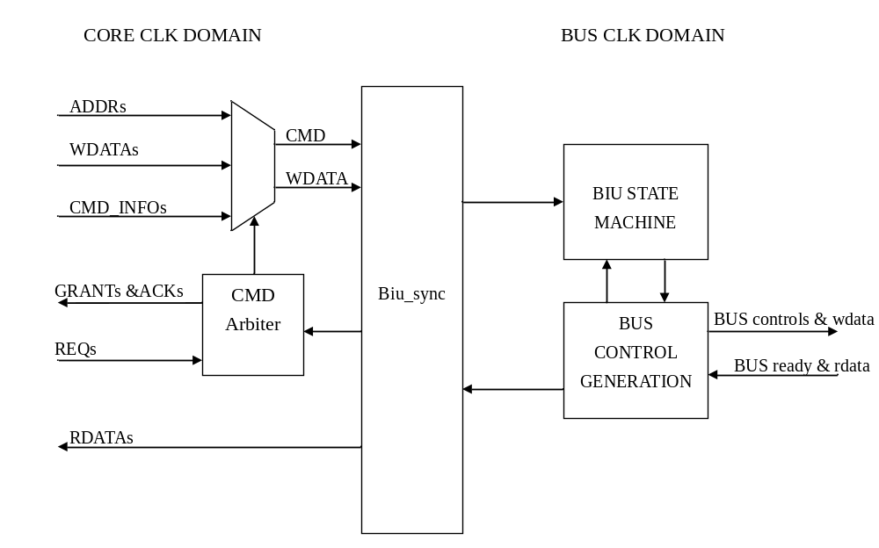
Figure 1 the block diagram of BIU

Configuration Option
NDS_BIU_AHB
NDS_BIU_AHB_LITE
NDS_BIU_SYNC
NDS_BIU_ASYNC
NDS_CLK_RATIO_N_1
NDS_CLK_RATIO_1_M

Interface

Interface signals

FCU interface signals
NAME | I/O | WIDTH | DESCRIPTION
fcu_biu_req | Input | 1 | FCU request a bus transaction
fcu_biu_addr | Input | ADDR_MSB-1 | FCU fetch address
fcu_biu_cachable | Input | 1 | Indicate the cachebility of this request  0: Non-cacheable  1:cacheable
biu_fcu_grant | Output | 1 | BIU accept the address of the request
biu_fcu_ack | Output | 1 | Data is valid from the BIU.
biu_fcu_rdata | Output | 32 | Return data from BIU
biu_fcu_error | Output | 1 | A bus error occurred in the fetch request
Table 1 interface signals between FCU and BIU

LSU interface signals
NAME | I/O | WIDTH | DESCRIPTION
lsu_biu_req | Input | 1 | LSU request a bus transaction
lsu_biu_cmd | Input | 1 | The request is read or write command.  0: read  1: write
lsu_biu_addr | Input | ADDR_MSB+1 | LSU fetch address
lsu_biu_wdata | Input | 32 | Write data of this request
lsu_biu_length | Input | 2 | Indicate the access length  2’b00: byte  2’b01: halfword  2’b10: word  2’b11: reserved
lsu_biu_cachable | Input | 1 | Indicate the cachebility of this request  0: Non-cacheable  1:cacheable
lsu_biu_buf | Input | 1 | Indicate the request is bufferable or not.  0: non-bufferable  1:bufferable
lsu_biu_wt | Input | 1 | Indicate the request is write-through or write-back.  0: write-back  1: write-through
biu_lsu_grant | Output | 1 | BIU accept the address of the request
biu_lsu_ack | Output | 1 | Data is valid from the BIU.
biu_lsu_rdata | Output | 32 | Return data from BIU
biu_lsu_error | Output | 1 | A bus error occurred in the request
Table 2 interface signals between lsu and biu

EDM interface signals
NAME | I/O | WIDTH | DESCRIPTION
NDS_EDM_SUPPORT
edm_biu_req | Input | 1 | EDM request a bus transaction
edm_biu_cmd | Input | 1 | The request is read or write command. 0: read 1:write
edm_biu_addr | Input | ADDR_MSB-1 | LSU fetch address
edm_biu_bwe | Input | 4 | Byte enable of this request
edm_biu_length | Input | 2 | The length of request
edm_biu_wdata | Input | 32 | Wdata of this request
biu_edm_grant | Output | 1 | BIU accept the address of the request
biu_edm_ack | Output | 1 | Data is valid from the BIU.
biu_edm_rdata | Output | 32 | Return data from BIU
biu_edm_error | Output | 1 | A bus error occurred in the fetch request
Table 3 interface signals between edm and biu

Interface signals with UCORE
NAME | I/O | WIDTH | DESCRIPTION
ucore_standby_stall_wait | input | 1 | Indicate a standby command.
biu_ucore_standby_ready | output | 1 | Biu is ready for standby
Table 4 inteface signals between ucore and biu

AHB interface signals
NAME | I/O | WIDTH | DESCRIPTION
NDS_AHB_SUPPORT or NDS_AHB_LITE_SUPPORT
hclk | Input | 1 | AHB clock
hreset_n | Input | 1 | AHB reset
haddr | Output | ADDR_MSB+1 | AHB address
hburst | Output | 3 | AHB burst length
hprot | Output | 4 | AHB protect
hsize | Output | 3 | AHB size
htrans | Output | 2 | AHB transfer type
hwdata | Output | 32 | AHB write data
hwrite | Output | 1 | AHB write. 0: read 1:write
hresp | Input | 2 | AHB response
hready | Input | 1 | AHB transfer done
hrdata | Input | 32 | AHB read data
NDS_AHB_SUPPORT
hbusreq | Output | 1 | AHB bus request
hgrant | Input | 1 | AHB bus grant
Table 5 interface signals between ahb and biu

APB interface
NAME | I/O | WIDTH | DESCRIPTION
NDS_APB_SUPPORT
pclk | Input | 1 | APB clock
preset_n | Input | 1 | APB reset
pwait | Input | 1 | APB wait
prdata | Input | 32 | APB read data
pwrite | Output | 1 | APB write 1:write 0:read
pwdata | output | 32 | APB write data
paddr | Output | ADDR_MSB-1 | APB access address
pbe | Output | 4 | APB byte enable
psel | Ouput | 1 | APB select
penable | Ouput | 1 | APB enable signal

Others
NAME | I/O | WIDTH | DESCRIPTION
core_clk | Input | 1 | Core clock
core_reset_n | Input | 1 | Core reset
bus_estrb | Input | 1 | synchronous cpu clock domain to bus clk domain
cpu_estrb | Input | 1 | synchronous hus clock domain to cpu clk domain
Table 6 other signals

Interface protocol
Figure 2 shows the protocol between internal modules and BIU. It is a single read transaction. The request address and control signals should be held until the BIU returns grant signal.
XXX_biu_req
XXX_biu_addr
addr0
biu_XXX_grant
biubiu_addr
biu_XXX_ack
biubiu_addr
biu_XXX_rdata
biubiu_addr
data0
XXX_biu_cmd
data1
addr1
core_clk
Figure 2 the waveform of single read transaction
XXX_biu_req
XXX_biu_addr
addr0
biu_XXX_grant
biubiu_addr
biu_XXX_ack
biubiu_addr
biu_XXX_rdata
biubiu_addr
data0
XXX_biu_cmd
data1
addr1
core_clk
Figure 3 the waveform of BIU returns grant and ack at the same cycle
Figure 3 shows the BIU returns grant and ack at the same cycle. When BUS clock runs faster than core clock, BIU can return grant and ack at the same cycle.

XXX_biu_req
XXX_biu_addr
addr0
biu_XXX_grant
biubiu_addr
biu_XXX_ack
biubiu_addr
biu_XXX_wdata
biubiu_addr
data0
XXX_biu_cmd
addr1
data1
core_clk
Figure 4 the waveform of single write transaction
Figure 4 shows the single write transaction. BIU also accepts the write data when it accepts the address.
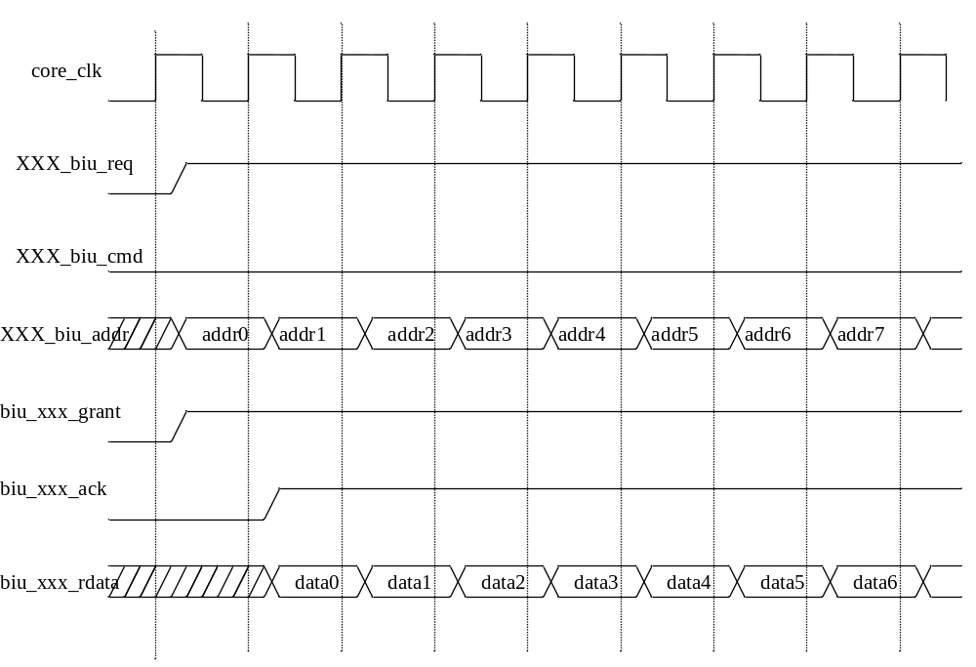
Figure 5 the waveform of sequential read transactions without wait cycles

XXX_biu_req
XXX_biu_addr
addr0
biu_XXX_grant
biubiu_addr
biu_XXX_ack
biubiu_addr
biu_XXX_rdata
biubiu_addr
data0
XXX_biu_cmd
addr1
data1
addr2
data2
core_clk
Figure 6 the waveform of sequential read transactions wait cycles
Figure 6 shows the sequential read transactions. Before BIU returns the first data, the protocol allows the second request. But the BIU accepts the second request after BIU returns the first request data or meanwhile.
XXX_biu_req
XXX_biu_addr
addr0
biu_XXX_grant
biubiu_addr
biu_XXX_ack
biubiu_addr
biu_XXX_wdata
biubiu_addr
data0
XXX_biu_cmd
addr1
data1
addr2
data2
core_clk
Figure 7 the waveform of sequential write transactions
Figure 7 shows the sequential write transactions.
XXX_biu_req
XXX_biu_addr
addr0
biu_XXX_grant
biubiu_addr
biu_XXX_ack
biubiu_addr
biu_XXX_rdata
biubiu_addr
data0
XXX_biu_cmd
addr1
data1
core_clk
Figure 8 the waveform of two sequential read transaction with non-sequential ack and grant
Figure 8 shows the BIU accepts the second request after it returns the first request data.
XXX_biu_req
XXX_biu_addr
addr0
biu_XXX_grant
biubiu_addr
biu_XXX_ack
biubiu_addr
biu_XXX_wdata
biubiu_addr
Wdata0
XXX_biu_cmd
addr1
biu_XXX_rdata
biubiu_addr
Rdata1
core_clk
Figure 9 the waveform of two sequential read-write transactions

Command Arbiter and Multiplex
Figure 10 shows the data path of arbiter and multiplex. According to the arbitration result, the multiplex select the address and control. When an address phase is completed, BIU asserts the enable of selection register.
There are three modules request the BIU. They are FCU, LSU, and EDM. The priority of arbitration is LSU > EDM > FCU. If the hold_arbitration is asserted, the arbiter will hold the grant. The hold_arbitration signal prevents the request signal changes before BIU returns ACK in NDS_BIU_ASYNC.
Request_ID
Cmd_request_IN

Biu_sync
Return_ID
RData
acks
Requests
Addr_grant
Grants
Ack decode
Wdata
Wdatas
ADDRs
ADDR&Control
CMDs
Cacheablity&BWEs
Arbiter & grant gen
Data_ack
Block_XXX_readHold_arbitration
Figure 10 the data path of bus arbiter and multiplex

Synchronization module
Biu_sync handles cross-clock-domain signals. The BIU supports synchronization and asynchronization mode.

NDS_BIU_SYNC
In Synchronization mode, biu_sync supports core-bus clock ratio 1:1, N:1(N>=2) and 1:M (M>=2). The two signals, cpu_estrb and bus_estrb, indicate the phase of each clock.
In core-bus clock ration 1:1, there is only register 3 in this module. Register 3 of Figure 11 stores the write data for the write transaction.
In core-bus clock ratio N:1, core can sample cmd_grant_in and read data ack until cpu_estrb is asserted. The set register 5 holds the signals to prevent the request address and controls change during bus transaction.
In core-bus clock ratio 1:M, biu_sync needs to store the cmd_grant and read data ack until bus_estrb is asserted. When bus wrapper grant the command and bus_estrb is de-asserted, biu_sync will remember the command has been granted in register 2 of Figure 11 and clear the request register 1 of Figure 11. Biu_sync set the request register 1 of Figure 11 when cmd_request_in and bus_estrb are asserted and cmd_grant_in is de-asserted. And it clears request register 1 of Figure 11 when bus_estrb is de-asserted and cmd_grant_in is asserted.
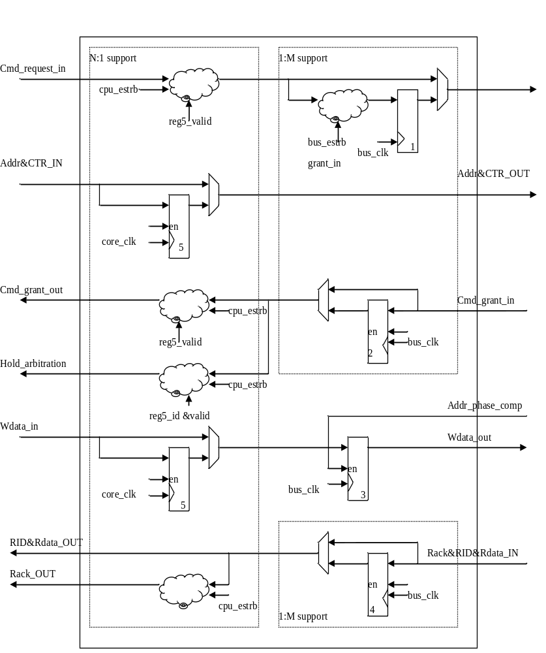
Figure 11 the data path of Sync mode in synchronization module for core-bus clock ratio N:1 and 1:M

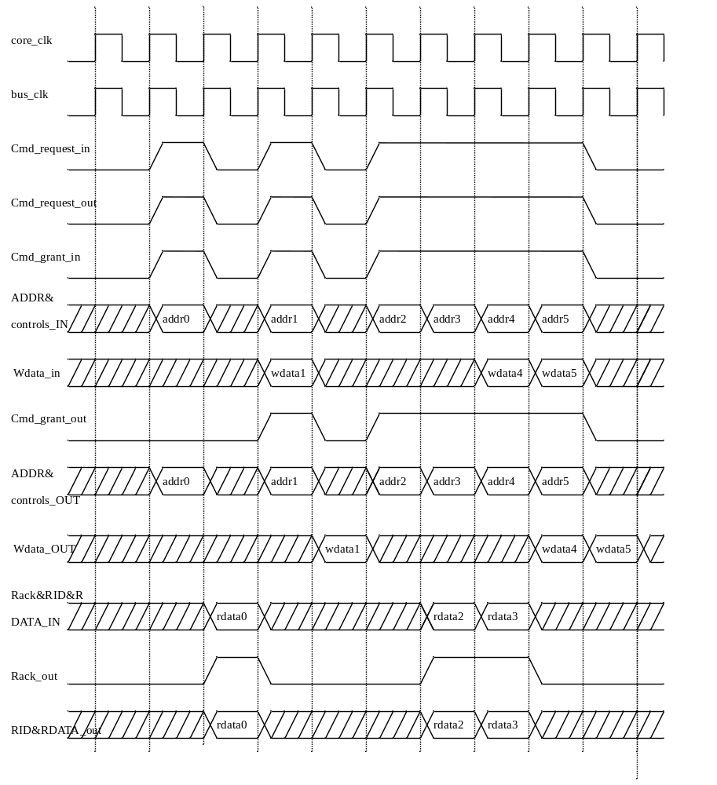
Figure 12 waveform of biu sync in bus ration 1:1

Cmd_request_IN
Cmd_request_OUT
Cmd_grant_out
ADDR&
controls_IN
ADDR&
controls_OUT
addr0
addr1addr0
addr1
Cmd_grant_in
addr2addr1
addr3addr2
addr2
Rack&RID
&RDATA_IN
data0
RID&
RDATA_OUT
data0
Rack_out
core_clk
bus_clk
cpu_estrb
Figure 13 wavefom of biu_syn in bus ration 3:1 (1)
addr0
core_clk
bus_clk
cpu_estrb
Cmd_request_IN
ADDR&
controls_IN
Cmd_request_OUT
addr2addr1
addr0
addr1
ADDR&
controls_OUT
Cmd_grant_in
Cmd_grant_out
data0
Rack&RID
&RDATA_IN
Rack_out
data0
RID&
RDATA_OUT
Figure 14 wavefom of biu_syn in bus ration 3:1 (2)
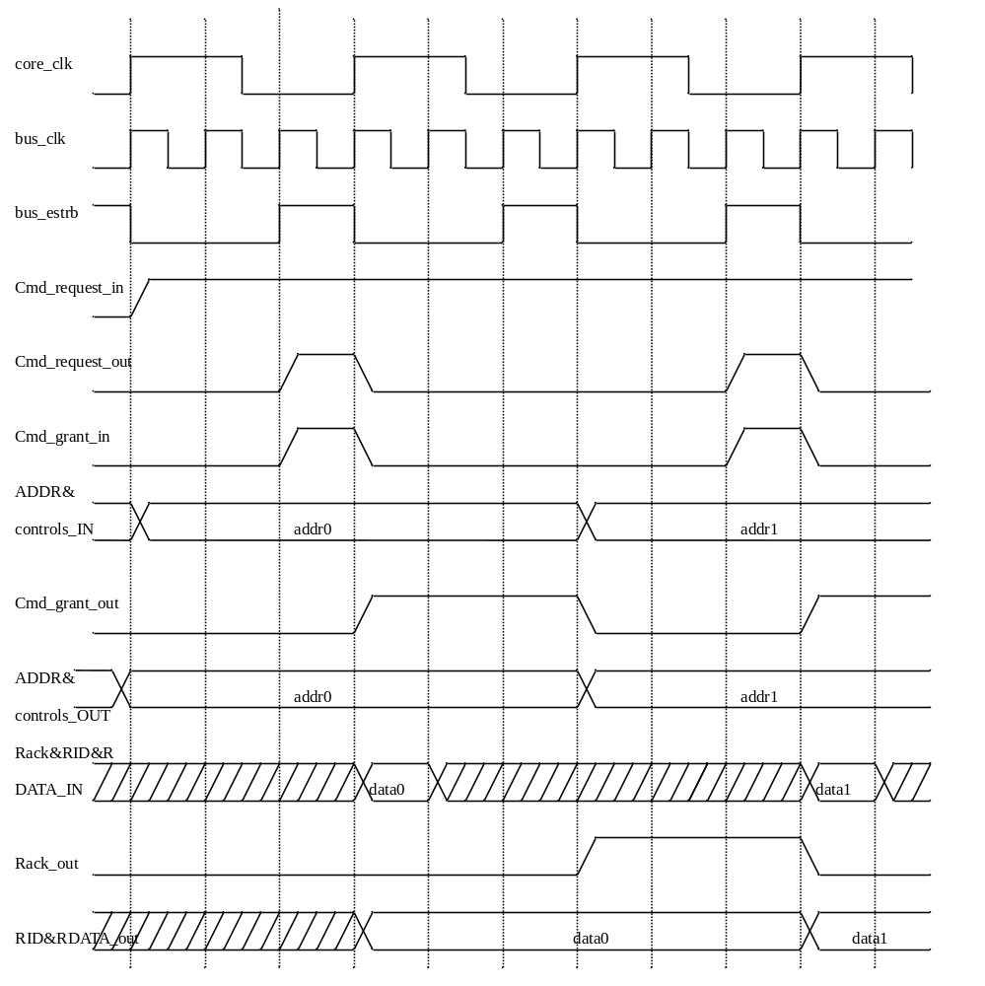
Figure 15 wavefom of biu_syn in bus ration 1:3(1)
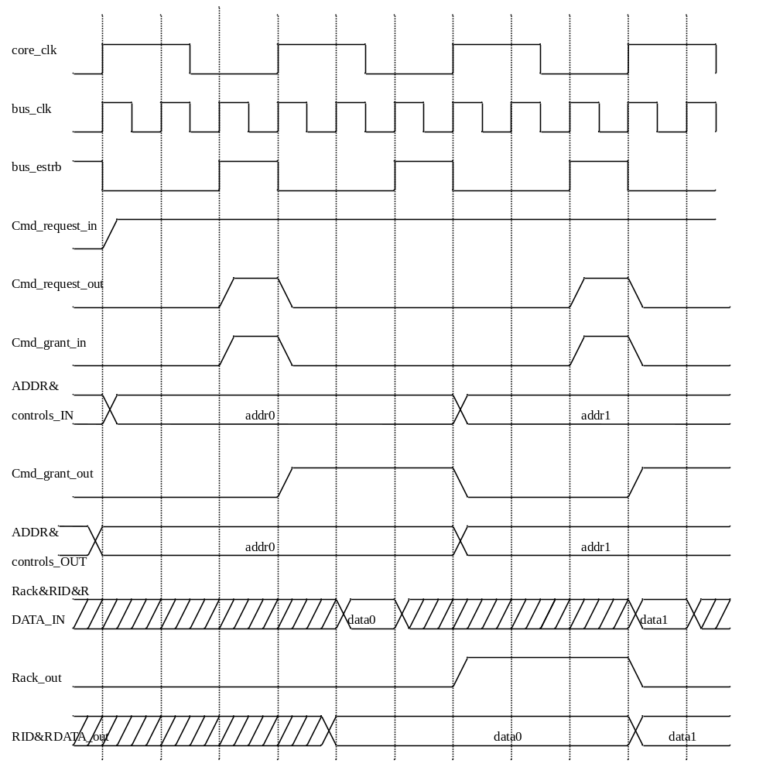
Figure 16 wavefom of biu_syn in bus ration 1:3(2)

NDS_BIU_ASYNC
In asynchronization mode, biu_sync uses three async fifos to handle the cross-clock domain signals. The three fifos are used to synchronize the command and write date from core clock to bus clock and read data from bus clock to core clock. After the biu_sync accepts a read request from a module, it will assert the relative block signal to prevent accept two read request from the same module without returning ack. The register 1 of Figure 17 remembers a read request has been granted and waits for data returned.
Biu_sync
Cmd_async_fifo
Wdata_async_fifo
Rdata_async_fifo
Cmd_request_IN
ADDR&controls_IN
Cmd_grant_out
RID&Rdata_OUT
Rdata_OUT_ack
Wdata_IN
Block_fcu_read
Block_lsu_read
Block_edm_read
ADDR&controls_OUT
Wdata_OUT
Cmd_request_out
Cmd_grant_in
Wdata_ack_in
Wdata_ack_out
RID&Rdata_IN
Rdata_IN_ack
set
reset
1
Figure 17 the data path of asynchronization mode in synchronization module

Bus wrapper

AHB wrapper
AHB wrapper handles bus request and returns data through biu_sync. To fit the AHB bus protocol AHB wrapper needs a 3-byte handler which divides 3-byte write access into an 1-byte and a half-word write access.

Biu_sync
AHB
FSM
&controls
3-byte handler
EN
Retry recover handler
ADDR & controls
HWDATA
HRDATA
Hready
HADDR,HTRANS, HSIZE, HWRITE…
ADDR_grant
Data_ack
Cmd_request_out
Hbusreq
Hgrant
Hresp
1

Figure 18 the data path of AHB wrapper
BUS_
REQ
BUS_
ERROR
IDLE
BUS_
TRANS
!bus_owner & cmd_request_out
bus_owner & cmd_request_out
!bus_owner & cmd_request_out
Htrans != OK
bus_owner &
(cmd_request_out | retry)
!bus_owner &
(cmd_request_out | retry)
!cmd_request_out&hready
bus_owner & cmd_request_out
Figure 19 the FSM of AHB wrapper
Figure 19 shows the state transaction of AHB wrapper. There are four states in the FSM. They are IDLE, BUS_REQ, BUS_TRANS and BUS_ERROR. When there is no bus request from core, the state machine parks in IDLE state. If there is a request and bus wrapper does not get the bus grant, the state jumps to BUS_REQ. Else the state jumps to BUS_TRANS. When bus response dose not equal OK, the state jumps to BUS_ERROR.

3-byte command handle
3-byte command handler can handle 3-byte write access which is generated by LSMW un-align command. There are two cases of 3-byte access. The one is bwe=4’b01111 and the other is bwe=4’b1110. As Figure 20 shows, the 3-byte handler divides 3-bytes access into two write access.
ADDR= 0
bwe =4’b0111
0
B
C
D
ADDR= 0
bwe =4’b0011 hsize = halfword
0
0
C
D
ADDR= 2
bwe =4’b0100 hsize = byte
0
B
0
0
ADDR= 0
bwe =4’b1110
A
B
C
0
ADDR= 1
bwe =4’b0010 hsize = byte
0
0
C
0
ADDR= 2
bwe =4’b1100 hsize = halfword
A
B
0
0
Figure 20 two cases of 3-byte access

Retry recover handler
Retry recover handler recovers the bus access when bus response is RETRY or SPLIT. The register 1 of Figure 18 stores the HADDR, HTRANS, HWRITE, HSIZE, HBURST, HLOCK and HPROT. The signals can completely recover the address phase of the retry request. The enable signal of register 1 in Figure 18 is asserted when ahb wrapper completes an address phase.

meeting minutes
bbus_owner & cmd_request_out
2010/09/10

- llw/scw => confirm with Arch. team for the removal (done)
- llw/scw is removed from v3m
- BIU arbitration/grant => watch out for the combinational/timing loops (done)
- SRAM only interface => AMI? Local memory? (Deferred)
Charlie> I suggest the following priority:
1). AHB-lite (must)
2). Add a config with 32-bit AMI on top of #1. (very good to have)
3). Add a config with DLM interface on top of #2. (low)
- BIU supports AHB, AHB-lite and APB.
- Single-cycle-latency load instruction => add staging flops for the data phase (as a configurable option) (Please refer UCORE design spec)
- Add waveform diagrams for the following back to back access in interface protocol (done)
  - The waveform is Figure 5
  - load-load, load-store, store-load, store-store
  - Add figures to describe the sync module running in bus ratio 1:1.
- Clarify the purpose of Block signal in biu_sync (done)
The signal is removed

protocol,2. Clarify the purpose of Block signal in biu_sync

