

BIU APB4 Interface Design Specification



Document Number
Date Issued
Copyright© 2011-2012 Andes Technology Corporation.  All rights reserved. |  | 

Copyright Notice
Copyright© 2012 Andes Technology Corporation. All rights reserved.
Words and logos marked with ™ are registered trademarks owned by Andes Technology Corporation. Other brands and names mentioned herein may be the trademarks of their respective owners.
This document contains confidential information of Andes Technology Corporation. Use of this copyright notice is precautionary and does not imply publication or disclosure. Neither the whole nor part of the information contained herein may be reproduced, transmitted, transcribed, stored in a retrieval system, or translated into any language in any form by any means without the written permission of Andes Technology Corporation
The product described herein is subject to continuous development and improvement; information herein is given by Andes in good faith but without warranties.
This document is intended only to assist the reader in the use of the product. Andes Technology Corporation shall not be liable for any loss or damage arising from the use of any information in this document, or any incorrect use of the product.

Contact Information
Should you have any problems with the information contained herein, please contact Andes Technology Corporation
by email support@andestech.com
or online website https://es.andestech.com/eservice/
for support giving:
-  the document title
-  the document number
-  the page number(s) to which your comments apply
-  a concise explanation of the problem
General suggestions for improvements are welcome.

Revision History
Rev. | Effective Date | Revised Chapter-Section | Revised Content | Author
0.2 | 2012/5/17 | ch2, ch3, ch5 | - Adding description for Andes APB2 extension interface.  - Adding Ch.5 | Kane
0.1 | 2012/1/9 | All | 1. initial draft | Kane

Table of Contents
Copyright Notice i
Contact Information i
1. Overviews 1
2. APB4 BUS Transfer 2
2.1. Write transfer with no wait state 2
2.2. Write transfer with wait states 2
2.3. Read transfer with no wait state 3
2.4. Read transfer with wait states 4
2.5. Read/Write transfers fail 4
2.6. Andes APB extension 5
3. N8 BIU (Bus Interface Unit) Design Implementation for APB4 6
3.1. Signal descriptions 6
3.2. Design Modifications 7
3.2.1. PREADY 7
3.2.2. PSLVERR 9
3.2.3. PPROT 9
3.2.4. PSTRB 9
4. Verification Plan for APB4 10
5. System Integration 11

List of Tables
Table- 1 Signal Descriptions for APB4 protocol 6
Table- 2 Signal Descriptions for additional signals for Andes APB2 extension 7

List of Figures
Figure- 1 waveform of write transfer with no wait state 2
Figure- 2 waveform of write transfer with wait states 3
Figure- 3 waveform of read transfer with no wait state 3
Figure- 4 waveform of read transfer with wait states 4
Figure- 5 waveform of APB write transfer fail 4
Figure- 6 waveform of APB read transfer fail 5
Figure- 7 design change on pready related signals 8
Figure- 8 waveform of PREADY related signals 8

Typographical Convention Index
Document Element | Font | Font Style | Size | Color
Normal | Georgia | Normal | 12 | Black
Code | Lucida Console | Normal | 11 | Indigo
USER VARIABLE | Lucida Console | ALL-CAPS | 11 | INDIGO
Note/Warning | Georgia | Normal | 12 | Red
Hyperlink | Georgia | Bold + Underlined | 12 | Blue

Overviews
The AMBA APB (Advanced Peripheral Bus) protocol defines the basic data transaction protocol interface which is used for connecting low-bandwidth peripherals. The APB protocol relates a signal transition to the rising edge of the clock, and every transfer takes at least two cycles.
In previous version design of N8 series BIU module, APB interface is implemented based on “AMBA 2 APB Specification” with two extension signals: PWAIT and PBE(N801s-data sheet, ch3.5). This implementation is also called “Andes APB2 Extension” interface. These two signals are used for creating transfer wait state and enabling byte transfer on APB bus.
In the following revision of official AMBA APB bus protocol APB3 and APB4, four new signals are defined to support a more flexible APB bus transaction: PREADY, PSLVERR, PPROT, and PSTRB. For a more detail information on APB4 bus protocol, please refer to the official AMBA APB protocol specification.
In this design specification, the APB interface is designed based on AMBA APB4 protocol. The functionality of our additional signals PWAIT and PBE are also kept, configurable by system design macro definitions.

APB4 BUS Transfer
In this chapter, several typical types of APB4 bus transfer are introduced. The extended APB2 interface with PWAIT and PBE signals is also described in ch.2.6.

Write transfer with no wait state

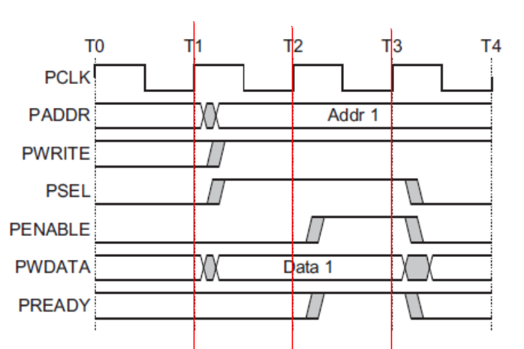
Figure- waveform of write transfer with no wait state

At T1, a write transfer starts with address PADDR, write data PWDATA, write signal PWRITE, and select signal PSEL - Setup phase (address).
At T2, enable signal PENABLE, and ready signal PREADY, are registered at the rising edge of PCLK.
When asserted, PENABLE indicates the start of the Access phase (data) of the transfer. When asserted, PREADY indicates that the slave can complete the transfer at the next rising edge of PCLK. PADDR, PWDATA, and control signals all remain valid until the transfer completes at T3, the end of the Access phase.

Write transfer with wait states

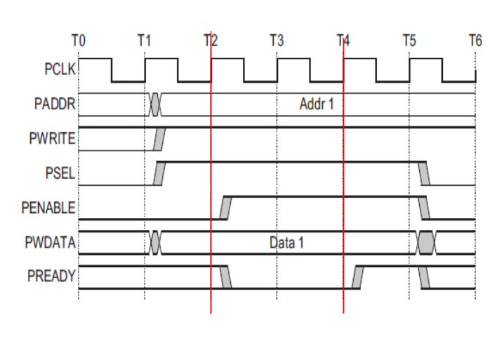
Figure- waveform of write transfer with wait states

During an Access phase, when PENABLE is HIGH, the slave extends the transfer by driving PREADY LOW. Other signals remain unchanged while PREADY remains LOW. PREADY can take any value when PENABLE is LOW.

Read transfer with no wait state

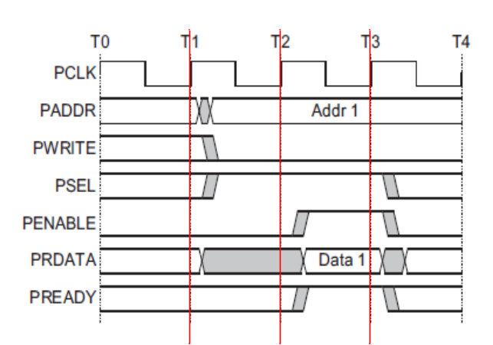
Figure- waveform of read transfer with no wait state

The timing of address, write, select, and enable signals are the same as write transfer. The slave must return the read data before the end of the read transfer.

Read transfer with wait states

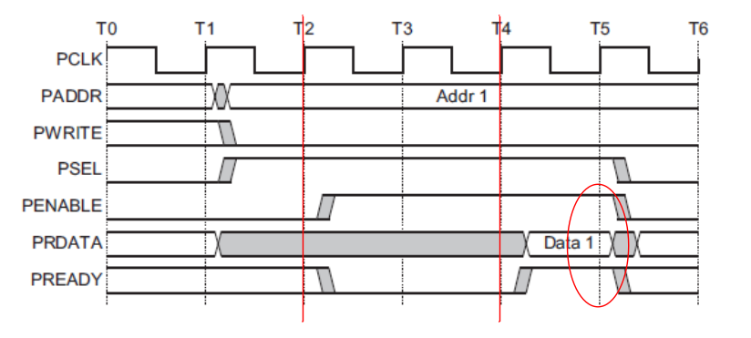
Figure- waveform of read transfer with wait states

The transfer is extended if PREADY is driven LOW during an Access phase. Other signals remain unchanged while PREADY remains LOW.

Read/Write transfers fail

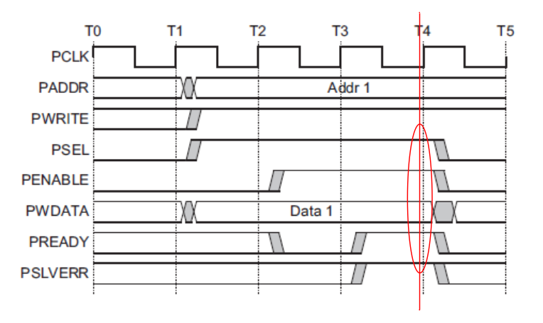
Figure- waveform of APB write transfer fail

PSLVERR is only considered valid during the last cycle of an APB transfer, when PSEL, PENABLE, and PREADY are all HIGH. - An error condition on an APB transfer. Figure- shows an error condition on write transactions.
APB peripherals are not required to support the PSLVERR pin. This is true for both existing and new APB peripheral designs.

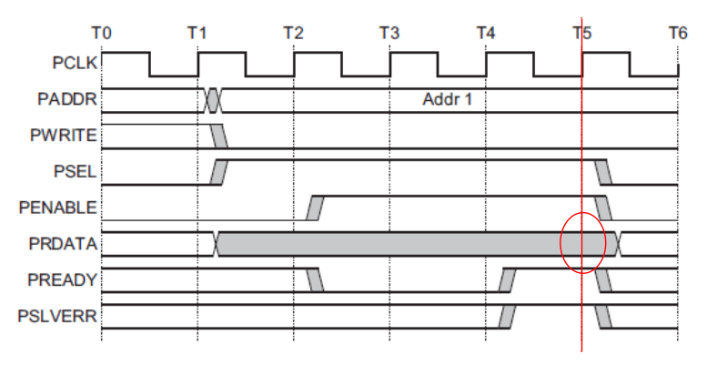
Figure- waveform of APB read transfer fail

Figure- shows a read transfer can also complete with an error response, indicating that there is NO valid read data available.
If there is any error on Read transactions:
  - Slave can return invalid data.
  - There is no requirement for the peripheral to drive the data bus to all 0s.

Andes APB extension
Andes extended APB2 is the standard APB2 interface plus two signals: PWAIT & PBE.
  - PWAIT: APB transfer wait signal. PWAIT is driven HIGH when PENABLE is HIGH to indicate additional wait cycle at access phase (the inverse of PREADY).
  - PBE[3:0]: APB bytes enable signal. When asserted HIGH, each bit of PBE indicates the corresponding byte of either read or write data bus contains valid data.

N8 BIU (Bus Interface Unit) Design Implementation for APB4

Signal descriptions

Table- Signal Descriptions for APB4 protocol
Signal | I/O | Width | Description
NDS_APB_SUPPORT

PCLK | Input | 1 | APB Clock signal.
PRESETn | Input | 1 | Reset (Active LOW).  Directly connected to the system bus reset signal.
PADDR | Output | ADDR_MSB - 1 | APB address bus (up to 32 bits wide).
PSEL | Output | 1 | APB select signal.
PWRITE | Output | 1 | Transfer direction.  Write (HIGH) / Read (LOW)
PENABLE | Output | 1 | Enable.  This signal indicates the second and subsequent cycles of an APB transfer.
PWDATA | Output | 32 | Write data (up to 32 bits wide).  This bus is driven by the peripheral bus bridge unit during write cycles when PWRITE is HIGH.
PRDATA | Input | 32 | Read Data. (up to 32 bits wide).  The selected slave drives this bus during read cycles when  PWRITE is LOW.
PREADY | Input | 1 | Ready.  The slave uses this signal to extend an APB transfer (asserted LOW to indicate additional wait cycles).
PSLVERR | Input | 1 | A transfer failure.  APB peripherals are not required to support the PSLVERR pin. This is true for both existing and new APB peripheral designs.  Pull-down by default.
PPROT | Output | 3 | Protection type.  A protection signal to support both non-secure and secure transactions on APB.
PSTRB | Output | 4 | Byte writes strobes.  There is one write strobe for each eight bits of the write data bus. Therefore, PSTRB[n] corresponds to PWDATA[(8n + 7):(8n)]. For read transfers the bus master must drive all bits of PSTRB to LOW.

Table- Signal Descriptions for additional signals for Andes APB2 extension
Signal | I/O | Width | Description
NDS_APB_EXTENSION
PWAIT | Input | 1 | Transfer wait.  The slave uses this signal to extend an APB transfer (asserted HIGH to indicate additional wait cycles).
PBE | Output | 4 | Bytes enable.  When asserted HIGH, each bit of PBE indicates the corresponding byte of either read or write data bus contains valid data.

Design Modifications

PREADY
- Signal requirement:
1. Input of CPU core.

2. PREADY is driven LOW when PENABLE is HIGH (at access phase) to extend an APB transfer.
3. PREADY can take any value when PENABLE is LOW.

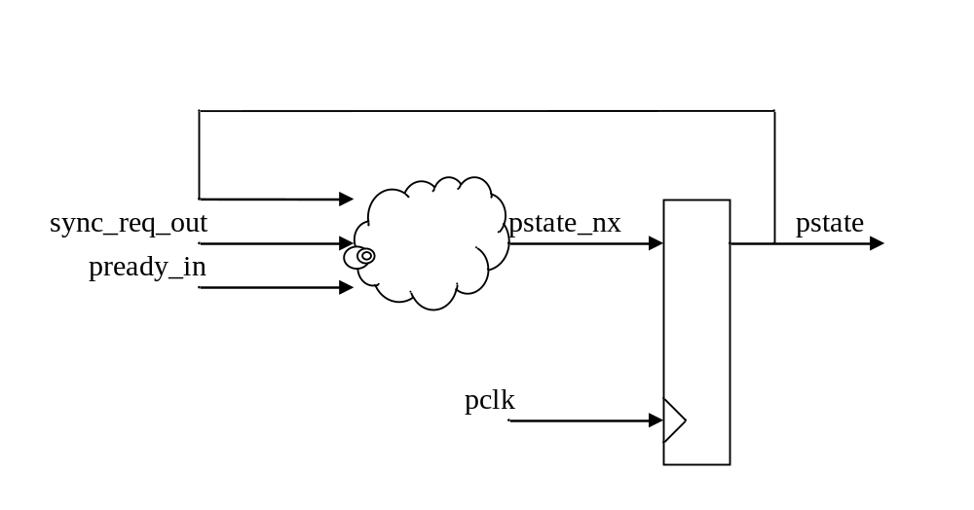
Figure- design change on pready related signals

assign pstate_set = sync_req_out & (~pstate) ;
assign pstate_clr = pstate & pready_in ;
assign pstate_nx = (~pstate_clr) & (pstate_set | pstate) ;

always @(posedge pclk or negedge preset_n) begin
if (!preset_n)
pstate <= 1'b0;
else
pstate <= pstate_nx;
end

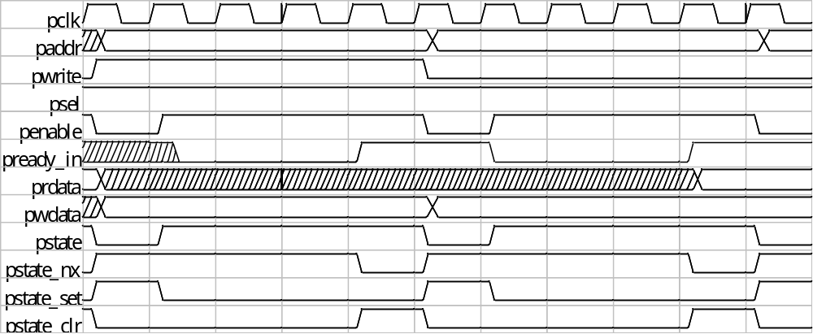
Figure- waveform of PREADY related signals

PSLVERR
Signal requirement:
1. Input of CPU core.
2. Indicating any bus read/write transfer fail.

sync_bus_error_in = (pstate & pready_in & pslverr) ;

PPROT
Signal requirement:
1. Output of CPU core
2. PPROT[0]: Normal or privileged.
3. PPROT[1]: Secure or non-secure.(no support)
4. PPROT[2]: Data or Instruction.

PPROT[0] = reg_psw_pom[0];
PPROT[1] = 1’b0 ;
PPROT[2] = ((sync_req_id_out == FCU_ID)) ;

PSTRB
Signal requirement:
1. Output of CPU core
2. Byte write strobe; tie to all zero if it is a read transfer

PSTRB = (PWRITE) ? ((pstate) ? bwe_out_d1 : sync_bwe_out)
: 4’d0 ;

Verification Plan for APB4
- Slave model supporting APB4.
- PREADY signal generation

- Random wait state
- Random number of wait cycles.
- Read or write transaction.
- PREADY is asserted in either APB address phase or data phase.
- PSTRB
- Original test patterns
- No effect on read transaction
- PPROT
- NEW
- PSLVERR
- NEW

System Integration
If user is using Andes extended APB2 interface (`define NDS_APB_EXTENSION), the PWAIT and PBE signals will exist in the port list along with PREADY, PSTRB, and other APB4 signals. Followings are the guidelines to handle these signals properly:
- PREADY/PWAIT
- Input
`ifdef NDS_APB_EXTENSION
assign pready_in = pready & ~pwait; /* with APB2 extension */
`else
assign pready_in = pready; /* APB4 only */
`endif
  - With APB2 extension
    - If using PREADY, tie PWAIT to LOW.
    - If using PWAIT, tie PREADY to HIGH.
- PSTRB/PBE
- Output – floating connection to the unused signals.
`ifdef NDS_APB_EXTENSION
assign pbe = (pstate) ? be_out_d1 : sync_be_out;
`endif
- PSLVERR
- Input – tie to LOW if not using.
- PPROT
- Output – floating connection if not using.

