

AndeShape™ ATCBUSDEC200 Design Specification

|  |  |
| --- | --- |
| Document Number | DSP-00089 |
| Date Issued | 2015-12-29 |
| Status | Final release |



**CONFIDENTIAL**

Revision History

| Rev. | Revision Date | Revised Chapter-Section | Revised Content | Author |
| --- | --- | --- | --- | --- |
| 1.0 | 2015-12-29 | Chapter 2, 3 | 1. Revised figure 6 and figure 7 | Masa |
| 0.2 | 2015-12-07 | All | 1. Revised  * block diagram * signal description * micro-architecture  1. Moved chapter 3.2 to chapter 5 2. Changed parameters to define macro 3. Added  * write/read transactions with nonexistent address * default slave | Masa |
| 0.1 | 2015-11-27 | All | Initial draft | Masa |

|  |  |  |  |  |
| --- | --- | --- | --- | --- |
| **Review History** | | | | |
| **Rev.** | **Review Date** | **Reviewed Chapter-Section** | **Comments** | **Reviewer** |
| **0.2** | 2015-12-08 | All | 1. Add us_hsel signal 2. Default_hrdata always returns 32’hffffffff | Jonathan, Joshua, Eric, Yun-Chi, Frank, Feng |
| **0.1** | 2015-11-30 | All | 1. Revise block diagram 2. Change parameters to define macro 3. Move chapter 3.2 to chapter 5 4. Revise parameter and define macro naming 5. Add error response case for timing diagram 6. Revise micro-architecture block diagram | Jonathan, Joshua, Eric, Yun-Chi, Wolfson, Frank, Feng |

|  |  |  |  |
| --- | --- | --- | --- |
| **Document Sign-off List** | | | |
| **Department** | **Name** | **Date** | **Comment** |
| VLSI | Jonathan | 2015-12-29 | Accepted as final release |

Table of Contents

Revision History ii

List of Tables vi

List of Figures vii

1. Overview 1

1.1. Introduction 1

1.2. Features 1

1.3. Block Diagram 2

1.4. Function Description 2

1.4.1. Interconnect Logic 3

1.4.2. Internal Slave 3

1.5. Timing Diagram 3

1.5.1. Write Transactions 3

1.5.2. Read Transactions 3

1.5.3. Write Transactions with Nonexistent Address 4

1.5.4. Read Transactions with Nonexistent Address 4

2. Signal Description 6

3. Micro-Architecture 8

3.1. ATCBUSDEC200 Block Diagram 8

3.2. Default Slave 9

4. Design Configuration 10

4.1. Hardware Configuration 10

4.2. Local Parameters 11

5. Programming Model 12

5.1. Summary of Registers 12

5.1.1. Internal Slave 12

5.2. Register Description 12

5.2.1. ATCBUSDEC200 ID Number and Reversion Number (0x00) 12

5.2.2. Offset/Size of Slave 1~31 (0x10 + (n-1) * 0x4) 12

5.3. Programming Sequence 14

List of Tables

Table 1. ATCBUSDEC200 Signal Description 6

Table 2. ATCBUSDEC200 Internal Slave Summary 12

Table 3. ATCBUSDEC200 ID Number and Reversion Number 12

Table 4. Offset/Size of Slave 1~31 in 24-bit mode 12

Table 5. Offset/Size of Slave 1~31 in 32-bit mode 13

List of Figures

Figure 1. ATCBUSDEC200 Block Diagram 2

Figure 2. Write Transactions 3

Figure 3. Read Transactions 4

Figure 4. Write Transactions with Nonexistent Address 4

Figure 5. Read Transactions with Nonexistent Address 5

Figure 6. ATCBUSDEC200 Input/Output Ports 6

Figure 7. ATCBUSDEC200 Block Diagram 8

**Typographical Convention Index**

|  |  |  |  |  |
| --- | --- | --- | --- | --- |
| Document Element | Font | Font Style | Size | Color |
| Normal | Georgia | Normal | 12 | Black |
| Code | Lucida Console | Normal | 11 | Indigo |
| USER VARIABLE | Lucida Console | ALL-CAPS | 11 | INDIGO |
| Note/Warning | Georgia | Normal | 12 | Red |
| Hyperlink | Georgia | Bold + Underlined | 12 | Blue |

# Overview

## Introduction

The ATCBUSDEC200 is designed as the AHB-Lite decoder. The AHB-Lite decoder receives AHB transactions from an upstream port and determines the downstream port(s) to send the received transactions based on the base/size information of AHB slaves.

## Features

List the features of the design:

* One internal slave to provide the base/size information of the downstream AHB slaves
* Up to 31 AHB-Lite slave ports
* Configurable base/size of each AHB slaves

## Block Diagram

ATCBUSDEC200 consists four major functional blocks: interconnect logic, and internal slave.



Figure 1. ATCBUSDEC200 Block Diagram

## Function Description

### Interconnect Logic

The interconnect logic include an address decoder and downstream-to-upstream multiplexor. The address decoder bases on the slave address base and size configuration to dispatch the upstream transaction to the appropriate slave ports. The downstream-to-upstream multiplexor dispatches the returned data of corresponsive slave to the upstream port.

### Internal Slave

The internal slave provides the base/size information of each AHB-Lite slave for software to get the configuration of each AHB-Lite slave. This internal slave is read only.

## Timing Diagram

### Write Transactions

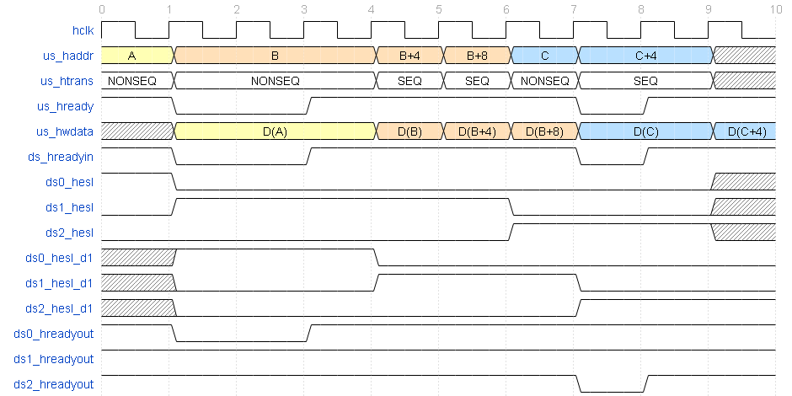

Figure 2. Write Transactions

### Read Transactions

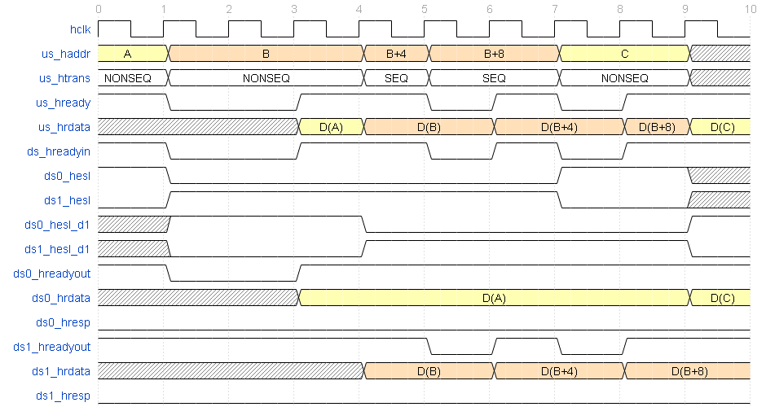

Figure 3. Read Transactions

### Write Transactions with Nonexistent Address

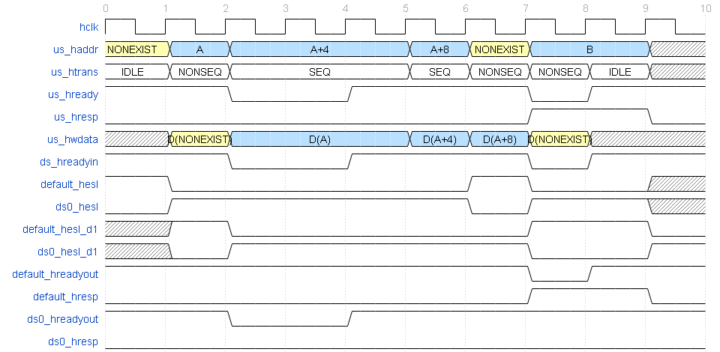

Figure 4. Write Transactions with Nonexistent Address

### Read Transactions with Nonexistent Address

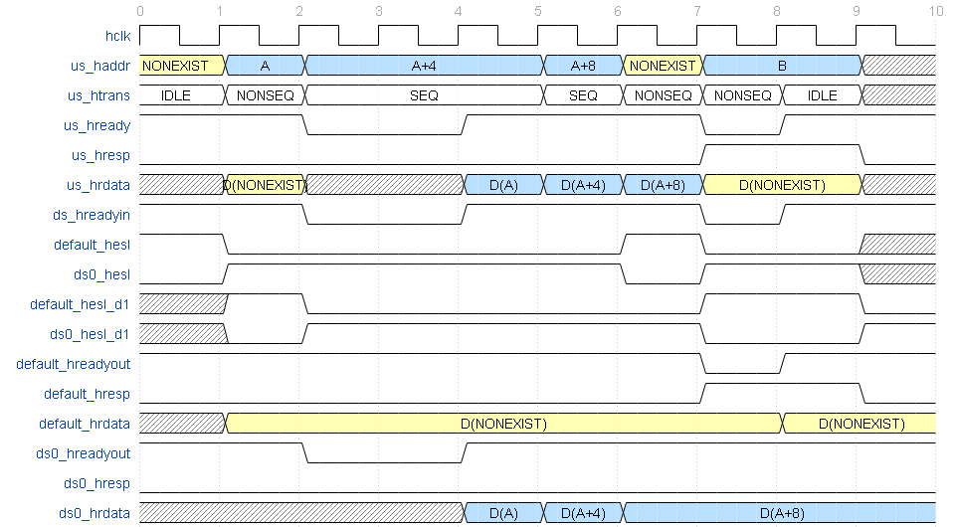

Figure 5. Read Transactions with Nonexistent Address

## Latency

Both read and write latency is one clock cycle.

# Signal Description

Figure 6 shows the signal overview and Table 1 gives the detailed descriptions of I/O signals.



Figure 6. ATCBUSDEC200 Input/Output Ports

Table 1. ATCBUSDEC200 Signal Description

| **Signal Name** | **I/O Type** | **Description** |
| --- | --- | --- |
| **AHB-Lite Global Signals** | | |
| hclk | I | AHB-Lite bus clock |
| hresetn | I | AHB-Lite bus reset |
| **AHB-Lite Interface** | | |
| us_haddr[ADDR_MSB:0] | I | AHB-Lite bus address |
| us_htrans | I | AHB-Lite transfer types |
| ds*n*_hsel | O | This signal indicates that the current transfer is intended for the selected slave n |
| ds_hready | O | AHB-Lite input ready for each slave. This signal and us_hready are the same |
| ds*n*_hrdata[DATA_MSB:0] | I | The read data bus transfers data from the selected slave n |
| ds*n*_hreadyout | I | This signal indicates that a transfer from the selected slave n has finished on the bus |
| ds*n*_hresp | I | This signal indicates that the transfer status from the selected slave n |
| us_hrdata[DATA_MSB:0] | O | AHB-Lite read data is returned to the upstream |
| us_hreadyout | O | AHB-Lite ready is returned to the upstream. This signal and ds_hready are the same. |
| us_hresp | O | AHB-Lite transfer status is returned to the upstream |

# Micro-Architecture

## ATCBUSDEC200 Block Diagram

Figure 7 shows the data path of ATCBUSDEC200.



Figure 7. ATCBUSDEC200 Block Diagram

## Default Slave

The default slave is designed to provide a response when any of the nonexistent address locations are accessed.

`ifdef ATCBUSDEC200_OOR_ERR_EN

always @( posedge hclk or negedge hresetn) begin

if (~hresetn) begin

default_hreadyout <= 1’b1;

default_hresp <= 1’b0;

end

else if (us_htrans[1] && default_hsel && us_hready) begin

default_hreadyout <= 1’b0;

default_hresp <= 1’b1;

end

else if (us_hresp && ~us_hready && default_hsel_d1) begin

default_hreadyout <= 1’b1;

default_hresp <= 1’b1;

end

else begin

default_hreadyout <= 1’b1;

default_hresp <= 1’b0;

end

end

`endif















# Design Configuration

## Hardware Configuration

* AHB-Lite Slave Ports

Define ATCBUSDEC200_SLVn_SUPPORT to enable AHB-Lite ports, where n = 1~31. For example,

`define ATCBUSDEC200_SLV1_SUPPORT

`define ATCBUSDEC200_SLV15_SUPPORT

`define ATCBUSDEC200_SLV31_SUPPORT

* AHB-Lite Bus Address Width

Define ATCBUSDEC200_ADDR_WIDTH_24 to set the address width to 24-bit. Default address width is 32-bit.

`define ATCBUSDEC200_ADDR_WIDTH_24

* AHB-Lite Bus Data Width

Define ATCBUSDEC200_DATA_WIDTH_64 and ATCBUSDEC200_DATA_WIDTH_128 to set the data width to 64-bit and 128-bit, respectively. Default data width is 32-bit. For example, 128-bit data width

`define ATCBUSDEC200_DATA_WIDTH_64

`define ATCBUSDEC200_DATA_WIDTH_128

* AHB-Lite Space Width

Define ATCBUSDEC200_ADDR_DECODE_WIDTH to identify the partial address bits for AHB-Lite address decoding. For the 24-bit mode, this macro could be 11–24; for the 32-bit mode, this macro could be 21–32. For example, 4MB decoding space

`define ATCBUSDEC200_ADDR_DECODE_WIDTH 22

* AHB-Lite Slave Size

Define ATCBUSDEC200_SLVn_SIZE (n=1~31) to identify the space size of an AHB-Lite slave based on Table 4 and Table 5 for 24-bit mode and 32-bit mode, respectively. For example, specify the space size of AHB-Lite slave #3 to be 8MB in 32-bit mode:

`define ATCBUSDEC200_SLV3_SIZE 4

* AHB-Lite Slave Address Offset

Define ATCBUSDEC200_SLVn_OFFSET (n=1~31) to identify the address offset of an AHB-Lite slave which must align on the AHB-Lite slave size. SLV0 is for the ATCBUSDEC200 internal slave. For example, suppose the size of the entire AHB-Lite bus address space is 2GB and the size of the AHB-Lite slave #3 is 8MB, specify the address offset of the AHB-Lite slave #3 to be 0x10800000:

`define ATCBUSDEC200_ADDR_DECODE_WIDTH 31

`define ATCBUSDEC200_SLV3_SIZE 4

`define ATCBUSDEC200_SLV3_OFFSET `ATCBUSDEC200_ADDR_DECODE_WIDTH’h10800000

* AHB-Lite Default Slave Error Response

Define ATCBUSDEC200_OOR_ERR_EN to identify that the default slave returns two-cycle ERROR response to upstream when decoding nonexistent address which is a NONSEQUENTIAL or SEQUENTIAL transfer. If this macro is not defined, it always returns OK response.

`define ATCBUSDEC200_OOR_ERR_EN

## Local Parameters

* ATCBUSDEC200 ID Number

PRODUCT_ID = 24’h000320

* ATCBUSDEC200 Reversion Major

REV_MAJOR = 4’h0

* ATCBUSDEC200 Reversion Minor

REV_MINOR = 4’h0

# Programming Model

## Summary of Registers

### Internal Slave

Internal slave provide the ID number of ATCBUSDEC200, reversion number and the information of base/size for each slave. The following table shows that the information corresponds to address. All of these fields are read only.

RO: Read Only

Table 2. ATCBUSDEC200 Internal Slave Summary

|  |  |  |
| --- | --- | --- |
| Address | Type | Description |
| +0x00 | RO | ATCBUSDEC200 ID and reversion number |
| +0x04~0x1C | - | Reserved |
| +0x20~0x98 | RO | Offset/size of slave 1~31 |

## Register Description

### ATCBUSDEC200 ID Number and Reversion Number (0x00)

Table 3. ATCBUSDEC200 ID Number and Reversion Number

|  |  |  |  |  |
| --- | --- | --- | --- | --- |
| Name | Bit | Type | Description | Reset |
| Reserved | HDATA_MSB:32 | - | - | - |
| ID | 31:8 | RO | ATCBUSDEC200 ID number | PRODUCT_ID |
| RevMajor | 7:4 | RO | Major revision number | REV_MAJOR |
| RevMinor | 3:0 | RO | Minor revision number | REV_MINOR |

### Offset/Size of Slave 1~31 (0x20 + (n-1) * 0x4)

Table 4. Offset/Size of Slave 1~31 in 24-bit mode

|  |  |  |  |  |
| --- | --- | --- | --- | --- |
| Name | Bit | Type | Description | Reset |
| Reserved | 31:M | - | M= ATCBUSDEC200_ADDR_DECODE_WIDTH | - |
| Offset | M-1:10 | RO | AHB-Lite slave address offset | Hardware Configurable |
| Reserved | 9:4 | - | - | - |
| Size | 3:0 | RO | Size of the slave address space:  0x0: Invalid slave  0x1: 1K  0x2: 2K  0x3: 4K  0x4: 8K  0x5: 16K  0x6: 32K  0x7: 64K  0x8: 128K  0x9: 256K  0xA: 512K  0xB: 1M  0xC: 2M  0xD: 4M  0xE: 8M  0xF: Reserved | Hardware Configurable |

Table 5. Offset/Size of Slave 1~31 in 32-bit mode

|  |  |  |  |  |
| --- | --- | --- | --- | --- |
| Name | Bit | Type | Description | Reset |
| Reserved | 31:M | - | M= ATCBUSDEC200_ADDR_DECODE_WIDTH | - |
| Offset | M-1:20 | RO | AHB-Lite slave address offset | Hardware Configurable |
| Reserved | 19:4 | - | - | - |
| Size | 3:0 | RO | Size of the slave address space:  0x0: Invalid slave  0x1: 1M  0x2: 2M  0x3: 4M  0x4: 8M  0x5: 16M  0x6: 32M  0x7: 64M  0x8: 128M  0x9: 256M  0xA: 512M  0xB: 1G  0xC: 2G  0xD~0xF: Reserved | Hardware Configurable |

## Programming Sequence

N/A