Take the price of oil, and double it. That’s probably a conservative short-term assessment of any scenario in which Tehran follows through on threats made down the years—including in 2005, in 2008, in 2011 and in 2019—to [close the Strait of Hormuz](https://www.bloomberg.com/news/articles/2019-04-22/iran-will-close-strait-of-hormuz-if-it-can-t-use-it-fars).這可能是任何情景的保守短期評估，這個評估裏，Terhran遵守通過威脅關閉海峽 With some of the world’s biggest economies reliant on the oil pumped and shipped from the region, Iran is unlikely to attempt such a drastic move. But it’s repeatedly targeted merchant shipping there, [seizing vessels](https://www.bloomberg.com/news/articles/2024-04-17/msc-aries-israeli-linked-ship-seized-by-iran-carrying-industrial-goods) as a bartering 以物易物 tool in disputes or, more recently, to antagonize the US and Israel. Ships sailing through the strait are also vulnerable to mines 地雷 because of its shallow淺的 depth, and its proximity to land—Iran, in particular—leaves vessels open to attack from shore-based missiles or interception by patrol boats and helicopters 使船容易遭受到從以岸變為基礎的導彈和被巡邏船和直升機所攔截.

Source: Clarksons Research

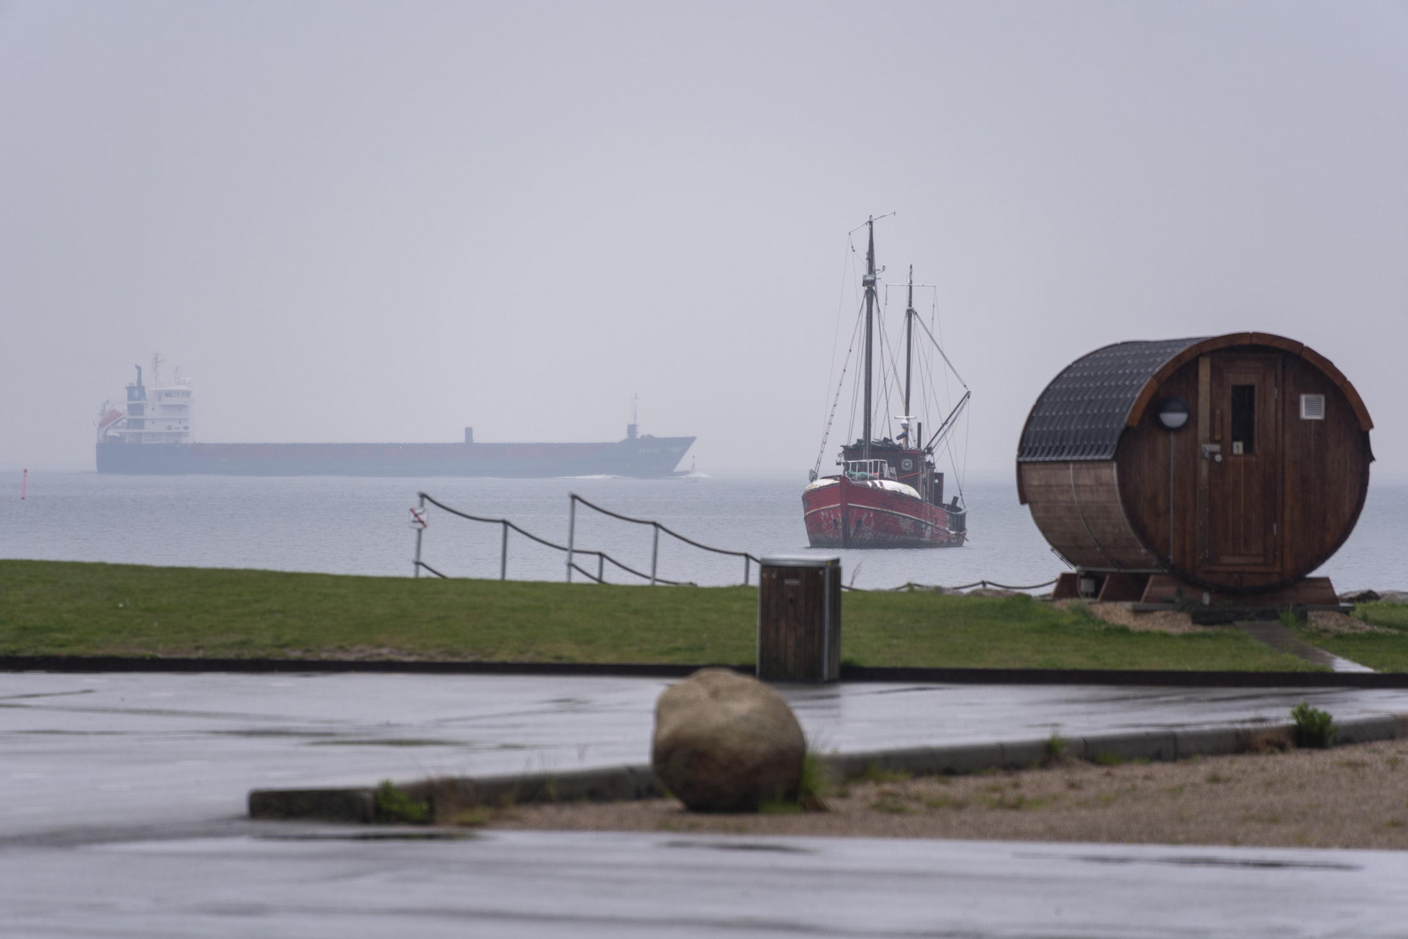

Boats at the Øresund junction 交界處 of the Danish Straits.*Photographer: Stephan Schulz/imageBROKER/Shutterstock*

About 45% of Russia’s seaborne oil exports must pass near the coastline of Denmark丹麥 on their way to international markets. The waters here are relatively shallow and can be treacherous 【ˈtreCH(ə)rəs】非常危險的 in bad weather, so international maritime authorities recommend that experienced local pilots guide vessels through the area. The risk of accidents has grown since 2022, when Russia began using a so-called shadow fleet of tankers 油輪—aging 老化的ships with dubious可疑的 safety records and inadequate insurance cover—to get around a [US-led effort to restrict Moscow’s revenues](https://www.bloomberg.com/news/articles/2022-09-13/vital-oil-chokepoint-gets-caught-up-in-eu-s-sanctions-on-russia) from oil exports. The captains of many of these ships are increasingly choosing to navigate the straits without assistance, sowing alarm 發出警報 among Danish environmentalists 環保人士. One tanker from Russia’s shadow fleet was involved in a collision 發生相撞 near Denmark in March. If one of these vessels caused an ecological disaster, Denmark’s government would come under heavy pressure from the public to forbid them from its waters—potentially inflating energy prices.

Source: Clarksons Research

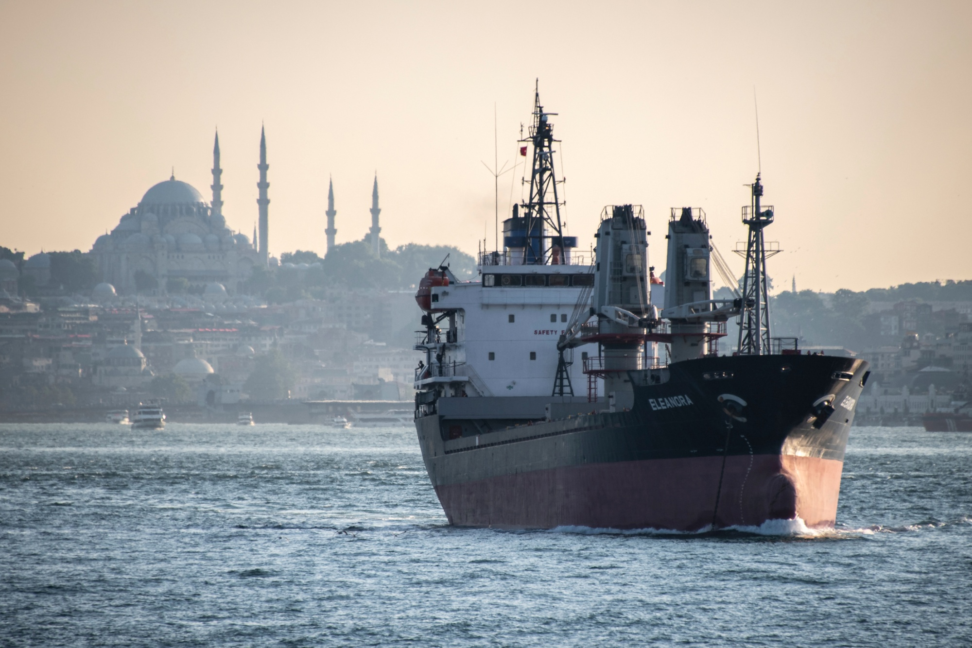

A ship passes in front of Istanbul’s Fatih Mosque.*Photographer: Diego Cupolo/NurPhoto/AP Photo*

Russia is also a major user of Turkey’s narrow Bosporus and Dardanelles shipping lanes to move its oil and other commodities from ports in the Black Sea. Turkey’s government has said in the past that it insists on clear proof of insurance 清楚的保險證明 for ships passing through the straits. Today, however, almost all the tankers sailing through them have opaque owner and insurance status—the hallmarks of shadow-fleet vessels. Should there be a major incident that threatened Turkey’s tourism industry and the value of prime real estate overlooking the straits 這應該是土耳其觀光產業的主要威脅事件和主要不動產價值忽視這個海峽, the government would close the channels immediately. So any kind of serious tanker accident in the area would be profound for the global commodity trade. Fog-ridden and sometimes beset[bəˈset]困擾 by strong currents, the Bosporus and Dardanelles are prone to shipping mishaps 不幸事故. [Wildfires](https://www.bloomberg.com/news/articles/2023-08-23/turkey-closes-dardanelles-strait-to-save-water-to-fight-canakkale-forest-fire) also forced the government to close the straits for two days in 2023 to allow emergency services to reach affected areas.

Source: Clarksons Research

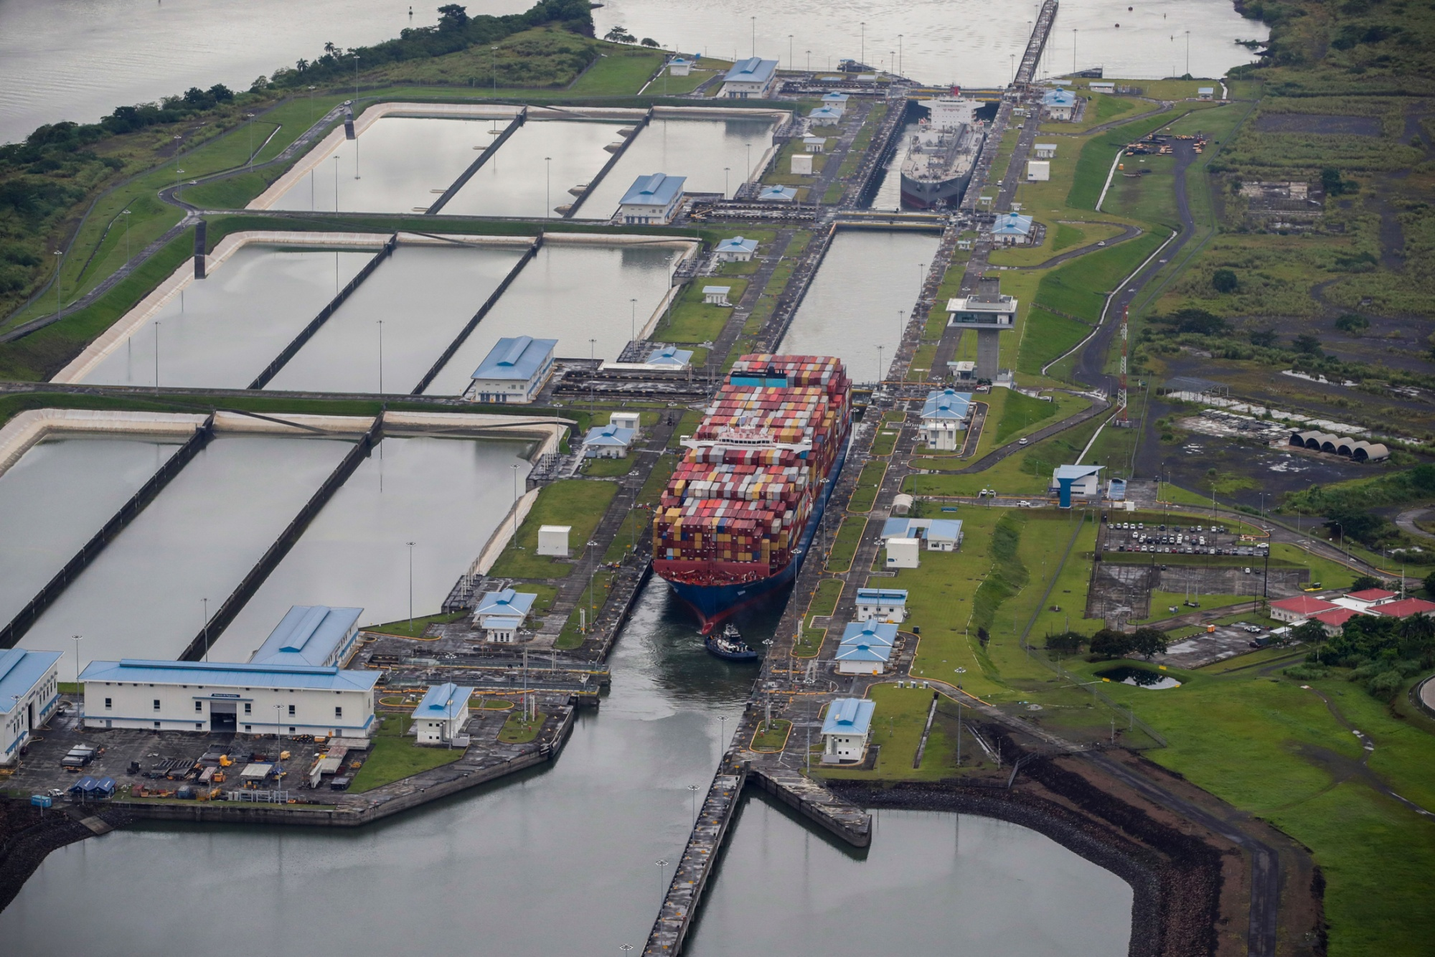

A container ship transits through the Cocoli Locks in the Panama Canal.*Photographer: Bienvenido Velasco/EPA-EFE/Shutterstock*

The Panama Canal is fed by a vast artificial lake—Lake Gatún—that allows the locks below to fill so ships can cut between the Atlantic and Pacific oceans. Climate change has [lowered Gatún’s water levels](https://www.bloomberg.com/news/articles/2023-12-04/panama-canal-bottleneck-prompts-detours-and-could-boost-inflation) to the point where the authority that oversees transits has had to curb 抑制how many vessels can pass. The dry weather last year has choked vessel traffic and cost shippers millions of dollars. The number of daily crossings has begun to recover from a low of 21 ships in late January 在一月每日的渡船數量從低於21開始回復, and a [La Niña weather phenomenon](https://www.bloomberg.com/news/articles/2024-03-14/chances-of-a-weather-roiling-la-nina-this-year-are-now-above-80) anticipated in late summer is expected to improve conditions. But daily traffic remains below the long-term average of 35 ships per day, and the canal authority will need at least the rest of this year to fully recover from the 2023 drought. *—With Brendan Murray and Julian Lee*

*Read More:*[*China Goods Flood Into Mexico, Making It Top Global Trade Route*](https://www.bloomberg.com/news/articles/2024-03-14/china-goods-flood-into-mexico-making-it-top-global-trade-route)