# Krugman Says China Is ‘Bizarrely Unwilling’ to Boost Demand

* US economist says Beijing’s economic model is not sustainable
* Adds that weak yen is good for Japan, not a source for panic

Error:

Could not download required scripts. Please update your browser or turn off ad blocker to continue to watch.

WATCH: Nobel laureate in economics Paul Krugman says China’s economic model is “not sustainable.”*Source: Bloomberg*

Gift this article

[Have a confidential tip for our reporters?](https://www.bloomberg.com/tips/" \t "_blank)**[Get in Touch](https://www.bloomberg.com/tips/" \t "_blank)**

**[Before it’s here, it’s on the Bloomberg Terminal](http://bloom.bg/dg-ws-core-bcom-m1" \t "_blank)**

**[LEARN MORE](http://bloom.bg/dg-ws-core-bcom-m1" \t "_blank)**

By Bloomberg News

June 3, 2024 at 9:51 AM GMT+8

*Updated on*

*June 3, 2024 at 12:47 PM GMT+8*

Save

Listen

3:54

China’s leaders are “bizarrely unwilling” to use more government spending to support consumer demand instead of production, according to Nobel laureate in economics Paul Krugman.

“The fact that we seem to have a complete lack of realism on the part of the Chinese is a threat to all of us,” Krugman told Bloomberg TV’s Shery Ahn and Haidi Stroud-Watts in an interview on Monday, where he also touched on Japan’s economy and the benefits of a weak yen.

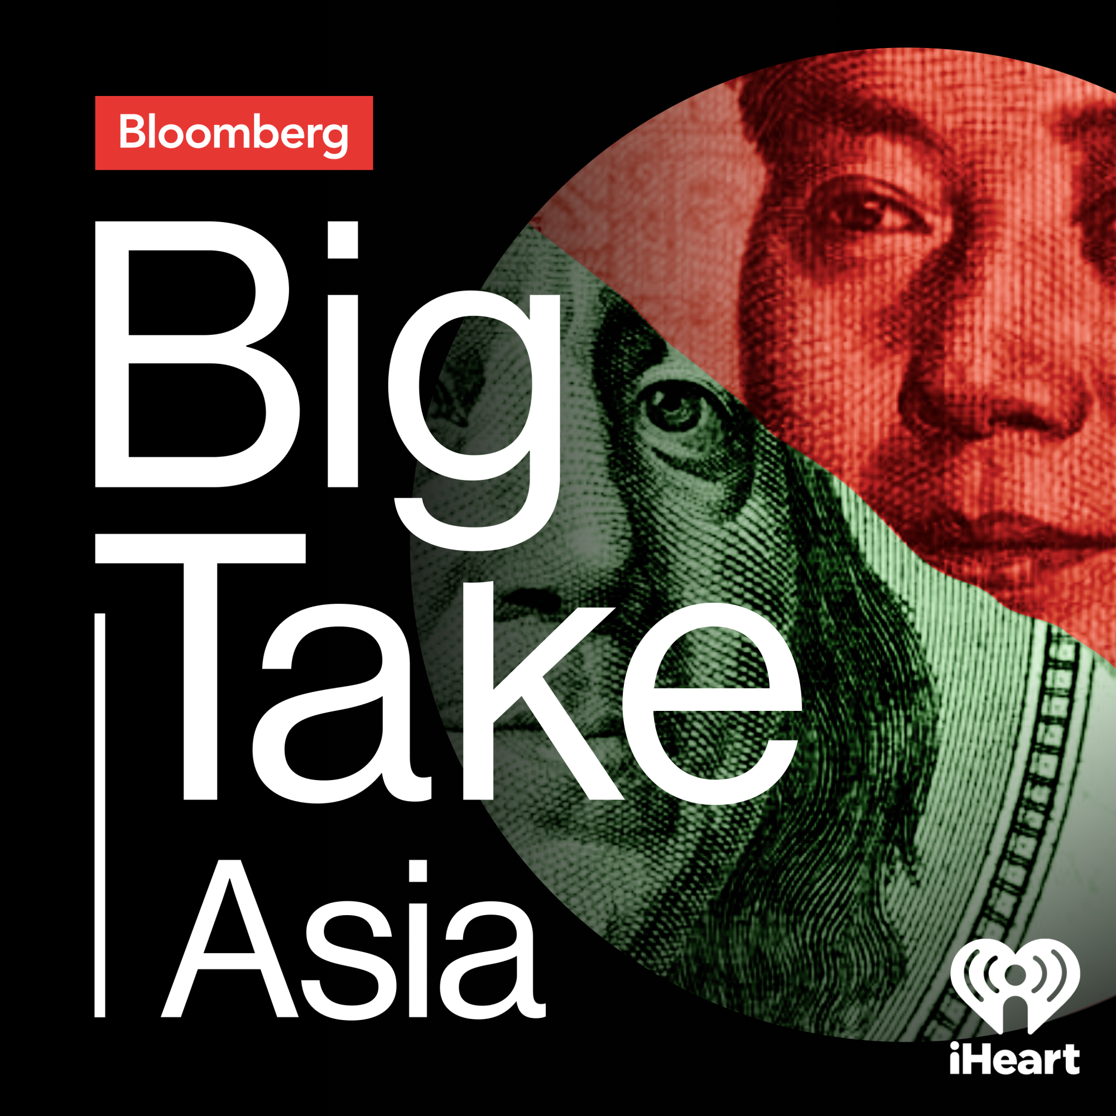

## **Big Take Asia**

## **Slowing Growth Stirs China Discontent**

20:04

Never miss an episode. [Follow The Big Take Asia podcast today](https://link.podtrac.com/jw5umzee).

Krugman echoed criticism by US economic officials including Treasury Secretary Janet Yellen that China can’t simply export its way out of trouble. The comments come amid renewed concern in the US and Europe over what is viewed as Chinese overproduction and the dumping of heavily subsidized products overseas.

Read more: [China Steps Up Warning to EU Just Days Before Tariff Decision](https://www.bloomberg.com/news/articles/2024-06-03/china-steps-up-warning-to-eu-just-days-before-tariff-decision)

“We can’t absorb, the world will not accept everything China wants to export,” Krugman said on Bloomberg TV’s [The Asia Trade](https://www.bloomberg.com/news/videos/2024-05-31/-the-asia-trade-premiers-june-3) program.

China’s whole economic model is not sustainable because of “vastly inadequate” domestic spending and a lack of investment opportunities, he added. Beijing should be supporting demand not more production, he said.

Another prominent economist, Stephen Roach, weighed in on China’s economy on Monday. He said he found a grim mood on the ground in Beijing during a visit recently, especially among entrepreneurs and students.

“I found a Beijing that really didn’t have much of the spark that I had been accustomed to over my many years of traveling there,” Roach said in a Bloomberg TV interview. “Certainly the best I could call it was a mood of grim resignation,” said the former chairman of Morgan Stanley Asia who now teaches at Yale University.

Read more: [US Risks a ‘Forever’ Trade War With China, Stephen Roach Says](https://www.bloomberg.com/news/articles/2024-05-31/us-risks-a-forever-trade-war-with-china-stephen-roach-says)

Error:

Could not download required scripts. Please update your browser or turn off ad blocker to continue to watch.

Stephen Roach, Senior Fellow at Yale Law School and former Morgan Stanley Asia chairman, discusses his concerns about US trade policy toward China and his latest assessment of the Chinese economy.

A regular policy adviser to the Chinese government, Li Daokui, predicted more supportive policies for the economy in the coming months. [Speaking](https://www.bloomberg.com/news/articles/2024-06-03/china-needs-much-more-central-government-debt-key-adviser-says) to Bloomberg TV, the Chinese economist called on Beijing to issue much more central government debt to make up for the inability of cash-strapped local authorities to spend money and drive growth.

### On Japan

Looking beyond China, Krugman said he found it hard to understand why Japanese authorities are panicking over a weaker yen that helps boost demand in that economy.

“I have to say what puzzles me is why Japan is so worried about the falling yen,” Krugman said.

“A weaker yen, after give it a bit of a lag, that’s actually positive for demand for Japanese goods and services,” Krugman said. It’s “puzzling why the weaker yen is inspiring as much panic as it seems to be.”

Krugman spoke after a government report Friday showed Japan spent a record amount to defend the currency in the past month. After the actions by the government side, the BOJ is increasingly seen likely to raise rates by July to ease pressure on the yen.

Read more: [Japan Spent Record $62 Billion to Prop Up Yen in Past Month](https://www.bloomberg.com/news/articles/2024-05-31/japan-spent-record-62-billion-in-past-month-on-yen-intervention)

Krugman, now at the City University of New York, isn’t all convinced that Japan is finally having sustainable inflationary pressures.

### ‘A Long Way’

“I hope so, but I’m not convinced by trying to look at the Japanese data,” Krugman said. “I still don’t see the kind of fundamental strength. A lot of Japan’s long-term weakness has to do with demography, has to do with extremely low fertility. That hasn’t changed, although Japan is at least more open to immigration than it used to be. But it’s a long way.”

Japan’s economy contracted in the last quarter, extending a period of no growth starting from the middle of last year. That underscored a lack of momentum even after the BOJ ended its massive monetary easing program in March with the first rate hike in 17 years.

The biggest driver for the yen weakening is a wide interest rate gap with the Federal Reserve. While few expect the Fed to cut rates soon on the back of sticky inflation, Krugman reiterated his view that it’s better to cut rates soon with the chance of re-accelerating inflation looks very small if the Fed cuts rates.

“I would go for the rate cut if only to signal, hey, you know, we’re not asleep here, we’re not going to be obsessed with inflation until that’s so far in the rear-view mirror that we really should have been focusing on the car wreck in front of us,” Krugman said.

*— With assistance from Toru Fujioka, Yujing Liu, Adrian Wong, Lucille Liu, Stephen Engle, Yvonne Man, and David Ingles*

*(Updates with comments from Chinese economist in eighth paragraph)*