Jessica Kwon

Professor Hong

05-430

Assignment 5

Low Fidelity Prototype

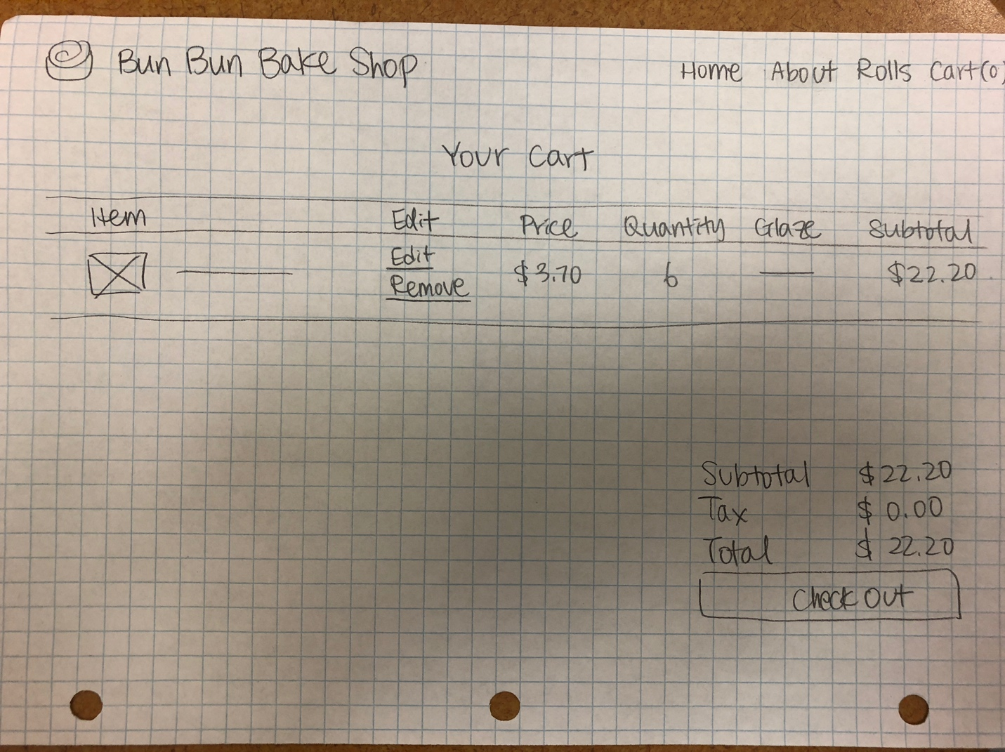

I tried to keep the cart page as minimal as possible, with just enough information so that the user can be fully informed of his or her choices. This is because anyone and everyone should be able to use the website.

High Fidelity Prototype

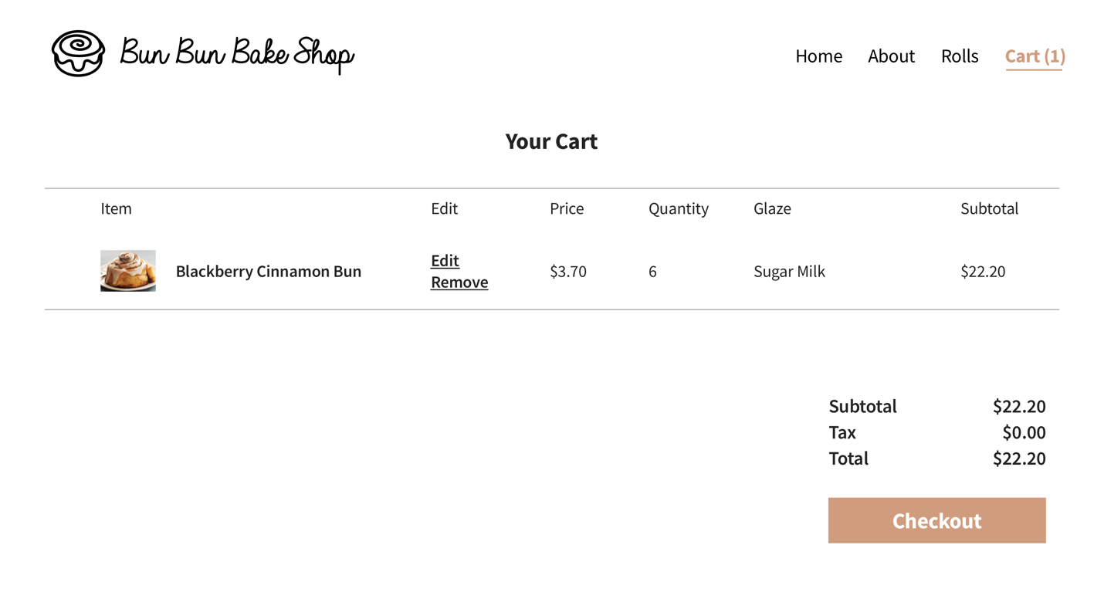

I added the color scheme and logo, but otherwise the high fidelity prototype is very similar to the low fidelity prototype. It still carries the simplicity and minimalism I wished to give.

Reflection

I had many different challenges in this assignment. One of the most frequent challenges was the type error, which I could not get to fix. Overall, I need to revisit this assignment.

I consulted different websites and looked at lab notes as well, but I was not able to solve my problems. I need to re-learn Javascript and consult the TA.