HW1: Mid-term assignment report

*João Nuno da Silva Luís [107403]*, v2024-04-09

1 Introduction 1

1.1 Overview of the work 1

1.2 Current limitations 1

2 Product specification 2

2.1 Functional scope and supported interactions 2

2.2 System architecture 2

2.3 API for developers 2

3 Quality assurance 2

3.1 Overall strategy for testing 2

3.2 Unit and integration testing 2

3.3 Functional testing 3

3.4 Code quality analysis 3

3.5 Continuous integration pipeline [optional] 3

4 References & resources 3

# Introduction

## Overview of the work

This report presents the midterm individual project required for TQS, covering both the software product features and the adopted quality assurance strategy.

The purpose of this work is to develop a full-stack application that allows users to search for trips between cities, and then, after a trip is selected, provide ways to “book” a ticket on that trip.

The developed application is composed by a frontend and backend. Despite dockerfile’s and Docker-Compose files are presented, running docker-compose instance is not working due to problems on node_modules on frontend. So, to run the application, it’s necessary to have 2 terminals open, running **mvn spring-boot:run** inside backend folder and **npm run dev** inside frontend folder.

Because the main focus of this assignment is on the test part, different test tools were used:

- Junit 5 for unit and repository tests;

- Mockito and AssertJ for service and repository tests;

- MockMvc, hamcrest and Mockito for the integration tests;

- Selenium + Cucumber for the frontend UI;

- Sonar Cloud for Static Code Quality checks (working on a GitHub action).

The Spring REST API is documented using OpenAPI 3.0 and is accessible at the following URL: http://localhost:8080/swagger-ui/index.html.

## Current limitations

The basic features have all been implemented. However, in some fields, there isn’t the proper validation required for a production app. Additional feature G’ is also done.

The currency API implementation has little tests, because it was difficult to mock it.

The cache developed for this project is also a little bit rudimentary. I used a HashMap and then passed a variable that was the Time-To-Live, but in case of a bigger/production system, probably was going to be necessary another mechanism for cache.

# Product specification

## Functional scope and supported interactions

The current application was designed for accommodating the needs of a user who intends

to search for a ticket between two cities, list the bus trips available between them,

book the desired trip with his information details and then see the confirmation.

There is only a single actor in this application, that is a a client that want to follow the behavior described above, because in this app, no administrative features were developed.

Therefore, the user is going to follow this Scenario/Steps:

1. User opens the app and selects the origin city, the date, the destination city and currency of the wanted trip;

2. The system retrieves available bus trips and some info about them;

3. Input user information (First and Last Names, City and email), as well as previous informations about the trip and ticket cost;

4. Click on the button “Purchase Ticket”;

5. Check all details related to the bought ticket on a confirmation page.

## System architecture

## API for developers

Endpoints developed for this assignment:

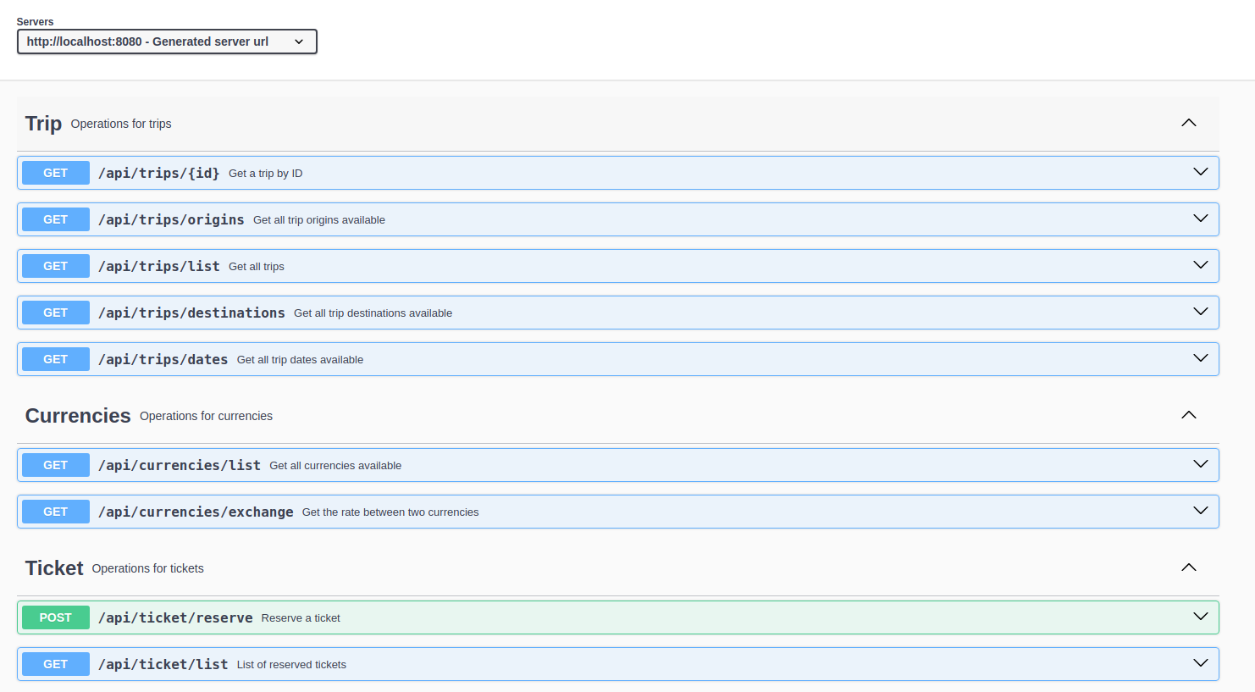

The following schemas were also developed:

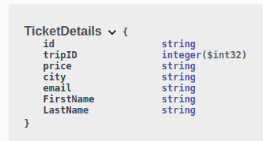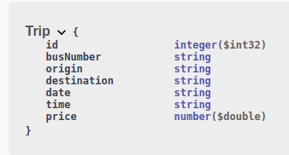

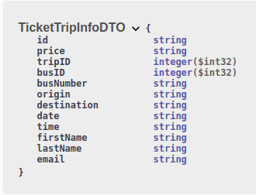

# Quality assurance

## Overall strategy for testing

To start the project, I started by creating the models I was thinking that were going to be necessary, alongside the creation of the frontend, because this visualization helped me to understand which attributes were going to be necessary. Also, the most part of the application was based on Blaze Demo from the labs exercises.

After that, I implemented the overall logic of the application creating controllers, repositories, and services.

I implemented integration with the External API only after this, and some tests to this parts.  
Then I implemented the cache system.

The Selenium+Cucumber tests were left to the final part, and due to lack of time, are incomplete.

Because I started using SonarCloud early on the project, I was correcting some issues that he would give me alongside the development of the project, instead of do that just when the full application was done.

## Unit and integration testing

The idea of the this UnitTests were check if the TTL component in the cache system was working or not.

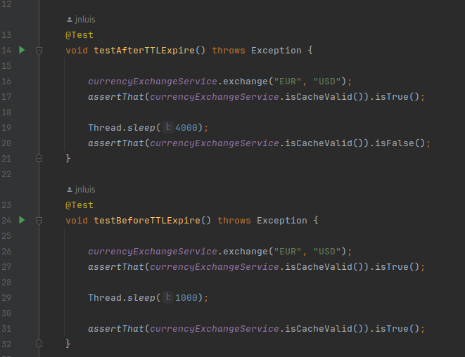

I used TestRestTemplate to verify if all layers were functioning as they should.

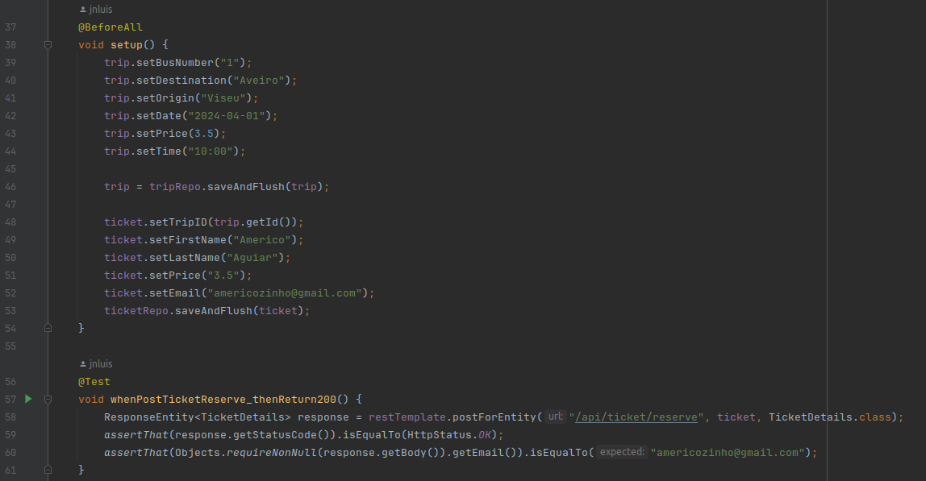

## Functional testing

For the functional testing, Cucumber and Selenium Web Driver were the way to go.

I used Cucumber to represent the workflow of the user, and the next step would be write the tests using Selenium.

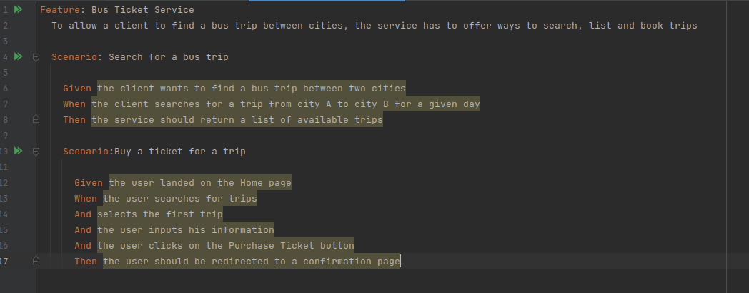

## Code quality analysis

For the static code quality analysis, I used SonarCloud with Jacoco for the coverage reports.

The Jacoco part was only added because we used it on labs, and I wanted to see the percentages, but I did not waste much time looking to Jacoco.

With SonarCloud, I really found some things really interesting, specially on security side, and SSRF. Most of the issues presented were easy to adress, and most of them I did not know that were a problem. What I found most strange, was the fact that as I worked out on the gived issues, the coverage actually dropped, ended below 80% (it was my objective to comply to)

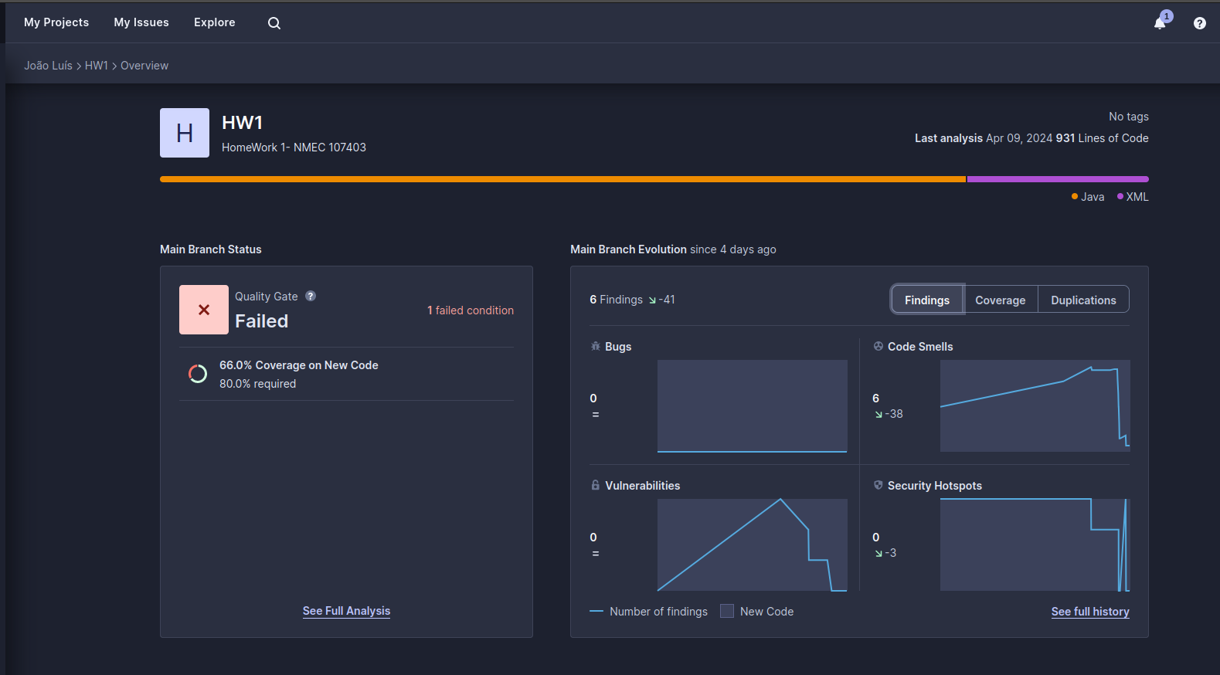

## Continuous integration pipeline [optional]

A CI pipeline was implemented for both automatic code testing and static analysis using Github Actions.

It consists of two actions with the following jobs:

- Code testing -> runs mvn test and mvn failsafe integration-test.

- Static code analysis -> static analysis using SonarCloud + Jacoco.

Because I am using both SONAR_TOKEN and External API TOKEN on a .env file, it was necessary to put them as secrets on repository and then do the 26 line trick (on first photo).  
Here is the code for code testing workflow:

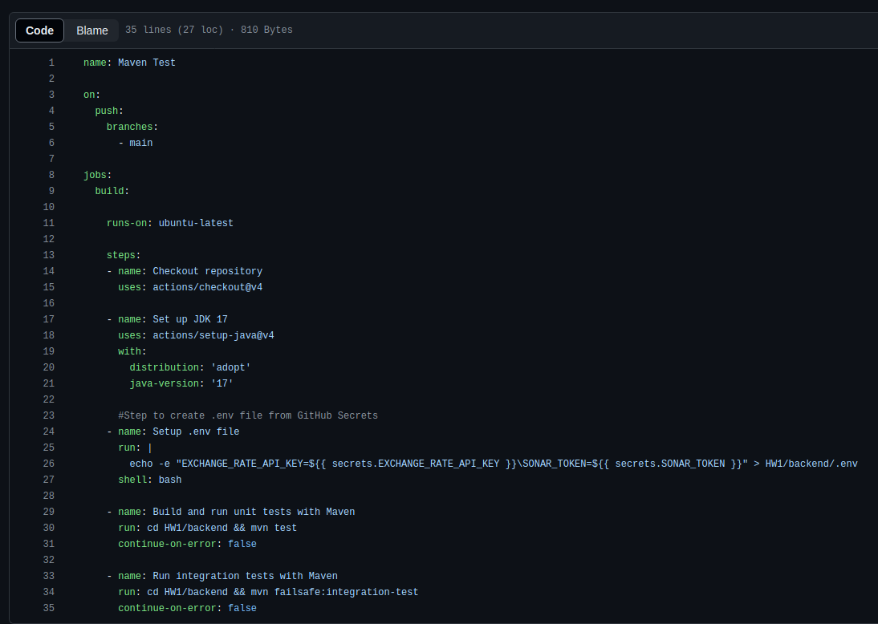

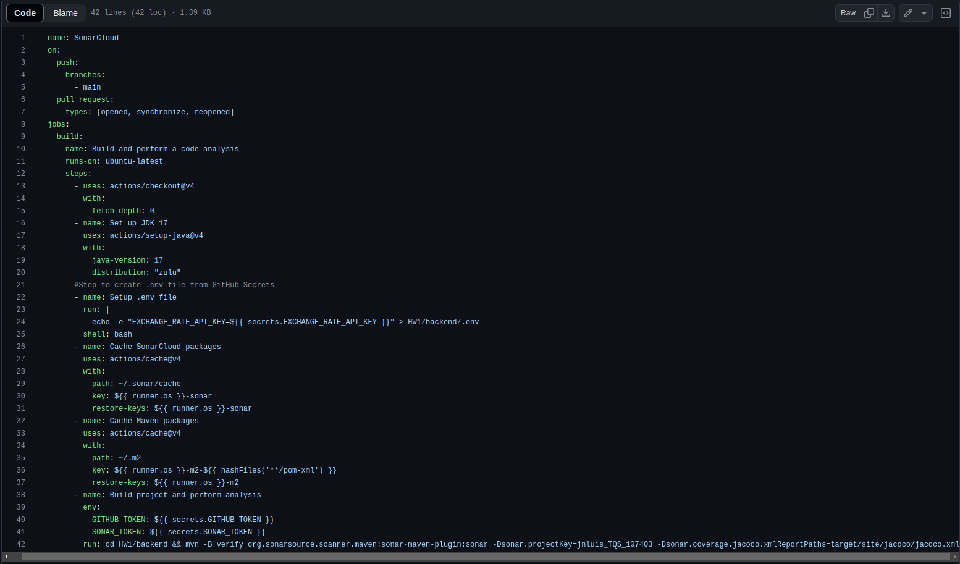

# References & resources

Project resources

|  |  |
| --- | --- |
| **Resource:** | **URL/location:** |
| Git repository | https://github.com/jnluis/TQS_107403 |
| Video demo | Video Available under reports/ directory |
| QA dashboard (online) | https://sonarcloud.io/summary/overall?id=jnluis_TQS_107403 |
| CI/CD pipeline | https://sonarcloud.io/summary/overall?id=tqs-hw_road-roamhttps://github.com/jnluis/TQS_107403/tree/main/.github/workflows |
| Deployment ready to use | Not done |

Reference materials

**Currency API:**

- https://www.exchangerate-api.com/

**API Document Generation**

- https://www.baeldung.com/spring-rest-openapi-documentation

**CI Github SonarCloud:**

- https://github.com/SonarSource/sonarcloud-github-action

**Sonar Cloud Website:**  
https://sonarcloud.io/