Fitts’ Law

CIS 482: Human Computer Interactions

J Nguyen

**Table of Contents**

Executive Summary iii

List of Figures and Tables iv, vii

1. Introduction 7

1.1 Purpose 7

1.2 Background 7

2. Conduction 7

2.1 Hypothesis and Research Question 7

2.2 Experimental Procedure 8

Analysis 9

Conclusions 9

**Executive Summary**

Fitts’ Law is a mathematical model that predicts the time required to move to a target area, based on the distance to the target and the size of the target. The law is widely used in human-computer interaction and user interface design. It states that the time taken to move to a target is proportional to the distance to the target and inversely proportional to the size of the target. More specifically, the larger the target and the closer it is in proximity to the starting position, the faster the movement time. Fitts’ Law has been found to have practical implications for interface design, pointing selections, and the positioning of controls on displays. It optimizes the designs to enhance the usability and efficiency of interfaces. The following documentation reports the results of the conceptualized law being integrated into the program. Ten participants were expected to enter the general demographic questions: gender, age, and handedness, and proceed in completing the task of clicking 32 randomly generated circles. The application was programmed in Python, with the modules of Tkinter, Random, Time, CSV, and Math.

<https://github.com/jnncode/Fitts_Law>

**List of Figures and Tables**

The figures below depict the various factors upon the trials of the participants in determining the performance. Each figure was executed with the following modules: pandas, and matplotlib.

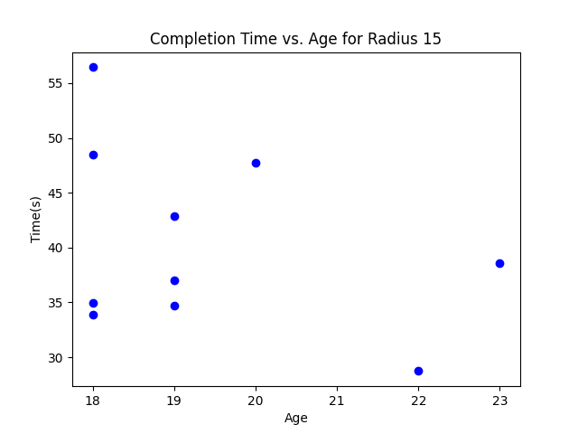

Figure 1 - Scatterplot exhibiting the age of the participant and their time taken to complete the study.

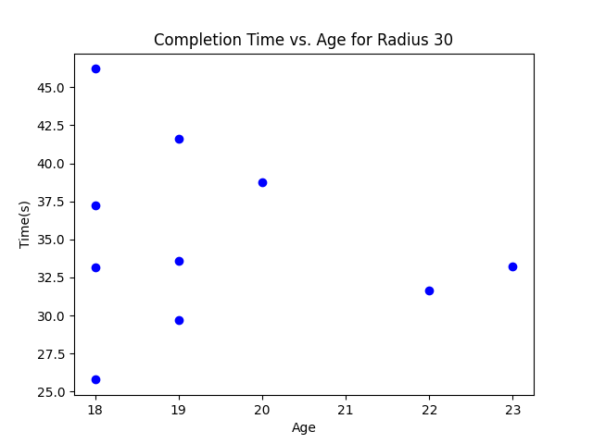

Figure 2 - Scatterplot depicting the gender of the participant and their time taken to complete the study.

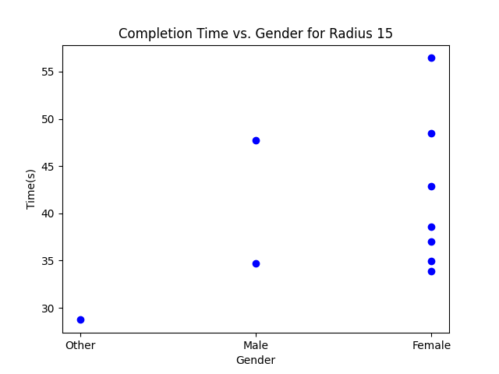

Figure 3 - The average time taken to complete the study when the radii of the circles were 15 versus 30, based on the gender of the participants.

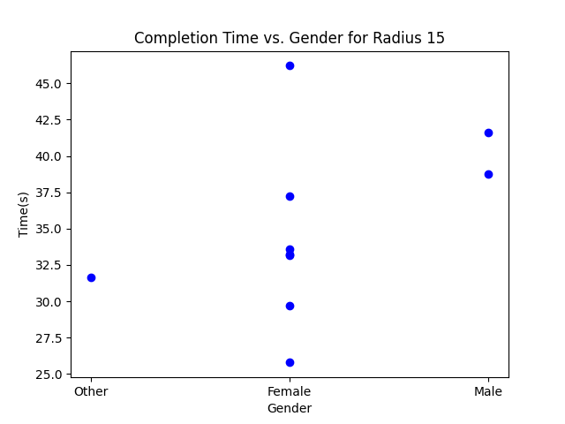

Figure 4 - The average time taken to complete the study when the radii of the circles were 15 versus 30, in accordance with the gender of the participants.

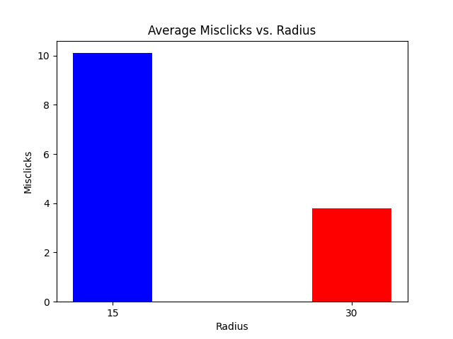

Figure 5 - The average quantity of misclicks when the radii of the circles were 15 versus 30.

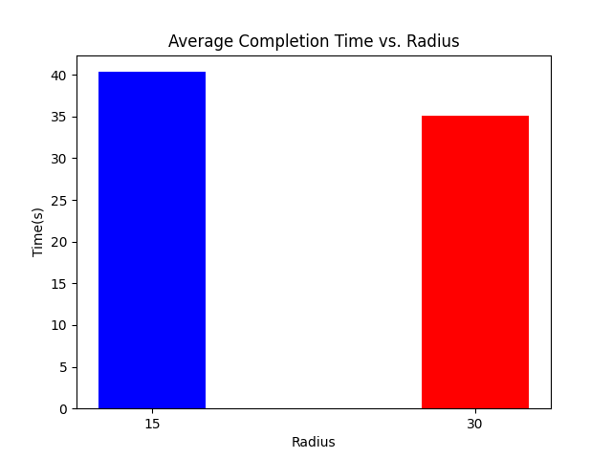

Figure 6 - The average completion time when the radii of the circles were 15 versus 30.

**Introduction**

* 1. **Purpose**

To provide a quantitative analysis of the performance of an interface based on Fitts’ Law as well as to provide information on how to improve designs of interfaces to optimize their performances. The report details the experiment design of the tasks performed, the participants involved, and the measurement techniques used to gather the data information. In addition, the report includes statistical analyses of the data collected and assesses the significance of the results.

* 1. **Background**

Fitts’ Law predicts that the time and accuracy of user-interface interactions corresponds with the size and distance of targets. Understanding Fitts’ Law becomes increasingly useful in being able to track the way users interact with a particular webpage or application, which allows for more comprehensive and effective designing and programming.

The study was conducted as follows: pilot study, full experimentation, and output analyzation. The pilot study consisted of testing the procedures and making any necessary adjustments before conducting the full experiment. These adjustments included establishing conditions in which users are restricted to certain inputs in text fields, for example, age had to be a digit between 18 and 100. Additionally, participant ID had issues with incrementation and had to be adjusted to increase by one each time the application was performed so each participant was granted a unique ID. Furthermore, data was collected and analyzed to identify any potential issues or areas for improvement upon the experiment design.

**Conduction**

**2.1 Hypothesis and Research Question**

The study was conducted as follows: pilot study, full experimentation, and output analyzation. The pilot study consisted of testing the procedures and making any necessary adjustments before conducting the full experiment. These adjustments included establishing conditions in which users are restricted to certain inputs in text fields, for example, age had to be a digit between 18 and 100. Additionally, participant ID had issues with incrementation and had to be adjusted to increase by one each time the application was performed so each participant was granted a unique ID. Furthermore, data was collected and analyzed to identify any potential issues or areas for improvement upon the experiment design.

The hypothesis developed prior to the study was that increasing the size of targets in a user interface would result in faster and more accurate user interactions. Thus, this begs the question as to how altering the size of targets affects the time and accuracy of user interactions, as predicted by Fitts’ Law.

The independent and dependent variables in this study were the participants themselves, including their specific attributes of age, gender, and handedness, and the time it took them to complete the study as well as the number of inaccurate clicks, respectively. While conducting

the pilot study, a significant amount of testing and validation was done, and errors were resolved via searching through alternatives of algorithmic functions. During the development of the algorithm of generating random circles within a specific geometric interface size, issues arose when adding additional conditions as well as inserting the generated data into the comma delimited file (csv) on Excel. To resolve the issues, tasks were separated, and additional reviewers overlooked the program. Many of the reviewers had background of programming and specialized in the programming language, Python. All reviewers validated the code base prior to the conduction of the experiment.

**2.2 Experimental Procedure**

The experiment focused on having users click on 32 randomly generated circles. First, the user would begin by inputting their age, gender, and handedness. Conditions were placed on these variables; age was limited between 18-100, gender was limited to either male, female, or other, and handedness was limited to right or left-handed. After this, users were met with a page of instructions and a button to begin. Once pressed, the first circle was generated, with each subsequent circle being generated after each correct click. Then, the data each participant inputted, as well as the time it took them to complete the study and the number of misclicks, was recorded in the CSV file, Fitts’_Data. This study utilized a small sample population of 10 participants for the purposes of this report. Additionally, this study was conducted twice with the same participants, with the first attempt having circles of This radius 15, and the second attempt containing circles of radius 30. The completion time and quantity of misclicks were then compared against one another to determine if an increase in target size was more effective for user interaction.

**Analysis**

The average time needed to complete the study when the radius of the circles was 15 ranged

from 30 to 60 seconds. However, the average time needed for completion when the radius

of the circles was 30 ranged from 25 to 50 seconds. When looking at the mean, the average

time needed to complete the study for radii 15 versus 30 were 40.3305 and 35.0960 seconds, respectively.

Since both the time ranges and average time needed to complete the study were lower when the radius of the circle was 30 as opposed to 15, it can be concluded that a larger radius of a target allows for a faster reaction time and more efficient overall user-interface interaction to occur.

The average misclicks occurred in the completion of the study when the radius of the circle was 15 was 40. However, the average misclicks occurred in the completion of the study when the radius of the circle was 30 was 34. Based on the differences described from the bar graph, there appears to be a correlation between misclicks and the size of the target, particularly that a larger target results in fewer misclicks. This would fit accordingly with the prediction Fitts’ Law makes in assuming that a larger target would allow for more efficient interactions.

Gender did not seem to have a connection with Fitts’ Law, as the data collected from the men, women, and gender non-conforming participants did not have noticeable or considerable effect on completion time or accurate clicks. Additionally, no figure was created for handedness as all participants, though chosen randomly, were right-handed.

**Conclusion**

From the data, it can be fairly concluded that the hypothesis discussed prior was supported. Both the average time taken to complete the study and the quantity of misclicks were both lower when the radius of the generated circles was larger as opposed to their smaller counterparts. Thus, Fitts’ Law, which states that a more efficient user-interface interaction can occur when the size of targets is larger, has been proven with this study. Going forward, additional testing could be done to determine the effect of distance and could utilize a larger sample population size.