**CS 301**

**Josh Daniels**

**5/28/2025**

**Normal Input:**

2026 (future) contract expiration

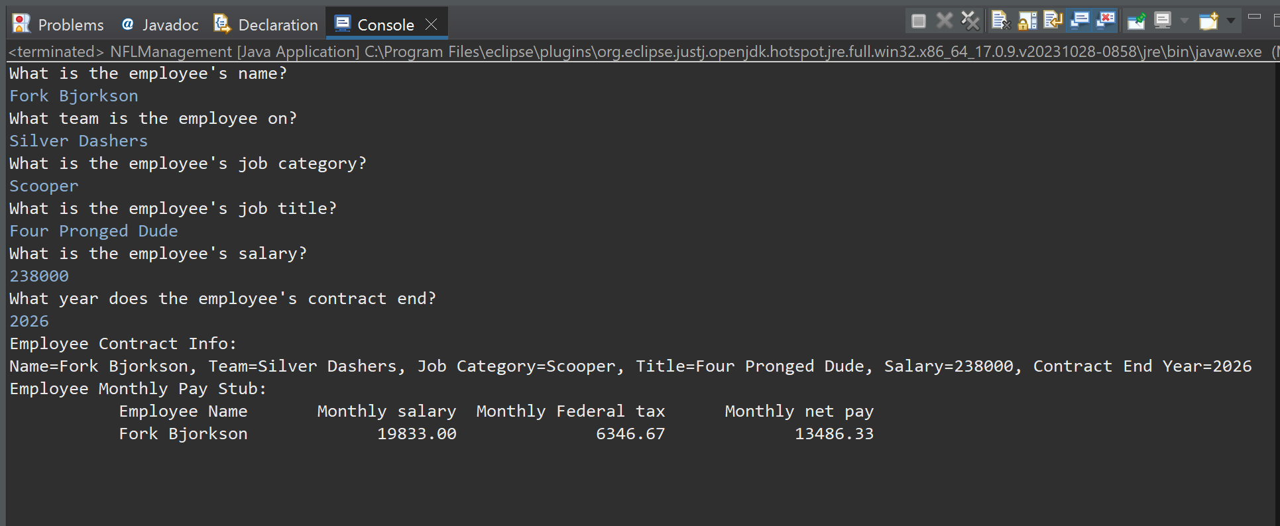

2025 contract expiration:

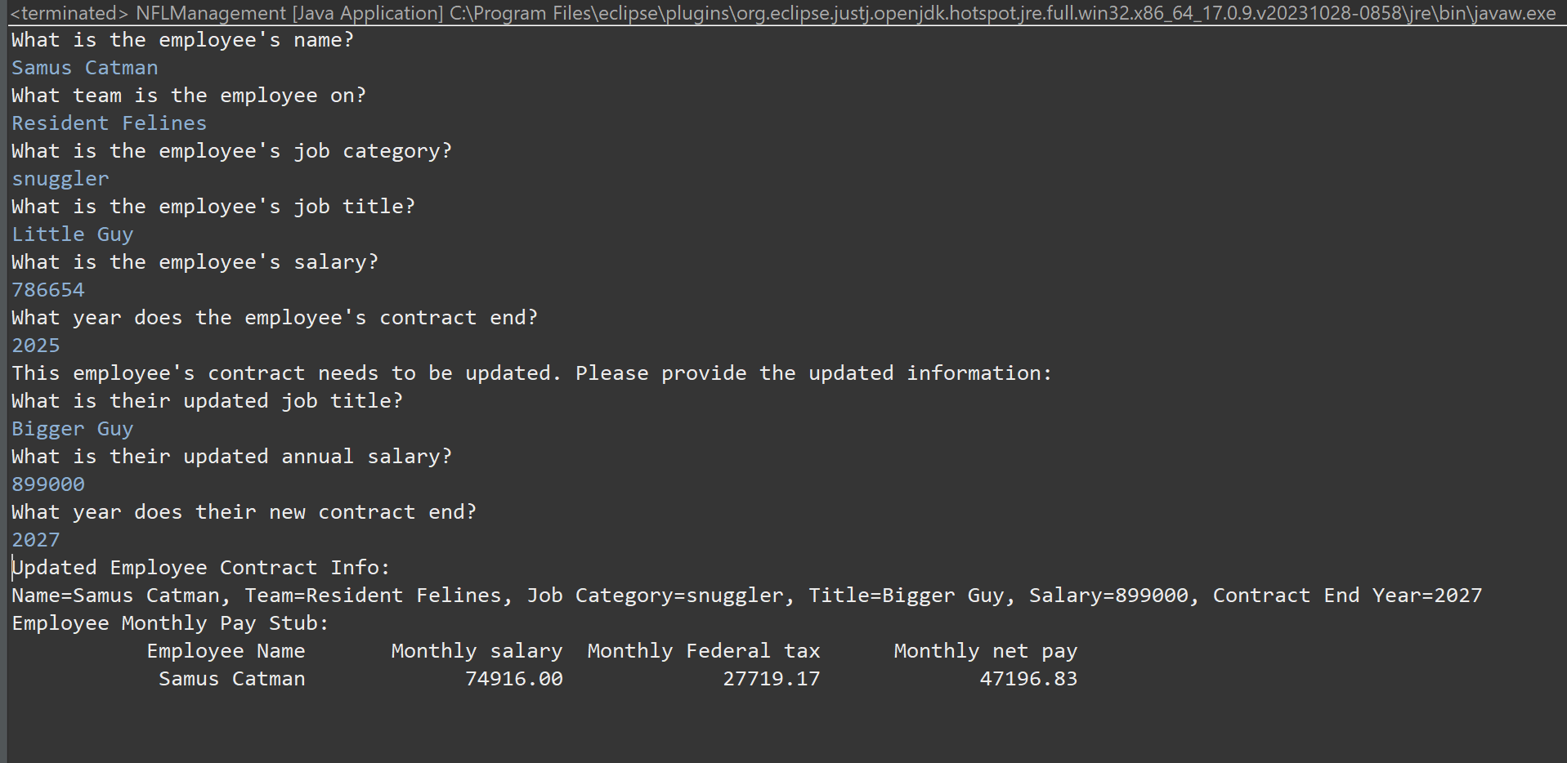

2024 (past) expiration:

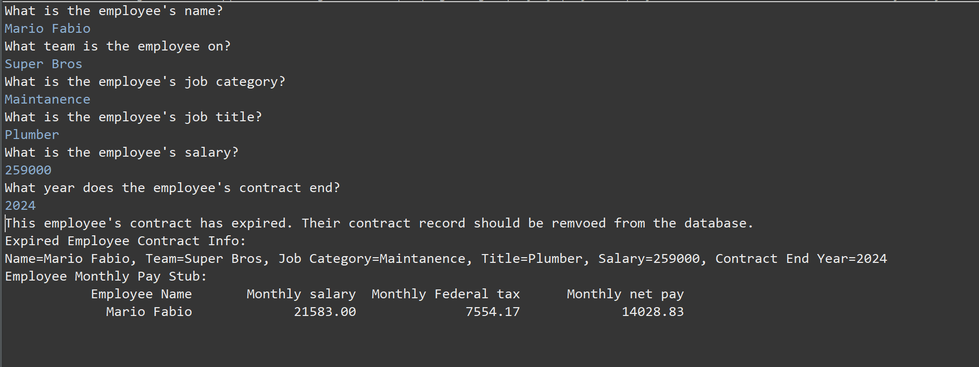

**Unusual Input (errors & default values):**

2023 or earlier contract end year

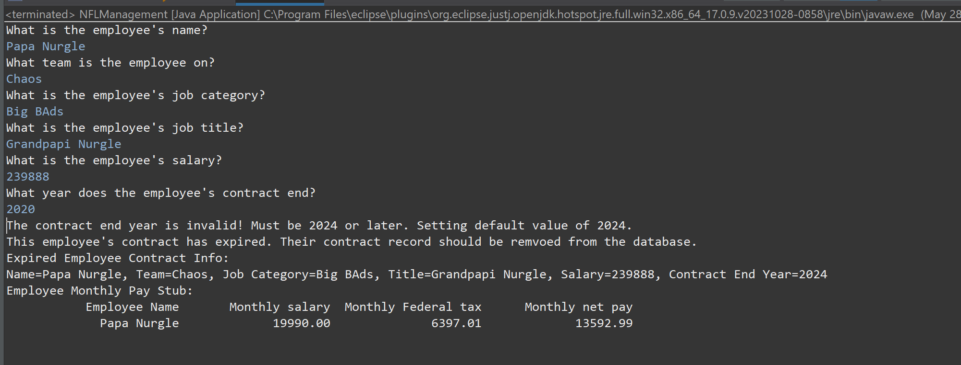

Low Salary (less than minimum wage):

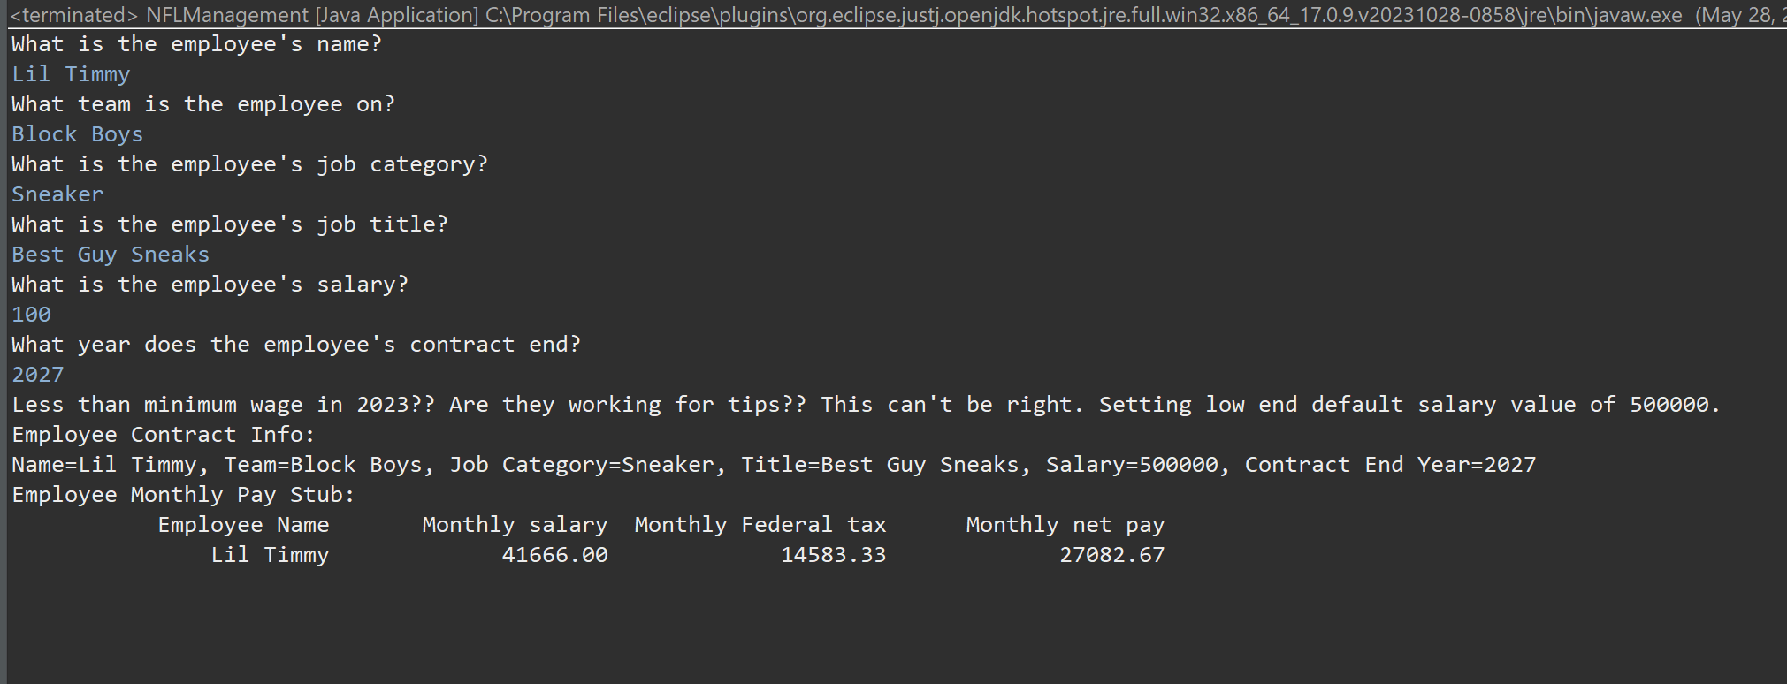

Too High Salary (over a billion dollars):

