Michael Ruby
CS 6643 – Computer Vision, Spring 2020
James Fishbaugh

Project 1
A1b) Image denoising
To explore image denoising, I developed a set of Python functions (in modules denoise.py, image_denoising.py, and user_input.py) that consist of simple implementations of several image processing filters. They are organized into an appendix at the end of this document. Three filters were tested for their performance in reducing noise on an image (lena.png), to which I had added three different levels of Gaussian blur. The three filters are 1) a box filter of user-defined size, 2) a Gaussian filter of user-defined sigma, and 3) a median filter of user-defined size. I also created 4) a convolving filter that resembles embossing, but this was not used for the comparisons.

Figure 1 contains the original image, and Gaussian blurs at 0.1, 0.2, and 0.3. Images are not centered with respect to each other, as filter-defined padding was added in order to make the filters function correctly at edge pixels. This was not corrected by returning the original image coordinate set.

Figure 1: Three levels of Gaussian blur
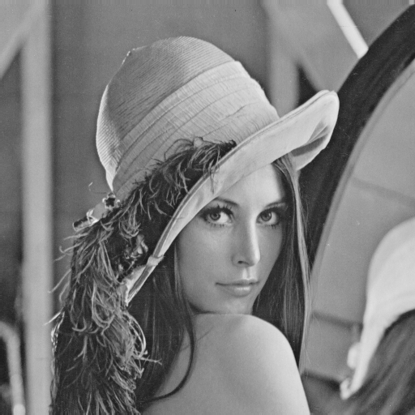 | 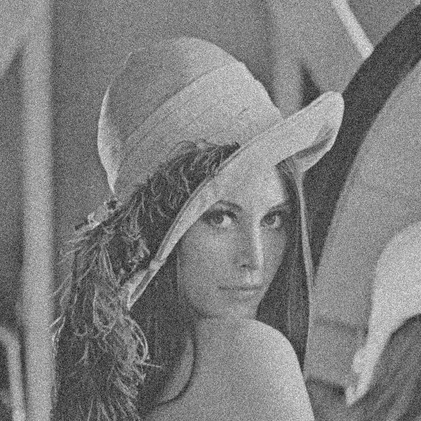 | 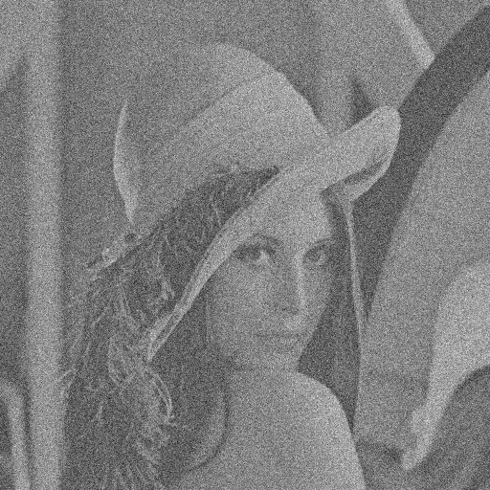 | 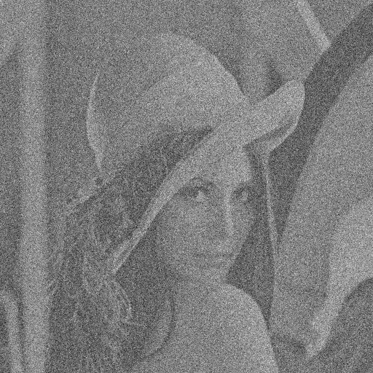
Lena | Lena +  Gaussian blur(0.1) | Lena +  Gaussian blur(0.2) | Lena +  Gaussian blur(0.3)

The performance of box filter, Gaussian filter, and median filter are shown for each of the blurred images in Figure 2. In order to determine appropriate comparisons, I used a formula from an unpublished paper by Peter Kovesi, who determined that a proper comparison Gaussian for a box filter width can be approximated by:

Because I chose a box filter for the examples, I also input Gaussian . For the median filter, I chose to parallel the size of the box filter.
 | 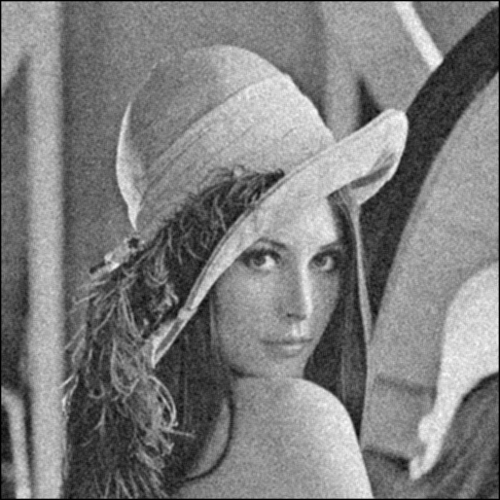 | 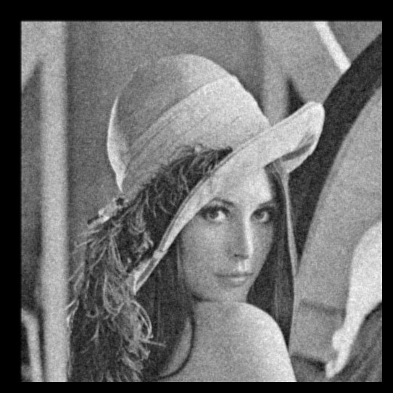 | 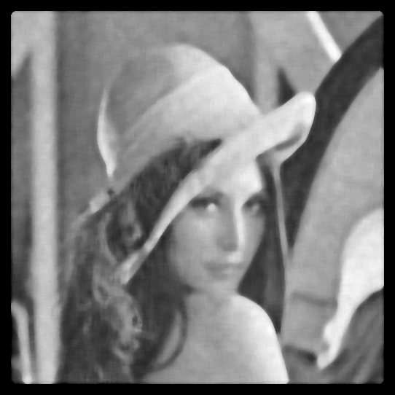
Lena +  Gaussian blur(0.1) | + box filter | + Gaussian filter | + median filter
 | 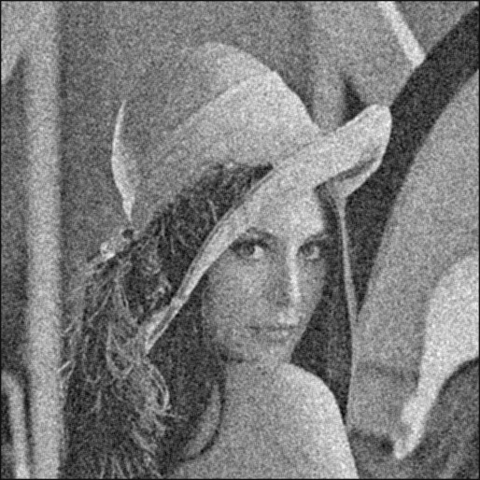 | 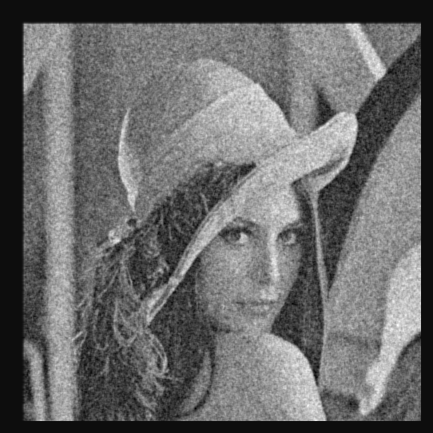 | 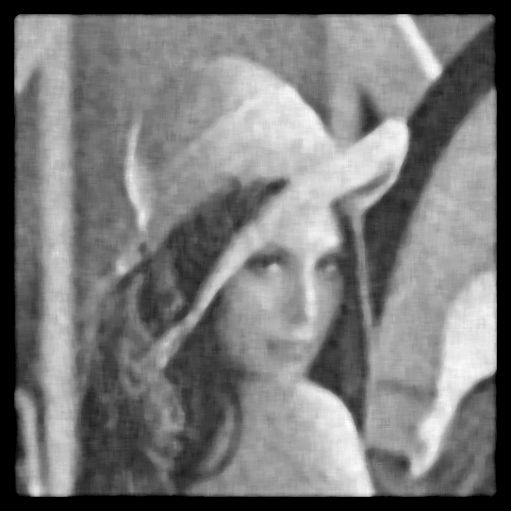
Lena +  Gaussian blur(0.2) | + box filter | + Gaussian filter | + median filter
 | 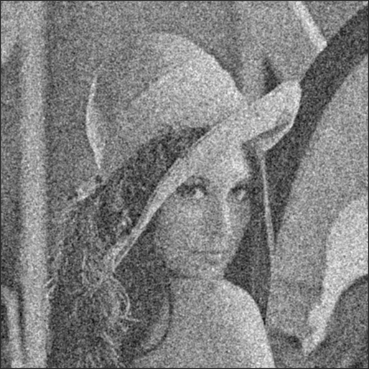 |  | 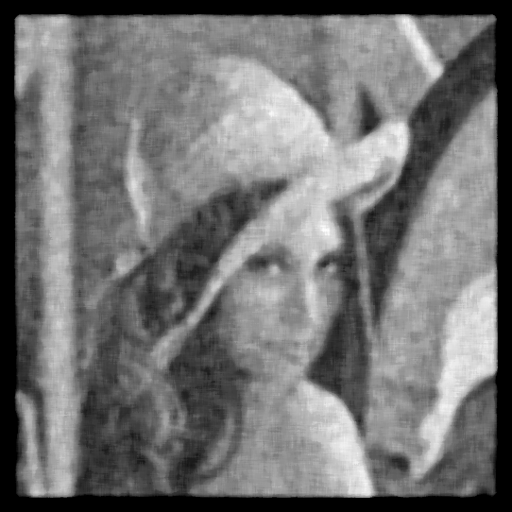
Lena +  Gaussian blur(0.3) | + box filter | + Gaussian filter | + median filter

Discussion:

Include convolved if psilobse.

A2) Derivative filters

A3) Template matching

Appendix: Code

