Once you have downloaded the BSD-QBio repository from GitHub and have installed PyCharm on your computer, please launch PyCharm, then follow these steps.
Step 1
Go to File > New Project…
For the workshop, we will need Python 3.10. Under “Python version”, select 3.10. If necessary, it will automatically download and install this version of Python. (If this does not work, please see “Troubleshooting” at the end.)
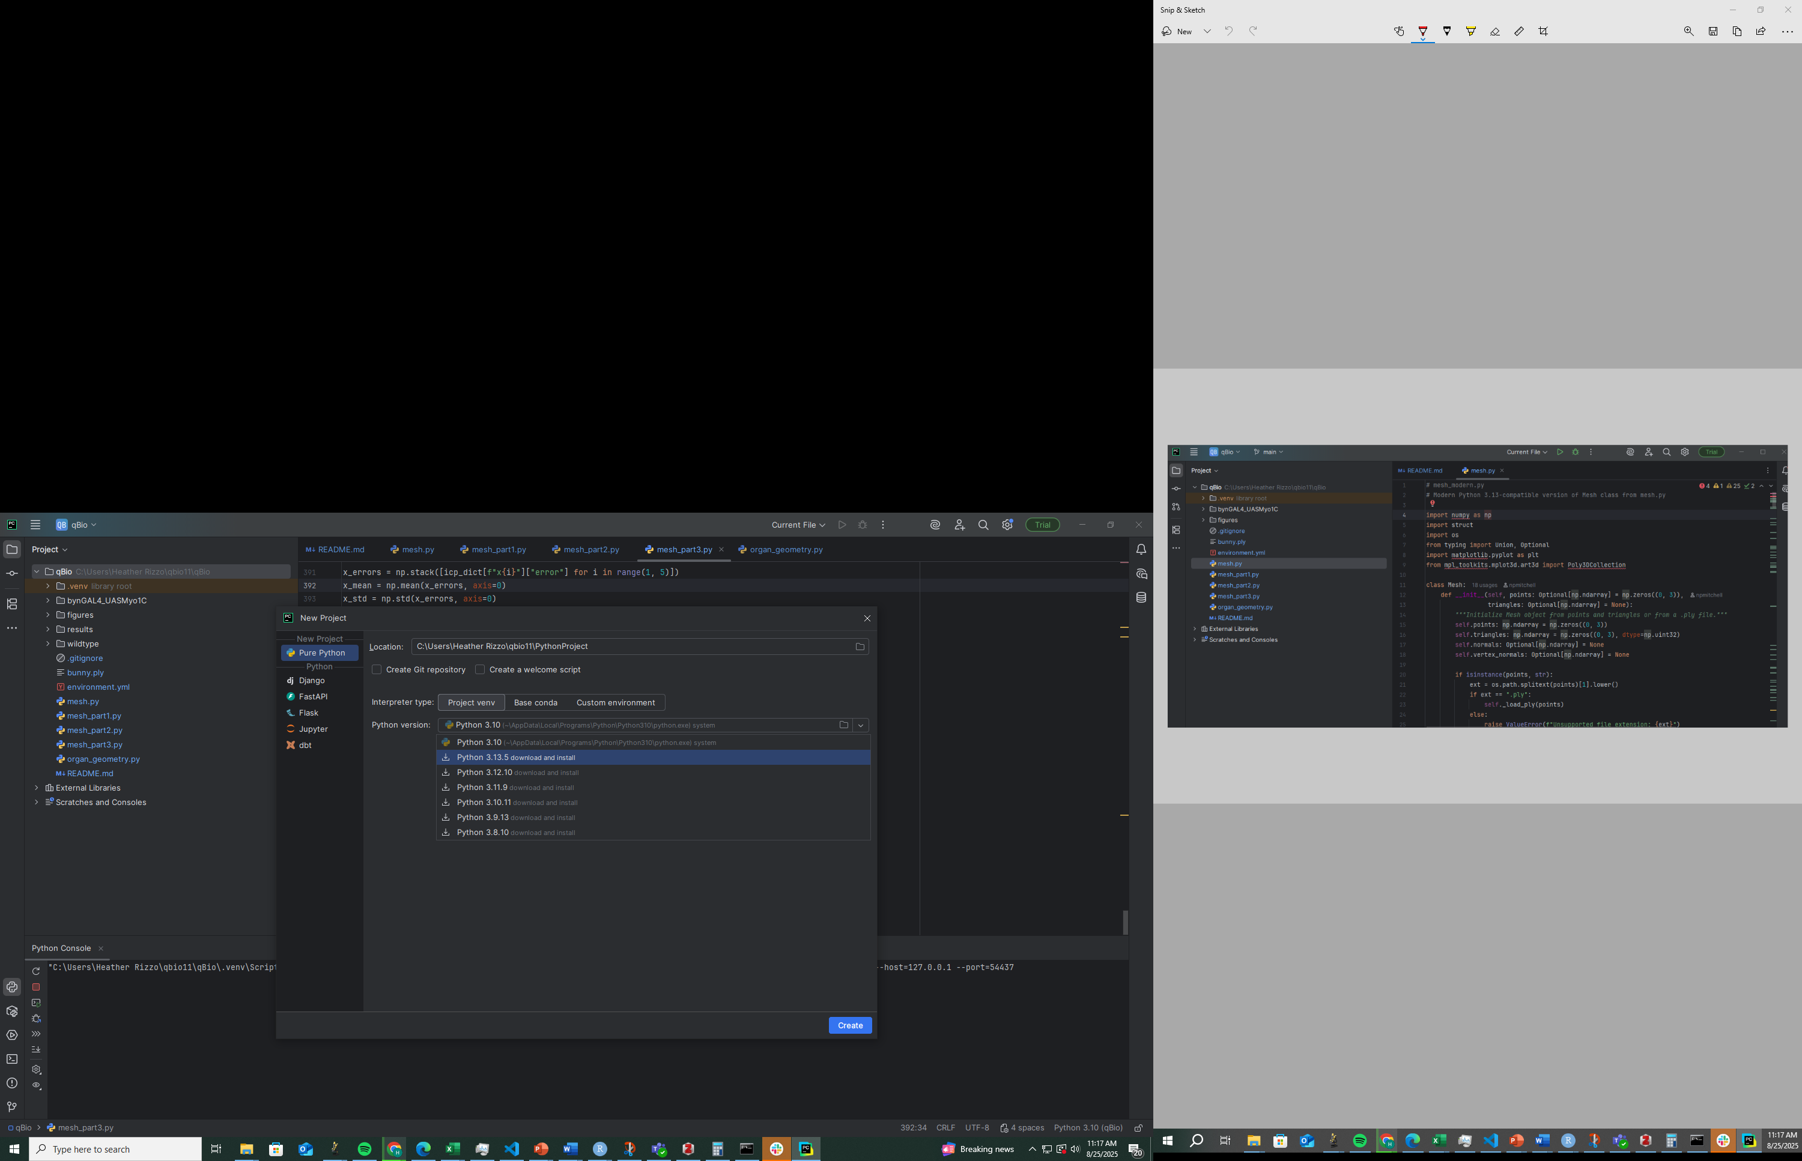
1
- The location of your new project should be the same as the folder containing the materials for the Biological Shape Analysis workshop (…/BSD-QBio/workshops/npmitchell). Note that the name of the folder containing the workshop materials (“npmitchell”) will also be the name of your project.
- Check that python version 3.10 is being used.
- Click create!
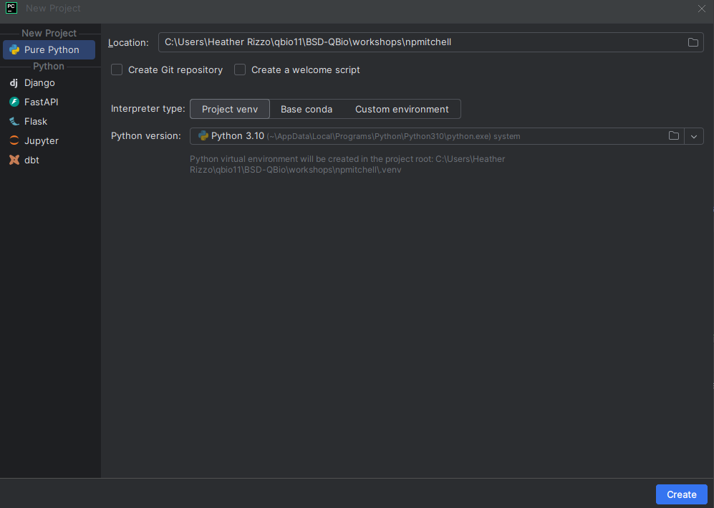
3
2

Step 2
Install the Python packages you will need for the workshop.
Open the Terminal (red box in image below) in PyCharm, and install the packages by typing
pip install numpy scipy pandas matplotlib pyvista open3d
then hit the enter or return key.
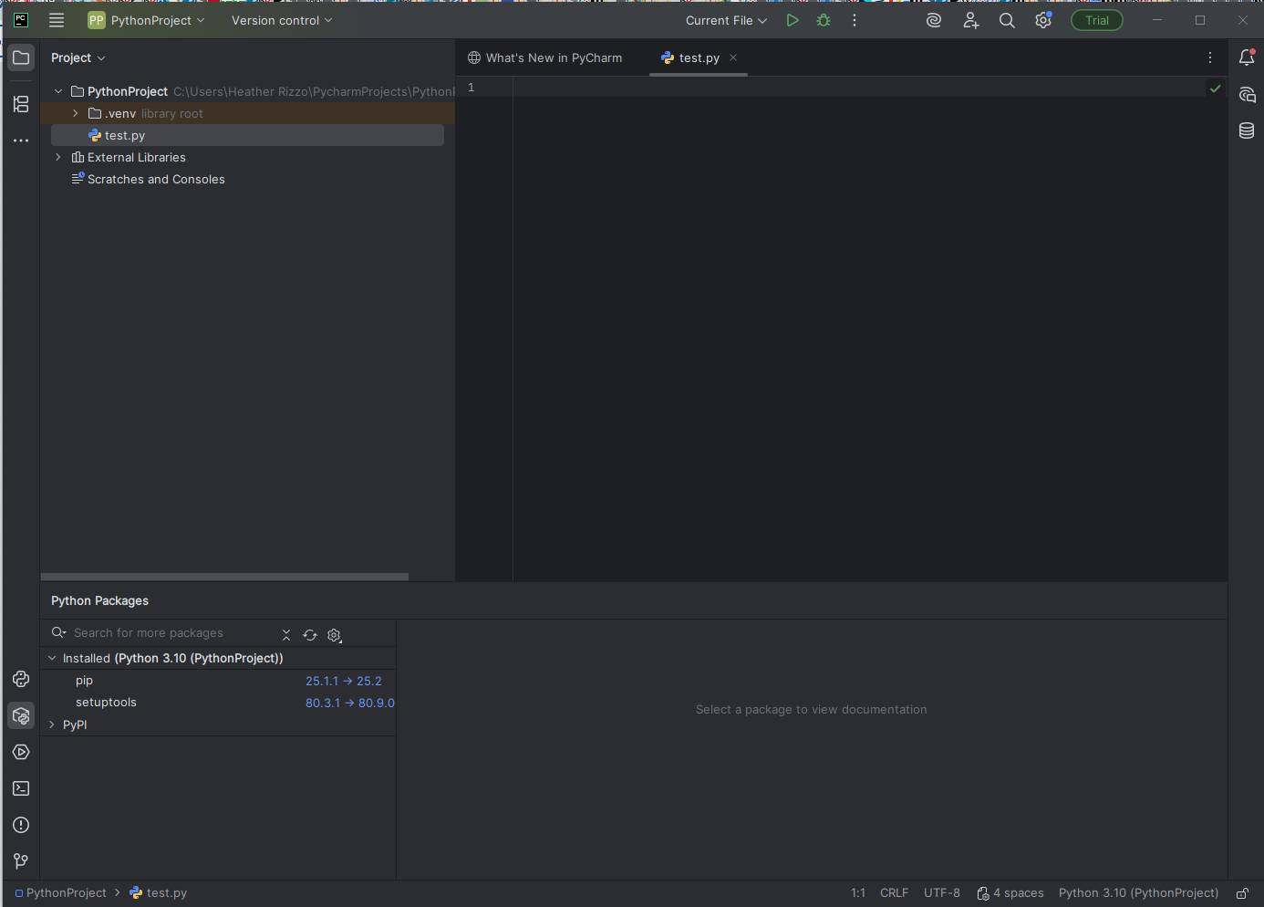
To check that the packages have been installed successfully, go the Python Console (it is one of the icons above the Terminal icon) and run the following lines of Python code:
import numpy
import pandas
import matplotlib
import pyvista
import scipy
import open3d
If you do not get an error when running these lines of code, then you have installed the packages correctly.
Step 3
Finally, the ZIP file(s) you downloaded from Box should be unzipped and moved to the “npmitchell” folder so that the “wildtype” and “bynGAL4_UASMyo1C” folders are inside the “npmitchell” folder. (You should also see the other workshop files in that folder such as npmitchell_workshop.Rmd and mesh.py.) In short, all the files needed for the Biological Shape Analysis workshop — the Python code and the data files — should be in the same folder.

Troubleshooting
We will need to have Python version 3.10 installed (do not install the latest version). If it does not install automatically when you create a new project, try this link (scroll down on the webpage to access the Python installers).
