**WEB DEVLOPMENT ASSIGNMENT - 2**

Name : Aarav Raj Singh

Roll: 01

Section: CCIS

1. WAP in HTML to implement a frame.

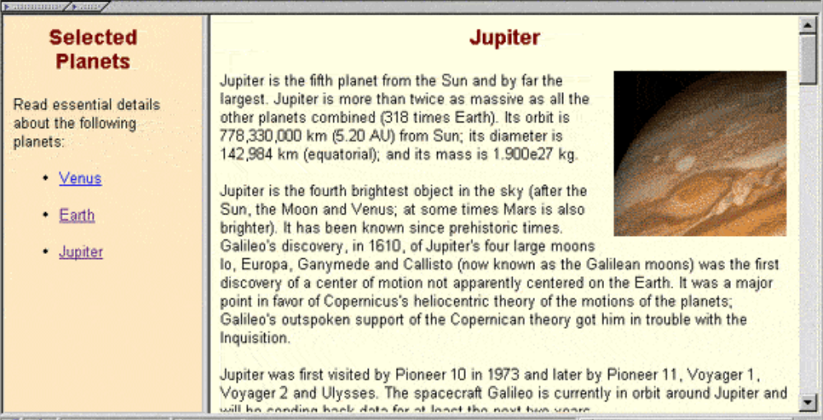

<!DOCTYPE html>

<html>

<head>

<title>Q2</title>

</head>

<frameset cols = "20%,80%" noresize="noresize" border = "10">

<frame src = "menu.html" name = "menu_page">

<frame src = "main.html" name = "main_page">

</frameset>

</html>

<!DOCTYPE html>

<html>

<head>

<style>

body{

background-color = "#fee7c1";

}

h1{

color: #81130f;

text-align: center;

font-family: sans-serif;

font-size: 35px;

}

a:link{

color: blue;

background-color: transparent;

}

a:visited {

color: purple;

background-color: transparent;

}

a:hover {

color: red;

background-color: transparent;

}

</style>

</head>

<body >

<h1> Selected Planets</h1>

<p style="font-size: 20px"> Read essential details about following planets.<p>

<ul style="font-size: 20px">

<li ><u> <a href="https://en.wikipedia.org/wiki/Venus" target="main_page">Venus</a></u></li>

<br>

<li ><u> <a href="https://en.wikipedia.org/wiki/Earth" target="main_page">Earth</a></u></li>

<br>

<li ><u> <a href="https://en.wikipedia.org/wiki/Jupiter" target="main_page">Jupiter</a></u></li>

</ul>

</body>

</html>

<!DOCTYPE html>

<html>

<body>

<h1 > <marquee Scrollamount=20>Select planet for details. </marquee></h1>

</body>

</html>

1. WAP in HTML to implement a table.

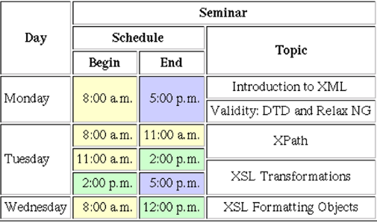

<!DOCTYPE html>

<html>

<head>

<title> Q2 </title>

<style>

hr{

border: 1px solid black;

}

table,th,td,tr{

border: 1px solid black;

text-align: center;

}

</style>

</head>

<body>

<table>

<tr>

<th rowspan="3"> Day </th>

<th colspan="3"> Seminar </th>

</tr>

<tr>

<th colspan="2"> Schedule </th>

<th rowspan="2"> Topic </th>

</tr>

<tr>

<th> Begin </th>

<th> End </th>

</tr>

<tr>

<td rowspan="2"> Monday </td>

<td rowspan="2" style="background-color: mistyrose"> 8:00 a.m. </td>

<td rowspan="2" style="background-color: mediumpurple"> 5:00 p.m. </td>

<td> Introduction to XML </td>

</tr>

<tr> <td> Validity: DTD and Relax NG</td></tr>

<tr>

<td rowspan="3"> Tuesday </td>

<td style="background-color: mistyrose"> 8:00 a.m.</td>

<td style="background-color: mistyrose"> 11:00 a.m.</td>

<td rowspan="3">

<p>XPath

<hr>

XSL Transformations

</p>

</td>

</tr>

<tr>

<td style="background-color: mistyrose"> 11:00 a.m. </td>

<td style="background-color: palegreen"> 2:00 p.m. </td>

</tr>

<tr>

<td style="background-color: palegreen"> 2:00 p.m.</td>

<td style="background-color: mediumpurple"> 5:00 p.m.</td>

</tr>

<tr>

<td> Wednesday </td>

<td style="background-color: mistyrose"> 8:00 a.m.</td>

<td style="background-color: palegreen"> 12:00 p.m.</td>

<td> XLS Formatting Objects </td>

</tr>

</table>

</body>

</html>