Description for 1TRK Transketolase Protein

James Qian

[jnqian@sfu.ca](mailto:jnqian@sfu.ca)

Simon Fraser University

The 1TRK Transketolase under investigation in this paper is obtained from Saccharomyces cerevisiae at 2.0 A resolution. Transketolase is an enzyme that plays a key role in the pentose phosphate pathway, which is a metabolic pathway that occurs in the cytoplasm of cells. It catalyzes the transfer of a two-carbon unit from a ketose sugar to an aldose sugar to form a new ketose sugar and a different aldose. This reaction is important for the interconversion of various sugars and for the production of pentose sugars that are used in nucleotide biosynthesis. The hetero group in transketolase is thiamine pyrophosphate (TPP). TPP is a coenzyme that is derived from vitamin B1 and is essential for the activity of transketolase. The TPP molecule acts by stabilizing the transition states of the reaction and by donating and accepting two-carbon units during the transfer reactions.

The 1TRK Transketolase is a homodimer with 678 amino acid residues in each of the two chains. Each chain contains 23 alpha-helices which encompass 272 amino acid residues, 16 beta-sheets which encompass 77 amino acid residues and 38 loops which encompass 329 amino acid residues. The following 3-D views generated by PyMol2 help to illustrate the structures and features of 1TRK Transketolase.

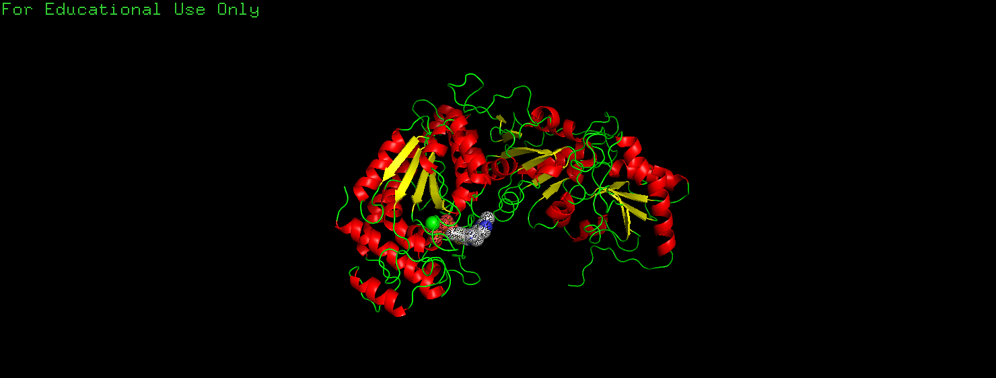

View 1. Cartoon illustration for one chain of 1TRK Transketolase with the dotted van der Waals interactions shown on a ligand (TPP) generated by PyMol2. The alpha helices are shown in red, the beta sheets are shown in yellow, and the loops are shown in green.

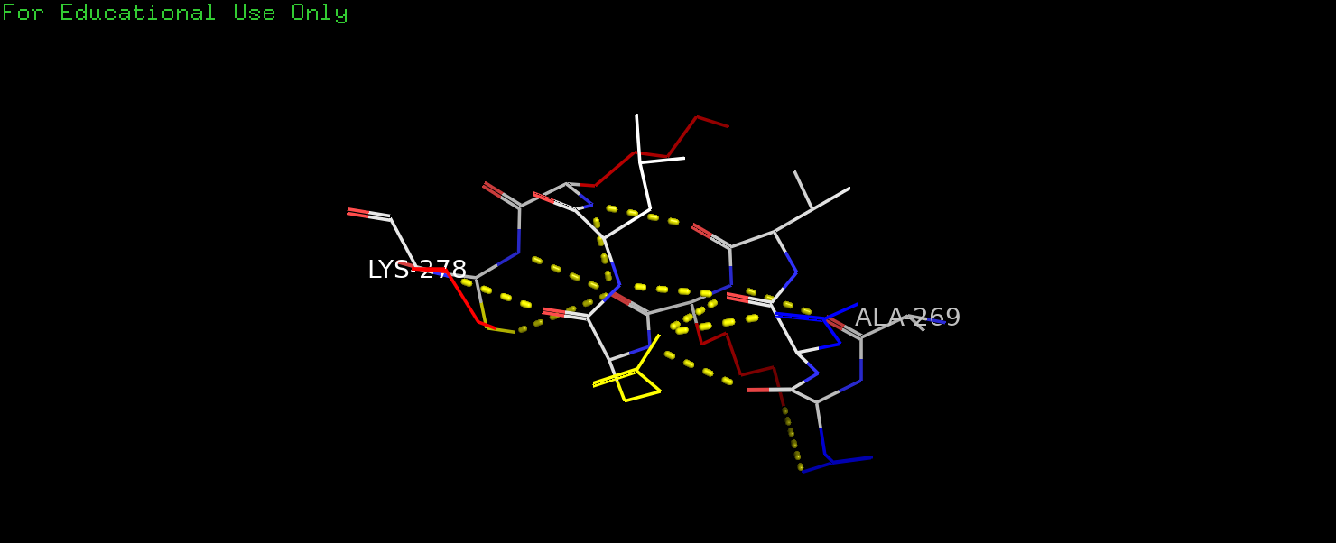

View 2. Line illustration of one alpha helix from 1TRK Transketolase along with its side groups generated by PyMol2. The side chains are colored by type (polar: yellow, nonpolar: white, positive: red, negative: blue). The polar (yellow) side chains point to the bottom while the nonpolar (white) side chains point to the top.

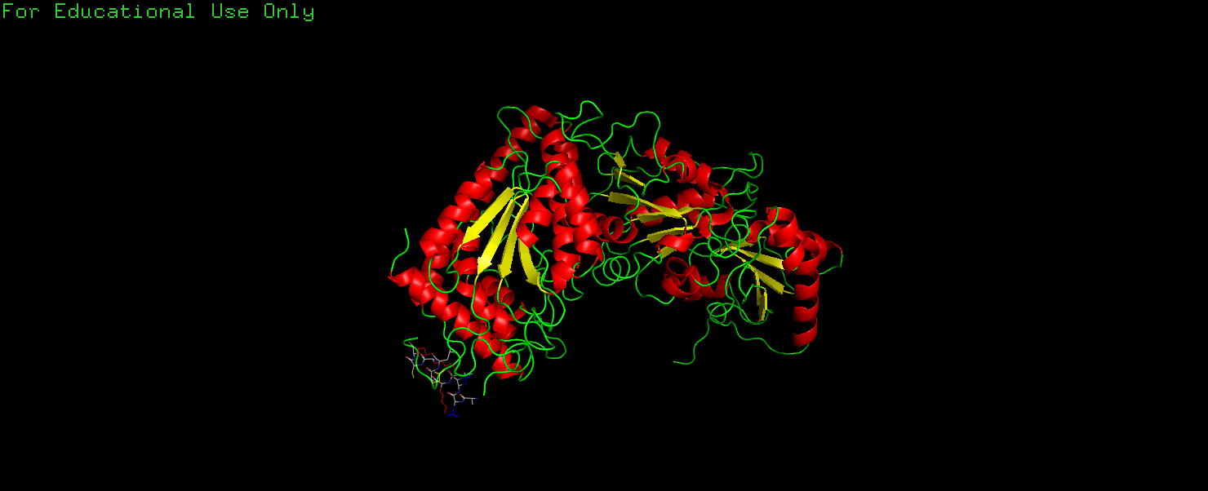

View 3. Line illustration for the same alpha helix as in View 2 along with the cartoon illustration for the rest of the structures in one chain of 1TRK Transketolase generated by PyMol2. It can be seen that this alpha helix is on the surface of the protein so its polar side chains are mostly facing outward toward the solvent while its nonpolar side chains are on the side facing the interior of the protein.

Reference

Summary Information, [*https://www.rcsb.org/structure/1TRK*](https://www.rcsb.org/structure/1TRK) , Protein Data Bank

Nikkola M, Lindqvist Y, Schneider G. *Refined structure of transketolase from Saccharomyces cerevisiae at 2.0 A resolution.* Journal of Molecular Biology. 1994 May;238(3):387-404. DOI: 10.1006/jmbi.1994.1299. PMID: 8176731.

4

The PyMOL Molecular Graphics System, Version 2.0 Schrödinger, LLC.