**PUZZLER PROJECT**

**Udacity VR Nanodegree**

Jose Rosenbluth Chiu

**INTRODUCTION**

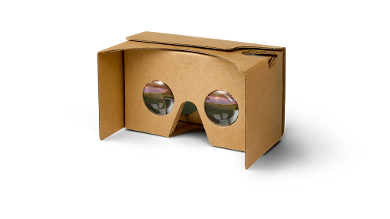

The Puzzler experience is a VR project in which you are to interact with a simple “Simon says” kind of game. 5 spheres will light up in a certain order, and you must click them in such order to win the game.

The only requirements are a phone to run the app (compatible with the google cardboard viewer) and a viewer.

The app targets both people that like games as those who just play to pass time, but do not have much experience with VR.

**PRODUCTION PROCESS**

The production process consisted on the following steps

1. First, a process of sketching to get a feeling or a direction of where the project had to go.

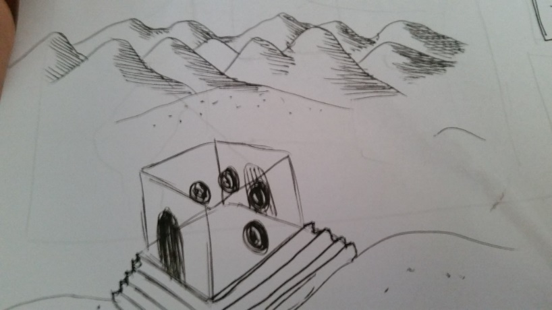

Figure 1. Sketch of the general setting of the scene.

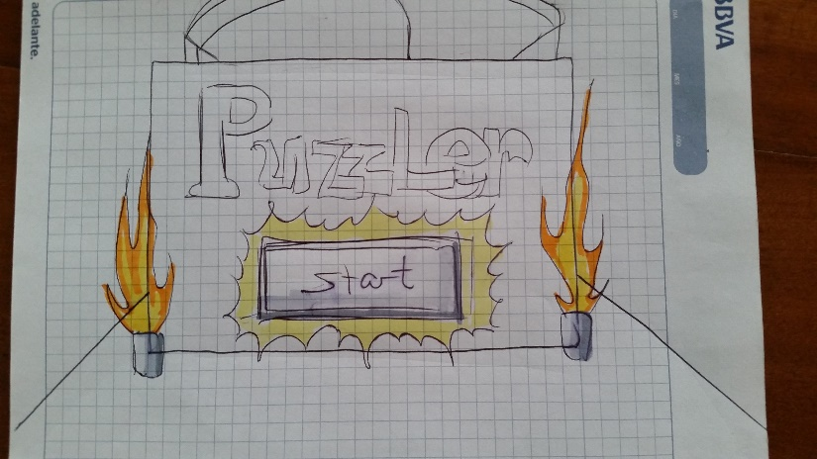

Figure 2. Sketch of the start game UI.

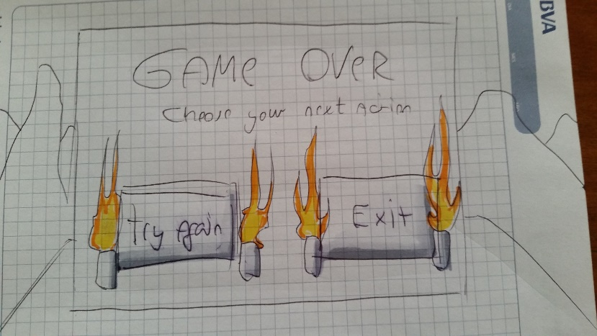

Figure 3. Sketch of the end game UI.

1. A first Unity build of the project, guided of course by the sketches mentioned in point number 1 (this implies a process of iteration until the result feels good enough to move on).

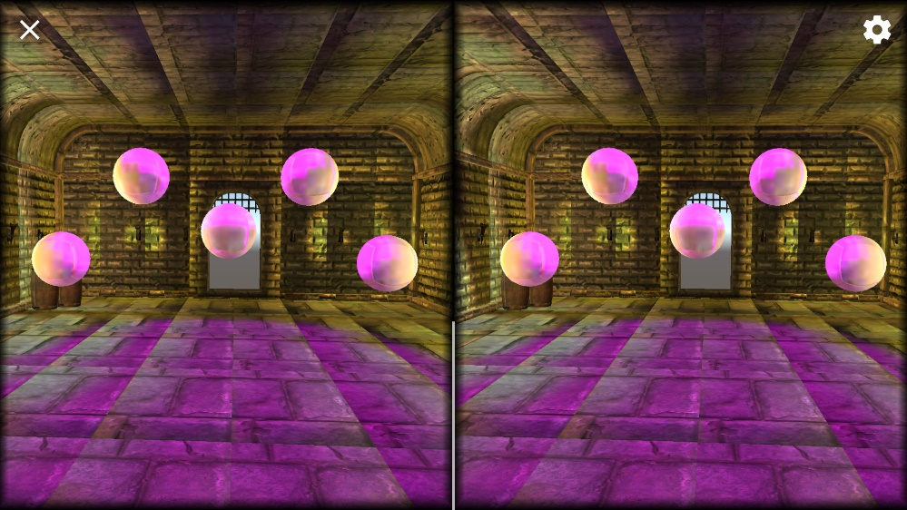

Figure 4. This is how the room in which the game takes place looked at first, before the first batch of iterations.

1. The first user test, which brings up any flaws the target client could potentially see in the application.

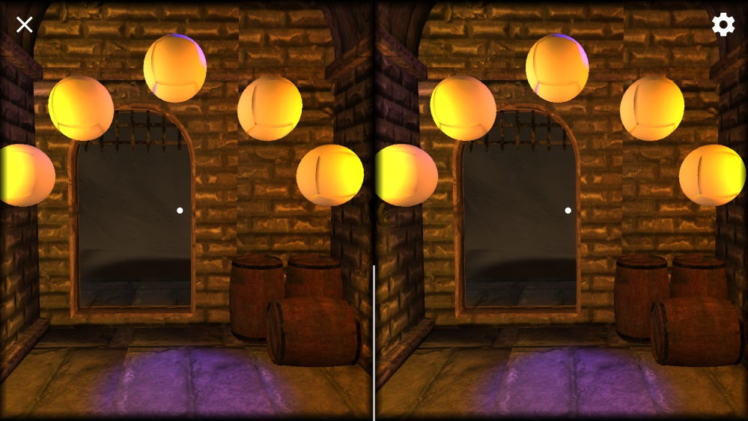

Figure 5. Here is an example of a picture the user found too poorly lit and therefore lead to an improvement.

1. Finally, the last process is iterating, this time taking the user tests feedback into account for the final product.

**USER TESTING**

There were in total 4 user test instances, each regarding one important aspect of the game. These were as follows:

1. One user test was to measure the lighting and atmosphere of the scene in general.

[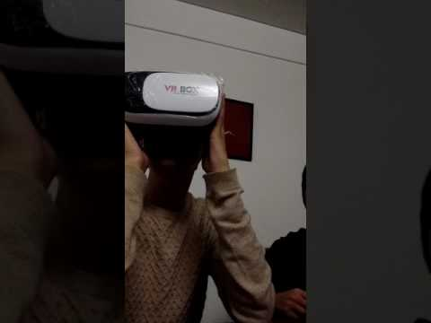](https://www.youtube.com/watch?v=8VJAxZgj1Z8)

1. Another was in terms of the UI, and how intuitive it felt for users.

[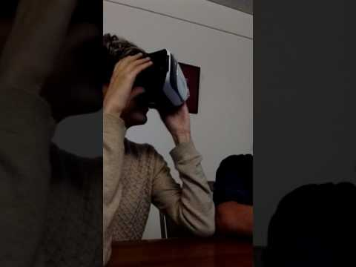](https://www.youtube.com/watch?v=7Y9lQkE0C9Y)

1. A third was regarding any potential discomfort while playing, mostly since the game involves movement, which can cause simulator sickness.

[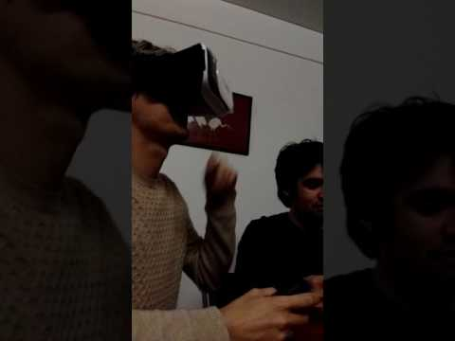](https://www.youtube.com/watch?v=2VZHaxJwLeI)

1. Finally, the last user test was to measure how the game played, and whether the feedbacks the game gave to the user were good enough.

[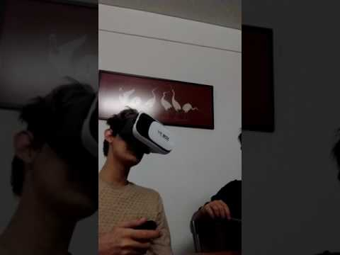](https://www.youtube.com/watch?v=kBrJVD9yaE8)

**FINAL OUTCOME**

The following is a video of the full game and a couple of screenshots:

[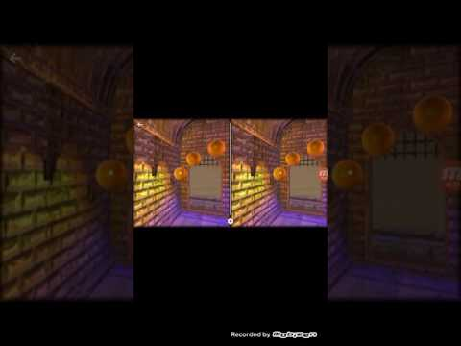](https://www.youtube.com/watch?v=hZqRy7C_QpU)

From the user testing, many things became apparent. The lighting needed fixing, the UI was at first too big and had a couple of visual errors, and finally, the spheres were too big and the color made It difficult to know when you were pressing them. All this was fixed via iteration.

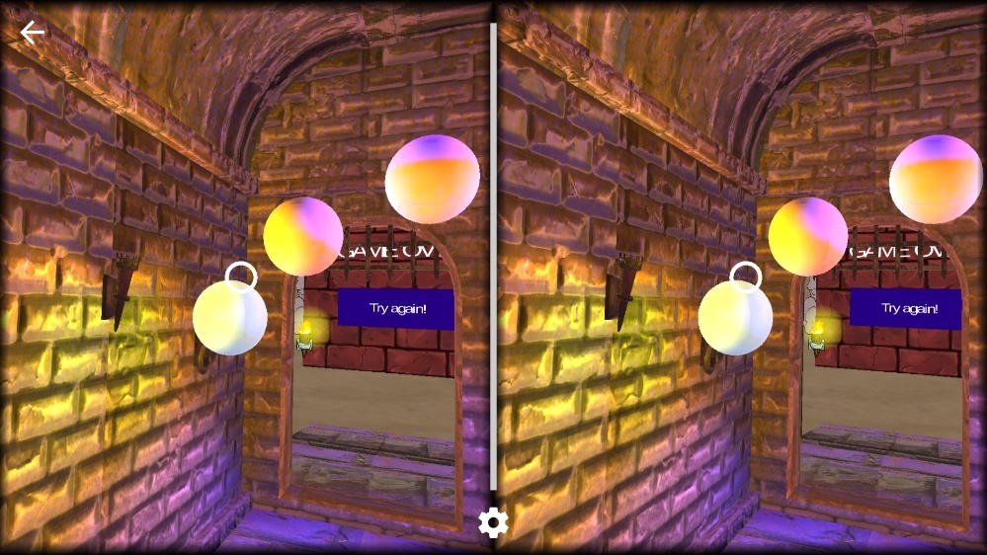

Figure 6. How the final scene looks like in the interiors.

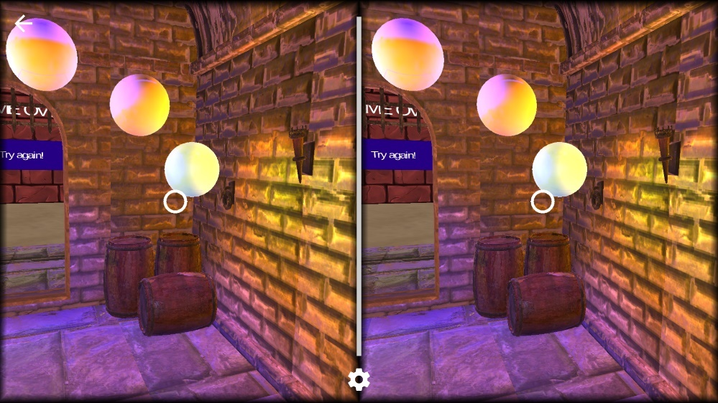

Figure 7. For the final project, a baked reflection probe was used in order to make the scene atmosphere more real.

**DESCRIPTION OF FINAL PROJECT**

So, the final project consists simply on a first UI screen which lets you start the game, the game screen where you play, and a final UI screen, where you can choose to restart the experience.

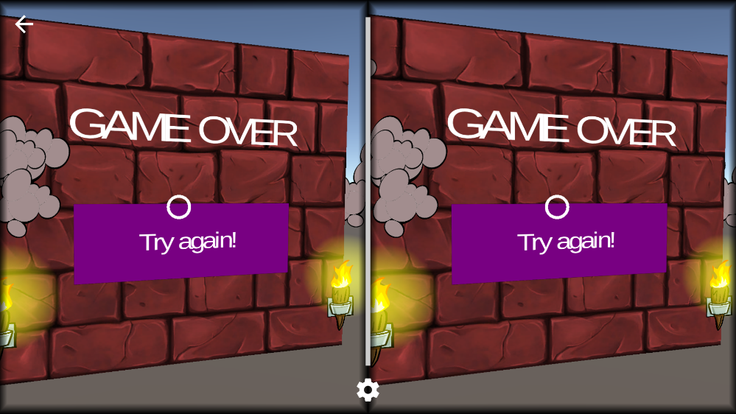

Figure 8. The final UI screen.

**CONCLUSION**

The next steps for this project would be to scale it. Maybe add more levels, or different difficulty settings (more spheres to memorize, or different layouts). Also, more could be done in terms of visuals and on the feedbacks department.

But all in all, it was a fun project and a great way to learn the process of iteration.