

**EZENTIA INC.**

Email Address: [ezentia.pres.22@gmail.com](mailto:ezentia.pres.22@gmail.com)

Contact Number: +639569647444 | 09958256469

Website: <https://www.itsapp2u.tech>

______________________________________________________________________________

**CERTIFICATE OF EMPLOYMENT**

TO WHOM IT MAY CONCERN:

This is to certify that John Mark R. Escober has been employed by our company since October 5, 2017 till this date as Branch Manager of Araullo University School partner. His monthly compensation / incentives is P27,000.00

This certification has been issued to him with the responsibility for RUSI MOTORCYCLE.

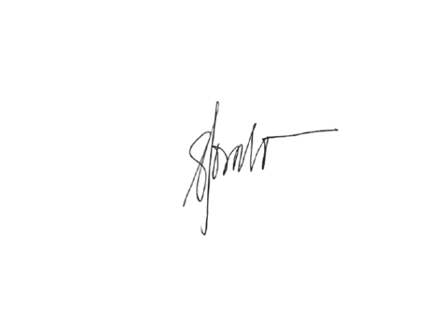

Respectfully yours,

**Ms. Verna E. Navida**  
President, EZENTIA INC.