# **Araullo University Registrar Document Request System (AURDRS)**

## **1. Introduction**

This project aims to design and develop the **Araullo University Registrar Document Request System (AURDRS)**, an online platform designed to streamline and modernize the process of requesting academic documents from the university's Registrar’s Office. The system will serve students, alumni, and university staff by providing a more efficient, accessible, and transparent method for document requests and processing.

**Key stakeholders:**

* Araullo University Administration
* Registrar’s Office personnel
* Current students and alumni
* Project development team

## **2. Objectives**

* Provide an online platform where users can request documents such as **Certificate of Grades, Transcript of Records (TOR), and Diploma**.
* Minimize **long queues** at the Registrar’s Office in both **South and Main campuses**.
* Improve **accessibility** for alumni and graduates living far from the university.
* Allow users to **track the status** of their requests remotely.
* Streamline the **Registrar’s workflow** for faster service.
* Enable **online payment integration** for more efficient processing.

## **3. Methodology**

The project will adopt the **Rapid Application Development (RAD)** methodology, which emphasizes quick prototyping, user feedback, and iterative improvements. This approach ensures faster delivery, adaptability to changes, and active involvement of stakeholders throughout the development cycle.

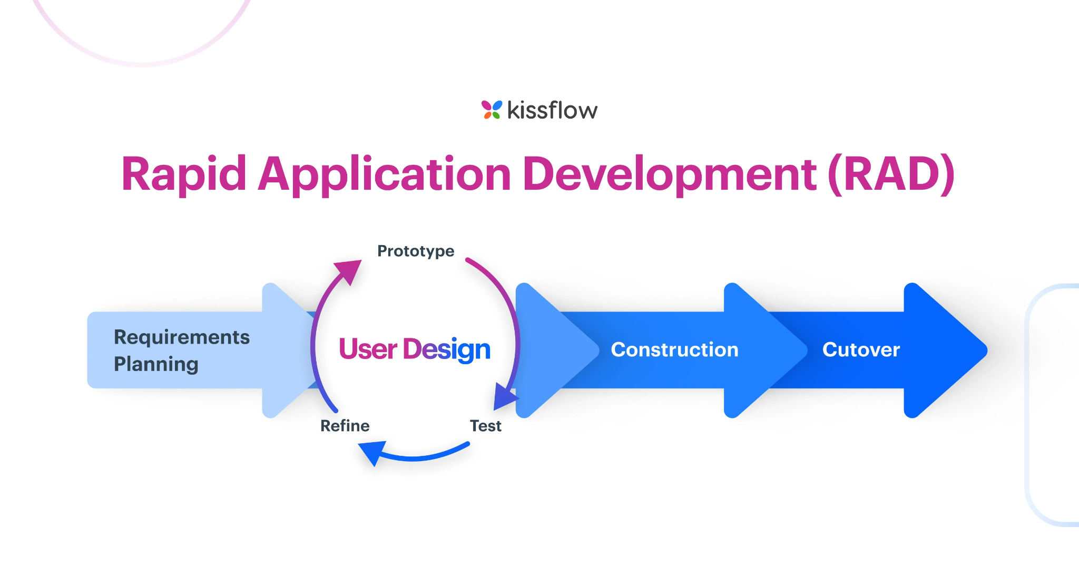

**Phases of RAD Methodology:**

1. **Planning & Requirement Analysis** – Gather system requirements from the Registrar’s Office and end-users.
2. **System Design** – Create mockups, diagrams, and user interface layouts.
3. **Prototyping & Development** – Build functional prototypes using modern web technologies.
4. **Testing & Evaluation** – Conduct system testing, usability testing, and user acceptance testing (UAT).
5. **Deployment & Maintenance** – Launch the system and continuously update based on user feedback.

## **4. Project Management Tools**

* **Canva** – for poster and UI mockup designs.
* **Visual Studio Code** – for coding and system development.
* **Trello Board** – for task tracking and team collaboration.
* **Google Docs** – for documentation and collaborative writing.
* **Gantt Chart** – for project timeline and progress monitoring.
* **Calendar** – for scheduling milestones and deadlines.

## **5. System Overview**

**Users:**

* Registrar Staff (Admin, Document Processing, Approval)
* Students and Alumni (Requesters)

**Features:**

* **User Registration & Login:** Secure and personalized access for requesters.
* **Online Request Forms:** Digital submission for certificates and records.
* **Security Features:** Data protection through authentication and validation.
* **Mobile-Friendly Design:** Accessible on any device for remote users.
* **Real-Time Request Tracking:** Transparency on the status of requests.
* **Online Payment (Future Feature):** Convenience in processing requests faster.

## **6. System Diagram**

*(Suggested content for you to include as a diagram in Canva or Draw.io)*

**Flow:** User → Login/Registration → Submit Request Form → Upload Receipt/Payment → Admin Review → Document Processing → Approval → QR Code/Claim Schedule → User Notification

## **7. Design Elements**

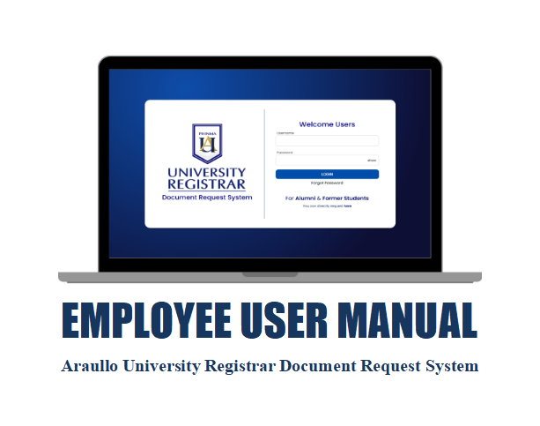

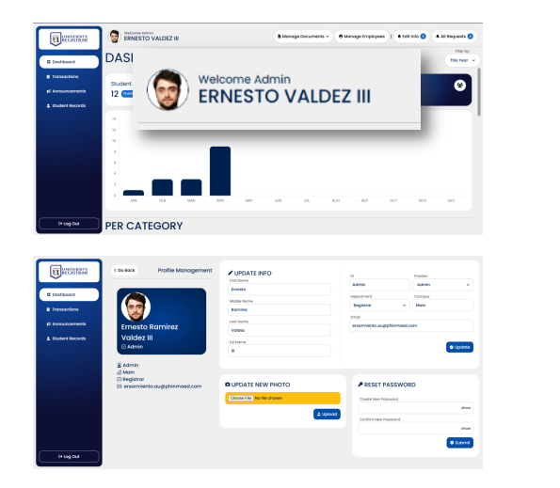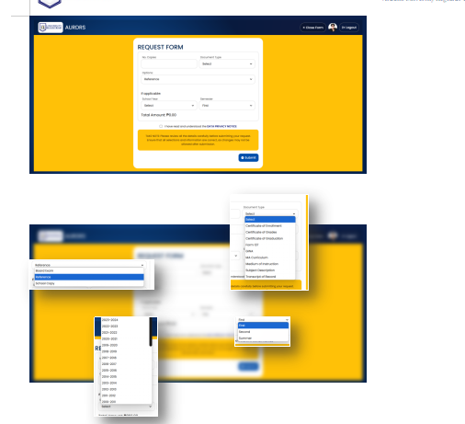

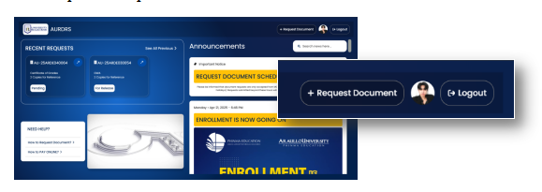

* 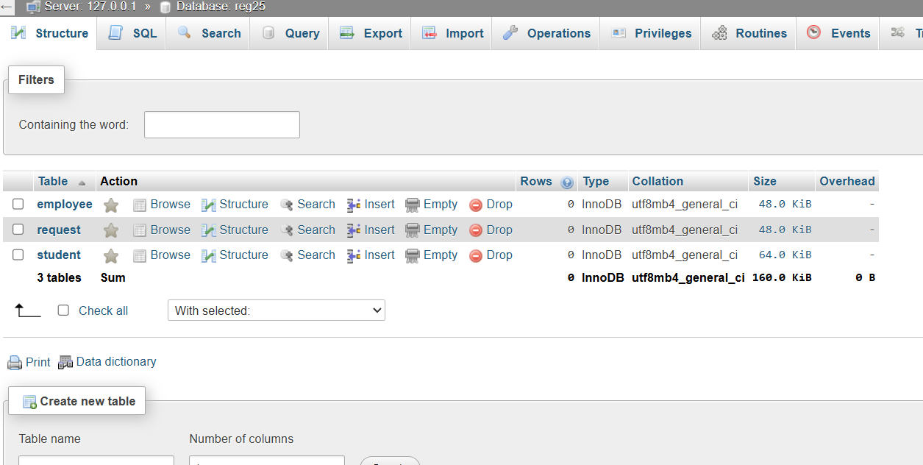
* 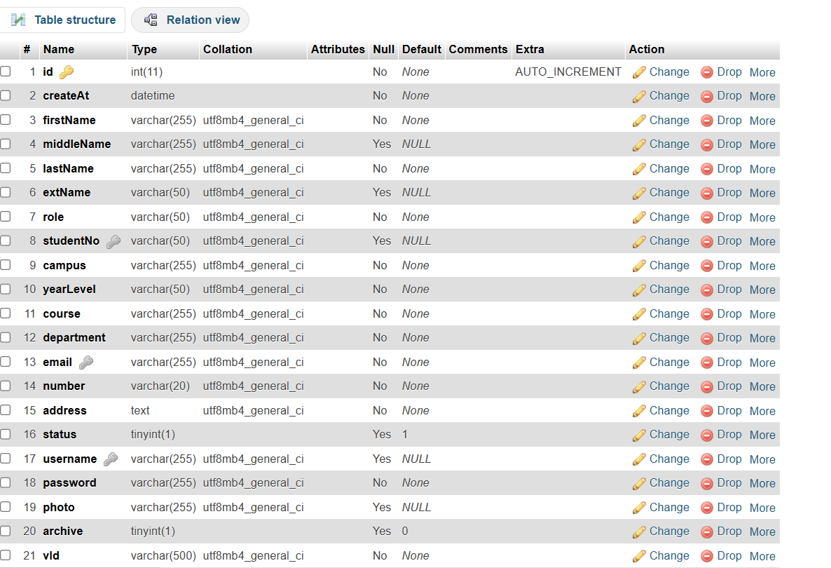
* 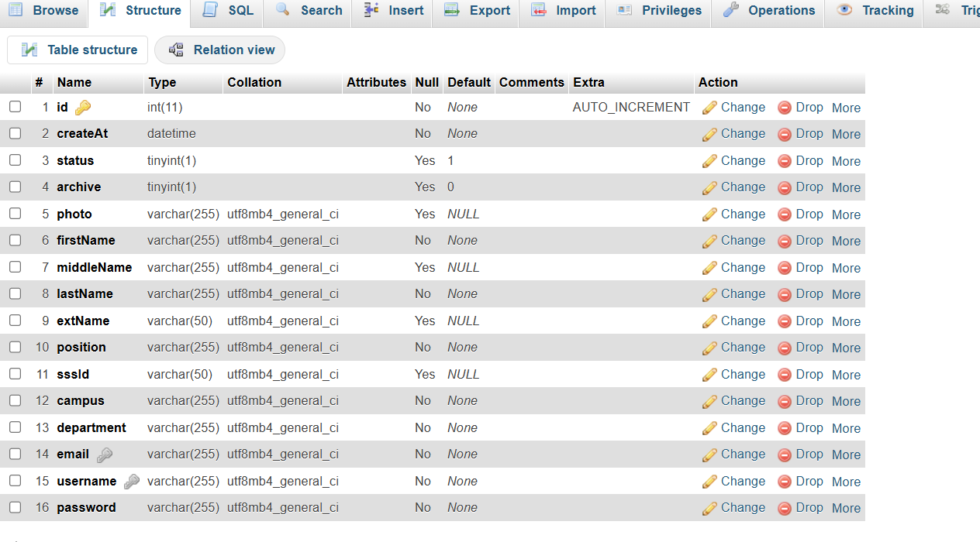

## **8. Benefits**

* **Efficiency:** Faster document processing with less manual workload.
* **Accessibility:** Alumni and students from distant locations can request documents online.
* **Transparency:** Real-time tracking builds trust and confidence.
* **Reduced Campus Congestion:** Minimizes long queues in South and Main campuses.
* **Security:** Protects sensitive student data with secure login and validation.
* **Convenience:** Mobile-friendly system allows access anytime, anywhere.

## **9. Conclusion**

The **Araullo University Registrar Document Request System (AURDRS)** is a significant step toward digital transformation in academic services. By integrating online request forms, secure user access, mobile responsiveness, and real-time tracking, the system will reduce campus congestion, provide better service to alumni and students, and streamline the Registrar’s operations. Ultimately, AURDRS supports the university’s vision of delivering **accessible, efficient, and student-centered services** in the digital era.