**The Poll System**

Purpose of this application is to manage a poll booth (including receiving vote, verifying booth) and process the voting system.

**Functionalities:**

1. Adding a poll question
2. Validate a poll question for voting
3. Stopping a poll
4. Automated calculation of vote
5. Validating a booth for polling
6. Taking “Yes/No” vote only with national id

**Use of the application:** There are two part of this application. One is Admin part and another is Voting part.

**Admin-part:**

1. For login use this link: <http://localhost/thepollSYSv3/thepollSYS/admin-func/>
2. Then the admin panel will appear with the list of polls.
3. Any poll can be added using the text box and click “Insert-Poll” button.
4. Poll can be opened by giving validity “1”.
5. “0” is used for stopping a poll.
6. “0” or “1” can be updated by using text box and “Update” button.
7. A poll can be deleted by using “Delete Poll”. [All data related to the poll will be lost. So we recommend not to delete a poll instead just give validity “0”].
8. All data related to a single poll can be seen by clicking the poll link.
9. Voting data of voters like who is voting “Yes” or who is voting “No”, it can’t be seen. Only the results/statistics can be seen.
10. Click “Logout” to logging out.

Poll Admin Panel

Monitor & Administrate

1

ADMIN LOGIN

2

**Voting-part:**

1. For activating a booth, please follow the link from the booth <http://localhost/thepollSYSv3/thepollSYS/> and click “Add This Counter for Vote (Admin Only)”
2. Active poll will be seen and select “Yes/No” from the drop down box. [Note: If “Yes” then the booth/counter will only be used for “Yes” vote and “No” for “No” vote]
3. Give admin username and password then click “Add Counter”.
4. Then go to <http://localhost/thepollSYSv3/thepollSYS/> and click “I am voter”.
5. Now the voting will open.
6. Any voter will be able to vote by giving his/her national id.

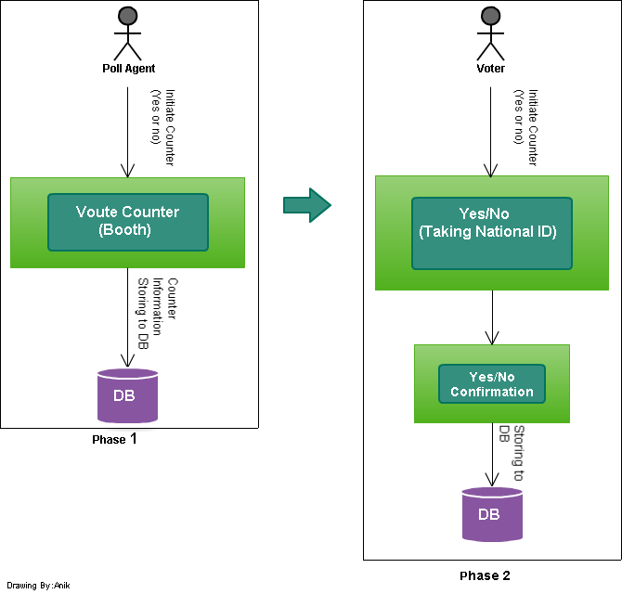

Figure: Sequence of Counter Initiation and Voting

**Technical Aspect:** In this part the technology used, file system, database, problems and installation will be described.

**Technology Used:** PHP, MySQL

**File System:**

* index.php [home page: go for voting or initiating a counter]
* addcounter.php [form for adding the booth/counter for voting]
* admin-func
  + index.php [admin login page]
  + actions
    - edit_deletepoll.php [coming from monitor(allpolls.php) – edit or delete ]
    - newpoll.php [coming from monitor(allpolls.php) – add new poll]
  + login
    - login.php [used for login verification – coming from admin-func->index.php]
  + monitor
    - allpolls.php [showing all polls with add, update and delete options]
    - logout.php [logout operation – directed from allpolls.php]
    - singlepoll.php [for seeing a single poll – directed from allpolls.php]
* common
  + db.php [db access credential]
* user-func
  + voting
    - varifycounter.php [verifying a counter/booth for a vote and “Yes/No”- coming from addcounter.php - root folder]
    - vote.php [showing national id space for vote]
    - voteconfirm.php [confirming vote.php and showing confirmation message and after 5 seconds it will be redirected to vote.php]
* dbModel
  + pollsysdb.sql – the sql file for the DDL
  + pollsysdb.png – the ERD

**Database:** The ERD of the database and the SQL (pollsysdb.sql) is given/attatched in the dbModel folder.

**Problems:**

* API of national id is not added but the place of that code is defined. [user-func/voting/voteconfirm.php line 16]
* Others API for IP and other things need to be added.
* Form verification is not done for this version (v3).
* UI is not beautiful for this version (v3).

**Installation:**

* Change the db password in common->db.php according to the db password need.
* Create database named “pollsysdb”.
* Open “pollsysdb.sql” file in a notepad and copy paste the sql in the the sql of created db named “pollsysdb”.
* Keep the project/application folder in the server’s root folder.

**Further Help:** For any kind of problem and please feel free to contact (condition applied) at [**zakaria@newgenbdworks.net**](mailto:zakaria@newgenbdworks.net)

**MD. Jakaria Nawaz**