Jackson Curtis

Irrigation EDA

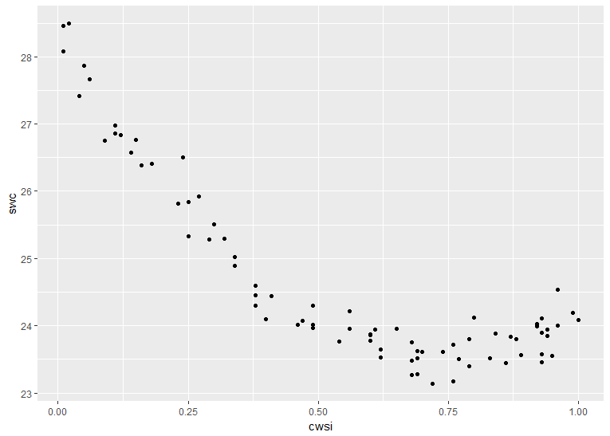The Crop Water Stress Index is a relatively cheap and simple way to see if crops are in need of more water. By using this measure farmers can target their use of irrigation to areas where it’s most needed. Typically, however, farmers need to perform a Soil Water Content test to see how much water to add. However, if we could predict SWC from the CWSI, they could bypass that step and use the CWSI to inform how much water to add.

Our dataset consists only of CWSI readings and SWC ratings. From the figure below there is clearly not a linear relationship between the two. In particular, as the stress index passes 0.75, the water content begins to go up, instead of down. Fortunately, we have data on the entire range of possible values for CWSI, so if we fit a non-linear model we will have no need to extrapolate.

To establish the relationship between CWSI and SWC we could do non-linear regression. This would allow us to make predictions on SWC using only CWSI and provide confidence intervals on those predictions, which should allow farmers to focus only on the places of uncertainty when taking SWC measurements.

I am concerned about confidence/prediction intervals when I do non-linear regression. If I used a simple polynomial model I could create confidence bands, however I’m not sure how more advanced methods like splines account for the uncertainty in their estimates.