暨南大学本科实验报告专用纸
课程名称 计算机视觉实验 成绩评定
实验项目名称 实验五
指导教师 赵乘骥,安荣邦
实验项目编号 实验项目类型 实验地点 教108
学生姓名 黄冠达 学号 2022150578
- 学院 国际能源学院 系 专业 自动化
实验时间 2026 年 4 月 17 日
实验题目

1.己知一张包含短形、国、平行线、据直线的训计图，分别对其施加:
相似变换
仿射变换
透视变换
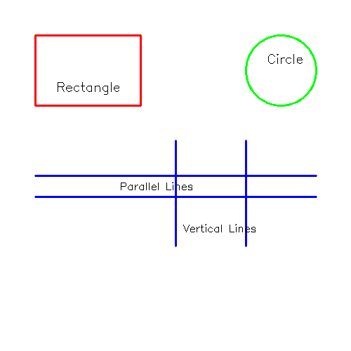
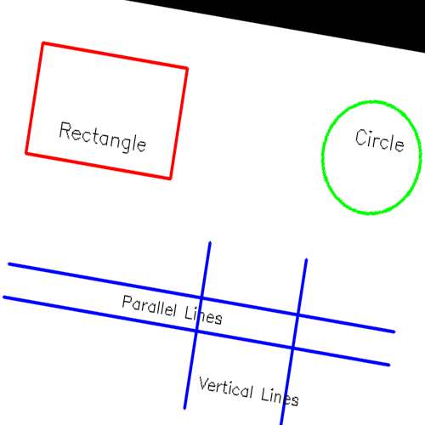
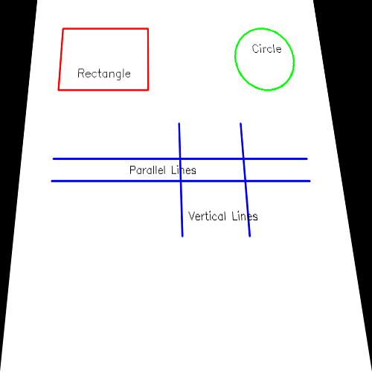
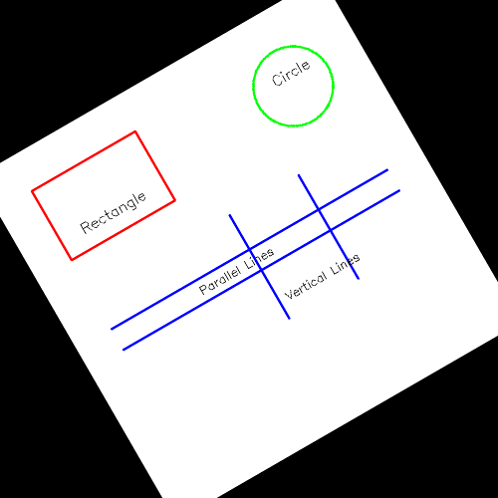

观察并总结每类变换对以下几何性质的影响:
1.直线是否保持为直线
2.平行线是否仍保持平行
3.两条垂直线是否仍垂直
4.圆是否仍保持为圆形

【仿射变换】
1. 直线是否保持为直线: ✓ 是
2. 平行线是否仍保持平行: ✓ 是
3. 两条垂直线是否仍垂直: ✗ 否
4. 圆是否仍保持为圆: ✗ 否 (变为椭圆)

【透视变换】
1. 直线是否保持为直线: ✓ 是
2. 平行线是否仍保持平行: ✗ 否
3. 两条垂直线是否仍垂直: ✗ 否
4. 圆是否仍保持为圆: ✗ 否 (变为椭圆)

代码
import cv2
import numpy as np

def create_test_image(size=500):
"""创建测试图像"""
img = np.ones((size, size, 3), dtype=np.uint8) * 255

# 绘制矩形（红色）
cv2.rectangle(img, (50, 50), (200, 150), (0, 0, 255), 2)
cv2.putText(img, "Rectangle", (80, 130), cv2.FONT_HERSHEY_SIMPLEX, 0.6, (0, 0, 0), 1)

# 绘制圆（绿色）
cv2.circle(img, (400, 100), 50, (0, 255, 0), 2)
cv2.putText(img, "Circle", (380, 90), cv2.FONT_HERSHEY_SIMPLEX, 0.6, (0, 0, 0), 1)

# 绘制平行线（蓝色）
cv2.line(img, (50, 250), (450, 250), (255, 0, 0), 2)
cv2.line(img, (50, 280), (450, 280), (255, 0, 0), 2)
cv2.putText(img, "Parallel Lines", (170, 270), cv2.FONT_HERSHEY_SIMPLEX, 0.5, (0, 0, 0), 1)

# 绘制垂直线（蓝色）
cv2.line(img, (250, 200), (250, 350), (255, 0, 0), 2)
cv2.line(img, (350, 200), (350, 350), (255, 0, 0), 2)
cv2.putText(img, "Vertical Lines", (260, 330), cv2.FONT_HERSHEY_SIMPLEX, 0.5, (0, 0, 0), 1)

return img

def apply_similarity_transform(img):
"""相似变换：旋转30度 + 缩放0.8倍"""
h, w = img.shape[:2]
center = (w // 2, h // 2)
M = cv2.getRotationMatrix2D(center, 30, 0.8)
return cv2.warpAffine(img, M, (w, h))

def apply_affine_transform(img):
"""仿射变换：倾斜效果"""
h, w = img.shape[:2]
pts1 = np.float32([[50, 50], [200, 50], [50, 150]])
pts2 = np.float32([[50, 50], [220, 80], [30, 180]])
M = cv2.getAffineTransform(pts1, pts2)
return cv2.warpAffine(img, M, (w, h))

def apply_perspective_transform(img):
"""透视变换：梯形效果"""
h, w = img.shape[:2]
pts1 = np.float32([[0, 0], [w-1, 0], [0, h-1], [w-1, h-1]])
pts2 = np.float32([[50, 0], [w-80, 0], [0, h-1], [w-1, h-1]])
M = cv2.getPerspectiveTransform(pts1, pts2)
return cv2.warpPerspective(img, M, (w, h))

def main():
print("=" * 60)
print("几何变换实验")
print("=" * 60)

# 1. 创建测试图像
print("\n[步骤 1] 创建测试图像...")
original = create_test_image(500)
cv2.imwrite('original.png', original)
print(" 已保存: original.png")

# 2. 相似变换
print("\n[步骤 2] 应用相似变换...")
similarity = apply_similarity_transform(original)
cv2.imwrite('similarity.png', similarity)
print(" 已保存: similarity.png")

# 3. 仿射变换
print("\n[步骤 3] 应用仿射变换...")
affine = apply_affine_transform(original)
cv2.imwrite('affine.png', affine)
print(" 已保存: affine.png")

# 4. 透视变换
print("\n[步骤 4] 应用透视变换...")
perspective = apply_perspective_transform(original)
cv2.imwrite('perspective.png', perspective)
print(" 已保存: perspective.png")

# 结果总结
print("\n" + "=" * 60)
print("实验结果总结")
print("=" * 60)

print("\n【相似变换】")
print(" 1. 直线是否保持为直线: ✓ 是")
print(" 2. 平行线是否仍保持平行: ✓ 是")
print(" 3. 两条垂直线是否仍垂直: ✓ 是")
print(" 4. 圆是否仍保持为圆: ✓ 是")

print("\n【仿射变换】")
print(" 1. 直线是否保持为直线: ✓ 是")
print(" 2. 平行线是否仍保持平行: ✓ 是")
print(" 3. 两条垂直线是否仍垂直: ✗ 否")
print(" 4. 圆是否仍保持为圆: ✗ 否 (变为椭圆)")

print("\n【透视变换】")
print(" 1. 直线是否保持为直线: ✓ 是")
print(" 2. 平行线是否仍保持平行: ✗ 否")
print(" 3. 两条垂直线是否仍垂直: ✗ 否")
print(" 4. 圆是否仍保持为圆: ✗ 否 (变为椭圆)")

print("\n" + "=" * 60)
print("实验完成！生成的图片:")
print(" - original.png")
print(" - similarity.png")
print(" - affine.png")
print(" - perspective.png")
print("=" * 60)

if __name__ == "__main__":
main()

最后，对一张存在透视畸变的平面图像进行校正(自己拍一张放在桌上的带文字和表格的A4纸)，看看自己是否满意，娇正的文字是否变形。

代码
import cv2
import numpy as np
import matplotlib.pyplot as plt

def click_points(event, x, y, flags, param):
"""鼠标回调函数：记录点击的四个点"""
if event == cv2.EVENT_LBUTTONDOWN:
points = param['points']
img = param['img']

if len(points) < 4:
points.append((x, y))
# 在点击位置画圆标记
cv2.circle(img, (x, y), 5, (0, 0, 255), -1)
cv2.putText(img, str(len(points)), (x+5, y-5),
cv2.FONT_HERSHEY_SIMPLEX, 0.5, (0, 0, 255), 2)
cv2.imshow('Select 4 corners (press ENTER when done)', img)
print(f"已选择点 {len(points)}: ({x}, {y})")

def select_corners(image_path):
"""手动选择四个角点"""
img = cv2.imread(image_path)
if img is None:
print(f"错误：无法读取图片 {image_path}")
return None, None

original = img.copy()
points = []

cv2.namedWindow('Select 4 corners (press ENTER when done)')
param = {'points': points, 'img': img}
cv2.setMouseCallback('Select 4 corners (press ENTER when done)', click_points, param)

print("\n请按顺序点击四个角点：")
print(" 1. 左上角")
print(" 2. 右上角")
print(" 3. 右下角")
print(" 4. 左下角")
print("选择完成后按 ENTER 键继续...")

while True:
cv2.imshow('Select 4 corners (press ENTER when done)', img)
key = cv2.waitKey(1)
if key == 13: # Enter 键
if len(points) == 4:
break
else:
print(f"请选择 {4 - len(points)} 个点，当前已选 {len(points)} 个")
elif key == 27: # ESC 键
cv2.destroyAllWindows()
return None, None

cv2.destroyAllWindows()

# 按顺序排列点：左上、右上、右下、左下
src_points = np.array(points, dtype=np.float32)

# 计算目标图像的尺寸（基于原始图像）
width = max(
np.linalg.norm(src_points[1] - src_points[0]), # 上边
np.linalg.norm(src_points[2] - src_points[3]) # 下边
)
height = max(
np.linalg.norm(src_points[3] - src_points[0]), # 左边
np.linalg.norm(src_points[2] - src_points[1]) # 右边
)

dst_points = np.array([
[0, 0],
[width - 1, 0],
[width - 1, height - 1],
[0, height - 1]
], dtype=np.float32)

return src_points, dst_points, original

def auto_detect_corners(image_path):
"""自动检测文档四个角点（如果对比度足够）"""
img = cv2.imread(image_path)
if img is None:
return None, None, None

gray = cv2.cvtColor(img, cv2.COLOR_BGR2GRAY)

# 高斯模糊降噪
blurred = cv2.GaussianBlur(gray, (5, 5), 0)

# Canny 边缘检测
edges = cv2.Canny(blurred, 50, 150)

# 膨胀连接边缘
kernel = np.ones((5, 5), np.uint8)
dilated = cv2.dilate(edges, kernel, iterations=2)

# 查找轮廓
contours, _ = cv2.findContours(dilated, cv2.RETR_EXTERNAL, cv2.CHAIN_APPROX_SIMPLE)

# 找到最大的四边形轮廓
max_area = 0
best_contour = None

for contour in contours:
peri = cv2.arcLength(contour, True)
approx = cv2.approxPolyDP(contour, 0.02 * peri, True)

if len(approx) == 4:
area = cv2.contourArea(contour)
if area > max_area:
max_area = area
best_contour = approx

if best_contour is not None:
# 获取四个角点并排序
points = best_contour.reshape(4, 2).astype(np.float32)

# 排序：左上、右上、右下、左下
rect = np.zeros((4, 2), dtype=np.float32)
s = points.sum(axis=1)
diff = np.diff(points, axis=1)

rect[0] = points[np.argmin(s)] # 左上（和最小）
rect[2] = points[np.argmax(s)] # 右下（和最大）
rect[1] = points[np.argmin(diff)] # 右上（差最小）
rect[3] = points[np.argmax(diff)] # 左下（差最大）

return rect, points, img

return None, None, img

def correct_perspective(image_path, src_points, dst_points):
"""执行透视校正"""
# 计算透视变换矩阵
M = cv2.getPerspectiveTransform(src_points, dst_points)

# 应用变换
width = int(dst_points[2][0] + 1)
height = int(dst_points[2][1] + 1)
corrected = cv2.warpPerspective(image_path if isinstance(image_path, np.ndarray) else cv2.imread(image_path),
M, (width, height))

return corrected

def analyze_text_quality(original, corrected):
"""分析校正后的文字质量"""
# 转换为灰度图
gray_original = cv2.cvtColor(original, cv2.COLOR_BGR2GRAY)
gray_corrected = cv2.cvtColor(corrected, cv2.COLOR_BGR2GRAY)

# 计算清晰度（拉普拉斯方差）
sharpness_original = cv2.Laplacian(gray_original, cv2.CV_64F).var()
sharpness_corrected = cv2.Laplacian(gray_corrected, cv2.CV_64F).var()

print("\n" + "=" * 60)
print("文字质量分析")
print("=" * 60)
print(f" 原始图像清晰度: {sharpness_original:.2f}")
print(f" 校正后清晰度: {sharpness_corrected:.2f}")

if sharpness_corrected > sharpness_original:
print(" ✓ 校正后文字更清晰")
else:
print(" - 校正后文字清晰度变化不大")

return sharpness_original, sharpness_corrected

def main():
print("=" * 60)
print("透视畸变校正程序")
print("=" * 60)

# 图片路径
image_path = "test.jpg"

# 检查图片是否存在
import os
if not os.path.exists(image_path):
print(f"\n错误：找不到图片 {image_path}")
print("请确保 test.jpg 在当前目录下")
return

print(f"\n加载图片: {image_path}")

# 选择校正方式
print("\n请选择校正方式:")
print(" 1. 自动检测文档边界（推荐用于高对比度文档）")
print(" 2. 手动选择四个角点（推荐用于复杂背景）")

choice = input("\n请输入选择 (1 或 2，默认 2): ").strip()

if choice == "1":
print("\n尝试自动检测文档角点...")
src_points, _, img = auto_detect_corners(image_path)
if src_points is not None:
print("自动检测成功！")
original = img
else:
print("自动检测失败，切换到手动模式...")
result = select_corners(image_path)
if result[0] is None:
return
src_points, dst_points, original = result
else:
result = select_corners(image_path)
if result[0] is None:
return
src_points, dst_points, original = result

# 计算目标尺寸
if 'dst_points' not in dir():
width = max(
np.linalg.norm(src_points[1] - src_points[0]),
np.linalg.norm(src_points[2] - src_points[3])
)
height = max(
np.linalg.norm(src_points[3] - src_points[0]),
np.linalg.norm(src_points[2] - src_points[1])
)
dst_points = np.array([
[0, 0],
[width - 1, 0],
[width - 1, height - 1],
[0, height - 1]
], dtype=np.float32)

print(f"\n目标尺寸: {int(dst_points[2][0]+1)} x {int(dst_points[2][1]+1)}")

# 执行透视校正
print("\n正在执行透视校正...")
M = cv2.getPerspectiveTransform(src_points, dst_points)
width, height = int(dst_points[2][0] + 1), int(dst_points[2][1] + 1)
corrected = cv2.warpPerspective(original, M, (width, height))

# 保存结果
cv2.imwrite('corrected.jpg', corrected)
print("✓ 已保存校正结果: corrected.jpg")

# 在原图上标记选择的角点
marked = original.copy()
for i, pt in enumerate(src_points):
cv2.circle(marked, tuple(pt.astype(int)), 8, (0, 0, 255), -1)
cv2.putText(marked, str(i+1), (int(pt[0])+10, int(pt[1])-10),
cv2.FONT_HERSHEY_SIMPLEX, 0.6, (0, 0, 255), 2)
cv2.imwrite('marked_corners.jpg', marked)
print("✓ 已保存角点标记图: marked_corners.jpg")

# 分析文字质量
analyze_text_quality(original, corrected)

# 显示结果对比
fig, axes = plt.subplots(1, 3, figsize=(15, 8))

# 原始图像（带标记）
axes[0].imshow(cv2.cvtColor(marked, cv2.COLOR_BGR2RGB))
axes[0].set_title("Original with Marked Corners")
axes[0].axis('off')

# 校正后图像
axes[1].imshow(cv2.cvtColor(corrected, cv2.COLOR_BGR2RGB))
axes[1].set_title("Perspective Corrected")
axes[1].axis('off')

# 局部放大对比（中心区域）
h, w = corrected.shape[:2]
center_h, center_w = h//2, w//2
crop_size = 200

if h > crop_size and w > crop_size:
crop_original = original[center_h-crop_size//2:center_h+crop_size//2,
center_w-crop_size//2:center_w+crop_size//2]
crop_corrected = corrected[center_h-crop_size//2:center_h+crop_size//2,
center_w-crop_size//2:center_w+crop_size//2]

axes[2].imshow(cv2.cvtColor(crop_corrected, cv2.COLOR_BGR2RGB))
axes[2].set_title("Corrected (Center Zoom)")
axes[2].axis('off')

plt.tight_layout()
plt.savefig('correction_comparison.png', dpi=150)
plt.show()

print("\n" + "=" * 60)
print("校正完成！生成的文件:")
print(" - marked_corners.jpg (标记了角点的原图)")
print(" - corrected.jpg (透视校正后的图像)")
print(" - correction_comparison.png (对比图)")
print("=" * 60)

print("\n【主观评价】")
print("请查看 corrected.jpg 图片，评估：")
print(" 1. 文字是否横平竖直？")
print(" 2. 表格线条是否平直？")
print(" 3. 文字是否有明显变形？")
print(" 4. 整体是否清晰？")

if __name__ == "__main__":
main()

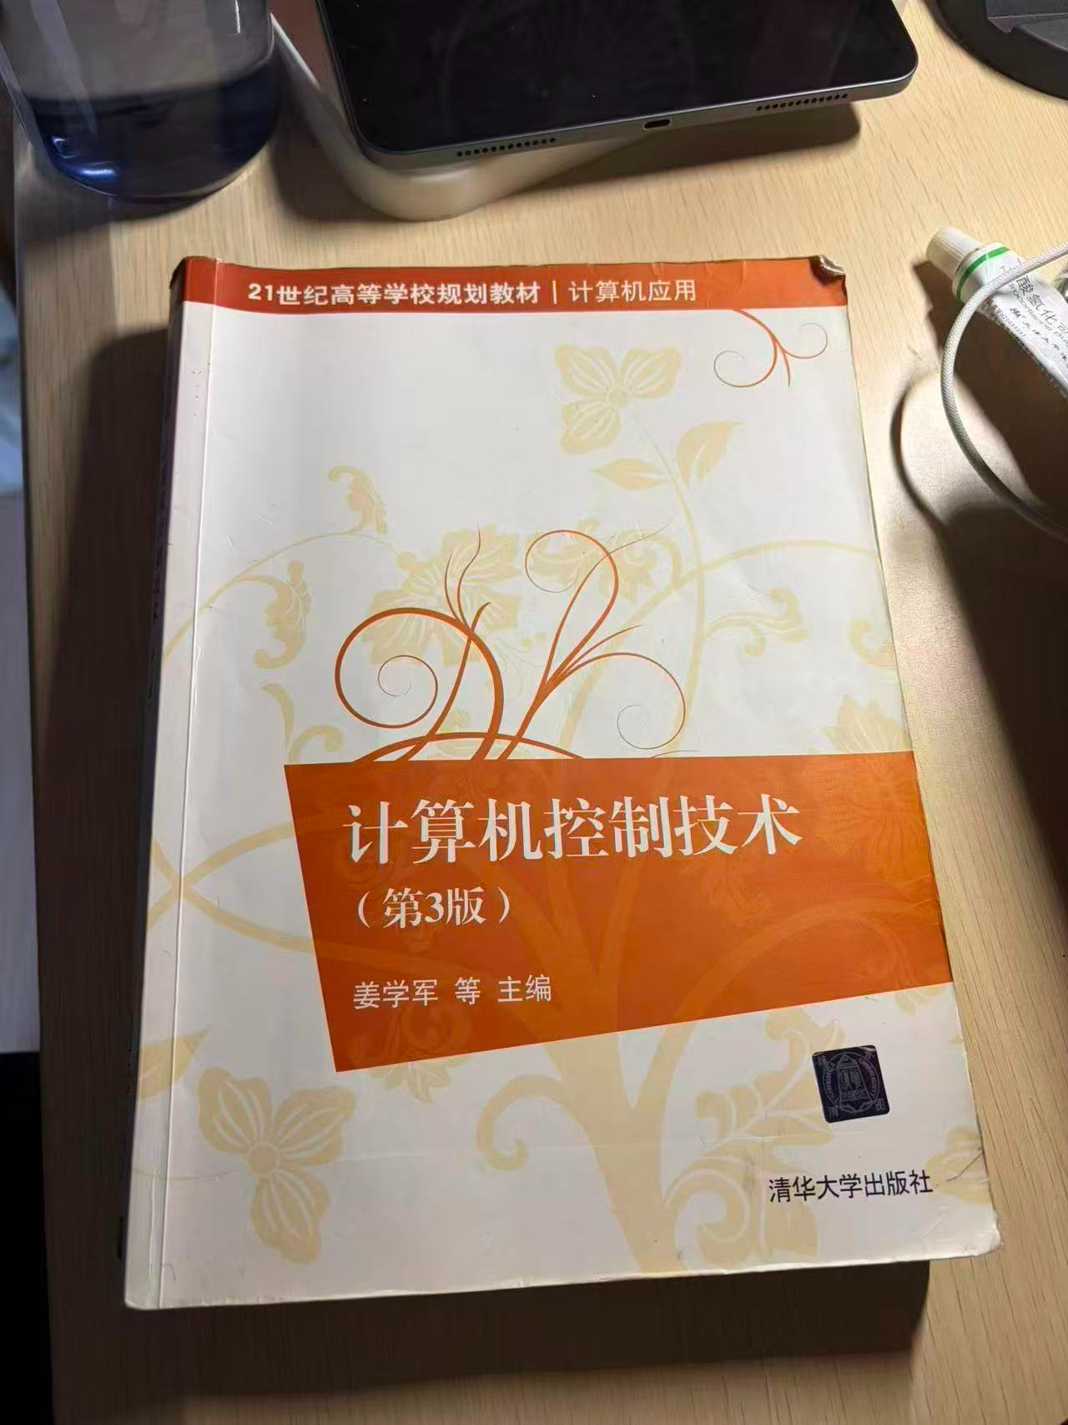
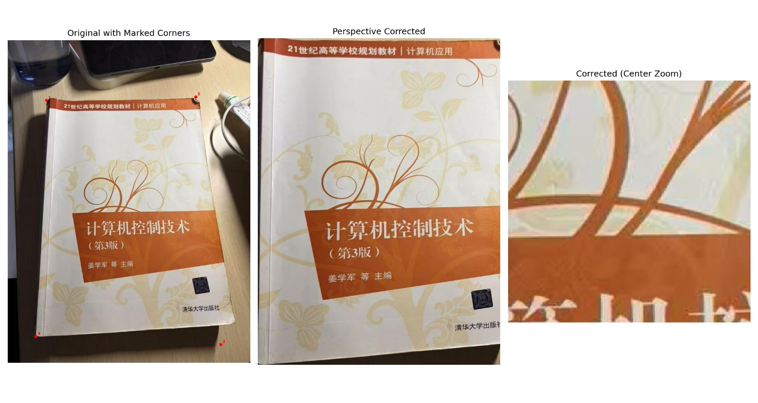原始图像清晰度: 164.25
校正后清晰度: 112.01
- 校正后文字清晰度变化不大

