Table of Contents

▪ WEEK1 1

I. What is a Neural Network? 1

i. Housing Price Prediction 2

* WEEK1

1. What is a Neural Network?
2. Housing Price Prediction

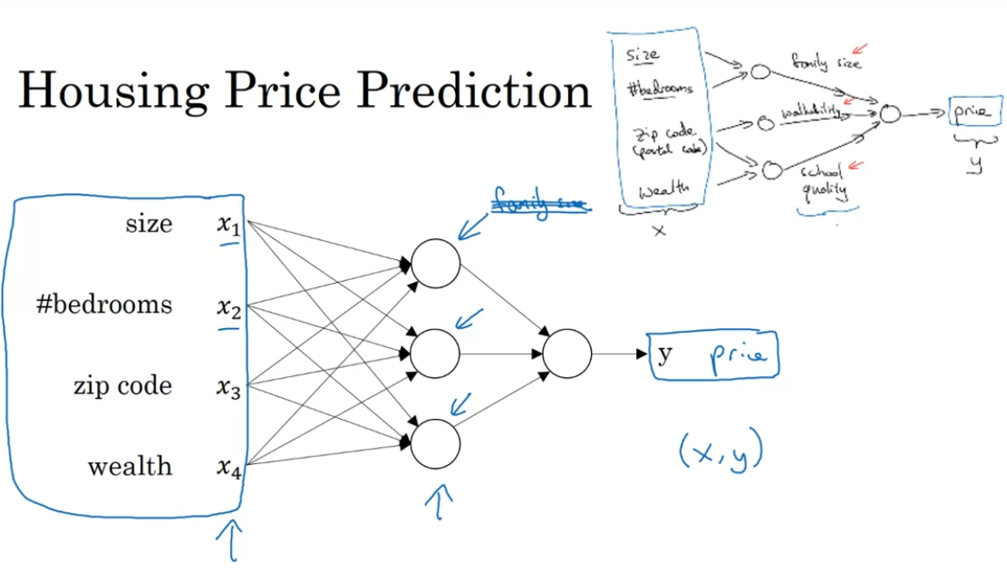

Hidden units takes all 4 inputs. Input layers are densely connected. Neural network predicts from x to y.

True or false? As explained in this lecture, every input layer feature is interconnected with every hidden layer feature. True.

1. Supervised Learning

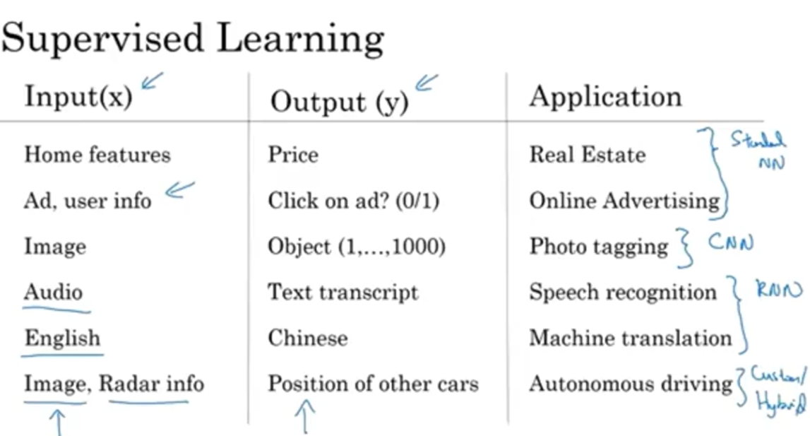

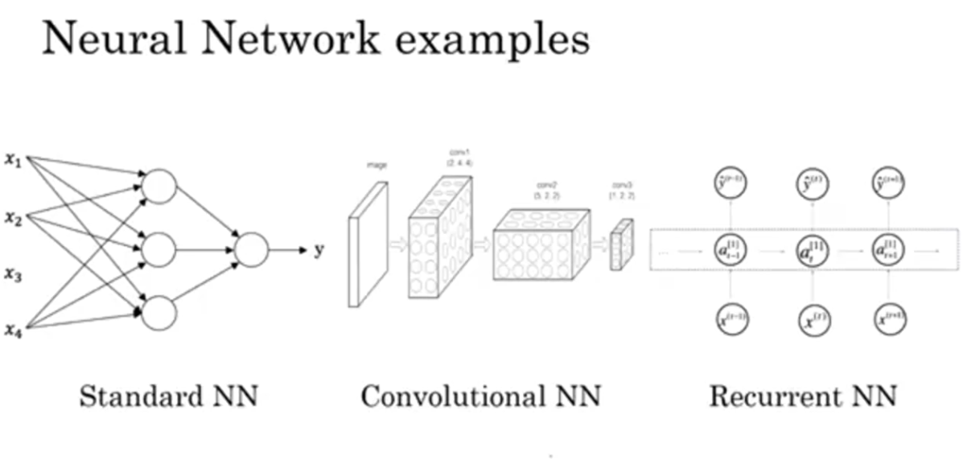

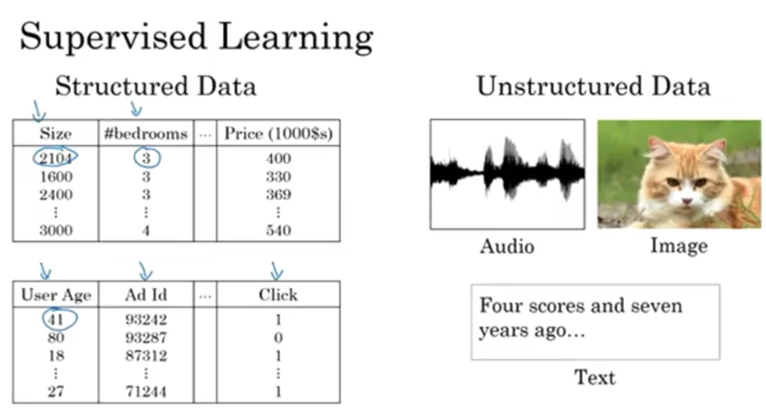

Would structured or unstructured data have features such as pixel values or individual words?

Structured data. Unstructured data

* Why is Deep Learning taking off?
  + Neural network
  + Data (labeled); m: number of training set

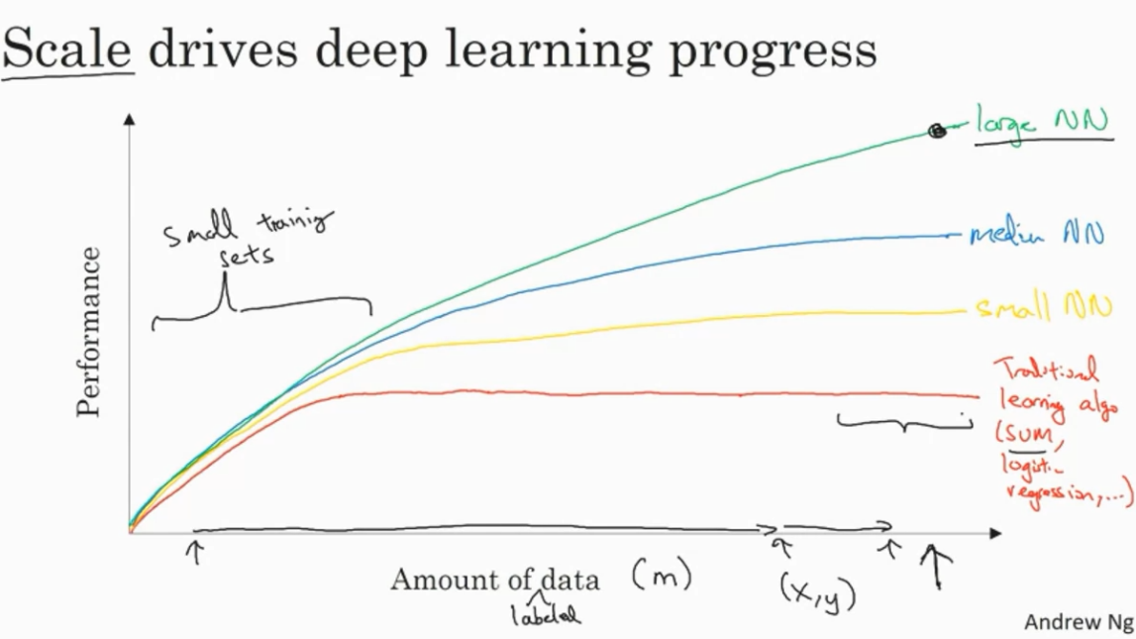

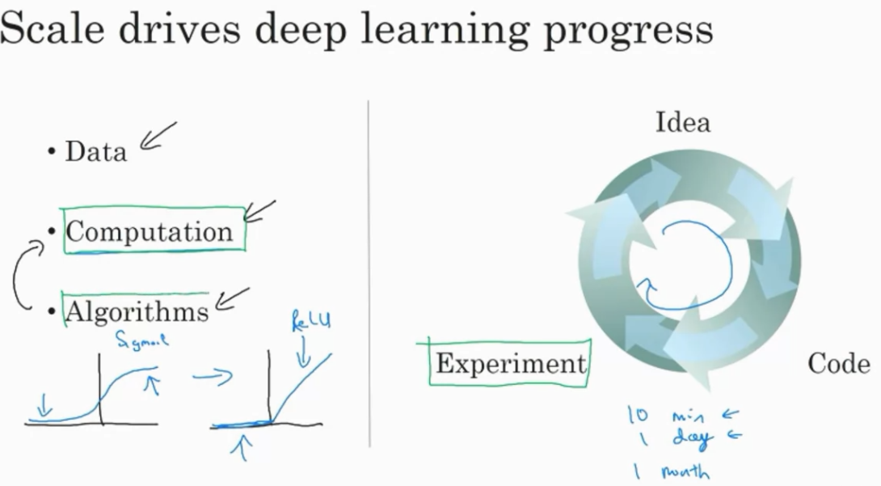

Sigmoid -> ReLu function

What will the variable **m** denote in this course?

Number of hidden layers

Number of training examples

The expected output

Slope

