Table of Contents
WEEK1 2
I. What is a Neural Network? 2
ii. Housing Price Prediction 2
II. Supervised Learning 3
I. Why is Deep Learning taking off? 4
WEEK2 6

- WEEK1
- What is a Neural Network?

- Housing Price Prediction
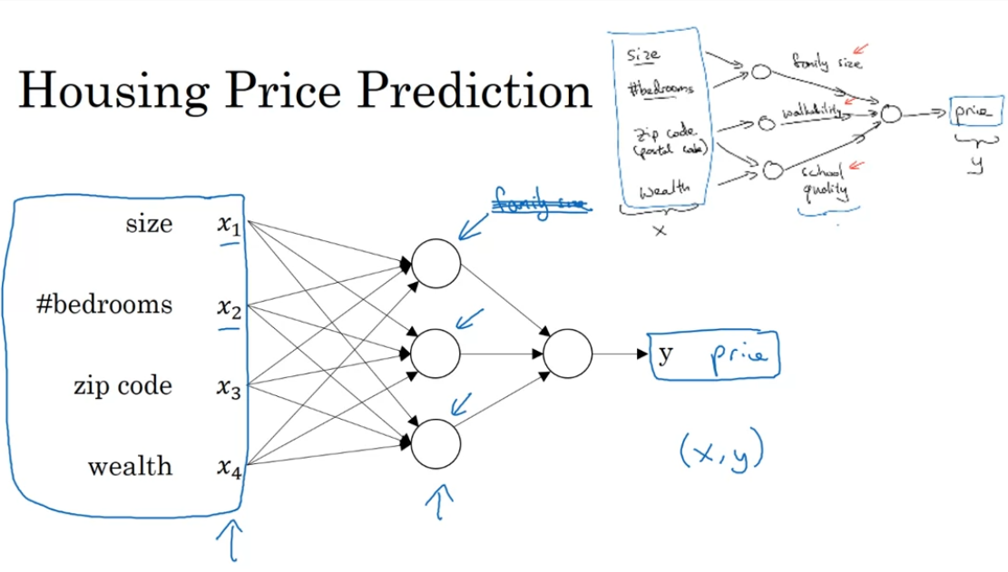

Hidden units takes all 4 inputs. Input layers are densely connected. Neural network predicts from x to y.
True or false? As explained in this lecture, every input layer feature is interconnected with every hidden layer feature. True.

- Supervised Learning
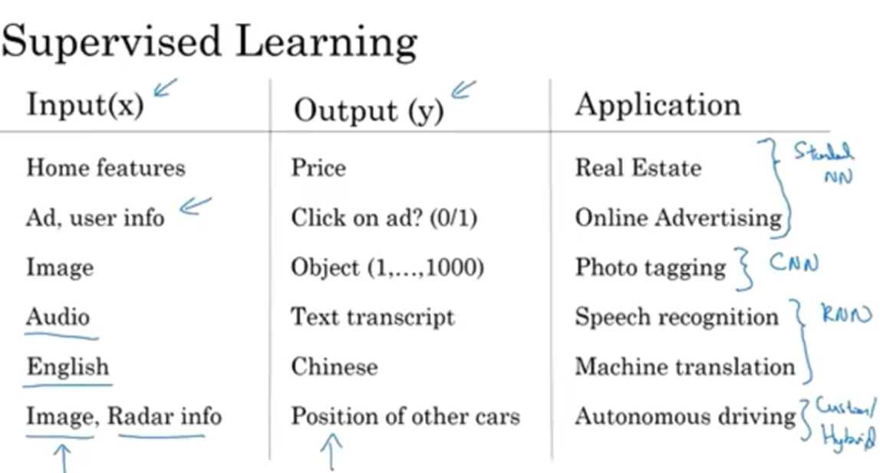
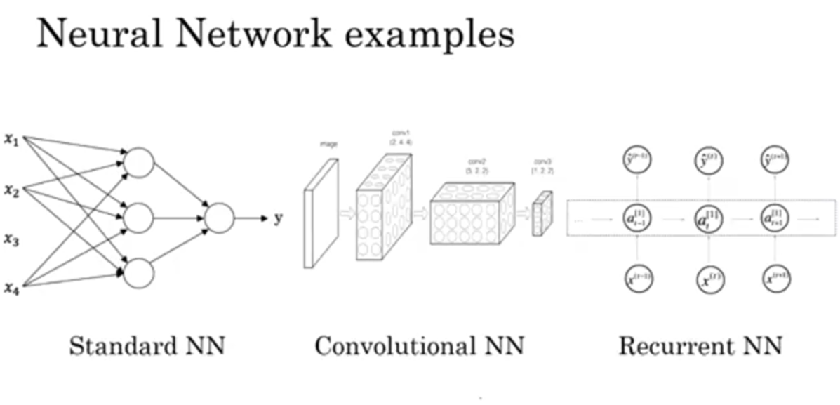
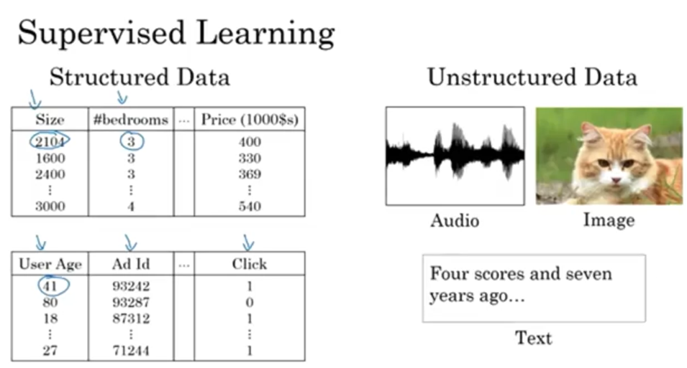
Would structured or unstructured data have features such as pixel values or individual words?
Structured data. Unstructured data
- Why is Deep Learning taking off?
  - Neural network
  - Data (labeled); m: number of training set
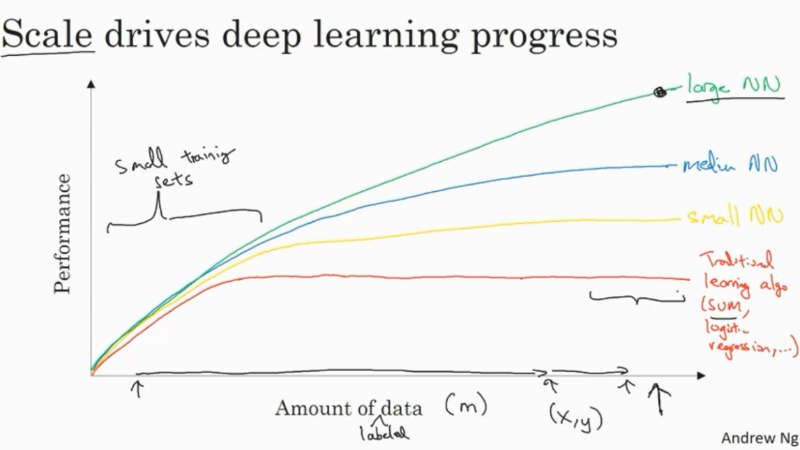
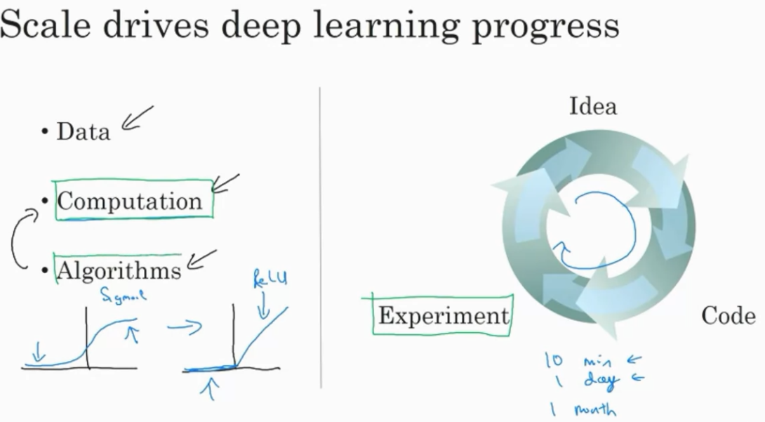
Sigmoid -> ReLu function
What will the variable m denote in this course?
Number of hidden layers
Number of training examples
The expected output
Slope

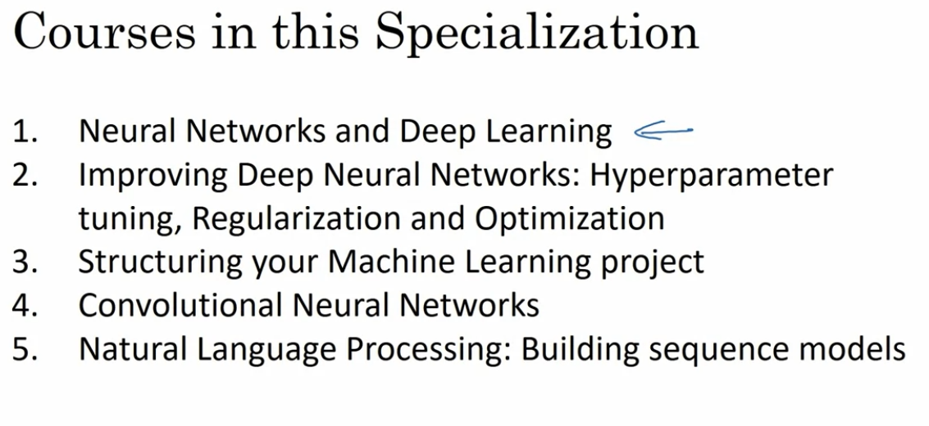
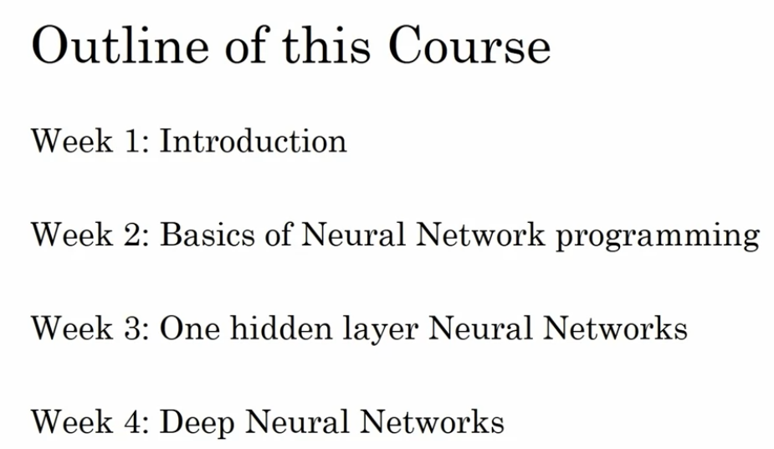

- WEEK2

Learning Objectives
- Build a logistic regression model structured as a shallow neural network
- Build the general architecture of a learning algorithm, including parameter initialization, cost function and gradient calculation, and optimization implemetation (gradient descent)
- Implement computationally efficient and highly vectorized versions of models
- Compute derivatives for logistic regression, using a backpropagation mindset
- Use Numpy functions and Numpy matrix/vector operations
- Work with iPython Notebooks
- Implement vectorization across multiple training examples
- Explain the concept of broadcasting

- Binary Classification

Logistic Regression is an algorithm for binary classification.

