**2022学年第一学期七年级英语学科作业一**

**时间：60分钟**

**Part 1 Listening (第一部分听力)**

**I. Listening comprehension （听力理解）（共25分）**

**A. Listen and choose the right picture.（根据你听到的内容，选出相应的图片）（5分）**

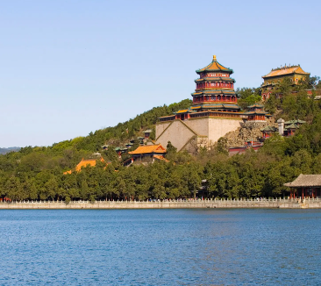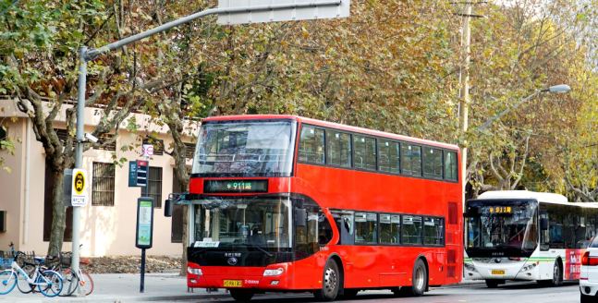 **A B C**

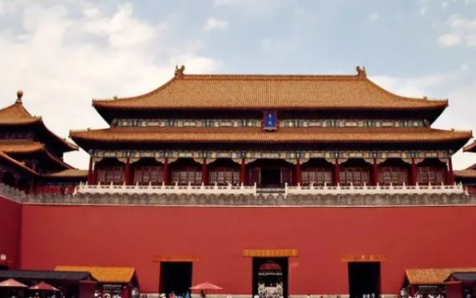  **D E F**

1. 2. 3. 4. 5.

**B. Listen to the dialogue and choose the best answer to the question you hear.（根据你听到的对话和问题，选出最恰当的答案）（7分）**

( )6. A. The girl’s brother and father. B. The girl’s brother and sister.

C. The girl’s mother and sister. D. The girl’s mother and brother.

( )7. A. Japan. B. Australia. C. Canada. D. Britain.

( )8. A. By bike. B. By bus. C. On foot. D. By underground.

( )9. A. Tea. B. Coffee. C. Both. D. Neither.

( )10. A. Yes, she does. B. No, she doesn’t.

C. She is not sure. D. We don’t know.

( )11. A. 2 May. B. 3 May. C. 5 May. D. 6 May.

( )12. A. In a farm house. B. In the mountains.

C. In a park. D. In the zoo.

**C. Listen to the passage and tell whether the following statements are true or false.（判断下列句子是否符合你听到的内容, 符合的用“T”表示，不符合的用“F”表示）（5分）**

( )13. The best time for reading is morning.

( )14. In the morning, the air is fresh and the mind (头脑) is clear.

( )15. If you have not known a text well, you should read the next one.

( )16.You should read books carefully, or you can get nothing from the book while you are reading.

( )17. You can understand your “why” by asking your teachers or parents, or friends.

**D. Listen to the passage and complete the following sentences.（听短文，完成下列内容。每空格限填一词）（8分）**

18. The man went to the restaurant to buy his ______.

19. The man bought a ______ and a Coke in the restaurant.

20. The worker put the food in a bag. The man ______ ______ his money and paid for the food.

21. After leaving the restaurant the man walked to ______ ______.

22. The man found only ______ ______ in the bag when he opened it.

**Part 2 Phonetics, Vocabulary and Grammar(语音，词汇和语法39分)**

**I. Fill in the blanks according to the phonetic transcription.（看音标写单词）（3分）**

23. He can hardly get onto the ______ /ˈkraʊdɪd/ bus.

24. My uncles works in a tourist ______ /ˈeɪdʒənsi/ and takes charge of the sales.

25. Children ______ /ˈprɒmɪst/ to look after their puppies well at the SPCA.

**Ⅱ. Choose the best answer.(选择最恰当的答案) （15分）**

( )26. It is good for you to have ____ walk after supper.

1. An B. / C. a D. the

( )27. Jerry goes to the swimming class ________ Saturday afternoons.

A.in B. at C. on D. for

( )28. My pen is out of ink. May I use ________?

A. you B. your C. yours D. yourself

( )29. There is only ________ food in the fridge. Would you like to buy some?

A. a few B. little C. few D. a little

( )30. Mum, you ________ pick me up at school this afternoon. I will take the bus home myself.

A. mustn’t B. shouldn’t C. needn’t D. can’t

( )31. It takes about ______ to go shopping in the supermarket.

A. two and a half hour B. two and half hours

C. two hour and a half D. two hours and a half

( )32. The fireman did his best to ______ the boy safe ______ danger.

A. keep, from B. leave, from C. take, out D. get, from

( )33. Thanks for your help, ________ I want to try it again by myself.

A. or B. but C. and D. so

( )34.Li Hua is a(n) ______ boy, but he can speak ______.

A. Chinese, Japan B. China, Britain C. American, China D.Chinese, Japanese

( )35.Is there anything in your ______ hand?

A. the others B. the other C. another D. other

( )36. She won’t go out if the wind ____________ hard.

A. blow B. blew C. blows D. is blowing

( )37. Parents should spend more time ______ their children at weekends.

A. playing B. play with C. to play D. playing with

( )38. — What good weather!

— Yes, the radio says it will get much ____ later.

A. Good B. better C. best D. the best

( )39. Betty is so excited that her new novel out in about two months.

A. came B. was coming C. has come D. will come

( )40. — Why not join us in playing football after school?

— ____.

A. Good idea B. You are welcome C. Not at all D. Never mind

**Ⅲ. Complete the following passage with the words in the box. Each word can only be used once.(选择恰当的词或词组填入所缺的空格) (5分)**

1. **like B. neither C. phoned D. neighbors E. friend F. before**

My friend，David Smith，kept birds. One day he 41 and told me he would be away for a week. He asked me to feed the birds for him and said he would leave his key in my mailbox.

Unfortunately，I did not remember to feed the birds until the night 42 David was going to return .I rushed out of my house and it was already dark when I arrived at his house. I soon found the key he gave me. However, I could unlock 43   the front door nor the back door！I kept thinking of what David would say when he came back.

Then I noticed that one bedroom window was open. I found a big stone and pushed it under the window. Because the stone was very heavy，I made a lot of noise. But in the end，I managed to climb up.

I had one leg inside the bedroom when I suddenly realized that someone shining a torch(电筒) up at me. I looked down and saw a policeman and an old lady，one of David's 44  .“What are you doing up there？”said the policeman. Feeling 45 a fool，I replied，“I was just going to feed Mr. Smith's birds.”

41. ______ 42. ______ 43. ______ 44. ______ 45. ______

**IV. Fill in the blanks with the given words in their proper forms. (用括号中所给词的适当形式填空) (6分)**

46. When Hillary visited Beijing, she met another American __________ (tour) in the Summer Palace.

47. The letter said Mother arrived in Shenzhen ______. (safe)

48. Do you know his ______? I have to write it down. (nation)

49. I think he is ______ because he doesn’t help his classmate with the homework. (kind)

50. Tom sent an ______ to his best friend to come to his birthday party last weekend. (invite)

51. The car drives on the left side of the road in ______. (Briton)

**V. Rewrite the sentences as required. (按要求改写句子,每空格限填一词) (10分)**

52. He had a great time in Shanghai last week. (改为一般疑问句)

______ he ______a great time in Shanghai last week?

53. Susan left for Beijing to attend an international meeting. (对划线部分提问)

________ ________ Susan leave for Beijing?

1. In old days people liked dogs better than cats.(保持原句意思不变)

In old days people________ dogs ________ cats.

55. The SPCA saved the poor animals from danger. (保持原句意思不变)

The SPCA ______ the poor animals ______from danger.

56. people, more than, to, thousand, the meeting, there, five, are, coming(连词成句)

.

**Part 3 Reading and Writing (阅读和写话36分)**

**I. Reading comprehension ( 阅读理解) （共26分）**

1. **Read the dialogue and choose the right answer. (阅读短文，选出最合适的答案)（6分）**

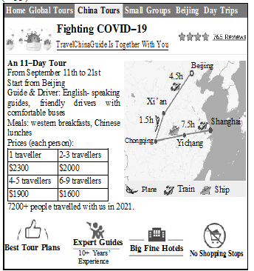

Plane

Chongqing

( )57. We can learn that the tour will start in ____.

A. Spring B. summer C. autumn D. winter

( )58. How will travelers get from Chongqing to Yichang?

A. By train. B. By plane. C. By ship. D. By bus.

( )59. How long will it take from Beijing to Xi’an if people take the tour?

A. 1.5 hours. B. 4.5 hours. C. 5.5 hours. D. 7.5 hours.

( )60. If seven people take the tour together, how much should each of them pay?

A. $1600. B. $1900. C. $2000. D. $2300.

( )61. We can know that ____ people traveled with them in 2019.

A. less than 7,000 B. more than 7,200

C. about 6,000 D. more than 10,000

( )62. Which of the following is **NOT** true?

A. People will visit five cities in China.

B. There are no shopping stops.

C. The tour guides can speak English.

D. The drivers have over 10 years’ experience.

**B. Choose the words or expressions and complete the passage.（选择最恰当的单词或词语完成短文）（6分）**

At the beginning of March, about 300 middle-school students went to Utah State University in the United States. They joined together to 63 the Young Writers and Artists Festival. It’s also a time to show their creativity (创造力).

Student writers shared their stories. And they got advice from professional writers. That was great because it could 64 help them improve their writing skills (技能).

Though it’s common for students to write stories in the classroom, they still feel excited about writing during the festival. This year’s writing was about “The Power of One”. It encouraged (鼓励) students to use their creativity to change the world.

Jeannie Brown is an art teacher from South Cache Middle School. She thinks this festival is 65 , because it gives teenagers a chance to show themselves.

Megan Rasmussen, an eighth grader at the school, 66 her own version (版本) of the story “Cinderella”. She loves writing so much that she thinks it is the most 67 thing in the world.

Well, others chose to tell stories or make arts and crafts. Lisa Saunderson is an art 68 . She and a group of students of hers made things with reusable (可重复使用的) materials. A girl, Dokota Brodniak, made a dress out of used paper. They really enjoyed the festival.

( )63. A. change B. celebrate C. visit D. learn

( )64. A. surely B. hardly C. only D. heavily

( )65. A. boring B. surprising C. long D. wonderful

( )66. A. bought B. wrote C. sold D. lost

( )67. A. difficult B. famous C. interesting D. serious

( )68. A. student B. worker C. parent D. teacher

**C. Read the passage and fill in the blanks with proper words. (在短文的空格内填入适当的词，使其内容通顺，每空格限填一词，首字母已给) (7分)**

Many things can cause driving accidents. The following suggestions can help you to cut down the number of traffic accidents while you are driving.

Firstly, keep your (69)e______ on the road. When you are driving, you should be doing just that and nothing else.

Secondly, keep as much space as you can(70) b______ your car and other cars. If you are travelling at a speed of 10 miles per hour, it is right to leave at least one car’s length between your car and the car in front of you. In (71)h______ traffic, it is difficult to leave that much space. But you should try to keep enough distance (距离).

Thirdly, never use your telephone. There is no good reason to be talking on a telephone while you are driving. If you do need to make a call, (72)w______ until you have parked.

Fourthly, never drink and drive. If you drink and drive and the traffic police (73)c______ you, you will have a huge fine (罚金) to pay, and you can’t use your driving license (驾驶执照) for some time. If you have to drink, you can have a designated driver (代驾), take a taxi or take a bus. It will just (74)c______ you a little money.

Finally, be polite all the time. Even if some drivers make you (75)a______, don’t shout at them. You may never see them again in the future.

1. e_____70. b_____71. h______72. w______73. c______74. c______75. a______

**D. Read the passage and answer the following questions with complete sentences. (根据短文内容回答下列问题) (7分)**

What kind of vehicle (工具) will you choose when travelling between provinces (省)? Many people may like travelling by train because it’s safer and cheaper. Now the high-speed railways have connected (连接) eastern and western China as well as the south and the north.

A new high-speed railway opened on Sept. 10th, 2016. It connects Zhengzhou in Henan Province with Xuzhou in Jiangsu Province. With this railway, China’s high-speed railways are over 20,000 kilometres long. It is the world’s longest and makes up 60 percent of the world’s total (全部的) high-speed railway lines.

Besides length, China also does better in speed. China is the only country with trains running at 350 kilometres an hour, such as the Beijing-Tianjin and Beijing-Shanghai high-speed railways.

With these surprising numbers, it is easy to forget that China wasn’t the first in the high-speed rail game. Japan started 50 years ago, while Germany did 20 years ago. China only began to build its high-speed railways 14 years ago.

China’s high-speed railways are developing (发展) fast now. Behind it, there is the country’s growing need for transportation. China’s high-speed trains gave 961 million trips to people last year.

“The high-speed railways not only bridge the distance (距离), but connect people, information and goods,” said Huang Xin, an official from the China Railway Corp.

Yet, China’s building of high-speed railways is still going on. China plans to have 38,000 kilometres of high-speed railways by 2025.

76. Why may many people like travelling between provinces by train according to the passage? (1分)

______________________________________

77. How long have China’s high-speed railways been since Sept. 10th, 2016? (1分)

______________________________________

78. How fast is the Beijing-Tianjin high-speed train? (1分)

______________________________________

79. Which country is the first one to build the high-speed railways? (1分)

______________________________________

80. China’s building of high-speed railways isn’t still going on, is it? (1分)

______________________________________

81. If you want to go to Beijing for the coming holidays, what kind of vehicle will you choose? Why? (2分)

______________________________________

**Ⅷ. Writing (作文) （10分）**

**Write a passage of at least 60 words on the topic ‘My animal friend'.**

动物是人类的朋友，它们陪伴我们度过许多美好的时光，同时我们也给与他们朋友般的照顾。请以“My animal friend”为题，写一篇短文，描述一下你的动物朋友，不少于60词。

**Use the following points as a reference.(以下内容仅供参考)**

1.Who is your animal friend?

2.How do you look after him/her?

3.Why do you think he/she is your friend?