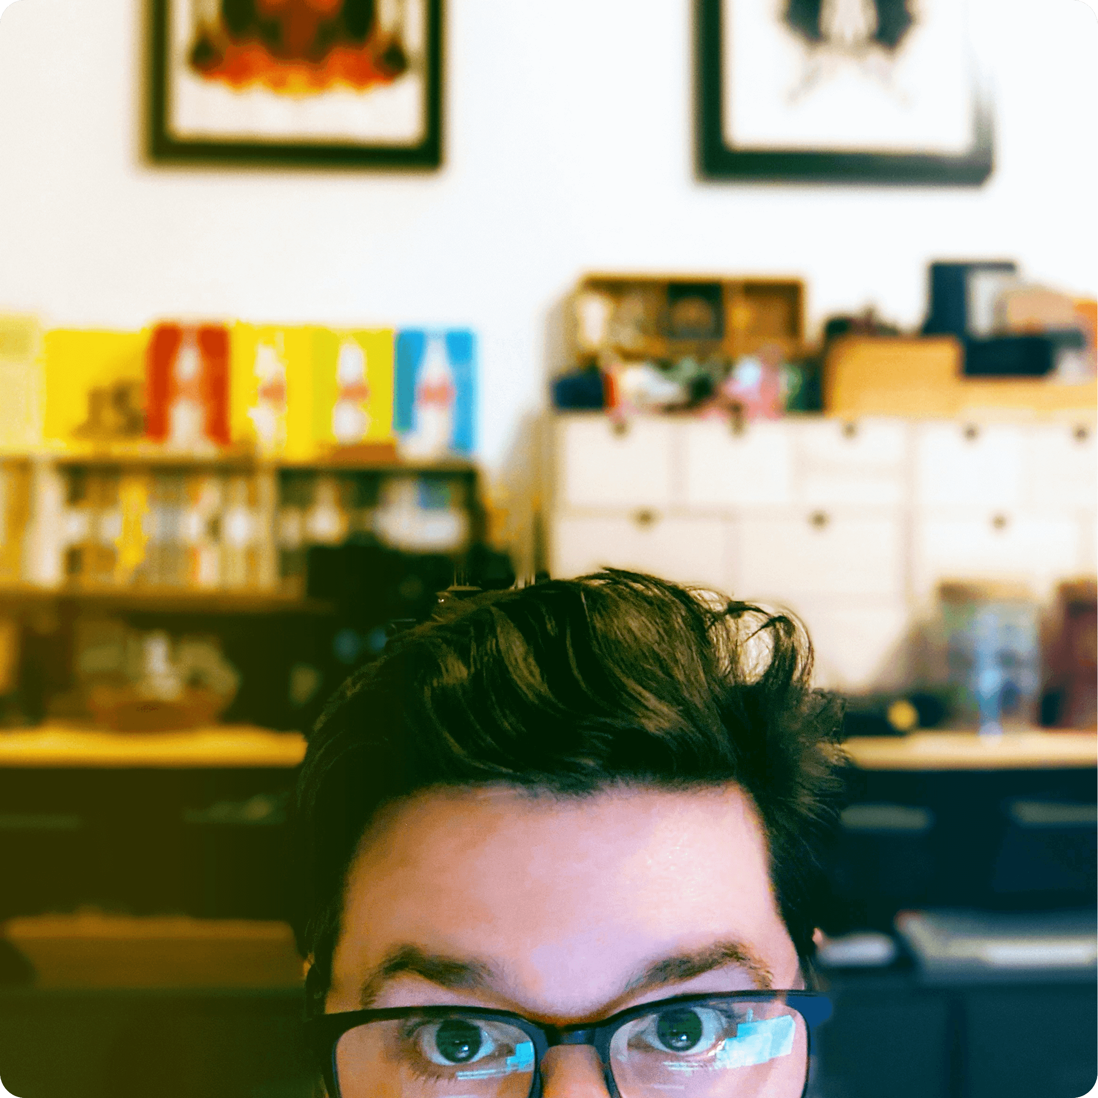

Fashion Institute of Technology: *BFA Illustration*

*(2005) => 2009*

++++++++++

++++++++++

++++++++++

++++++++++

++++++++--

++++++----

ADOBE CC:

FIGMA/SKETCH:

GSAP:

SASS/SCSS:

TAILWIND/BS:

SOLID:

++++++++++

++++++++++

++++++++++

++++++++++

++++++++--

++++++----

VUE:

REACT:

VITE:

REACT NATIVE:

NATIVESCRIPT:

SVELTE:

++++++++++

++++++++++

++++++++++

++++++++++

++++++++--

++++++----

HTML5/CSS:

JAVASCRIPT/ES6:  
TYPESCRIPT:NODE JS:

WORDPRESS:

PHP/MYSQL:

// SKILLS

// EDUCATION

*(2012) => 2015*

* Developed various projects involving front-end templates, complex UIs, interactive data, infographics, and large-scale animations.

F5 Interactive Agency: *Front End Designer & Developer*

*(2013) => 2015*

* Designed and managed Facebook advertisements and social media campaigns.
* Designed print ads, web ads, and HTML emails.

Everyday Media: *Digital Designer*

*(2014) => 2015*

* Created interactive animated advertisements for web and display for top media corporations, including ABC, CBS, FX and Hulu.
* Managed the transition from Flash to HTML5 animation.

Mammoth Advertising: *HTML5 Developer*

*(2014) => 2020*

* Assisted in all areas to redesign, build, and relaunch a new Ecommerce site for a nationwide retailer.
* Developed automated and streamlined workflows for static pages and emails.

Modells Sporting Goods: *Front End Developer*

*(2020) => present*

* Proficiently utilized cutting-edge technologies to deliver dynamic, interactive, and visually appealing user experiences for clients including Comcast, NBC, Showtime and Hulu.
* Created tailored solutions and interactive games, to boost employee engagement and training effectiveness.
* Spearheaded the development of a custom in-house tech solution for client site generation and administration.
* Excelled in a fast-paced agency environment, consistently delivering high-quality results under tight deadlines.

Renegade Communications: *Front End Developer*

// WORK EXPERIENCE

*Hey*, I am a Front-End Web Developer with a foundation in JavaScript and a background in Design. I am based in Brooklyn NY with 10+ years of professional experience in full stack development and digital design.

*http://jnwells.dev/2024*

*jnwellsdev@gmail.com*

*347-243-5863*

*Jesse Wells*

*Front-End Developer*