The Flashcard Project

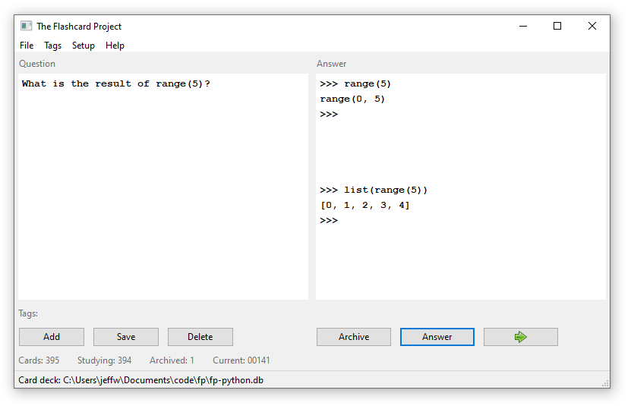

The Flashcard Project (FP) makes, manages, and facilitates viewing flashcards on a desktop. The native Windows interface and size-adjustable frame makes it easy to have other applications and study references displayed. This can be useful when studying a computer language so you can switch to a code editor or interpreter for testing and practice.

While other flashcard applications provide extended features, this offers a simple system that allows content sharing and merging. Cards can be categorized with tags and you can save your card decks. The files can be shared for use by anyone with a FP application.

With FP you can…

- Edit cards on the same screen as they are displayed.
- Save card decks to a database file.
- Export files in machine and human-readable formats.
- Merge card decks.
- Tag cards to allow filtering.
- Delete unwanted tags simultaneously from all cards.
- Display cards randomly or sequentially.
- Flag cards as archived so they will not be shown.
- Reset the deck so all archived and excluded cards are shown.

You can edit, add, and delete cards while you are studying. If there is a card you do not want to see again, click the “Archive” button. The deck can be reset at any time to return the status of all archived card to active. Otherwise, the deck will be automatically reset once all cards are viewed.

FP provides a way for multiple people to contribute when generating a card deck. To share a card deck, the card data can be exported to a human-readable YAML file. These files can be shared and then imported by someone else.

Use the FP application to help with learning for any subject. If you are an instructor your students could be tasked with producing their own flashcards and submit them as card files. Their cards can be easily consolidated into a single card deck file that is a useful learning asset for all of students.

The Flashcard Project is free and open source software written in Python. It can be used, redistributed, and modified it under the terms of its MIT license.

It would be great to receive contributions to the code and documentation. The repository also includes the following card database file for Python language learning:

fp-python.db

You can submit a pull request to provide your Python cards as YAML files exported by the FP application. They may be consolidated with fp-python.db.

In addition to the software, FP is also a curated deck of Python learning flashcards that are generated with the application. The master YAML file of cards is in the repository and is named:

fp-python.yaml

Submit a pull request to edit and add cards to this deck. You can edit the existing YAML
file or submit a new file and I can merge the content. Please follow the existing
format and include tags to categorize the cards.

Most of the cards should include example code for answers. Often, a line of example of code is all that is needed. Using a python CLI makes it easy to distinguish output from code at every step

INSTALLATION

You can compile the source code (fp.py) with dependencies defined in this file:

requirements.txt

Otherwise, download this Windows executable file and run it:

fp.exe

That is all that is needed, although you may wish to start with this python learning deck as well:

fp-python.db

Basic usage instructions are under the program’s Help menu.

