**Computer Organization and Assembly Language**

# Question 1:

Write a program to get a string from the user and search it in 2D string array by comparing character by character. If the string is found, then print a message (“String is found”).

1. Type the code in the MS word. The code should not be an image of your computer screen or any kind of snapshot.
2. Provide a snapshot of the output. The snapshot should be a complete screen snapshot (don’t cut the snapshot of your screen).

**Code:**

include Irvine32.inc

.data

stringArray BYTE "four"

BYTE "five"

BYTE "band"

BYTE "bags"

BYTE "fans"

row = 5

col = 4

userInput BYTE 4 DUP (?), 0

msg0 BYTE "Enter string: ", 0

msg1 BYTE "String found", 0

msg2 BYTE "String not found", 0

.code

main PROC

mov edx, OFFSET msg0

call WriteString

mov eax, 0

mov ecx, LENGTHOF userInput - 1

mov esi, OFFSET userInput

L1:

call ReadChar

call WriteChar

mov [esi], al

inc esi

loop L1

mov edx, 0

mov edx, row

mov edi, OFFSET stringArray

L2:

cld

mov esi, OFFSET userInput

mov ecx, LENGTHOF userInput - 1

repe cmpsb

JZ stringFound

dec edx

JNZ L2

sringNotFound:

mov edx, OFFSET msg2

call crlf

call crlf

call WriteString

call crlf

jmp endOfFunction

stringFound:

mov edx, OFFSET msg1

call crlf

call crlf

call WriteString

call crlf

endOfFunction:

exit

main ENDP

END main

(screenshots below)

**Screenshots:**

found:

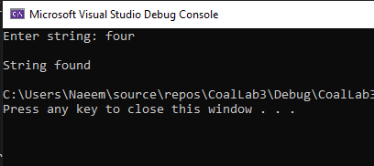

found (entire screen):

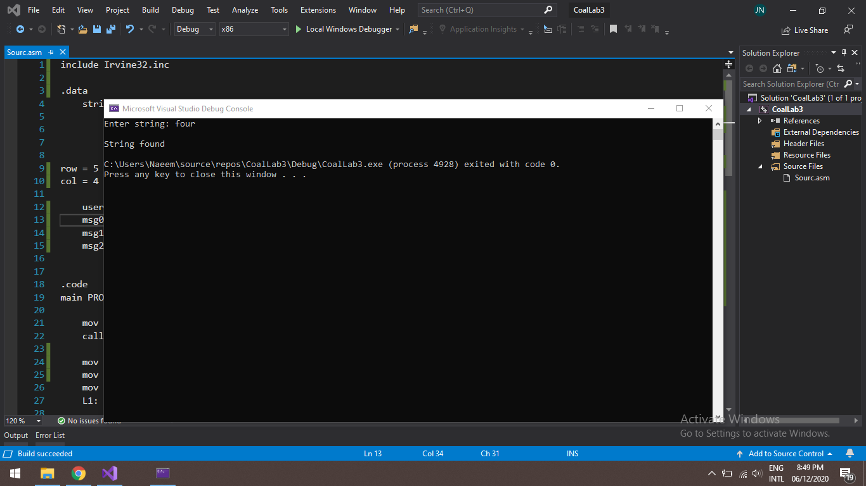

not found:

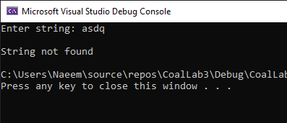

not found (entire screen):

