# Question 1:

Complete the following given code to Print Sum of Each Row in a line with space between them.

1. Type the code in the MS word. The code should not be an image of your computer screen or any kind of snapshot.
2. Provide a snapshot of the output. The snapshot should be a complete screen snapshot (don’t cut the snapshot of your screen).

# Source Code:

INCLUDE Irvine32.inc

.data

array2D dword 0,1,2,3,4,5,6,7,8,9

dword 1,1,1,1,1,1,1,1,1,1

dword 2,2,2,2,2,2,2,2,2,2

dword 3,3,3,3,3,3,3,3,3,3

dword 4,4,4,4,4,4,4,4,4,4

dword 5,5,5,5,5,5,5,5,5,5

dword 6,6,6,6,6,6,6,6,6,6

dword 7,7,7,7,7,7,7,7,7,7

dword 8,8,8,8,8,8,8,8,8,8

dword 9,9,9,9,9,9,9,9,9,9

Rows = 10

Columns = 10

.code

**Solution:**

Code:

include irvine32.inc

.data

array2D dword 0,1,2,3,4,5,6,7,8,9

dword 1,1,1,1,1,1,1,1,1,1

dword 2,2,2,2,2,2,2,2,2,2

dword 3,3,3,3,3,3,3,3,3,3

dword 4,4,4,4,4,4,4,4,4,4

dword 5,5,5,5,5,5,5,5,5,5

dword 6,6,6,6,6,6,6,6,6,6

dword 7,7,7,7,7,7,7,7,7,7

dword 8,8,8,8,8,8,8,8,8,8

dword 9,9,9,9,9,9,9,9,9,9

Rows = 10

Columns = 10

msg0 BYTE "Sum of each row (going from row 0 to row 9): ", 0

.code

main PROC

mov ebx, OFFSET array2D

push ebx

call printSums

exit

main ENDP

printSums PROC

;-------------------------------------------------------------

;Generates and prints sum of each row in a 2D array

;Receives: OFFSET of a 2D array (through runtime stack)

;Returns: nothing

;Requires: nothing

;-------------------------------------------------------------

call crlf

mov edx, OFFSET msg0

call WriteString

mov ebx, [esp + 4]

mov ch, Rows

L1:

mov edx, 0

mov cl, Columns

mov esi, 0

L2:

mov eax, [ebx + esi]

add edx, eax

add esi, 4

dec cl

JNZ L2

mov al, 32

call WriteChar

mov eax, edx

call WriteDec

add ebx, Columns * 4

dec ch

JNZ L1

call crlf

call crlf

ret

printSums ENDP

END main

Output:

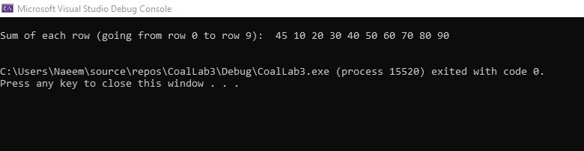

Entire screen:

