**Data Structures and Algorithms**

**Objective:** Understanding How Calculators Evaluate an Infix Expression Using Stack

**Problem Description:**

1. Create a Stack class (or use an existing class Template) to perform the following (No need to include the code for class ADT):
2. Write a driver program which gives users the following options by means of a menu() function:
3. To write an expression (infix/postfix) in an output file.
4. To read an infix expression from a file and check its validity (balanced/unbalanced).
5. To read a valid infix expression from a file and convert it into a postfix expression and write it in an output file.
6. To read a postfix expression from a file and evaluate it and display its value on console.

+++++++++++++++++++++

**Output screenshots:**

Function to write an infix expression and save it in file:

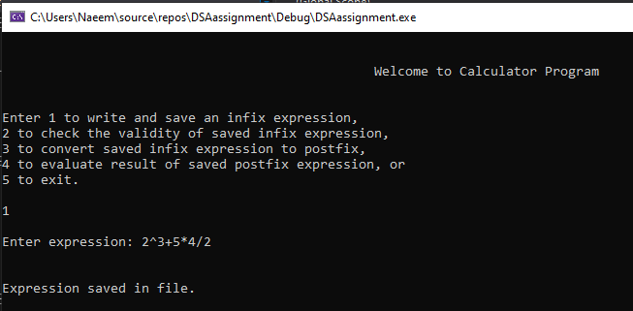

Function to check the validity of a saved infix expression:

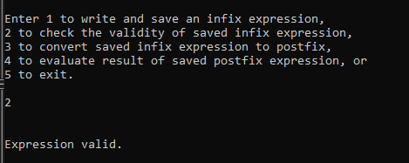

Function to convert a saved and valid infix expression to postfix and save it in another file:

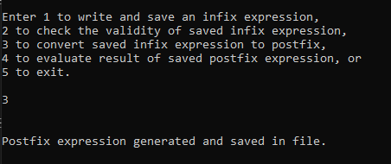

Function to evaluate the result of the saved postfix expression:

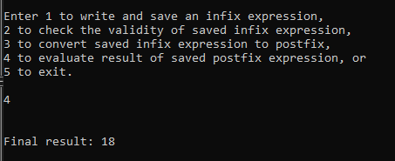

Exit:

