**Introduction**

**Data science**

Data science is the empirical synthesis of actionable knowledge from raw data through the complete lifecycle process (Roos, 2017). Is an extraction of knowledge from data, which is continuation of the field of data mining and predictive analytics?

Data science emphasizes the use of general methods without changing its application, irrespective of the domain. This approach is different from traditional statistics tend to focus on providing solutions that are specific to particular sectors or domains.

The following are the importance of data science

**Helps brands to understand their customers in a much enhanced and empowered manner.** Customers are the soul and base of any brand and have a great role to play in their success and failure. With the use of data science, brands can connect with their customers in a personalized manner, thereby ensuring better brand power and engagement.

**It allows brands to communicate their story in such an engaging and powerful manner**. When brands and companies utilize this data in a comprehensive manner, they can share their story with their target audience, thereby creating better brand connect. After all, nothing connects with consumers like an effective and powerful story, that can inculcate all human emotions.

**Data science can make you a better person**

Data science will not only give us a great career but will also help us in personal growth. We will be able to have a problem solving attitude, since many data science roles bridge IT and management, we will be able to enjoy the best of both world

**Helping brands and organizations to solve complex problems in IT, human resource, and resource management in an effective and strategic manner**

Big Data is a new field that is constantly growing and evolving. With so many tools being developed, almost on a regular basis, this means effective use of resources, both material and non-material.

**Data science is Versatile**

One of the most important aspect of data science is that its findings and results can be applied to almost any sector like travel, healthcare and education among others. There is a large amount of data available in the world today and utilizing them in a proper manner can spell success and failure for brands and organizations. Utilizing data in a proper manner will hold the key for achieving goals for brands, especially in the coming times.

**The Data Science Life Cycle**

Data science continues to evolve as one of the most promising and in-demand career paths for skilled professionals. Today, successful data professionals understand that they must advance past the traditional skills of analyzing large amounts of data, data mining, and programming skills. In order to uncover useful intelligence for their organizations, data scientists must master the full spectrum of the data science life cycle and possess a level of flexibility and understanding to maximize returns at each phase of the process

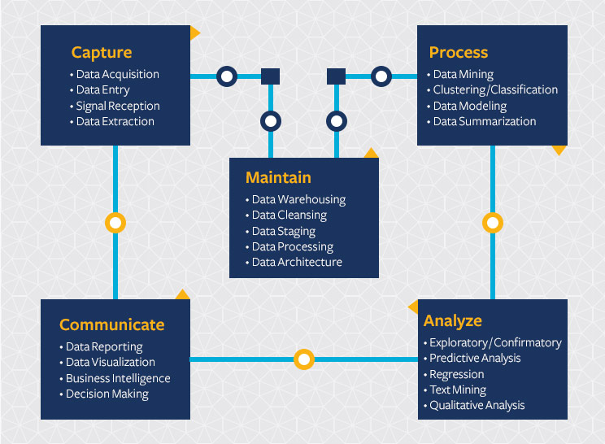

**References**

Roos, Teemu (2017) Introduction to data science from <https://courses.helsinki.fi/fall2017/data11001>

Retrieved 11th july 2019 at 6:35

<https://datascience.berkeley.edu/about/what-is-data-science/> accessed on 6:40 PM at Thuesday

<https://www.educba.com/data-science-and-its-growing-importance/> accessed on 6:30 PM at Thuesday