SPI2 Protocol Specification
STM32F446RE (Nucleo-64) ↔ Raspberry Pi 4 | MotionControl Project | Rev 2.0
Status: SPI comms proven — telem round trip validated 2026-05-09

1. Overview
SPI2 is the bidirectional communication bus between the Raspberry Pi 4 (master) and the STM32F446RE (slave). It carries two independent data flows on the same physical bus:
MOSI (Pi → STM): Trajectory command samples (pos_cmd + vel_ff) streamed as precomputed 2048-sample refill blocks. The STM buffers these in a 4096-sample ring buffer and interpolates between setpoints at the current loop rate.
MISO (STM → Pi): Telemetry frames returned on every transaction. The STM always has a fresh TelemetryFrame ready via circular DMA, updated by the TIM1 ISR at 20 kHz. Whatever the Pi clocks, the latest frame goes out.
NOTE: SPI is full-duplex. The Pi controls the clock and transaction length. The STM cannot initiate a transfer. All telemetry polling is Pi-driven.

2. DMA Architecture
Both RX and TX DMA streams run in circular mode. This is the critical architectural decision — the DMA never stops, never needs manual re-arming, and is not sensitive to NSS timing.
DMA1 Stream 3 (SPI2 RX): Moves bytes from SPI2->DR to spi2_rx_buf[] continuously. NDTR auto-reloads from 24 when it hits zero. IRQ fires every 24 bytes to decode the opcode.
DMA1 Stream 4 (SPI2 TX): Moves bytes from telem_buf[1] to SPI2->DR continuously. NDTR auto-reloads from 24. No IRQ needed — Pi reads whatever is clocked out.
NOTE: Hardware NSS (PB12) is wired and Pi drives CE0, but the STM uses software NSS mode (SSM=1, SSI=1) so SPI2 runs continuously regardless of NSS state. This eliminates a race condition where hardware NSS reset caused DMA to lose sync between transactions.

3. Physical Interface
Signal | STM32 Pin | Pi GPIO (BCM) | Wire Color (this build)
SCK | PB13 / CN10-30 | GPIO11 (SPI0) | Yellow
MOSI | PB15 / CN10-26 | GPIO10 | Orange
MISO | PB14 / CN10-28 | GPIO9 | Green
NSS | PB12 / CN10-16 | GPIO8 (CE0) | Brown/Black
GND | CN10-20 | GND | Black
READY | PC13 / CN7 | GPIO25 | Not yet wired — future

SPI mode: CPOL=0, CPHA=0 (Mode 0). Bit order: MSB first. Clock rate: 1 MHz initial validation, tunable to 8 MHz. Both STM32 and Pi 4 operate at 3.3V — no level shifting required.

4. Wiring Photos
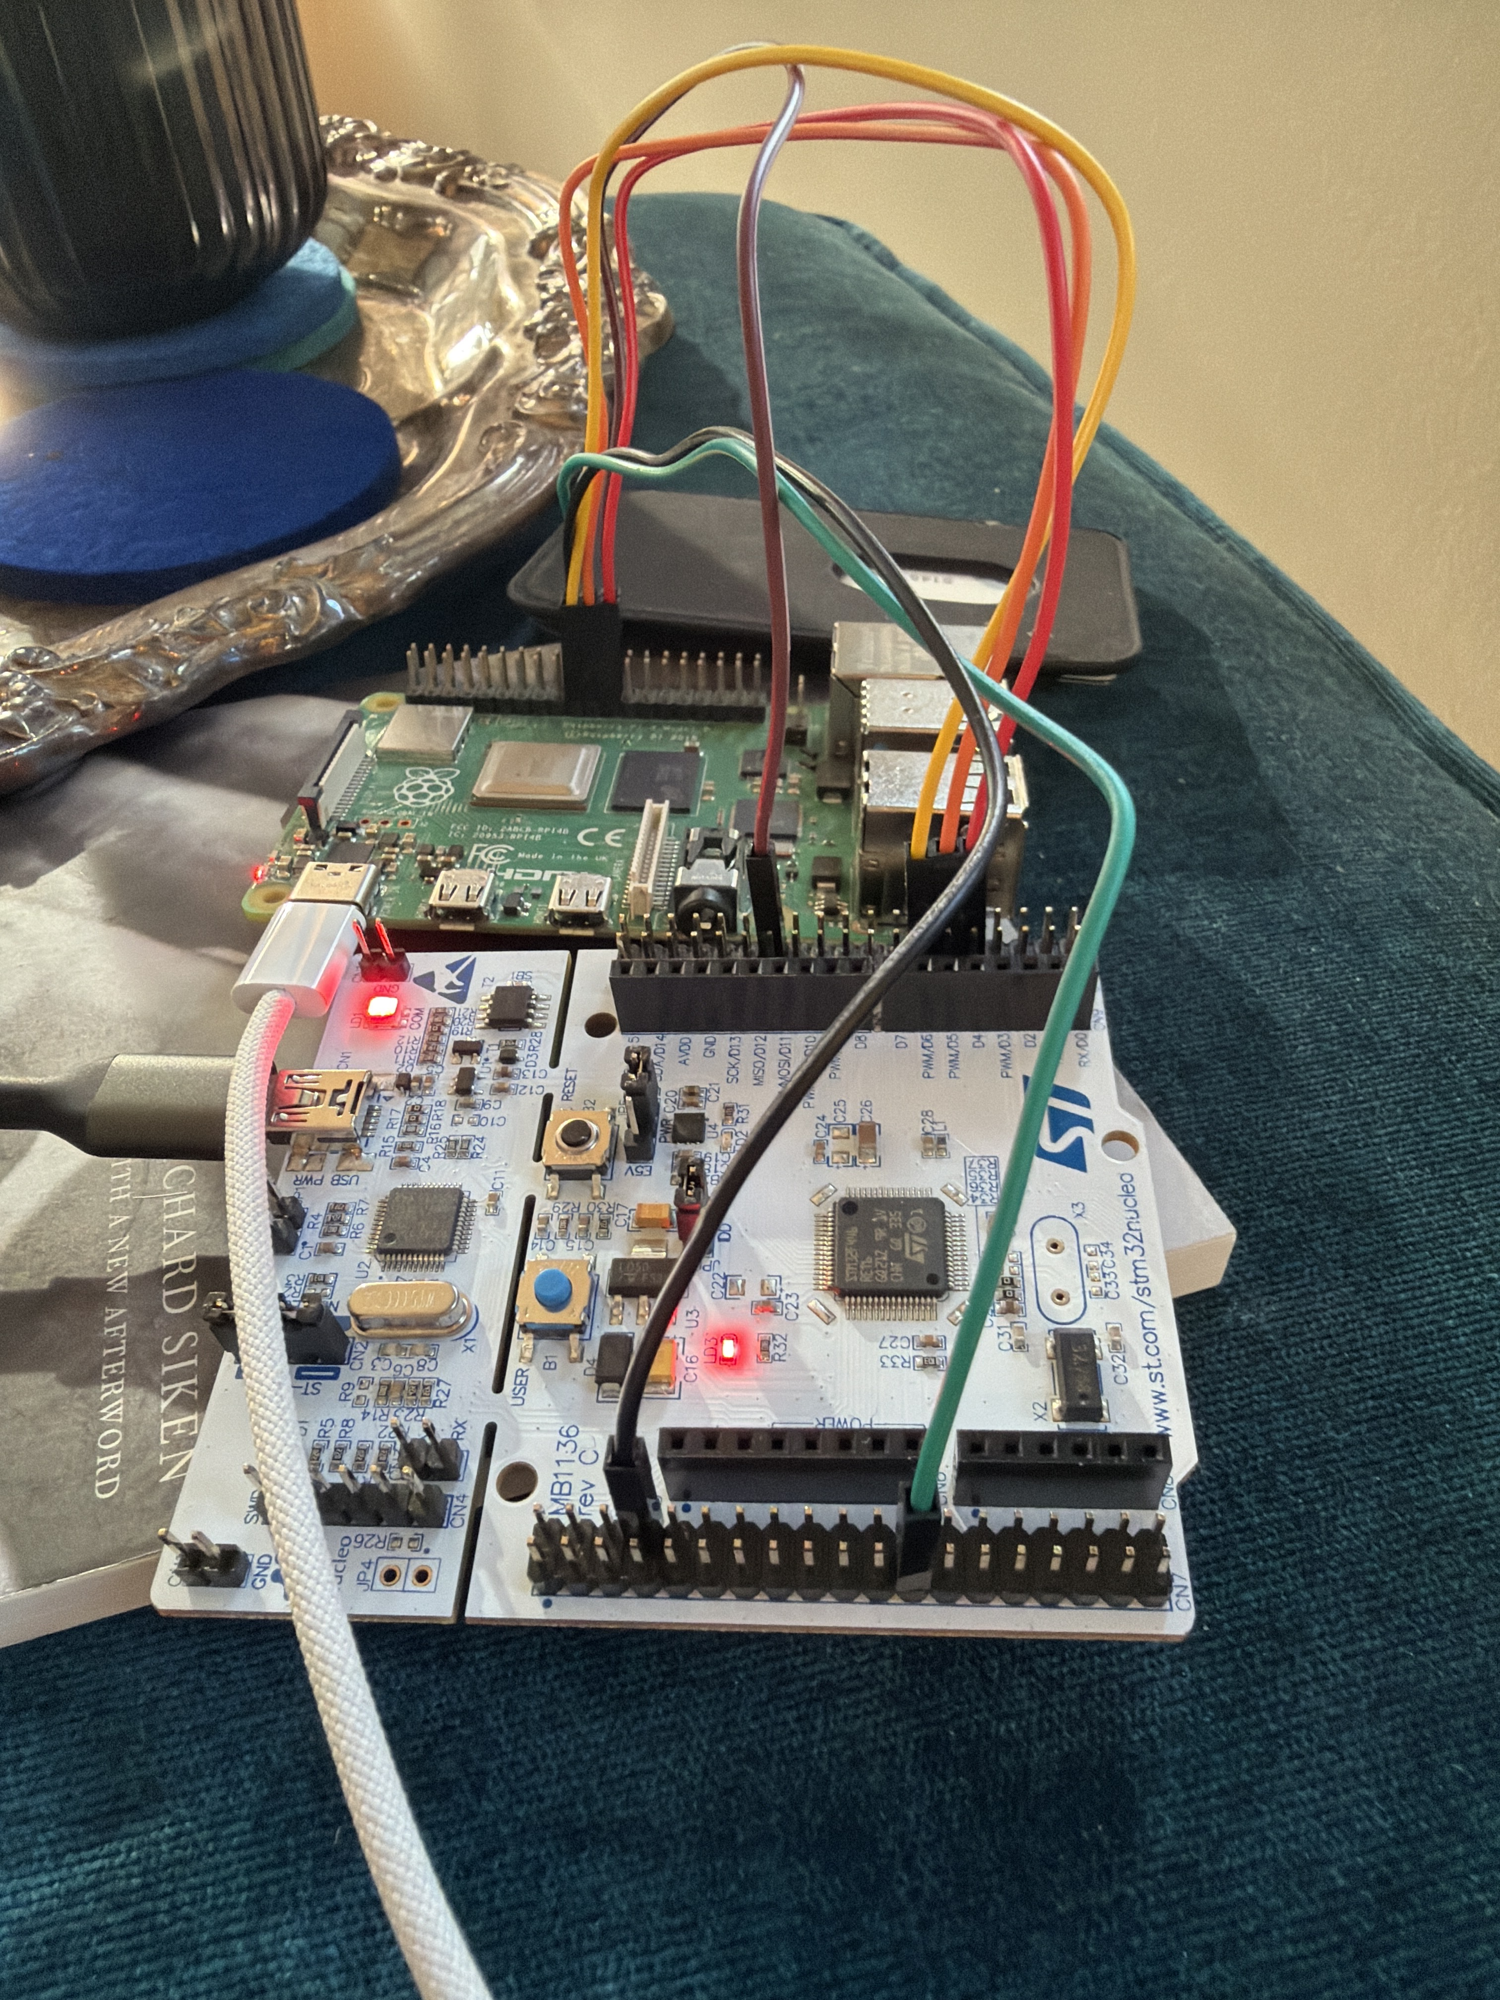
Full setup — Pi 4 stacked on Nucleo-F446RE with jumper wires

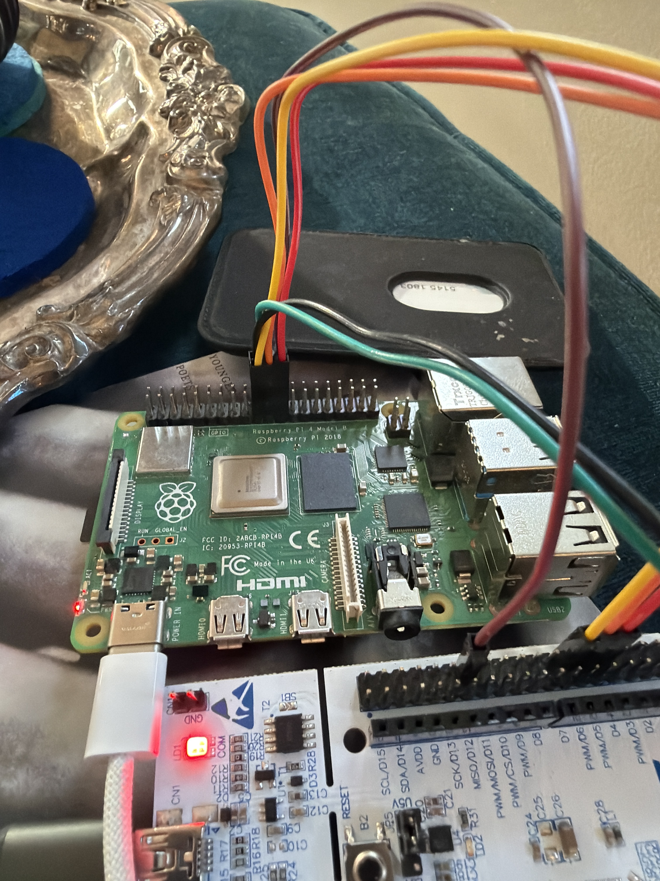
Pi 4 GPIO header — SPI0 pins with jumper wires

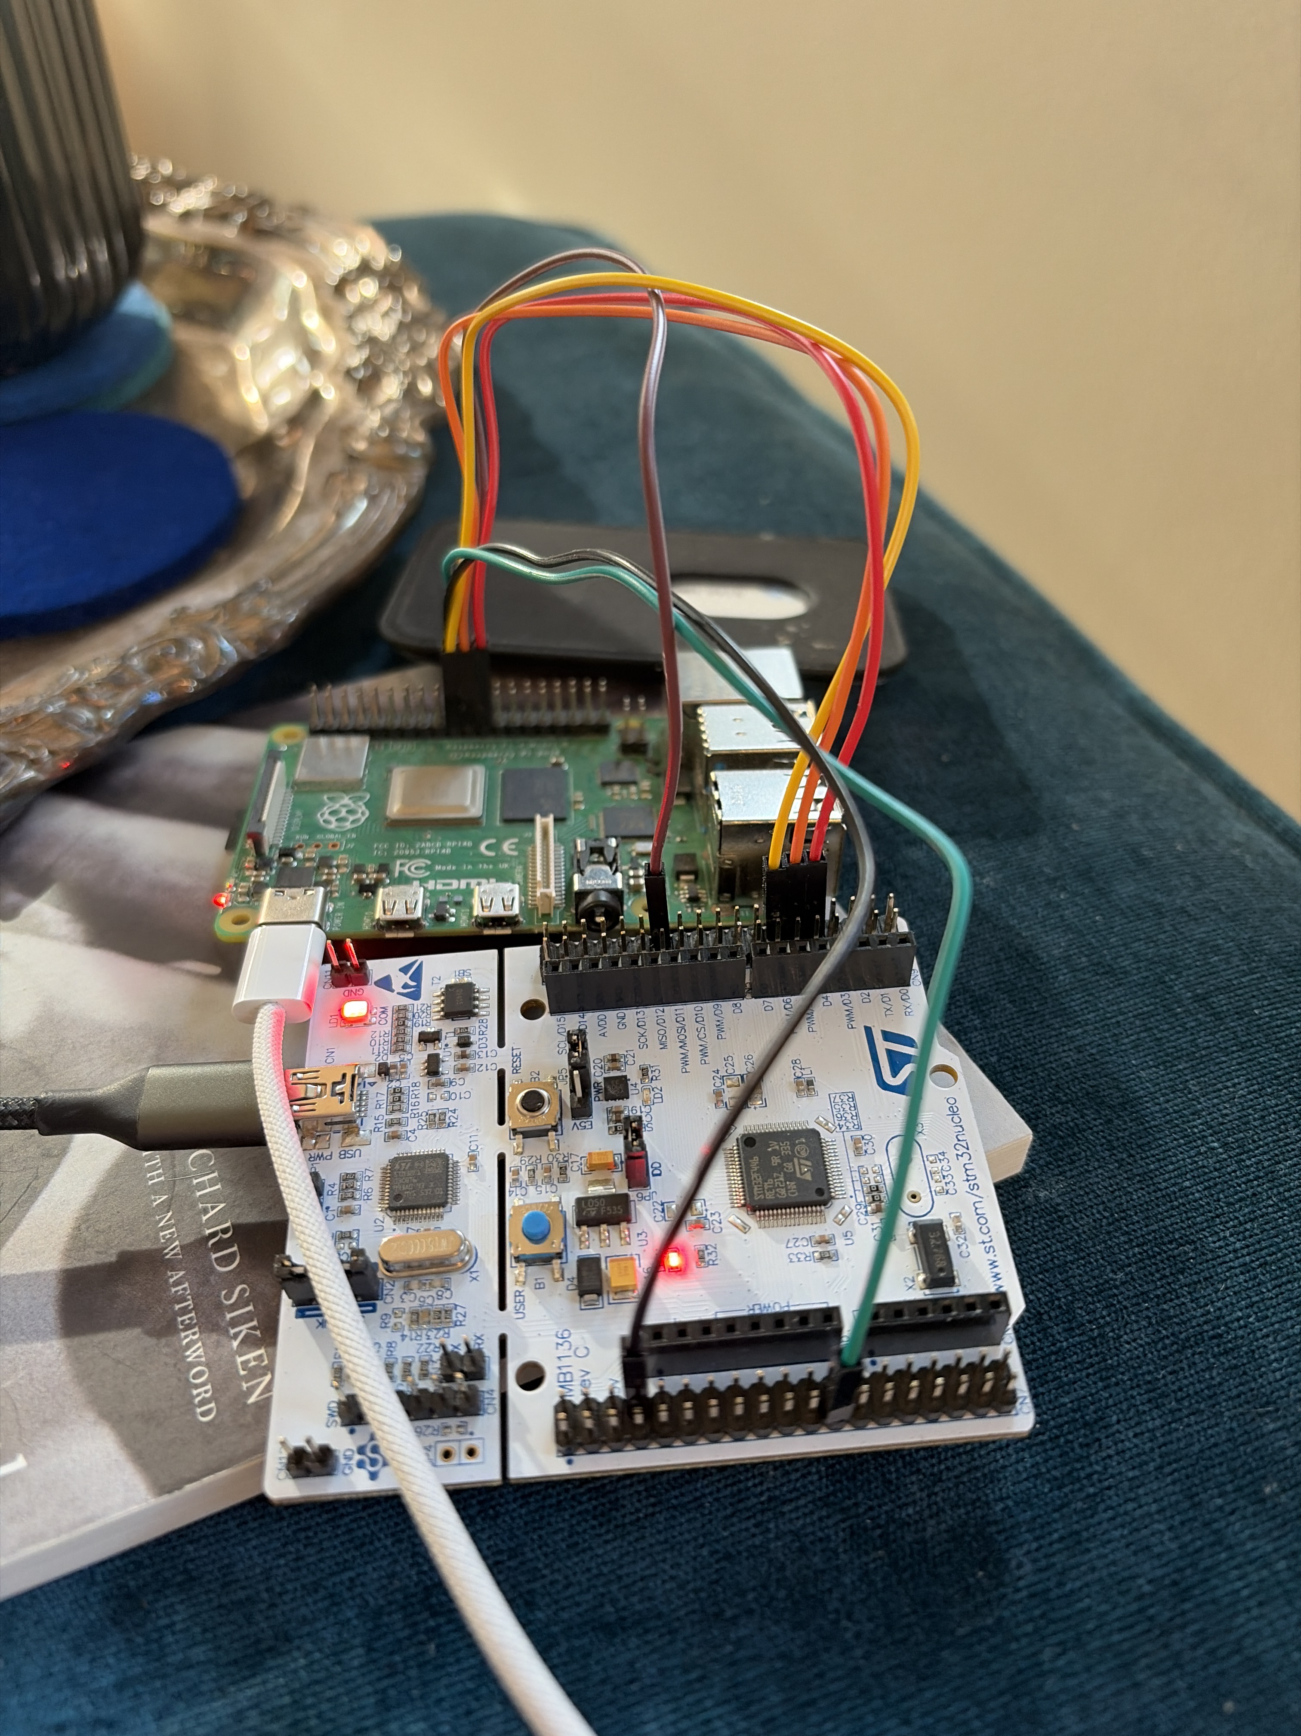
Nucleo CN10 connector — SPI2 pins

5. Opcode Table
Every Pi-initiated transaction begins with an opcode byte on MOSI. Every transaction is exactly 24 bytes. The STM always returns the current TelemetryFrame on MISO regardless of opcode.

Opcode | Hex | Direction | Description
CMD_NOP | 0x00 | Pi → STM | Idle / pad. STM ignores MOSI, returns latest telem frame on MISO.
TELEM_REQ | 0x06 | Pi → STM | Request telemetry. Pi sends 20 bytes (opcode + 23 pad), STM returns TelemetryFrame.
BLOCK_HDR | 0x03 | Pi → STM | Start of trajectory refill block. Followed by N DATA packets.
DATA | 0x04 | Pi → STM | Single trajectory sample: int32_t pos_cmd + int32_t vel_ff = 8 bytes payload.
READY_ACK | 0x05 | Pi → STM | Pi acknowledges PC13 READY signal. STM clears ready flag.

6. Telemetry Frame (MISO)
24-byte packed struct. No CRC — SPI is synchronous with short wires, corrupted samples are visible from obviously bad values, and the next 1ms poll provides a fresh frame automatically.

Byte | Field | Type | Size | Description
0–3 | pos_cmd | int32_t | 4 | Position command, encoder counts
4–7 | pos_fbk | int32_t | 4 | Position feedback from TIM5, encoder counts
8–9 | vel_cmd | int16_t | 2 | Velocity command, counts/sec
10–11 | vel_fbk | int16_t | 2 | dx/dt computed in velocity loop, counts/sec
12–15 | timestamp_ms | uint32_t | 4 | STM millisecond counter. Pi uses this to correct for Linux scheduler jitter on Bode plot frequency axis.
16 | drive_state | uint8_t | 1 | DriveStateMachine state enum
17 | fault_flags | uint8_t | 1 | Fault bitmask
18–23 | _pad | uint8_t[6] | 6 | Reserved, always 0x00. Pads frame to 24 bytes.

NOTE: All multi-byte fields are little-endian — STM32 and Pi 4 are both little-endian, no byte swapping required.
NOTE: timestamp_ms is critical for Bode plot accuracy. Pi scheduling jitter means polls are not evenly spaced. Use STM timestamp as the frequency axis, not wall clock.

7. Drive States
Value | State | Description
0x00 | DRIVE_IDLE | Powered, PWM disabled, waiting for enable
0x01 | DRIVE_ALIGN | Executing rotor alignment pulse
0x02 | DRIVE_ENABLED | FOC active, following trajectory setpoints
0x03 | DRIVE_FAULT | Fault latched, PWM disabled. fault_flags valid.
0x04 | DRIVE_ESTOP | E-stop commanded, controlled decel to zero

8. Fault Flags
Bit | Name | Description
0 | FAULT_OCP | DRV8353RS overcurrent protection tripped
1 | FAULT_OVP | Overvoltage protection
2 | FAULT_UVP | Undervoltage protection
3 | FAULT_OVERTEMP | Motor thermistor over temperature
4 | FAULT_ENC | Encoder loss or TIM5 error
5 | FAULT_ALIGN | Startup rotor alignment failed
6 | FAULT_CRC | SPI2 receive CRC error on command path
7 | FAULT_DRV | DRV8353RS nFAULT pin asserted

9. Pi-Side Poll Loop
// 1ms timer callback
void telem_poll() {
uint8_t tx[24] = {0x06, 0}; // TELEM_REQ + 23 pad bytes
uint8_t rx[24];
spi_transfer(tx, rx, 24); // atomic, Pi drives clock

TelemetryFrame *f = (TelemetryFrame*)rx;
if (f->timestamp_ms == last_ts) return; // duplicate
last_ts = f->timestamp_ms;
log_sample(f);
check_faults(f->fault_flags);
}

10. Validation Results
Round-trip test performed 2026-05-09 with STM hardcoding known values in telem_buf[1]:
telem_buf[1].pos_cmd = 0x12345678
telem_buf[1].pos_fbk = 0x87654321
telem_buf[1].timestamp_ms = 0xDEADBEEF
telem_buf[1].drive_state = DRIVE_IDLE

Pi received all 10 consecutive frames correctly:
pos_cmd: 0x12345678 pos_fbk: 0x87654321 ts: 3735928559 state: 0
pos_cmd: 0x12345678 pos_fbk: 0x87654321 ts: 3735928559 state: 0
... (10/10 frames correct)

11. Reserved Opcodes
Opcode | Planned Use
0x07 | FAULT_CLR — clear latched fault flags, transition DRIVE_FAULT → DRIVE_IDLE
0x08 | ESTOP — immediate controlled decel, transition to DRIVE_ESTOP
0x09 | TELEM_CURRENT — alternate telem frame returning Iq/Id for current loop debug
0x0A | DRIVE_ENABLE / DRIVE_DISABLE — explicit enable/disable from Pi

