Executive summary
This report analyses Australia’s renewable electricity transition from 2005 to 2024, compares Australia with China, Germany, and New Zealand, and forecasts Australia’s renewable electricity progress to 2035. The analysis was completed in Power BI using annual electricity generation data from Bundesnetzagentur (2025), DCCEEW (2025), MBIE (2025), and OWID (2026). DAX measures were used to calculate renewable share, renewable generation, source mix, and non-renewable generation. An R-based linear regression model was also used to forecast Australia’s renewable generation and renewable share.
The most important finding is that Australia has made clear progress, but the current trend is still not fast enough to reach the 82% renewable electricity goal by 2030 (DCCEEW, 2026). Australia’s renewable electricity share increased from about 9% in 2005 to 35% in 2024 (DCCEEW, 2025). However, the renewable share forecast suggests that Australia may only reach about 44.6% by 2035 if the historical linear trend continues. This means stronger action is needed if Australia wants to close the gap to the national target.
The report also found that Australia’s renewable mix has changed a lot. In 2005, hydro was the main renewable source, but by 2024, solar and wind became the main drivers of renewable growth. Solar increased from about 0.1 TWh to 48.6 TWh, while wind increased from about 0.9 TWh to 31.0 TWh (DCCEEW, 2025). This change is important because solar and wind need stronger grid capacity, storage, transmission, and investment planning.
The international comparison shows that Australia’s performance depends on which measure is used. China generated much more renewable electricity in total volume (OWID, 2026), but Australia slightly performed better than China in renewable share in 2024. New Zealand and Germany still had much higher renewable shares (Bundesnetzagentur, 2025; MBIE, 2025), showing that Australia has improved but still has room to grow. Germany is also a useful example because it shows how long-term policy support and investment can help increase renewable electricity share (Agora Energiewende, 2024)
In conclusion, Australia is moving in the right direction, but the current rate of growth remains insufficient to support the 82% renewable electricity goal in 2030 (DCCEEW, 2026), Australia will likely need stronger policy support, faster renewable investment, expanded grid capacity, and more storage infrastructure. Future analysis should also use scenario-based forecasting or multiple linear regression because renewable growth is not only affected by time. Other factors, such as policy, technology costs, investment, storage, grid capacity, and electricity demand, should also be included to make the forecast more realistic.

Executive summary 2
1. Introduction 4
2. Report Findings 5
2.1 Australia’s Renewable Electricity Share Since 2005 5
2.2 Changes in Australia’s Renewable Source Mix 6
2.3 International Comparison of Renewable Electricity Performance 8
2.4 Forecast of Australia’s Renewable Electricity Progress to 2035 10
3. Conclusion 12
Appendix A - Data Sources and Metadata 14
A1 - Primary Data Sources 14
Appendix B - Data Cleaning and Transformation Decisions 15
Appendix C - Power BI Data Model 16
C1 - Table Structure 17
C2 – Relationships 17
Appendix D - Key DAX Measures 18
Appendix E - R Forecasting Code 19
E1 - Renewable Generation Forecast (TWh) 19
E2 - Renewable Share Forecast (%) 24
Appendix F - Data Decisions Log 31
4. Reference list 33

Introduction
Australia’s electricity sector is transforming as renewable energy becomes a larger part of how the country generates electricity. The Department of Climate Change, Energy, the Environment and Water (DCCEEW, 2026) states that Australia has the resources and capability to reach 82% renewable electricity by 2030, making it important to understand whether current progress is on track. However, Australia’s renewable electricity share was only around 35% in 2024, which shows that the country still has a large gap to close before reaching the 2030 target. Therefore, this report analyses Australia’s renewable electricity transition from 2005 to 2024, assesses whether current progress is moving toward the 82% renewable electricity goal by 2030, and forecasts renewable generation to 2035.
Renewable electricity share is useful because it shows how much of Australia’s electricity comes from renewable sources compared with total electricity generation. This is different from only looking at renewable generation volume because a country may produce more renewable electricity but still depend heavily on non-renewable electricity if total electricity demand also grows. Therefore, renewable share gives a clearer picture of whether renewables are becoming a bigger part of the electricity system. The analysis also focus on renewable generation by source because Australia’s transition depends on which technologies are growing, not only on the total amount of renewable electricity produced. This helps show better future planning needs, such as grid capacity, storage, and investment.
The analysis was completed in Power BI using annual electricity generation data for Australia, China, Germany, and New Zealand from 2005 to 2024. Australia was the main focus country for this analysis, while China, Germany, and New Zealand were included to provide international comparison. China was included because its electricity system is much larger than Australia’s, generating more than 9,000 TWh of electricity in recent years (U.S. Energy Information Administration, 2025). Germany was chosen because it has strong renewable energy policy experience through the Energiewende, with renewables making up 59% of its electricity generation in 2024 (Bundesnetzagentur, 2025). Finally, New Zealand was included because it already has a very high renewable electricity share, with renewables making up 85.5% of its electricity generation in 2024 (MBIE, 2025). The datasets were cleaned and standardised before being imported into Power BI because some countries used different renewable source categories. After cleaning, renewable sources were grouped into solar, wind, hydro, biomass, and geothermal, while DAX measures were used to calculate renewable share, source mix percentage, generation totals, and non-renewable generation. An R-based linear regression visual was then used to forecast Australia’s renewable generation to 2035.
This report presents the main findings in four sections. Section 2.1 explains how Australia’s renewable electricity share has changed since 2005 and shows whether renewables are becoming a larger part of the national electricity system. Section 2.2 analyses how Australia’s renewable source mix has changed, especially the growth of solar and wind, to show which technologies are driving the transition. In Section 2.3, Australia is compared with China, Germany, and New Zealand using renewable generation volume and renewable share. This shows Australia’s position in terms of both total renewable generation and reliance on renewable electricity. In Section 2.4, Australia’s renewable generation is forecast through to 2035. This section also explains the uncertainty and ethical responsibility involved in presenting forecast results because future renewable growth can change depending on policy, investment, grid capacity, and technology costs. The report finishes with a conclusion that summarises the key findings and limitations. The appendices then provide supporting details, including the data model, ETL process, DAX measures, and data decisions log.

Report Findings

2.1 Australia’s Renewable Electricity Share Since 2005
It is important to understand how Australia’s renewable electricity share has changed since 2005 because it shows whether renewables are becoming a bigger part of the national electricity system. This is also important for government planning because Australia has a goal to reach 82% renewable electricity by 2030 (DCCEEW, 2026). However, the data shows that Australia’s renewable electricity share increased from about 9% in 2005 to around 35% in 2024 (DCCEEW, 2025). Therefore, this section helps assess whether Australia is moving in the right direction and how large the remaining gap is.
Data was sourced from DCCEEW Australian Energy Statistics Table O (DCCEEW, 2025), which covers financial years from 2004–05 to 2023–24. To match the dashboard timeline, each financial year was treated as the ending calendar year, so 2023–24 was treated as 2024. Renewable share was calculated in Power BI by dividing renewable electricity generation by total electricity generation using a DAX measure. This was done in Power BI instead of Excel so the calculation could stay dynamic and work properly with the data model. A line chart was used because this section focuses on change over time, and the chart clearly shows how Australia’s renewable electricity share changed from 2005 to 2024.
Figure 1
Australia’s Renewable Electricity Share, 2005–2024
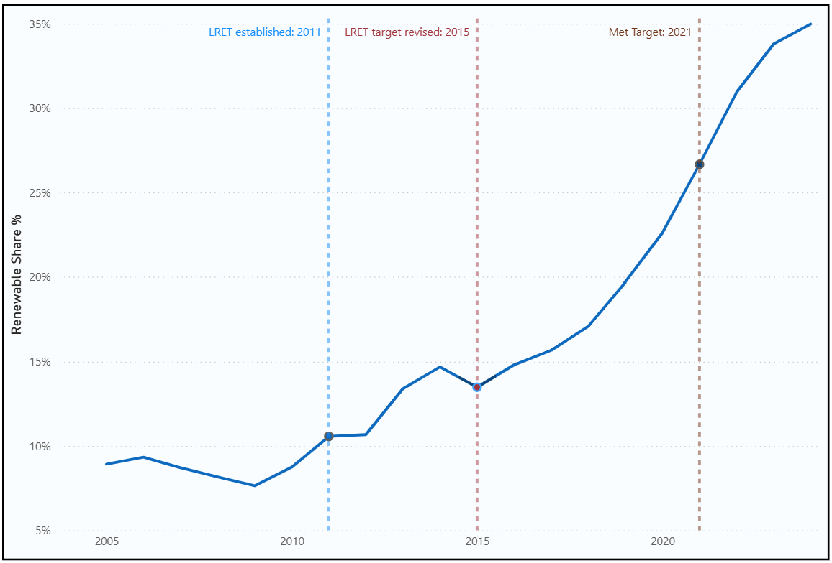
Note. From Power BI dashboard based on DCCEEW Australian Energy Statistics, Table O
Figure 1 shows that Australia’s renewable electricity share increased from about 9% in 2005 to around 35% in 2024 (DCCEEW, 2025). Yet, the increase did not happen at the same speed across the whole period. Renewable share grew slowly in the early years, and even after the Renewable Energy Target was split into the LRET and SRES in 2011, the chart does not show a rapid increase straight away (Clean Energy Regulator, 2026). This may be because large renewable projects take time to plan, finance, approve, build, and connect to the electricity grid. In addition, policy uncertainty during the early 2010s may have made investors more cautious because they were unsure whether the renewable target would stay the same or be changed. The stronger increase appears after the 2015 LRET target revision, when the target was set at 33,000 GWh of additional renewable electricity by 2020 (Clean Energy Regulator, 2026). This revision helped provide clearer policy direction for large-scale renewable investment. By September 2019, enough renewable capacity had been approved to guarantee that the 33,000 GWh target would be met in 2020, and the target was met in January 2021 (Clean Energy Regulator, 2026). However, this increase cannot be explained by policy alone. Falling solar and wind technology costs, private investment, state-level policies, and grid development also likely contributed to the growth.
Overall, Australia’s renewable electricity share has increased strongly since 2005, from about 9% to around 35%. This shows that Australia is moving in the right direction and renewables are becoming a larger part of the electricity system. However, the 2024 share is still well below the 82% renewable electricity goal for 2030 (DCCEEW, 2026). Therefore, Australia has made clear progress, but it still needs faster renewable growth to close the remaining gap by 2030. This will likely require continued policy support, more investment in renewable projects, and better grid and storage infrastructure.

2.2 Changes in Australia’s Renewable Source Mix
Australia’s renewable transition is not only about producing more renewable electricity. It is also about understanding which energy sources are growing the most. This matters because each renewable source has different infrastructure needs. It also helps show whether Australia’s renewable growth is mainly coming from older sources such as hydro, or newer sources such as solar and wind. For government planning, this is useful because different renewable technologies need different levels of grid capacity, storage, investment, and infrastructure.
Data for this section was taken from DCCEEW Australian Energy Statistics Table O (DCCEEW, 2025). Renewable generation was grouped into five main sources: solar, wind, hydro, biomass, and geothermal. The original data was recorded in gigawatt-hours (GWh), but the dashboard converted values into terawatt-hours (TWh) to make large national generation numbers easier to read. One TWh equals 1,000 GWh. Some categories were cleaned before the data was imported into Power BI because the source categories were not always the same. For example, Australia separated solar into small-scale PV and large-scale PV, so a Source Category dimension was created to combine both into one Solar category. This made the comparison clearer and more consistent. A clustered column chart was used because it clearly compares 2005 and 2024 and shows which renewable sources increased the most.
Figure 2
Australia's Renewable Electricity Source Mix, 2005 and 2024
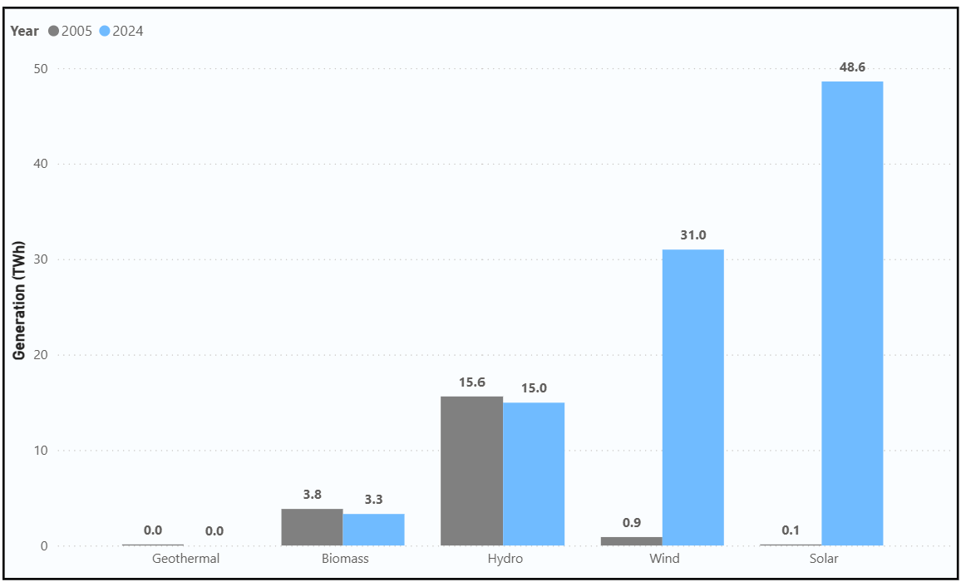
Note. From Power BI dashboard based on DCCEEW Australian Energy Statistics Table O (DCCEEW, 2025).
Figure 2 illustrates that Australia’s renewable electricity source mix changed strongly between 2005 and 2024. In 2005, hydro was the main renewable source, while solar and wind were still very small. Solar generated only about 0.1 TWh in 2005, and wind generated about 0.9 TWh. By 2024, solar had increased to about 48.6 TWh, while wind increased to about 31.0 TWh (DCCEEW, 2025). Hydro stayed almost the same, changing from about 15.6 TWh in 2005 to about 15.0 TWh in 2024, while biomass decreased slightly from 3.8 TWh to 3.3 TWh (DCCEEW, 2025). Hydro did not increase much because future hydro growth in Australia is limited by water availability, suitable dam locations, and competition for scarce water resources. Geoscience Australia explains that future hydro growth is likely to come mainly from small-scale hydro projects and upgrades to existing hydro plants, rather than large new hydro developments (Geoscience Australia, 2026). Geothermal remained almost zero in the chart because Australia has not developed utility-scale geothermal electricity in the same way as solar and wind. This is partly because geothermal projects need suitable underground heat, expensive drilling, and locations close enough to electricity markets. In Australia, many geothermal resources are difficult or costly to develop, so geothermal has stayed very small compared with solar, wind, and hydro (Clean Energy Council, 2023). This reflects that Australia’s renewable growth mainly came from solar and wind, not from hydro, biomass, or geothermal.
Table 1
Global Renewable Technology Cost Reduction, 2010–2024
Technology | 2010 LCOE (USD/kWh) | 2024 LCOE (USD/kWh) | Approximate reduction
Utility-scale solar PV | 0.460 | 0.043 | 90%
Onshore wind | 0.111 | 0.034 | 70%
Note. Data from IRENA (2025)
This change can be explained by policy support, technology development, and Australia’s natural conditions. The LRET supported large-scale renewable projects, while the SRES supported small-scale systems such as rooftop solar (Clean Energy Regulator, 2026). Solar and wind also became more attractive because their costs dropped a lot over time. As shown in Table 1, the global cost of utility-scale solar PV fell by around 90% between 2010 and 2024, while onshore wind costs fell by around 70% (IRENA, 2025). Australia’s geography also supports solar and wind because the country has strong sunlight, consistent wind in many areas, and large land resources for renewable projects (DCCEEW, 2026). These factors help explain why solar and wind expanded faster than hydro, biomass, and geothermal.

2.3 International Comparison of Renewable Electricity Performance
This section uses both renewable generation volume and renewable share because each measure shows a different part of the comparison. Renewable generation volume shows the size of renewable electricity production, while renewable share shows how much each country relies on renewables within its own electricity system. This is important because a large country such as China can produce much more renewable electricity than Australia, but still have a similar or lower renewable share because its total electricity demand is much larger.
Data for this section was taken from annual electricity generation data for Australia, China, Germany, and New Zealand from 2005 to 2024 (Bundesnetzagentur, 2025; DCCEEW, 2025; MBIE, 2025; OWID, 2026) Two horizontal bar charts were used to compare countries in 2024. Horizontal bar charts were selected because they make it easier to compare several countries at one point in time. The horizontal layout also makes the country names clearer and easier to read than vertical bar charts. The first chart compares renewable generation volume, while the second chart compares renewable share.
Figure 3
Renewable Electricity Generation by Country, 2024
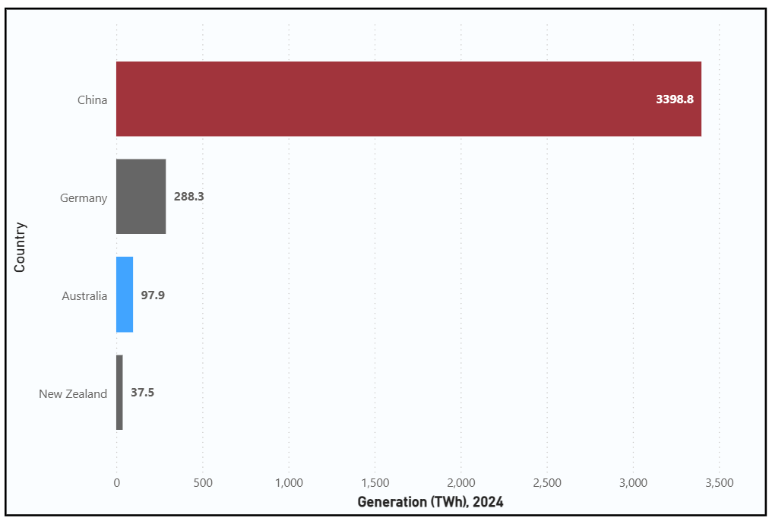
Note. From Power BI dashboard based on annual electricity generation data (Bundesnetzagentur, 2025; DCCEEW, 2025; MBIE, 2025; OWID, 2026).
Figure 3 illustrates that China generated the most renewable electricity in 2024, with about 3,398.8 TWh. This was much higher than Germany at 288.3 TWh, Australia at 97.9 TWh, and New Zealand at 37.5 TWh (Bundesnetzagentur, 2025; DCCEEW, 2025; MBIE, 2025; OWID, 2026). If only renewable generation volume is considered, China looks like the strongest performer and that will be misleading. This is mainly because China has one of the world’s largest electricity systems with a lot more population compared to other countries. U.S. Energy Information Administration (2025) reported that China generated about 9,300 TWh of electricity in 2023, showing the much larger scale of China’s electricity system compared with Australia . This means generation volume alone does not fully explain how much a country depends on renewable electricity.

Figure 4
Renewable Electricity Share by Country, 2024
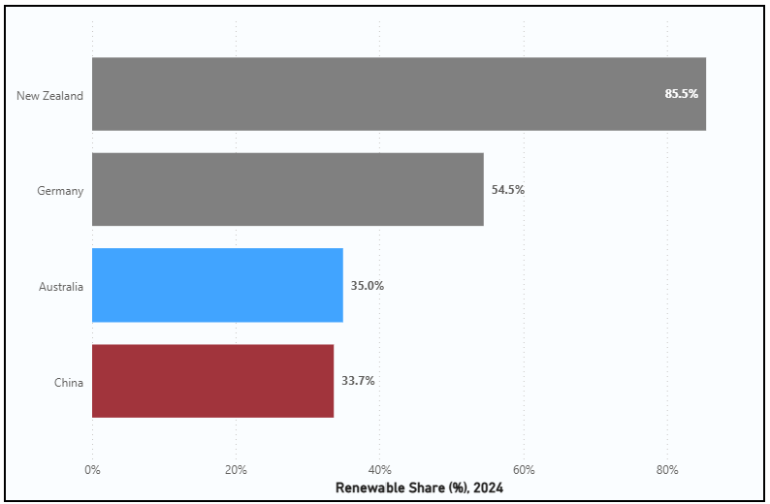
Note. From Power BI dashboard based on annual electricity generation data (Bundesnetzagentur, 2025; DCCEEW, 2025; MBIE, 2025; OWID, 2026).
Figure 4 provides a different view by comparing renewable electricity share. New Zealand had the highest renewable share in 2024 at 85.5%, followed by Germany at 54.5%. Australia reached 35.0%, which was slightly higher than China at 33.7% (Bundesnetzagentur, 2025; DCCEEW, 2025; MBIE, 2025; OWID, 2026). This indicates that China produced far more renewable electricity in total, but renewables made up a slightly smaller part of China’s electricity system compared with Australia. New Zealand’s high share is linked to its natural advantages because hydro generation is a major part of its electricity system, and geothermal energy is also important due to New Zealand’s location on the boundary between two tectonic plates (MBIE, 2018). This is why renewable share is important because it explains renewable reliance, not only production size.
Figure 5
Renewable Electricity Share Trend by Country, 2005–2024
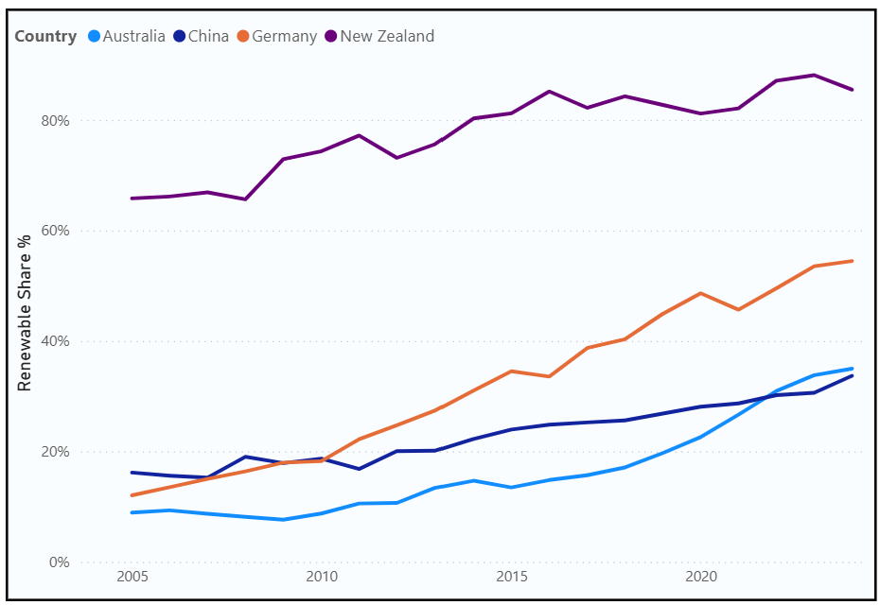
Note. Created from annual electricity generation data used in the Power BI dashboard (Bundesnetzagentur, 2025; DCCEEW, 2025; MBIE, 2025; OWID, 2026).
Figure 5 indicates that China had a higher renewable share than Australia for most of the study period. China started at around 16% in 2005 and increased to 33.7% in 2024, while Australia started lower at about 9% in 2005 but increased to 35.0% by 2024 (DCCEEW, 2025; OWID, 2026). This means Australia improved faster than China over the study period, especially after the mid-2010s. Germany also showed strong progress and reached 54.5% in 2024. Germany is useful for comparison because its renewable growth has been supported by long-term renewable energy policy, including the Energiewende and Renewable Energy Sources Act and this suggests that consistent policy support and investment can help increase renewable electricity share (Agora Energiewende, 2024)

2.4 Forecast of Australia’s Renewable Electricity Progress to 2035
Forecasting Australia’s renewable electricity progress is important because the government needs to understand whether the current trend is strong enough to support the 82% renewable electricity goal by 2030. Forecasting does not give a guaranteed future result, but it helps show the likely direction if the historical trend continues. Understanding this trend early can help the government plan better and identify whether more policy support, investment, grid capacity, or storage infrastructure may be needed.
Data for this section was taken from Australia’s annual renewable electricity data from 2005 to 2024 (DCCEEW, 2025). Two R-based linear regression visuals were created in Power BI. R was used instead of Power BI’s built-in forecast because it made the method more transparent by showing the regression equation, R² value, p-value, and 95% prediction interval directly on the chart. Linear regression was selected because it is simple, transparent, and easy to interpret for a non-technical government audience. It also provides a clear way to estimate the future direction of Australia’s renewable electricity trend using historical data. The first forecast uses renewable generation in TWh, while the second forecast uses renewable electricity share as a percentage. The share forecast was calculated using the Renewable Share % measure, which divides renewable generation by total electricity generation. A 95% prediction interval was included to show uncertainty in the forecast.
Figure 6
Australia's Renewable Electricity Generation Forecast to 2035
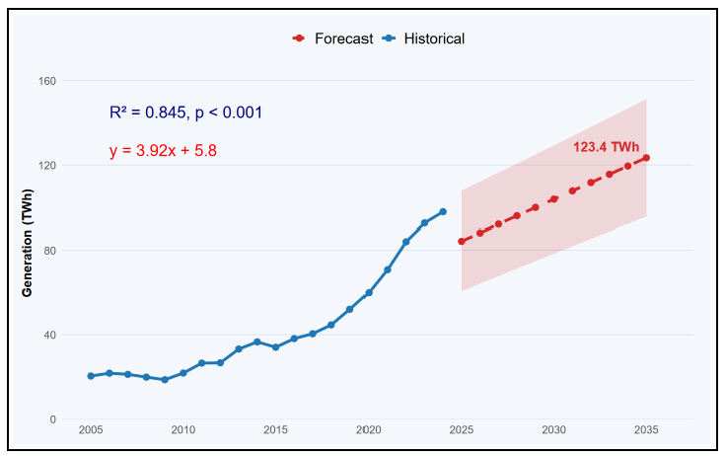

Note. Created using an R-based linear regression visual in Power BI based on DCCEEW Australian Energy Statistics Table O (DCCEEW, 2025).
Figure 6 forecasts Australia’s renewable electricity generation in TWh. The model has a strong fit, with an R² value of 0.845 and p < 0.001. This means the historical trend explains a large part of the change in renewable generation over time. Based on this model, Australia’s renewable generation is forecast to reach about 123.4 TWh by 2035. This suggests that renewable generation is expected to continue increasing if the historical trend continues.
Figure 7
Australia's Renewable Electricity Share Forecast to 2035
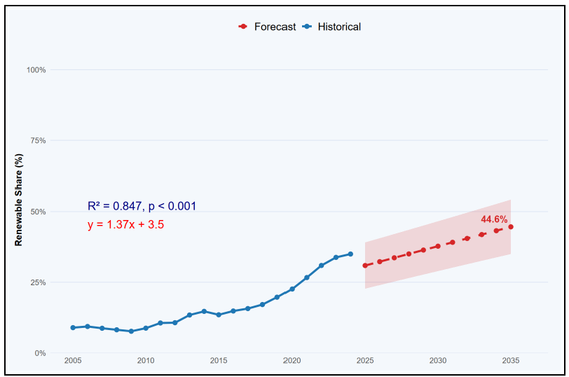
Note. Created using an R-based linear regression visual in Power BI based on DCCEEW Australian Energy Statistics Table O (DCCEEW, 2025).
Figure 7 gives a more direct view of progress toward the 82% renewable electricity goal because it forecasts renewable electricity share. The 82% target is a 2030 policy goal, while this model extends the forecast to 2035 to show the longer-term direction of the trend. The model has a strong fit, with an R² value of 0.847 and p < 0.001. Based on the linear trend, Australia’s renewable electricity share is forecast to reach about 44.6% by 2035. This is higher than the 2024 level of about 35%, but it is still far below the 82% target even five years after the target year. This means that, based on the historical linear trend alone, Australia is not on track to reach 82% renewable electricity by 2030.
The forecast should be interpreted carefully because it is based on a simple linear regression. Renewable electricity growth may not continue in a straight line. The model uses data from 2005 to 2024 to give a longer historical pattern, but this also means the slower growth period before 2015 is included in the trend. This may make the forecast more conservative because Australia’s renewable growth increased faster after the mid-2010s. However, using only 2015 to 2024 would give too few data points for a reliable long-term forecast and could make the result too sensitive to recent changes. Therefore, the forecast may contain some bias depending on the period selected. Growth could increase faster if there is stronger policy support, more investment, faster grid upgrades, more storage, and lower technology costs. For example, the Australian Government’s Capacity Investment Scheme aims to accelerate investment in renewable energy generation such as wind and solar, and clean dispatchable capacity such as battery storage (DCCEEW, 2026). Growth could also slow down if there are delays in transmission projects, approval issues, supply chain problems, or weaker investment conditions. For this reason, the forecast is best used as a planning signal, not as a certain prediction.
There is also an ethical responsibility when presenting this forecast to a government client. The analyst must make clear that the prediction is not 100% correct and should not be treated as a guaranteed result. Forecasting guidance highlights the importance of communicating uncertainty through prediction intervals rather than relying only on a single point estimate. The 95% prediction interval is important because it shows that the future result could be higher or lower than the central forecast. A government client could make poor decisions if the uncertainty range was removed or if the forecast was presented as definite. Therefore, the forecast should be communicated honestly, with a clear explanation of its assumptions, limitations, and uncertainty.
Therefore, the forecast shows that Australia’s renewable electricity generation and renewable share are both expected to increase. However, the renewable share forecast of about 44.6% by 2035 suggests that the current historical trend is not fast enough to reach the 82% renewable electricity goal by 2030. To close this gap, Australia will likely need stronger policy support, faster renewable investment, grid expansion, and storage development.

Conclusion
This report analysed Australia’s renewable electricity transition from 2005 to 2024 and assessed whether current progress is strong enough to support the 82% renewable electricity goal by 2030 (DCCEEW, 2026). The analysis was completed in Power BI using annual electricity generation data for Australia, China, Germany, and New Zealand (Bundesnetzagentur, 2025; DCCEEW, 2025; MBIE, 2025; OWID, 2026). DAX measures were used to calculate renewable share, renewable generation, source mix, and non-renewable generation. An R-based linear regression model was also used to forecast Australia’s renewable generation and renewable share to 2035, with a prediction interval included to show uncertainty.
The most important finding is that Australia has made clear progress, but the current trend is still not fast enough to reach the 82% target by 2030. Australia’s renewable electricity share increased from about 9% in 2005 to around 35% in 2024 (DCCEEW, 2025). This shows that renewables are becoming a larger part of the electricity system, but the remaining gap is still large. The renewable share forecast also supports this concern because it only reaches about 44.6% by 2035. This means Australia will need much faster renewable growth than the historical trend if it wants to meet the national target.
The second key finding is that Australia’s renewable transition is now mainly driven by solar and wind. In 2005, hydro was the main renewable source, but by 2024, solar and wind had become the main drivers of renewable growth. Solar increased to about 48.6 TWh and wind increased to about 31.0 TWh, while hydro stayed almost stable (DCCEEW, 2025). This matters for government planning because solar and wind create different system needs, especially for grid capacity, storage, transmission, and investment.
The international comparison also showed that Australia’s performance depends on which measure is used. China produced far more renewable electricity in total volume, but Australia slightly performed better than China in renewable share in 2024. New Zealand and Germany still had much higher renewable shares than Australia, which shows that Australia has improved but still has room to grow. Germany is a useful comparison because its progress shows how long-term policy support and investment can help increase renewable electricity share (Agora Energiewende, 2024)
There are some limitations in this analysis. The forecast is based on a simple linear regression, so it should not be treated as a guaranteed future result. The model uses annual data from 2005 to 2024, which gives a longer trend, but it also includes the slower growth period before the mid-2010s. This may make the forecast more conservative. Another limitation is that the Australian data was originally reported by financial year, but it was converted to calendar year using the end-year convention. For example, 2023-24 was treated as 2024. This may create a small timing difference when comparing Australia with countries that report by calendar year. Using only the recent high-growth period from 2015 to 2024 would give fewer data points and could make the forecast less reliable. Forecasting should communicate uncertainty clearly, so the prediction interval is important because it shows that the future result could be higher or lower than the central estimate.
To conclude, Australia is moving in the right direction, but not fast enough under the current historical trend. To close the gap to the 82% renewable electricity goal, Australia will likely need stronger policy support, faster renewable investment, expanded grid capacity, and more storage infrastructure. Future analysis should also use scenario-based forecasting or multiple linear regression because renewable growth is not only affected by time. Other factors such as policy support, technology costs, grid capacity, storage, electricity demand, and investment levels could also be included to produce a more detailed forecast.

Appendix A - Data Sources and Metadata
All data used in this report was sourced from official national government or intergovernmental publications. Generation values are stored in gigawatt-hours (GWh) in the dataset and converted to terawatt-hours (TWh) where appropriate for display purposes.

A1 - Primary Data Sources
Country | Source Organisation | Publication | Years | Accessed | Type | Notes
Australia | DCCEEW | Australian Energy Statistics, Table O: Electricity generation by fuel type 2023-24 and 2024 | 2005-2024 | May 2026 | Gross electricity generation (GWh) | Financial years converted to calendar years using end-year convention
New Zealand | MBIE | Electricity Statistics, December 2025 Quarter | 2005-2024 | May 2026 | Net electricity generation (GWh) | Annual GWh sheet used. Net generation differs from gross by approximately 1-2%
Germany | Umweltbundesamt / AGEE-Stat | Time Series for the Development of Renewable Energy Sources in Germany, February 2026 | 2005-2024 | May 2026 | Gross electricity generation (GWh) | Published as PDF - values extracted manually from official tables
China | Our World in Data (OWID) / IEA | Energy Dataset | 2005-2024 | May 2026 | Electricity generation (TWh converted to GWh) | Chinese official statistics not freely available in English - OWID used as authoritative intermediary sourcing from IEA

A2 - Data Composition and Sub-source Combinations
Country | Raw Sub-sources in Original File | Combined Into | Reason
Australia | Large-scale Solar PV, Small-scale Solar PV | Solar | To show total solar generation consistently across countries
Australia | Biomass (Bagasse/Wood), Biogas | Biomass | To match five-category structure used for other countries
Australia | Wind, Hydro, Geothermal | Unchanged | Already single category in source file
New Zealand | Wood, Biogas | Biomass | To match five-category structure
New Zealand | Hydro, Geothermal, Wind, Solar | Unchanged | Already single categories
Germany | Onshore Wind, Offshore Wind | Wind | To match single Wind category used for other countries
Germany | Solid biomass, biogas, biomethane, sewage gas, landfill gas, biogenic waste | Biomass (All) | To match five-category structure
Germany | Solar PV, Hydro, Geothermal | Unchanged | Already single categories
China | Wind, Solar, Hydro, Biomass | Unchanged | OWID already aggregated sub-sources
China | Geothermal | Set to zero | Negligible capacity - Yangbajain plant ceased 2020, not separately reported in OWID

Appendix B - Data Cleaning and Transformation Decisions
The following table documents all data cleaning and transformation decisions made during the ETL process. Each decision records the issue identified, the decision made, and the reason for that decision.
Issue | Decision Made | Reason
Australia reports by financial year (e.g. FY 2023-24) | Converted to calendar year using end-year convention - FY 2023-24 = 2024 | To align Australia with other countries that report by calendar year
Sub-source categories differ across countries | Grouped all countries into five consistent categories: Solar, Wind, Hydro, Biomass, Geothermal | To enable consistent and fair cross-country comparison
Australia separates large-scale and small-scale solar PV | Combined into one Solar category using Source_Group column in dim_EnergySource | To show total solar generation and enable comparison with other countries
Australia separates bagasse/wood waste and biogas | Combined into one Biomass category | To match five-category structure used for other countries
Germany reports onshore and offshore wind separately | Combined into one Wind category using Source_Group | To match single Wind category used for Australia, New Zealand and China
Germany has seven biomass sub-categories | Combined into Biomass (All) | To match five-category structure - individual sub-categories not meaningful for cross-country comparison
China geothermal reported as negligible or within other renewables | Set to zero for all years | Yangbajain plant ceased 2020 - capacity is negligible and OWID does not separately report it
All generation values originally in GWh | Stored in GWh in fact table - converted to TWh for display using DAX measure | Preserves raw data integrity while making large national figures readable
China data in OWID published in TWh | Multiplied by 1,000 to convert to GWh before loading into fact table | Ensures consistent units across all countries in the fact table
New Zealand reports net generation - Australia and Germany report gross | Acknowledged as limitation - difference is typically less than 2% | Does not materially affect comparisons at annual aggregation level but noted for transparency
Policy_Year in dim_Country could be summed by Power BI | Changed data type to Text in Power Query | Prevents Power BI from treating Policy_Year as a numeric measure
Net_Zero_Target year in dim_Country could be summed | Changed data type to Text in Power Query | Prevents accidental summation of target years

Appendix C - Power BI Data Model
Figure A1 below shows the Power BI data model used in this project. The model follows a galaxy schema with two fact tables connected to three shared dimension tables.
Figure A1
Power BI Data Model Used for Renewable Electricity Analysis
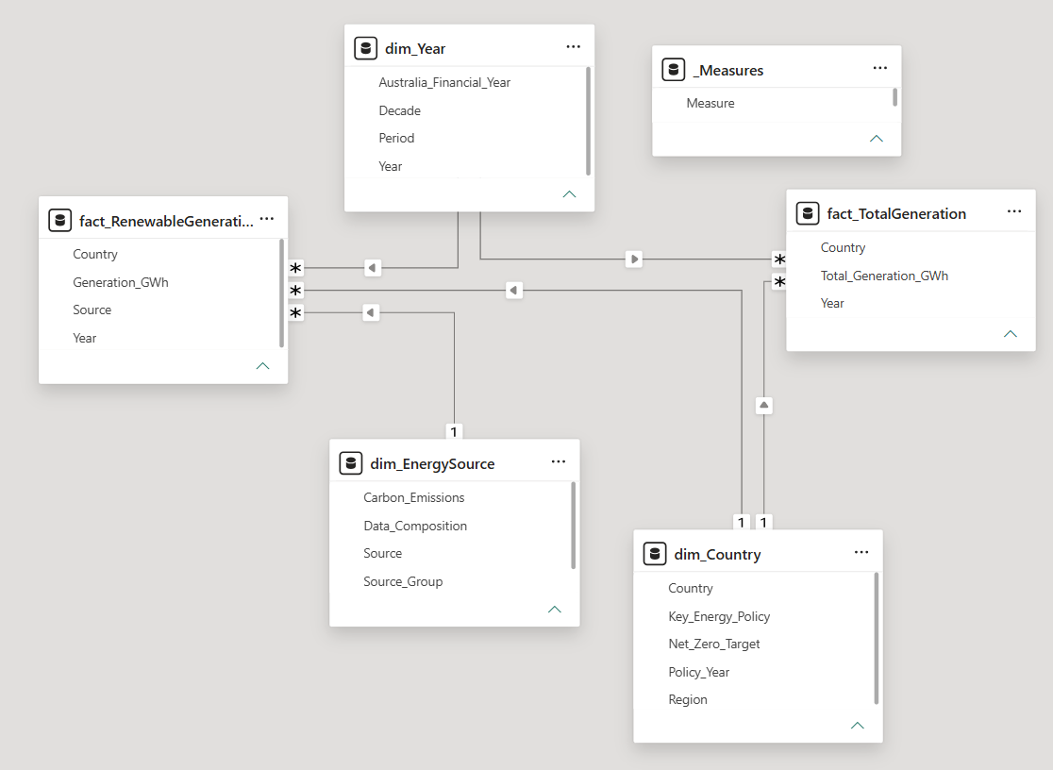
Note. Screenshot from Power BI Desktop Model View.

C1 - Table Structure
Table | Type | Rows | Grain | Key Columns
fact_RenewableGeneration | Fact | 480 | One row per country, year, and source | Country, Year, Source, Generation_GWh
fact_TotalGeneration | Fact | 80 | One row per country and year | Country, Year, Total_Generation_GWh
dim_Country | Dimension | 4 | One row per country | Country, Region, Key_Energy_Policy, Policy_Year, Net_Zero_Target
dim_Year | Dimension | 20 | One row per year (2005-2024) | Year, Australia_Financial_Year, Decade, Period
dim_EnergySource | Dimension | 14 | One row per raw source | Source, Source_Group, Source_Type, Carbon_Emissions, Data_Composition

C2 – Relationships
From (Dimension) | To (Fact) | Cardinality | Cross-filter Direction
dim_Country[Country] | fact_RenewableGeneration[Country] | One-to-Many (1:M) | Single
dim_Country[Country] | fact_TotalGeneration[Country] | One-to-Many (1:M) | Single
dim_Year[Year] | fact_RenewableGeneration[Year] | One-to-Many (1:M) | Single
dim_Year[Year] | fact_TotalGeneration[Year] | One-to-Many (1:M) | Single
dim_EnergySource[Source] | fact_RenewableGeneration[Source] | One-to-Many (1:M) | Single

Appendix D - Key DAX Measures
All measures are stored in a dedicated _Measures table in Power BI Desktop. This keeps measures separate from fact and dimension tables for clarity and maintainability.

-- Calculates electricity generated from non-renewable sources
Non-Renewable Generation GWh =
[Total Generation GWh] - [Renewable Generation GWh]

-- Converts non-renewable generation from GWh to TWh for cleaner dashboard display
Non-Renewable Generation TWh =
DIVIDE(
[Non-Renewable Generation GWh],
1000
)

-- Sums renewable electricity generation from all renewable sources
Renewable Generation GWh =
SUM(fact_RenewableGeneration[Generation_GWh])

-- Converts renewable electricity generation from GWh to TWh
Renewable Generation TWh =
DIVIDE([Renewable Generation GWh], 1000)

-- Calculates renewable electricity as a proportion of total electricity generation
Renewable Share % =
DIVIDE(
[Renewable Generation GWh],
[Total Generation GWh])

-- Calculates each renewable source as a share of total renewable generation
Renewable Source Mix % =
DIVIDE(
[Renewable Generation GWh],
CALCULATE(
[Renewable Generation GWh],
ALL(dim_EnergySource[Source_Group] ))

-- Sums total electricity generation for each country and year
Total Generation GWh =
SUM(fact_TotalGeneration[Total_Generation_GWh])

-- Converts total electricity generation from GWh to TWh
Total Generation TWh =
DIVIDE([Total Generation GWh], 1000)

Appendix E - R Forecasting Code
The R visual was used in Power BI to produce the forecast charts in Section 2.4. Linear regression was selected because it provides a transparent trend-based forecast and displays the regression equation, R-squared value, p-value, and 95% prediction interval directly on the chart, making the statistical methodology visible and verifiable.

E1 - Renewable Generation Forecast (TWh)
Required fields in Power BI R visual Values: dim_Year[Year], dim_Country[Country], Renewable Generation TWh (from _Measures). Visual filter: Country = Australia.
# Power BI creates the dataset automatically from the fields added to the R visual
# Required fields: Year, Country, Renewable Generation TWh
df <- dataset
# Clean column names
names(df) <- make.names(names(df), unique = TRUE)
# Find columns automatically
year_col <- grep("Year", names(df), value = TRUE)[1]
country_col <- grep("Country", names(df), value = TRUE)[1]
value_col <- grep("Renewable.*Generation.*TWh|Renewable.Generation.TWh|TWh", names(df), value = TRUE)[1]
# Keep only required columns
df <- df[, c(year_col, country_col, value_col)]
names(df) <- c("Year", "Country", "Renewable_TWh")
# Convert data types
df$Year <- as.numeric(as.character(df$Year))
df$Country <- as.character(df$Country)
df$Renewable_TWh <- as.numeric(gsub(",", "", as.character(df$Renewable_TWh)))
# Keep Australia only
aus <- df[df$Country == "Australia", ]
# Remove missing values
aus <- aus[!is.na(aus$Year) & !is.na(aus$Renewable_TWh), ]
# Aggregate in case Power BI sends duplicate rows
aus <- aggregate(Renewable_TWh ~ Year, data = aus, sum)
# Sort by year
aus <- aus[order(aus$Year), ]
# Forecast years
last_year <- max(aus$Year)
future_years <- data.frame(Year = (last_year + 1):2035)
# Create year index for simpler regression equation
aus$Year_Index <- aus$Year - min(aus$Year)
future_years$Year_Index <- future_years$Year - min(aus$Year)
# Linear trend model
model <- lm(Renewable_TWh ~ Year_Index, data = aus)
pred <- predict(model, newdata = future_years, interval = "prediction", level = 0.95)
# Model statistics
model_summary <- summary(model)
r_squared <- model_summary$r.squared
intercept <- coef(model)[1]
slope <- coef(model)[2]
p_value <- model_summary$coefficients["Year_Index", "Pr(>|t|)"]
p_label <- ifelse(
p_value < 0.001,
"p < 0.001",
paste0("p = ", round(p_value, 3))
)
r2_label <- paste0("R² = ", round(r_squared, 3), ", ", p_label)
eq_label <- paste0("y = ", round(slope, 2), "x + ", round(intercept, 1))
# Forecast dataframe
forecast_data <- data.frame(
Year = future_years$Year,
Renewable_TWh = pred[, "fit"],
Lower_95 = pred[, "lwr"],
Upper_95 = pred[, "upr"],
Type = "Forecast"
)
# Historical dataframe
historical_data <- data.frame(
Year = aus$Year,
Renewable_TWh = aus$Renewable_TWh,
Lower_95 = NA,
Upper_95 = NA,
Type = "Historical"
)
library(ggplot2)
ggplot() +
# Prediction interval
geom_ribbon(
data = forecast_data,
aes(x = Year, ymin = Lower_95, ymax = Upper_95),
fill = "#D62728",
alpha = 0.16
) +
# Historical line and points
geom_line(
data = historical_data,
aes(x = Year, y = Renewable_TWh, colour = Type),
linewidth = 1.4
) +
geom_point(
data = historical_data,
aes(x = Year, y = Renewable_TWh, colour = Type),
size = 2.6
) +
# Forecast line and points
geom_line(
data = forecast_data,
aes(x = Year, y = Renewable_TWh, colour = Type),
linewidth = 1.4,
linetype = "dashed"
) +
geom_point(
data = forecast_data,
aes(x = Year, y = Renewable_TWh, colour = Type),
size = 2.6
) +
# Forecast label
geom_text(
data = tail(forecast_data, 1),
aes(
x = Year,
y = Renewable_TWh,
label = paste0(round(Renewable_TWh, 1), " TWh")
),
hjust = 1.1,
vjust = -0.6,
size = 4.8,
fontface = "bold",
colour = "#D62728"
) +
# R2 and p-value
annotate(
"text",
x = 2006,
y = max(c(historical_data$Renewable_TWh, forecast_data$Upper_95), na.rm = TRUE) * 0.96,
label = r2_label,
hjust = 0,
size = 5.8,
colour = "navy"
) +
# Regression formula
annotate(
"text",
x = 2006,
y = max(c(historical_data$Renewable_TWh, forecast_data$Upper_95), na.rm = TRUE) * 0.84,
label = eq_label,
hjust = 0,
size = 5.8,
colour = "red"
) +
# Manual colours
scale_colour_manual(
values = c(
"Historical" = "#1F77B4",
"Forecast" = "#D62728"
)
) +
# Axes
scale_x_continuous(
breaks = c(2005, 2010, 2015, 2020, 2025, 2030, 2035),
limits = c(2005, 2036)
) +
scale_y_continuous(
limits = c(0, NA),
expand = expansion(mult = c(0, 0.10))
) +

labs(
x = NULL,
y = "Generation (TWh)",
colour = NULL
) +

theme_minimal(base_size = 14) +
theme(
legend.position = "top",
legend.text = element_text(size = 15),
axis.title.y = element_text(size = 13, face = "bold"),
axis.text = element_text(size = 11, colour = "#555555"),
panel.grid.minor = element_blank(),
panel.grid.major.x = element_blank(),
panel.grid.major.y = element_line(colour = "#D9E2F3", linewidth = 0.4),

# background
panel.background = element_rect(fill = "#F4F8FC", colour = NA),
plot.background = element_rect(fill = "#F4F8FC", colour = NA),

plot.margin = margin(8, 18, 8, 8)
)

E2 - Renewable Share Forecast (%)
# Power BI creates the dataset automatically from the fields added to the R visual
# Required fields: Year, Country, Renewable Share %

df <- dataset

# Clean column names
names(df) <- make.names(names(df), unique = TRUE)

# Find columns automatically
year_col <- grep("Year", names(df), value = TRUE)[1]
country_col <- grep("Country", names(df), value = TRUE)[1]
share_col <- grep("Renewable.*Share|Share", names(df), value = TRUE)[1]

# Check missing columns
if (is.na(year_col)) stop("Year column not found. Add Year to the R visual.")
if (is.na(country_col)) stop("Country column not found. Add Country to the R visual.")
if (is.na(share_col)) stop("Renewable Share % column not found. Add Renewable Share % to the R visual.")

# Keep only required columns
df <- df[, c(year_col, country_col, share_col)]
names(df) <- c("Year", "Country", "Renewable_Share")

# Convert data types
df$Year <- as.numeric(as.character(df$Year))
df$Country <- as.character(df$Country)

# Convert share to numeric
df$Renewable_Share <- as.character(df$Renewable_Share)
df$Renewable_Share <- gsub("%", "", df$Renewable_Share)
df$Renewable_Share <- gsub(",", "", df$Renewable_Share)
df$Renewable_Share <- as.numeric(df$Renewable_Share)

# If Power BI sends share as decimal, convert to percentage
# Example: 0.35 becomes 35
if (max(df$Renewable_Share, na.rm = TRUE) <= 1) {
df$Renewable_Share <- df$Renewable_Share * 100
}

# Keep Australia only
aus <- df[df$Country == "Australia", ]

# Remove missing values
aus <- aus[!is.na(aus$Year) & !is.na(aus$Renewable_Share), ]

# Aggregate in case Power BI sends duplicate rows
aus <- aggregate(Renewable_Share ~ Year, data = aus, mean)

# Sort by year
aus <- aus[order(aus$Year), ]

# Forecast years
last_year <- max(aus$Year)
future_years <- data.frame(Year = (last_year + 1):2035)

# Create year index for simpler regression equation
aus$Year_Index <- aus$Year - min(aus$Year)
future_years$Year_Index <- future_years$Year - min(aus$Year)

# Linear trend model
model <- lm(Renewable_Share ~ Year_Index, data = aus)
pred <- predict(model, newdata = future_years, interval = "prediction", level = 0.95)

# Model statistics
model_summary <- summary(model)
r_squared <- model_summary$r.squared
intercept <- coef(model)[1]
slope <- coef(model)[2]
p_value <- model_summary$coefficients["Year_Index", "Pr(>|t|)"]

p_label <- ifelse(
p_value < 0.001,
"p < 0.001",
paste0("p = ", round(p_value, 3))
)

r2_label <- paste0("R² = ", round(r_squared, 3), ", ", p_label)
eq_label <- paste0("y = ", round(slope, 2), "x + ", round(intercept, 1))

# Forecast dataframe
forecast_data <- data.frame(
Year = future_years$Year,
Renewable_Share = pred[, "fit"],
Lower_95 = pred[, "lwr"],
Upper_95 = pred[, "upr"],
Type = "Forecast"
)

# Historical dataframe
historical_data <- data.frame(
Year = aus$Year,
Renewable_Share = aus$Renewable_Share,
Lower_95 = NA,
Upper_95 = NA,
Type = "Historical"
)

library(ggplot2)

ggplot() +
# Prediction interval
geom_ribbon(
data = forecast_data,
aes(x = Year, ymin = Lower_95, ymax = Upper_95),
fill = "#D62728",
alpha = 0.16
) +

# Historical line and points
geom_line(
data = historical_data,
aes(x = Year, y = Renewable_Share, colour = Type),
linewidth = 1.4
) +
geom_point(
data = historical_data,
aes(x = Year, y = Renewable_Share, colour = Type),
size = 2.6
) +

# Forecast line and points
geom_line(
data = forecast_data,
aes(x = Year, y = Renewable_Share, colour = Type),
linewidth = 1.4,
linetype = "dashed"
) +
geom_point(
data = forecast_data,
aes(x = Year, y = Renewable_Share, colour = Type),
size = 2.6
) +

# Forecast label
geom_text(
data = tail(forecast_data, 1),
aes(
x = Year,
y = Renewable_Share,
label = paste0(round(Renewable_Share, 1), "%")
),
hjust = 1.1,
vjust = -0.6,
size = 4.8,
fontface = "bold",
colour = "#D62728"
) +

# R2 and p-value
annotate(
"text",
x = 2006,
y = max(c(historical_data$Renewable_Share, forecast_data$Upper_95), na.rm = TRUE) * 0.96,
label = r2_label,
hjust = 0,
size = 5.8,
colour = "navy"
) +

# Regression formula
annotate(
"text",
x = 2006,
y = max(c(historical_data$Renewable_Share, forecast_data$Upper_95), na.rm = TRUE) * 0.84,
label = eq_label,
hjust = 0,
size = 5.8,
colour = "red"
) +

# Manual colours
scale_colour_manual(
values = c(
"Historical" = "#1F77B4",
"Forecast" = "#D62728"
)
) +

# Axes
scale_x_continuous(
breaks = c(2005, 2010, 2015, 2020, 2025, 2030, 2035),
limits = c(2005, 2036)
) +
scale_y_continuous(
limits = c(0, 100),
labels = function(x) paste0(x, "%"),
expand = expansion(mult = c(0, 0.08))
) +

labs(
x = NULL,
y = "Renewable Share (%)",
colour = NULL
) +

theme_minimal(base_size = 14) +
theme(
legend.position = "top",
legend.text = element_text(size = 15),
axis.title.y = element_text(size = 13, face = "bold"),
axis.text = element_text(size = 11, colour = "#555555"),
panel.grid.minor = element_blank(),
panel.grid.major.x = element_blank(),
panel.grid.major.y = element_line(colour = "#D9E2F3", linewidth = 0.4),

panel.background = element_rect(fill = "#F4F8FC", colour = NA),
plot.background = element_rect(fill = "#F4F8FC", colour = NA),

plot.margin = margin(8, 18, 8, 8)
)

Appendix F - Data Decisions Log
The following log records genuine analytical decision points made during this project. Each entry documents what alternatives were considered, what was decided, and why. Entries are specific to this project and its data.

# | Decision Point | Alternatives Considered | Decision Made | Reason and Impact
1 | Data model design | Single fact table vs galaxy schema | Galaxy schema with two fact tables | Single fact table would repeat Total_Generation_GWh 5-6 times per country-year, causing overcounting if summed. Galaxy schema prevents this.
2 | Australian financial year convention | Start-year (FY 2023-24 = 2023) vs end-year (= 2024) | End-year convention | More data in FY 2023-24 falls in 2024 (January-June 2024). Aligns Australia with calendar-year countries.
3 | China data source | Official NBS website vs OWID / IEA | OWID drawing on IEA statistics | NBS data not freely available in English downloadable format. OWID is authoritative intermediary - data chain: NBS to IEA to OWID.
4 | Germany data format | Excel download vs PDF extraction | PDF - AGEE-Stat official publication | No Excel version available. Values extracted manually from official government PDF.
5 | Source category structure | Keep all raw sub-sources vs combine into 5 groups | Combine into 5 groups via Source_Group in dim_EnergySource | Enables consistent cross-country comparison. Raw sub-sources preserved in fact table - aggregation happens through dimension relationship.
6 | China geothermal values | Include small OWID values vs set to zero | Set to zero for all years | Yangbajain plant ceased 2020 - capacity is negligible and OWID does not separately report it. Setting to zero prevents double counting with other renewables.
7 | Unit of measurement for display | Keep GWh vs convert to TWh | Store GWh in fact table - convert to TWh via DAX for display | Preserves raw data integrity. TWh makes large national generation figures more readable for government audience.
8 | Forecast method | Power BI built-in forecast vs R linear regression | R linear regression in Power BI | R displays regression equation, R-squared, p-value and 95% prediction interval on chart - more transparent and statistically verifiable than Power BI built-in forecast.
9 | Forecast data range | 2005-2024 vs 2015-2024 only | 2005-2024 (full period) | More data points gives statistically stronger and more defensible model. Limitation of including slow early years is acknowledged in report.
10 | Number of forecast charts | One chart only vs two separate | Two separate - TWh and Share % | TWh answers the volume question. Share % directly addresses the 82% policy target. Both are needed for a complete government planning answer.
11 | Q2 chart type | Stacked column overtime vs clustered 2005 vs 2024 | Clustered column 2005 vs 2024 | Section 2.1 already shows time trend. Clustered column shows make-up of individual sources more clearly than stacked. Two-year snapshot directly answers the question.
12 | Q3 comparison measure | Volume only vs share only vs both | Both - two separate bar charts | Volume alone misleads due to country size differences. Share alone loses absolute scale context. Both together give the complete picture required by the question.
13 | Q1 reference line year | 2011 only vs 2015 only vs both | Both 2011 and 2015 | 2011 marks LRET introduction - visible small uptick. 2015 marks the policy confirmation that caused the major visible acceleration. Both tell the complete policy story.
14 | New Zealand net vs gross generation | Treat as equivalent vs acknowledge difference | Acknowledged as minor limitation | Net vs gross difference is typically less than 2% at annual level - not material for trend analysis but noted for transparency.
15 | Slicer scope on dashboard | Global slicers vs restricted slicers | Year slicer restricted to Q3 only; Source slicer restricted to Q2 only | Q1 and Q4 show full time trends - filtering would break the analytical story. Q3 is a point-in-time comparison - year filter makes sense. Q2 source filter allows source-level exploration without affecting other questions.

Reference list

Agora Energiewende. (2024). Renewables in Germany's Energy Transition. https://www.agora-energiewende.org/about-us/the-german-energiewende/what-is-the-role-of-renewable-energy-in-germany
Bundesnetzagentur. (2025). Bundesnetzagentur publishes 2024 electricity market data. German Federal Network Agency Retrieved from https://www.bundesnetzagentur.de/SharedDocs/Pressemitteilungen/EN/2025/20250103_SMARD.html
Clean Energy Council. (2023). Geothermal. https://cleanenergycouncil.org.au/for-consumers/technologies/geothermal
Clean Energy Regulator. (2026). Renewable Energy Target. Australian Government Clean Energy Regulator Retrieved from https://cer.gov.au/schemes/renewable-energy-target
DCCEEW. (2025). Australian Energy Statistics, Table O: Electricity generation by fuel type 2023-24 and 2024. Australian Government Department of Climate Change Energy the Environment and Water Retrieved from https://www.energy.gov.au/publications/australian-energy-statistics-table-o-electricity-generation-fuel-type-2023-24-and-2024
DCCEEW. (2026). Renewable energy. https://www.dcceew.gov.au/energy/renewable
Geoscience Australia. (2026). Hydro Energy. Australian Government Geoscience Australia Retrieved from https://www.ga.gov.au/scientific-topics/energy/resources/other-renewable-energy-resources/hydro-energy
IRENA. (2025). Renewable Power Generation Costs in 2024. https://www.irena.org/Publications/2025/Jul/Renewable-Power-Generation-Costs-in-2024
MBIE. (2018). Geothermal energy generation. Ministry of Business Innovation and Employment New Zealand Retrieved from https://www.mbie.govt.nz/building-and-energy/energy-and-natural-resources/energy-generation-and-markets/geothermal-energy-generation
MBIE. (2025). Energy in New Zealand 2025 - Electricity. Ministry of Business Innovation and Employment Retrieved from https://www.mbie.govt.nz/building-and-energy/energy-and-natural-resources/energy-statistics-and-modelling/energy-publications-and-technical-papers/energy-in-new-zealand/energy-in-new-zealand-2025/electricity
OWID. (2026). China - Energy Country Profile. https://ourworldindata.org/profile/energy/china
U.S. Energy Information Administration. (2025). China - Analysis. U.S. Energy Information Administration, Retrieved from https://www.eia.gov/international/analysis/country/CHN

