From windows open git bash..then..

$ git config --global init.defaultBranch main

$ git init

$ git config --global user.name "jaisimhanster@gmail.com"

$ git config user.name

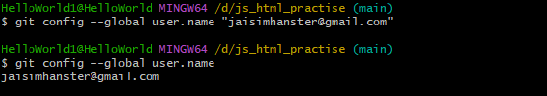

$ git clone --recurse-submodules https://github.com/jo777750/jo777750.github.io

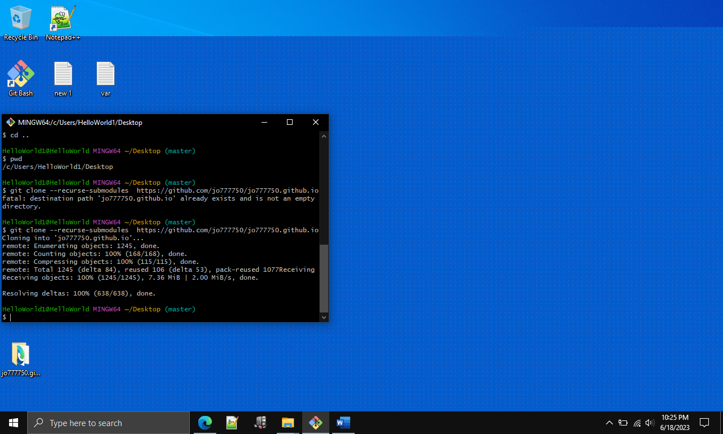

$ git fetch https://github.com/jo777750/jo777750.github.io main

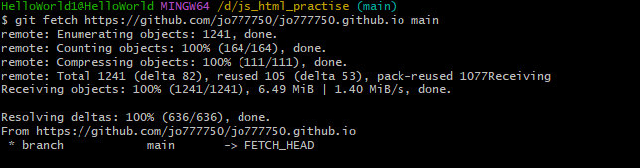

$ git diff --stat FETCH_HEAD

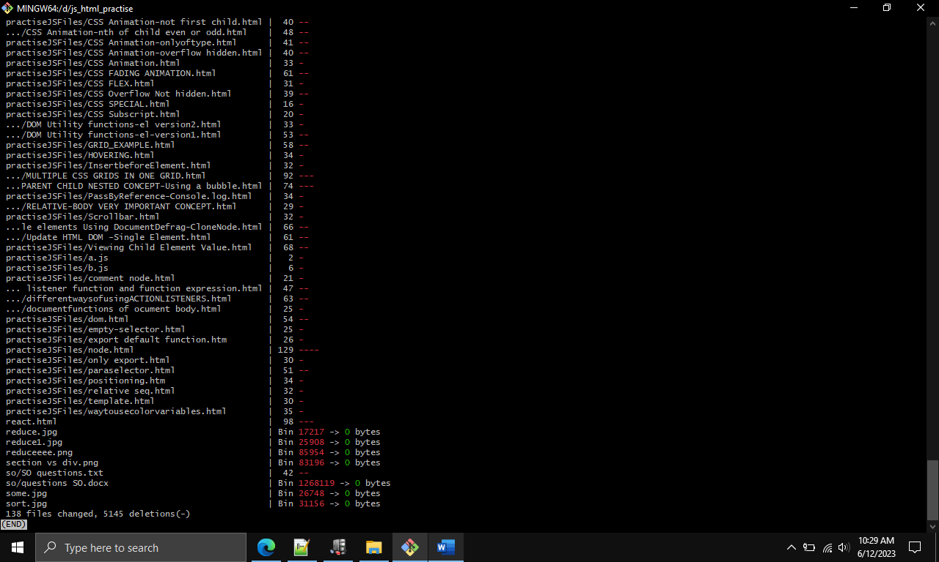

JAISIMHA@Laptop MINGW64 ~/desktop/fun (main)

$ touch a.py

JAISIMHA@Laptop MINGW64 ~/desktop/fun (main)

$ git add a.py

JAISIMHA@Laptop MINGW64 ~/desktop/fun (main)

$ git commit -m 'pyfile'

[main 697b5bf] pyfile

1 file changed, 0 insertions(+), 0 deletions(-)

create mode 100644 a.py

JAISIMHA@Laptop MINGW64 ~/desktop/fun (main)

$ git remote add o https://github.com/jo777750/jj.git

JAISIMHA@Laptop MINGW64 ~/desktop/fun (main)

$ git push -u o

Enumerating objects: 4, done.

Counting objects: 100% (4/4), done.

Delta compression using up to 4 threads

Compressing objects: 100% (2/2), done.

Writing objects: 100% (3/3), 279 bytes | 93.00 KiB/s, done.

Total 3 (delta 0), reused 0 (delta 0), pack-reused 0

To https://github.com/jo777750/jj.git

626007f..697b5bf main -> main

