Missing data in runtime data VEIW as shown below---

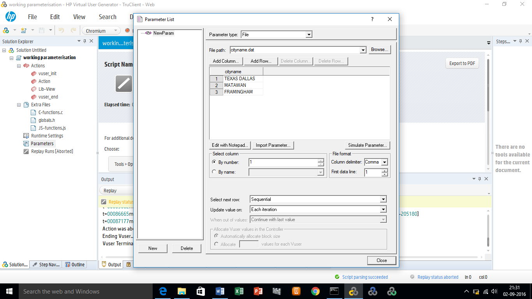

Parameters file-

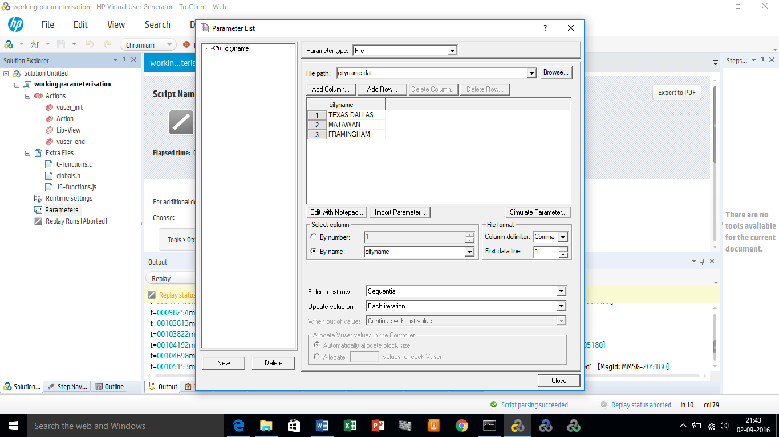

Script-

**truclient_step**("1", "Navigate to https://www.tgifridays.com/", "snapshot=**Action_1.inf**");  
    **truclient_step**("2", "Click on Line listitem", "snapshot=**Action_2.inf**");  
    **truclient_step**("3", "Click on Locations link", "snapshot=**Action_3.inf**");  
    **truclient_step**("4", "Wait for Enter City or Zip Code textbox", "snapshot=**Action_4.inf**");  
    **truclient_step**("5", "Click on Enter City or Zip Code textbox", "snapshot=**Action_5.inf**");  
    **truclient_step**("6", "Type TC.getParam('cityname') in Enter City or Zip Code textbox", "snapshot=**Action_6.inf**");  
    **truclient_step**("7", "Wait for Search button", "snapshot=**Action_7.inf**");  
    **truclient_step**("8", "Click on Search button", "snapshot=**Action_8.inf**");