**WEB API HANDS ON - OUTPUT**

OUTPUT SCREENSHOTS:

Returning employee details via GET request (Postman):

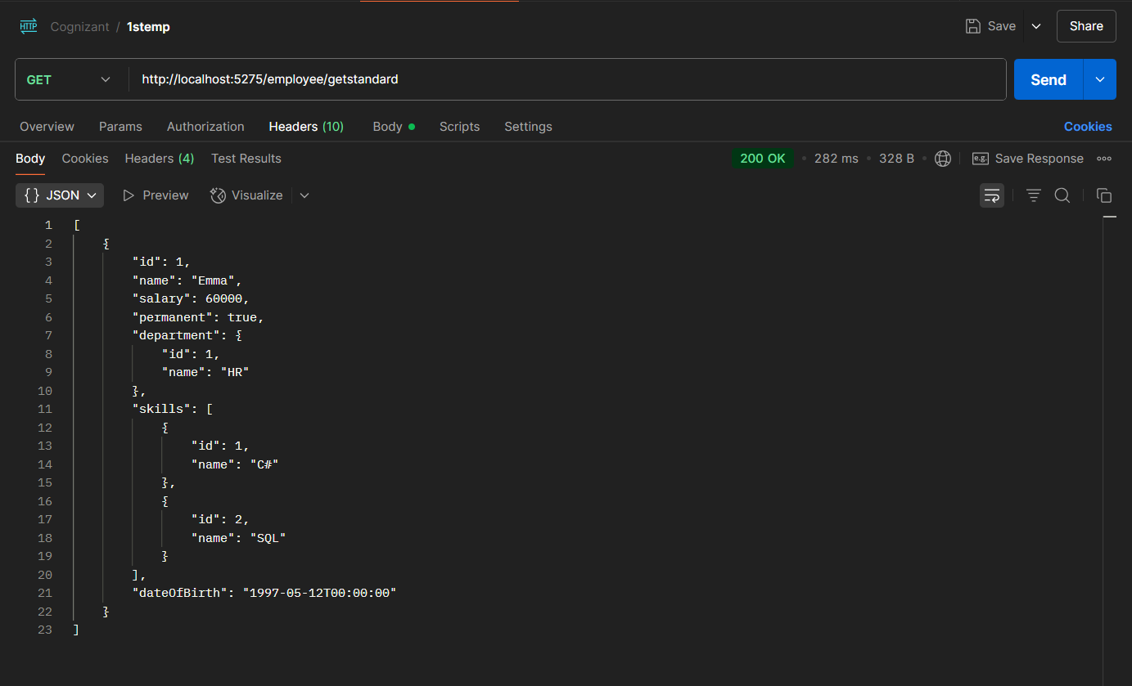

Adding employees with POST request (Swagger):

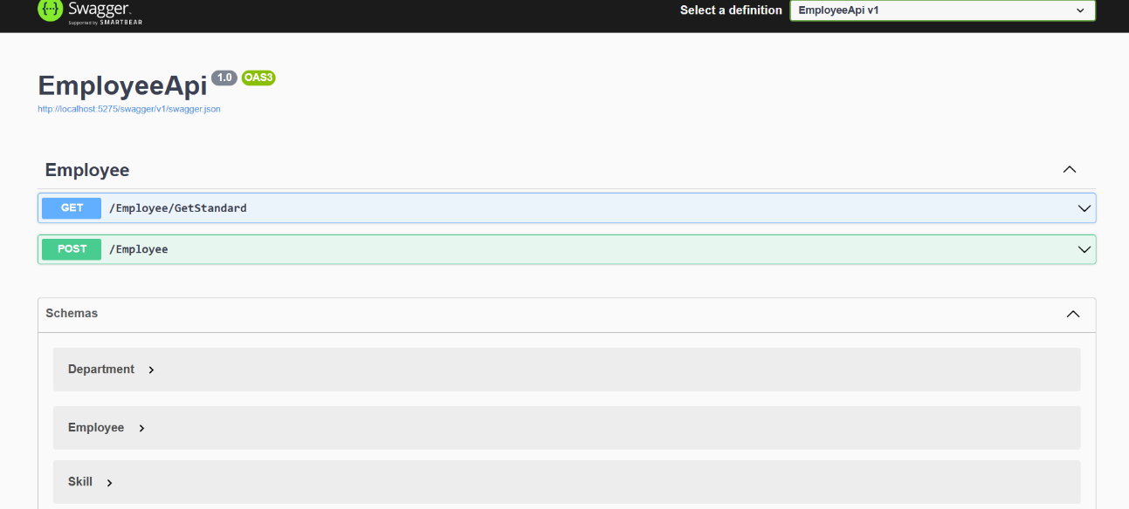

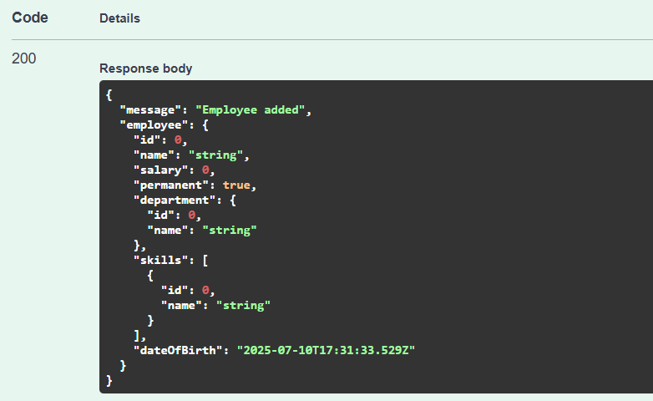

Adding employee route (Postman):

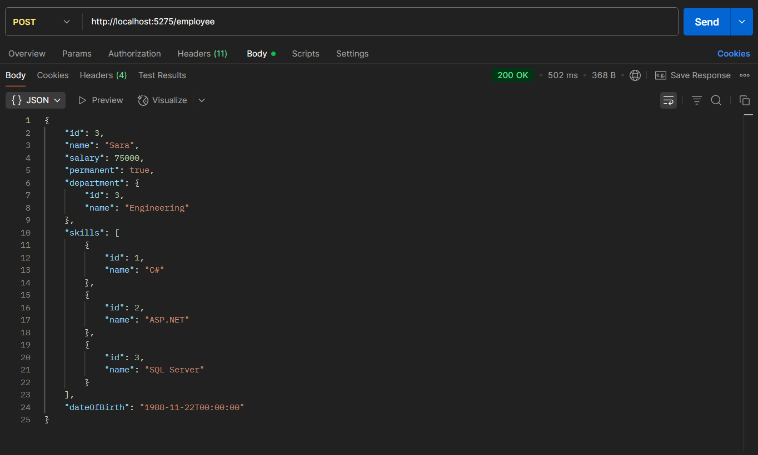

PUT request for updating employee details:

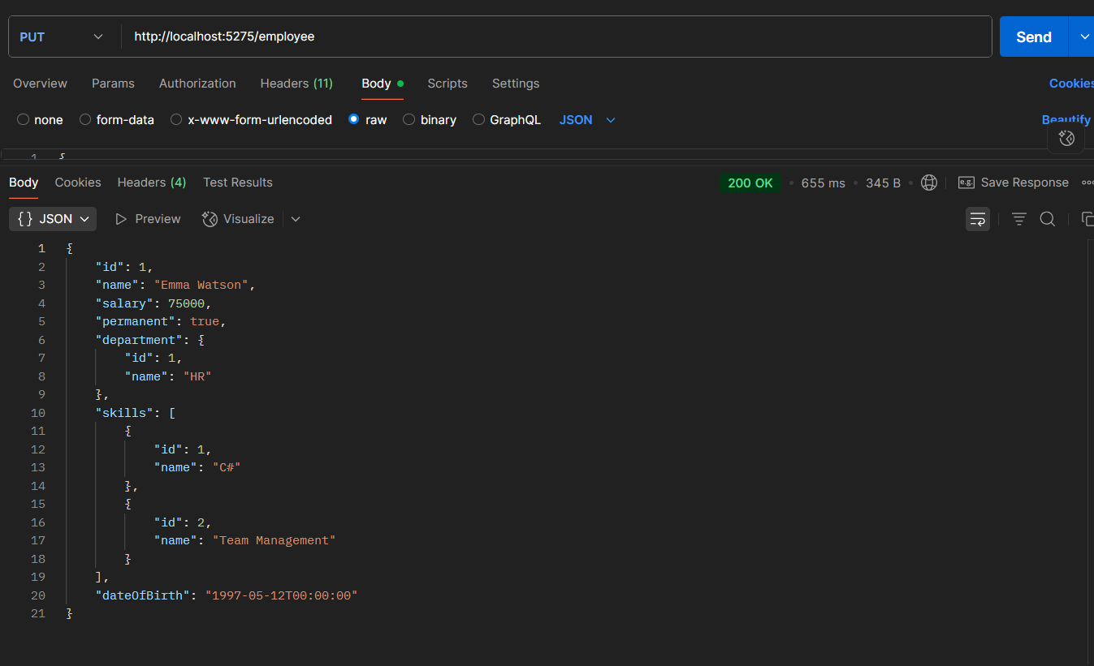

Deleting employee with specified id number using DELETE request (Postman):

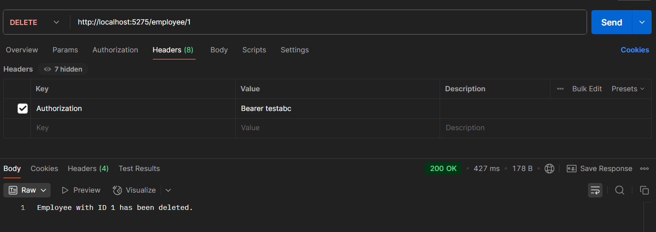

“Invalid id” shown when id is not found:

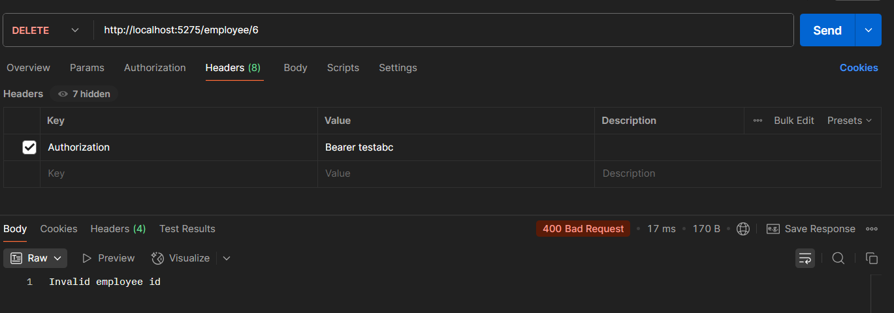

CRUD operations for employee data(Swagger):

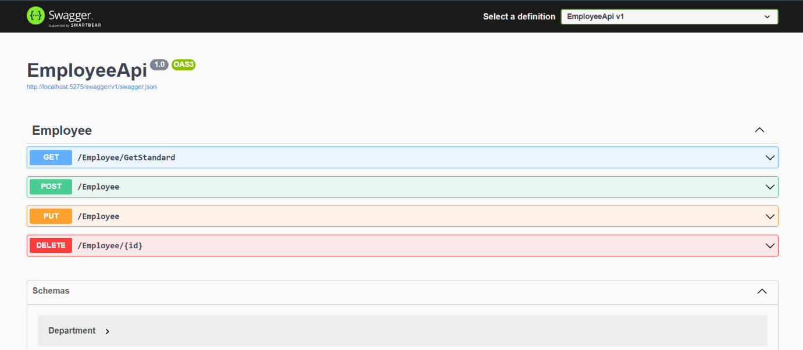

JWT token for authentication (Admin):

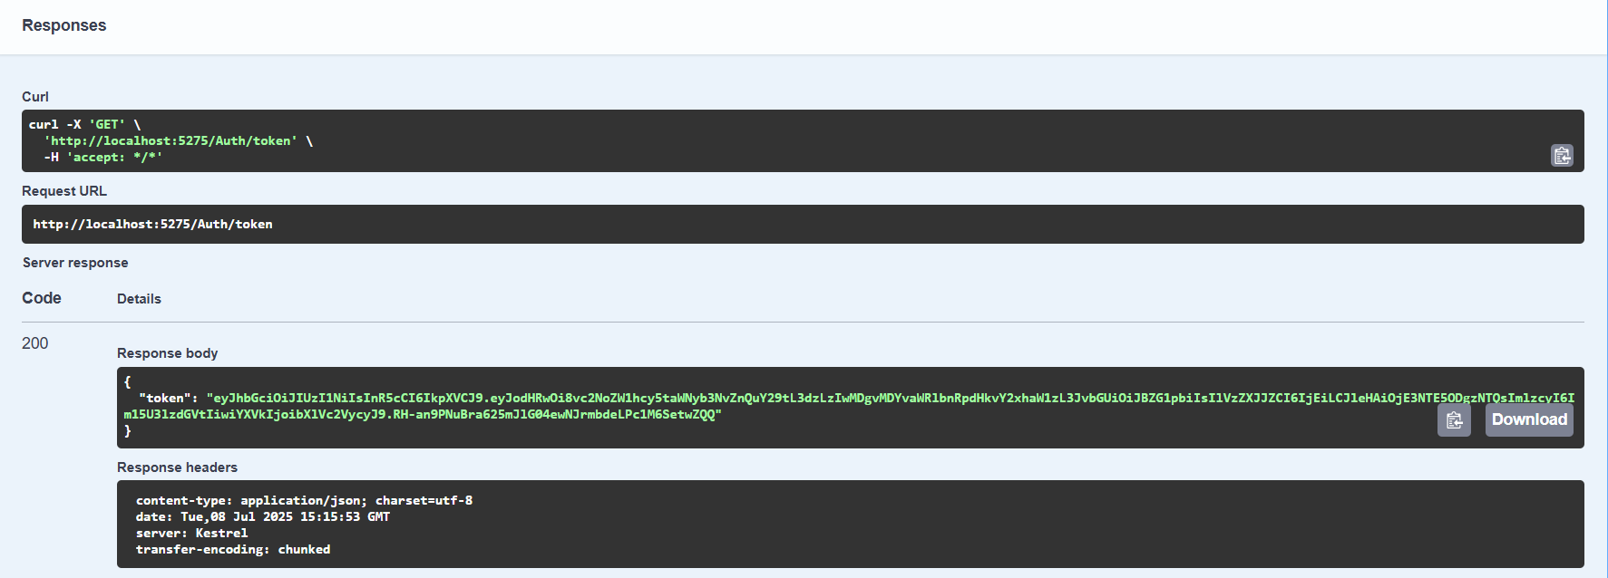

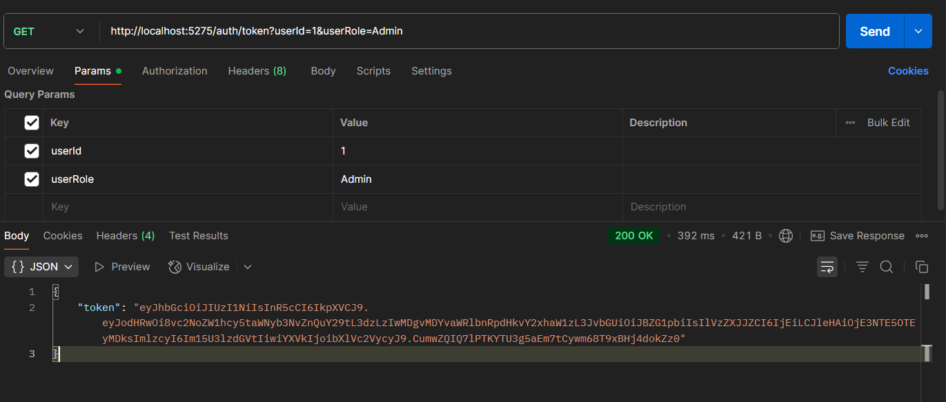

“Invalid request” shown after token is altered:

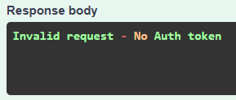

“Unauthorized” error shown after JWT expires soon (Swagger):

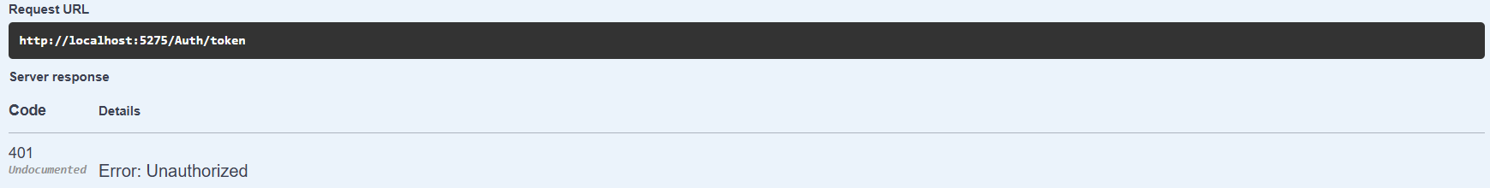

Authorization button for entering JWT:

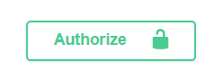

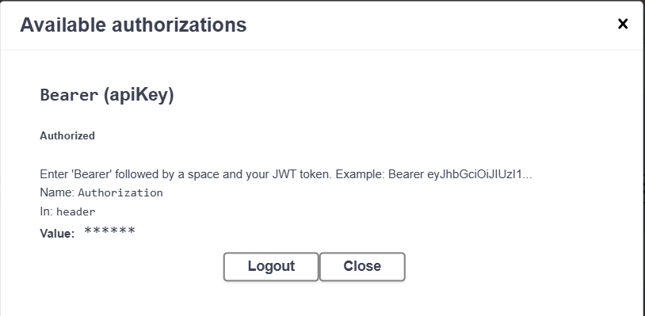

401 Error after changing roles in Authorize attribute:

